Offision 4.6.4-21500
Recurring meetings can now have a clear end and a separate duration limit for each occurrence.
2026-10-23 · https://offision.com/help/en/release-notes/4.6.4-21500/

Give a recurring series a clear end
You could permit standing meetings without bounding the series itself. In a resource policy, keep recurring bookings enabled, open Advanced recurring settings and turn on Limit series span to set the maximum calendar days. Bookers must choose an end date or occurrence count, and the final actual occurrence must end within that span; the advance-booking window remains a separate rule.
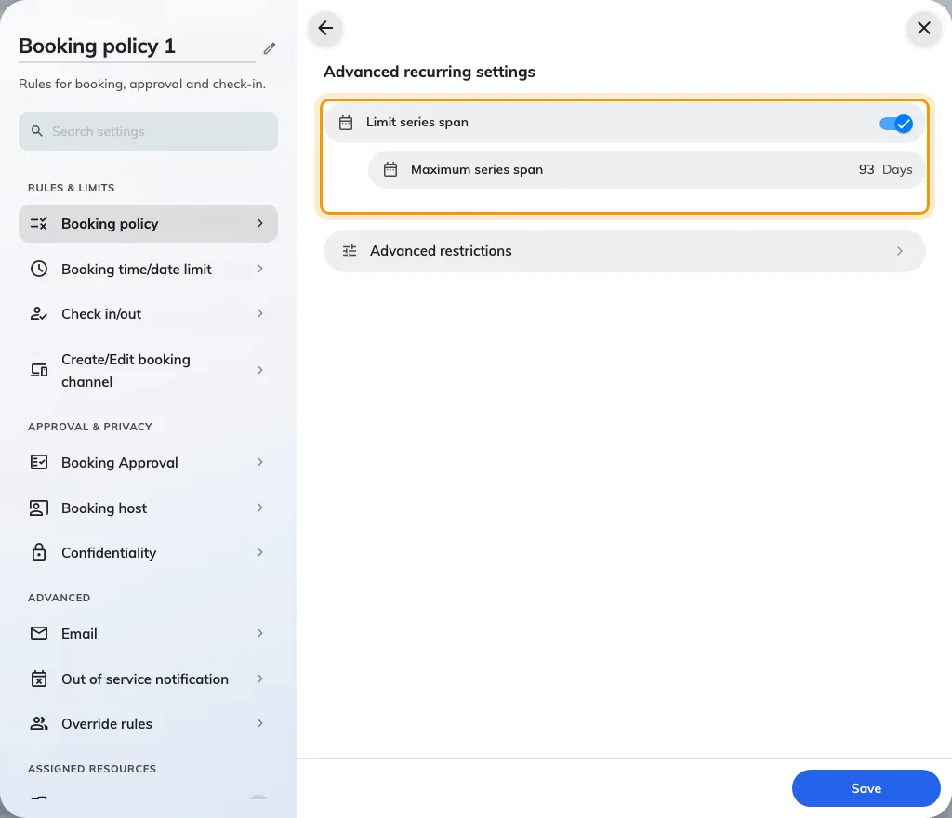
Give a recurring series a clear end
Where in Offision: admin app → booking/advance-policy (Booking policy)

Keep each recurring meeting short
Ordinary bookings and standing meetings previously shared the same duration limit. In Advanced recurring settings, open Advanced restrictions and enable Limit each recurring occurrence to set its maximum minutes; the stricter of this and the ordinary maximum applies. Saved bookings stay in place when you change the limits, while later date, time, recurrence or resource edits must meet the current rules, including edits to one occurrence.
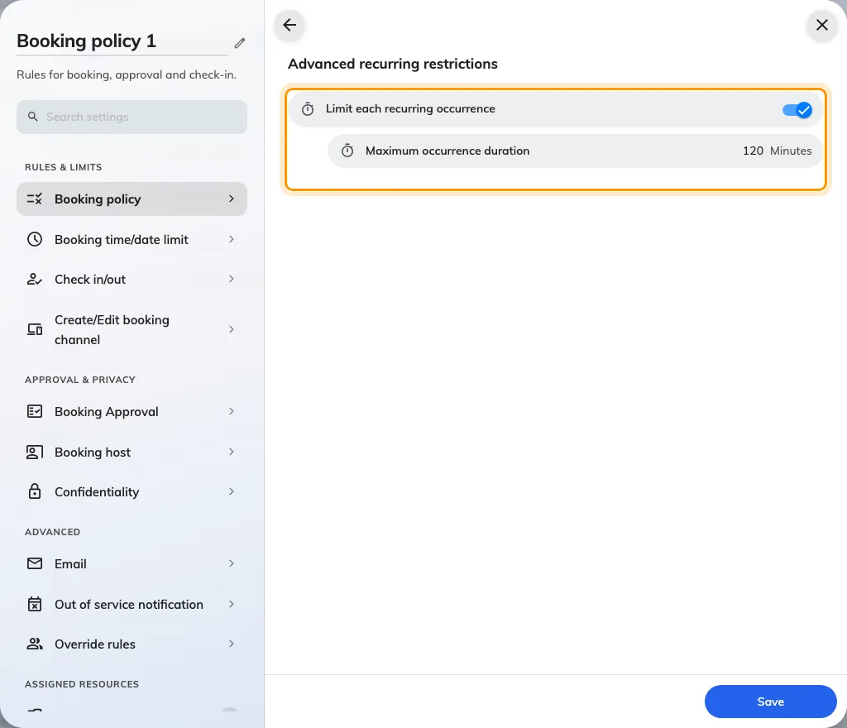
Keep each recurring meeting short
Where in Offision: admin app → booking/advance-policy (Booking policy)

What changed

Booking
- You could allow recurring meetings without limiting how long one series reserved a room. Now you can cap its span in calendar days when you enable Limit series span in a resource policy’s Advanced recurring settings.
- One duration limit had to cover ordinary and recurring bookings. Now you can add a separate limit for each recurring occurrence when you enable Limit each recurring occurrence under Advanced recurring settings → Advanced restrictions; the ordinary maximum still applies.

Fixes
- Whole-day Guest booking calendars could open on the wrong month instead of the selected day or first available date.
- Approval-history navigation could disappear when a list was empty.
- Visitor badges could fail to download in production.

