Offision 4.6.3-21400
Set guest prices by weekday and holiday, share room documents, and choose exactly when booking opens.
2026-10-22 · https://offision.com/help/en/release-notes/4.6.3-21400/

Set prices for selected days
A single rate could not represent your weekday and holiday charges. On a Guest booking page, open its room pricing plan and add day-rate tables, then select their weekdays or holidays. Check a date, save the page and review a mixed-day guest quote; existing bookings retain their recorded prices.
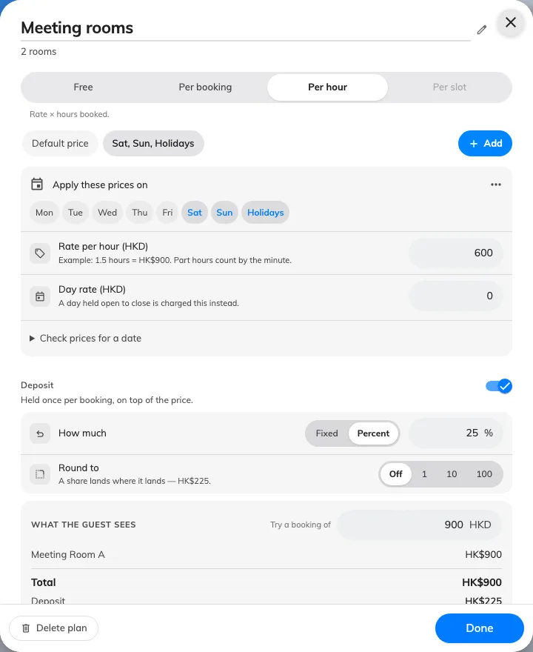
Set prices for selected days
Where in Offision: admin app → public-booking/overview (Overview)

Keep reference files with each room
Guests previously needed a separate route to room documents. In a Guest booking page’s Room tab, add and order each room’s Public booking attachments and set their translated button names. Save the whole page to publish that page’s files, then check that guests can open them without losing their booking selections.
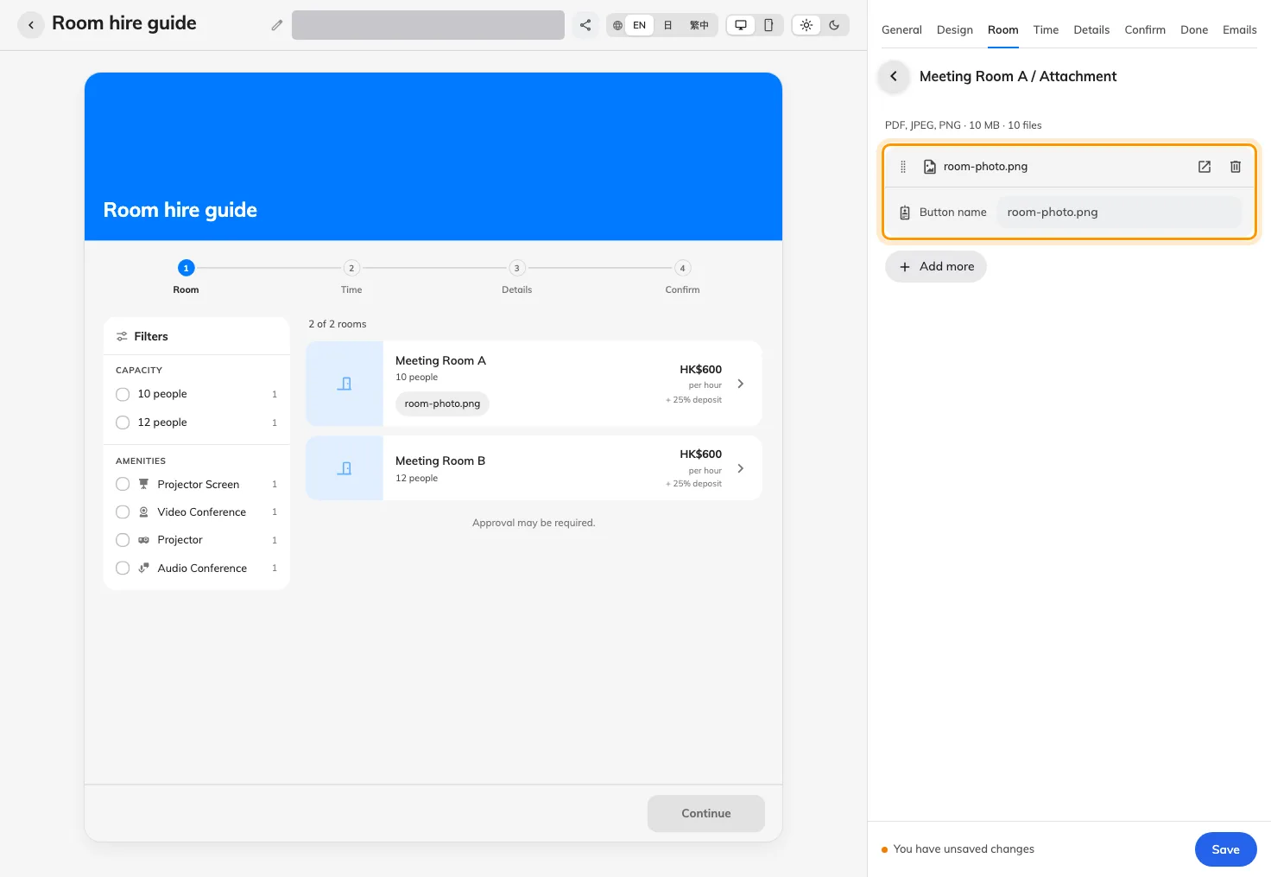
Keep reference files with each room
Where in Offision: admin app → public-booking/overview (Overview)

Open bookings for a fixed period
Relative notice and advance limits could not describe a fixed season. In a Guest booking page’s Time tab, choose Specified date for either Starts or Ends and enter its date. Each boundary uses the room’s time zone; the end date is included, and other availability restrictions still apply.
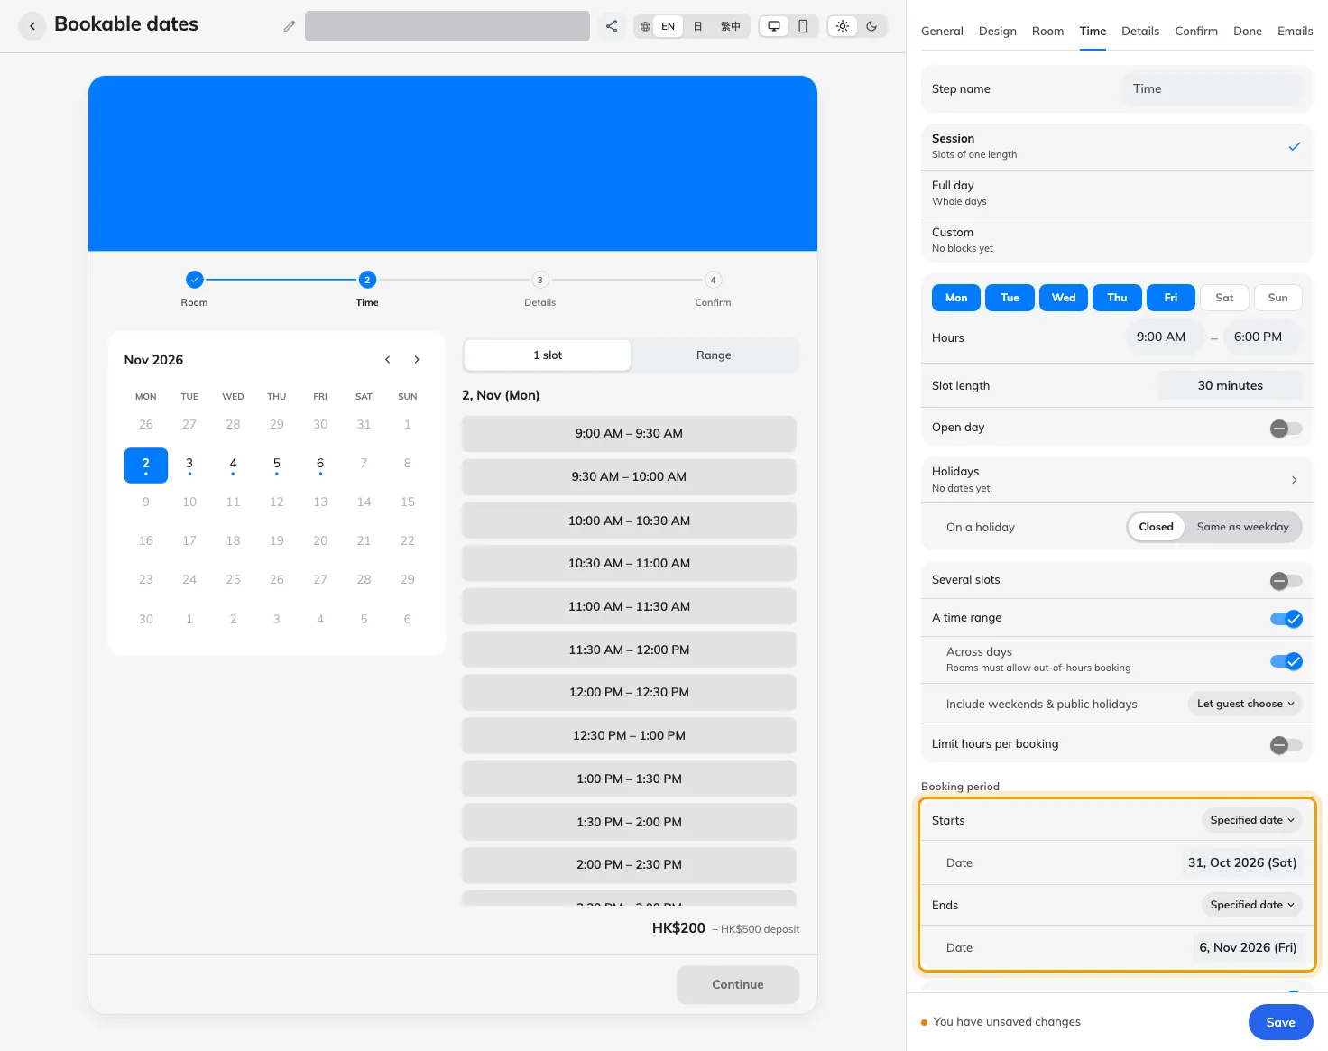
Open bookings for a fixed period
Where in Offision: admin app → public-booking/overview (Overview)

Include weekends, or let guests choose
The old skipping label made the direction of the choice harder to read. For a Guest booking page with an across-day range, set Include weekends & public holidays to Always, Never or Let guest choose. The guest switch starts on; closed weekends and page holidays may be crossed without charge, while the complete room interval remains held.
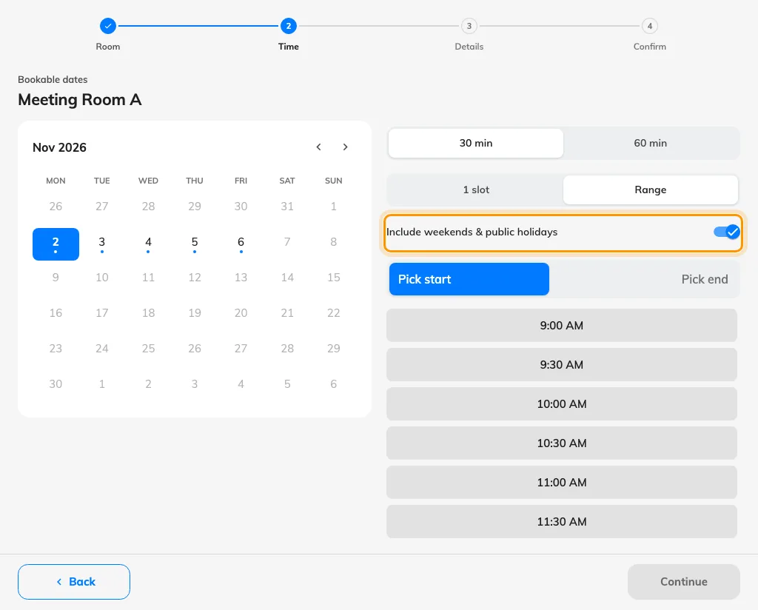
Include weekends, or let guests choose
Where in Offision: admin app → public-booking/overview (Overview)

Give the general public page its own look
The public list previously had no separate appearance settings. Open Guest booking Settings and use General public page to choose Appearance and List item corners, then save. Open or copy Public link to check the published-page list; each booking page keeps its own design.
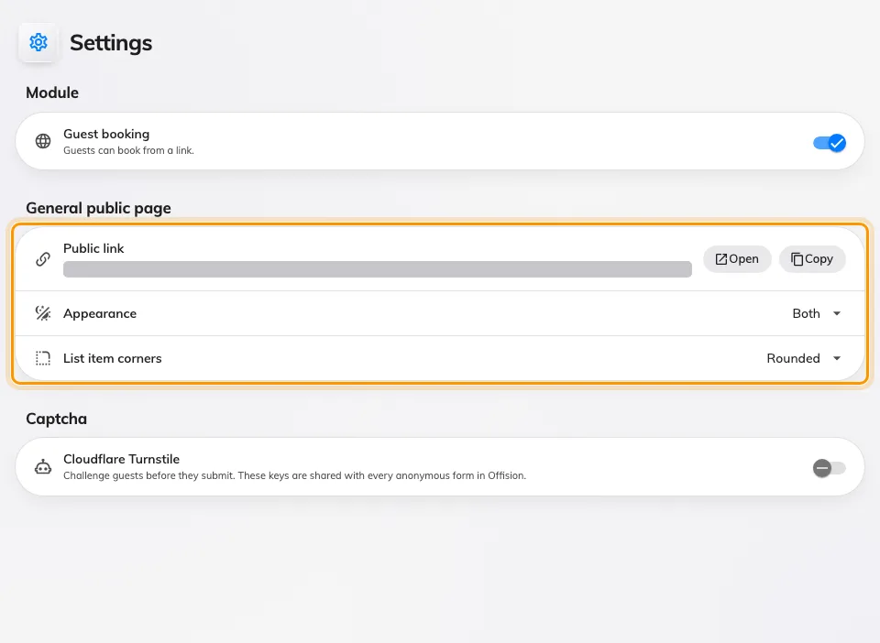
Give the general public page its own look
Where in Offision: admin app → public-booking/settings (Settings)

Review whole days as dates
Clock times obscured a whole-day guest booking. On a page using whole-day selection, choose the highlighted calendar date and check the date-only recap before submitting. Desktop shows the chosen date beside the calendar; phones keep the calendar selection without that extra panel.
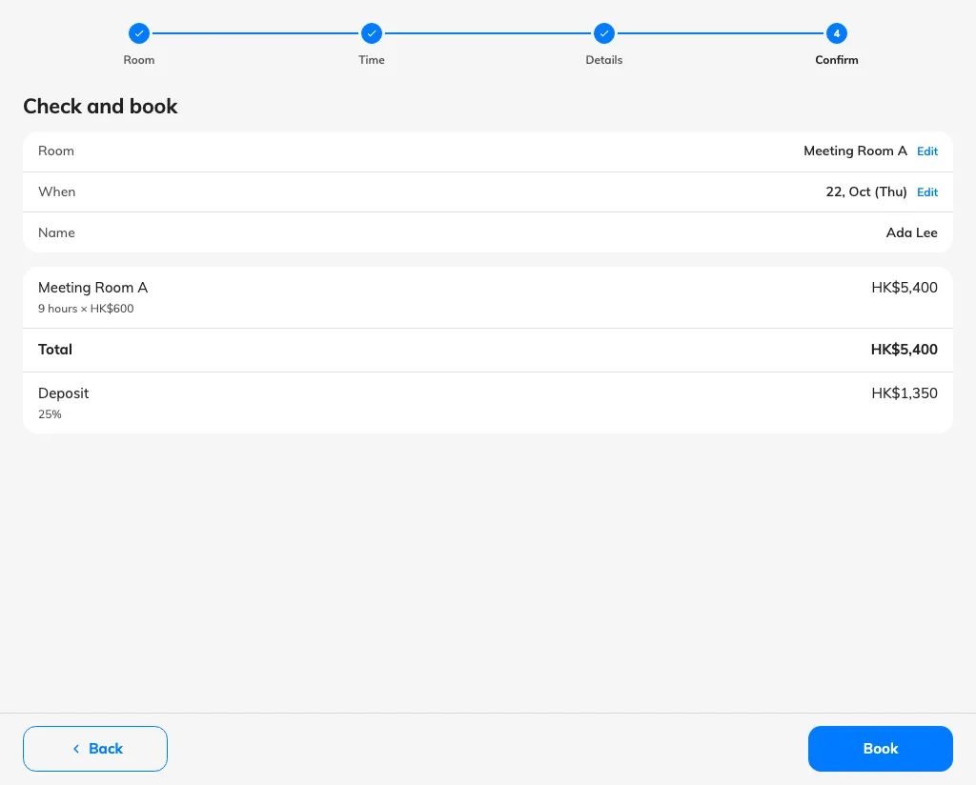
Review whole days as dates
Where in Offision: admin app → public-booking/overview (Overview)

Keep your management calendar order
An organization default did not preserve your own preferred calendar order. Set the initial order in UI customization → Management calendar, then use the order selector above Resource on the management calendar for your personal choice. Your account keeps that choice independently of the organization default and everyone else’s order.
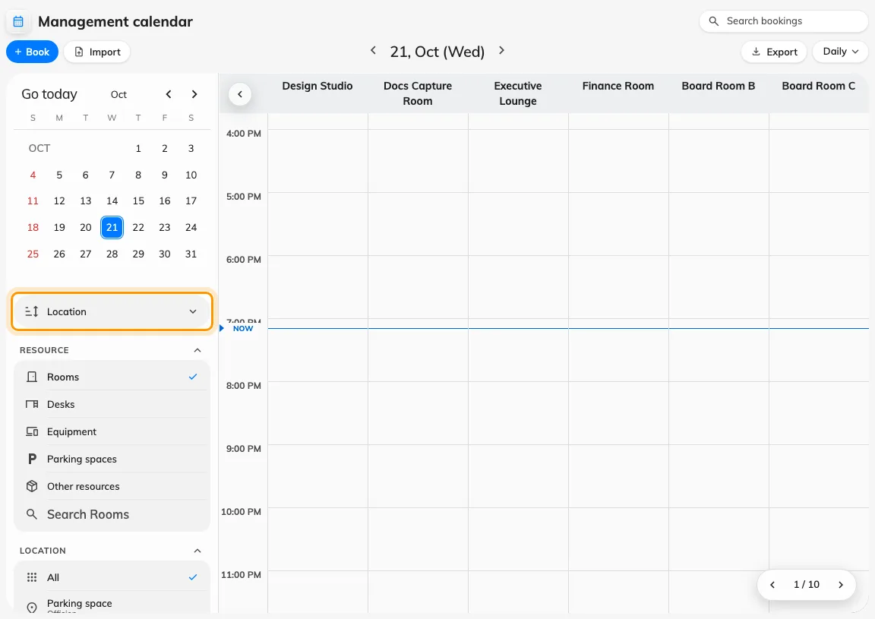
Keep your management calendar order
Where in Offision: admin app → ui-customization/management-calendar (Management calendar)

What changed

Guest booking
- One guest-booking price could not cover weekday and holiday rates. Now you can add day-specific price tables to a page’s pricing plan, with holidays taking precedence over weekday rates.
- Guests had to obtain room documents separately. Now you can add ordered PDF or image attachments for each room on a Guest booking page; save the page to publish its own files and translated button names.
- A rolling window could not express a fixed booking season. Now you can choose Specified date independently for Starts and Ends on a Guest booking page’s Time tab, with the end date included.
- Weekend skipping was expressed in reverse. Now Include weekends & public holidays offers Always, Never or Let guest choose on Guest booking pages with across-day ranges; the guest choice starts on, and the full interval remains held.
- The general Guest booking page had no separate appearance controls. Now Guest booking Settings lets you choose its appearance and list corners, and open or copy its public link without changing individual page designs.
- Whole-day guest bookings displayed clock times. Now whole-day pages highlight the selected date and show dates in the guest recap, completion, manage page and booking emails.
- A guest-booking price could change while you completed the form. Now you must review and accept the refreshed quotation before submitting when its price changes.

Booking
- The management calendar followed one initial resource order. Now UI customization sets its own default, and your personal order on the management calendar is saved for your account without changing anyone else’s choice.

Fixes
- Guest calendars could open on an empty month even when the next month had available dates.
- Dates outside a Guest booking page’s booking period could look available in the calendar.
- Named Guest booking blocks copied to a closed weekend could disappear after saving.
- Combined-room names could be missing from guest-booking emails.
- Guest-booking attachments could fail validation when stored in cloud storage.
- Check-in and no-show reminder time zones could display literal HTML.
- Regular visitor Apple Wallet passes could carry inappropriate relevance metadata, and scheduled passes could expire at a different time from their badge.
- Closing a workflow node’s configuration could discard the edit still in progress.
- Workflow saves could replace newer draft changes or lose dependent bindings after a node rename.
- Room presentation on Map 2.0 could become stale after a scene rebuild.

