Offision 4.6.2-21300
Shape your Map Editor scenes with searchable furniture and new finishes, offer guest booking types, and write reminders with real booking fields.
2026-10-17 · https://offision.com/help/en/release-notes/4.6.2-21300/

Find objects and keep placing them
Browsing map categories made repeated furnishing slow. In the Map 2.0 editor, search the furniture, equipment, door or template catalogue, then choose the object you need. Drag a supported furniture tile onto the floor and keep placing copies, or repeat a duplication, until you press Esc; the catalogue also includes more seating, storage, booths and meeting pods.
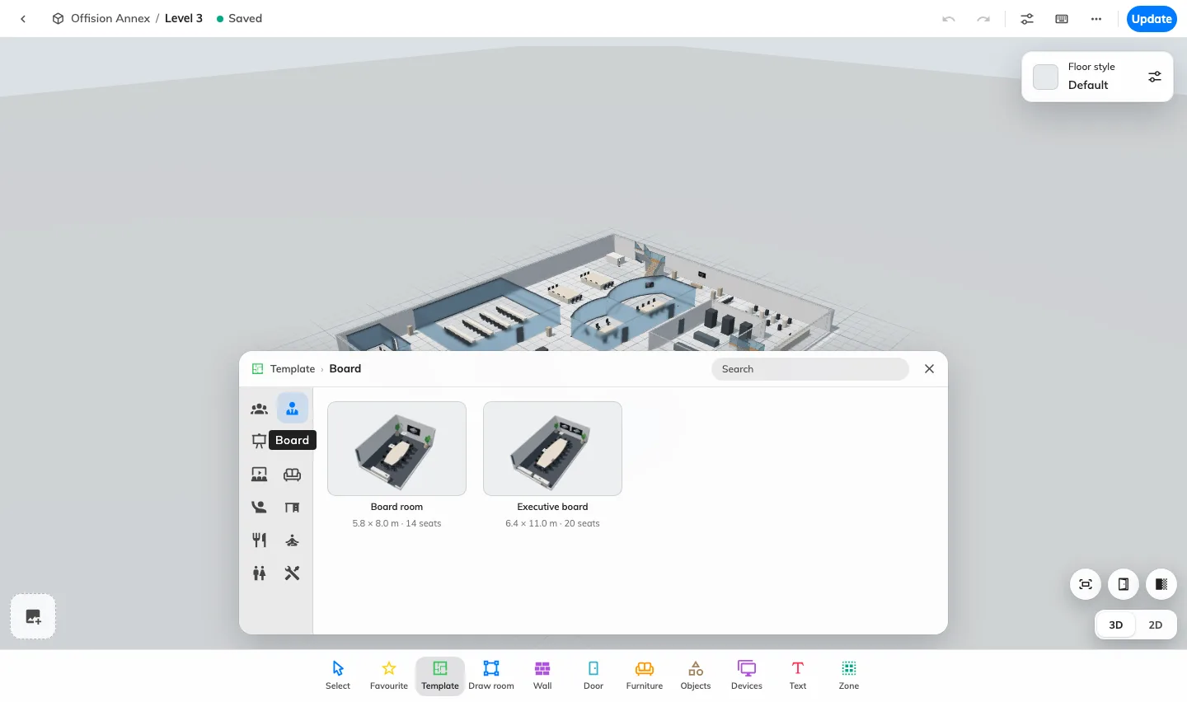
Find objects and keep placing them
Where in Offision: admin app → map/floor-plan (Map)

See heights and finishes as you edit
Changing heights and materials was harder to judge while editing. In the Map 2.0 editor, use the wall’s live height slider or a wall-mounted object’s vertical handle, and choose upper or lower wall finishes where supported. Open Floor style to set the whole floor’s material and colour, then inspect the room floors alongside it before updating the published map.
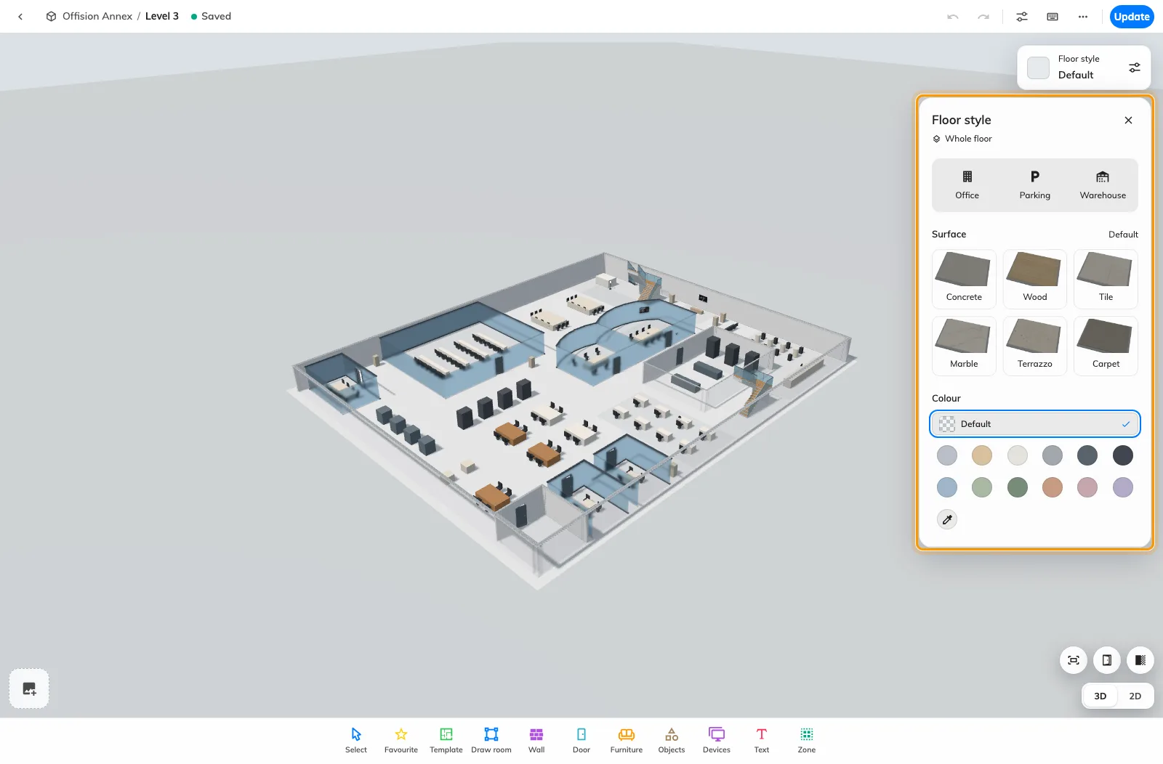
See heights and finishes as you edit
Where in Offision: admin app → map/floor-plan (Map)

Let guests choose a booking type
A room or time alone could not express what a guest wanted to book. On a guest booking page, choose a type-based flow in General, then add types with translated descriptions, eligible rooms and optional or required remarks in Type. Each type narrows the page’s own rooms, which must have guest-booking licences; save the page and test the published flow.
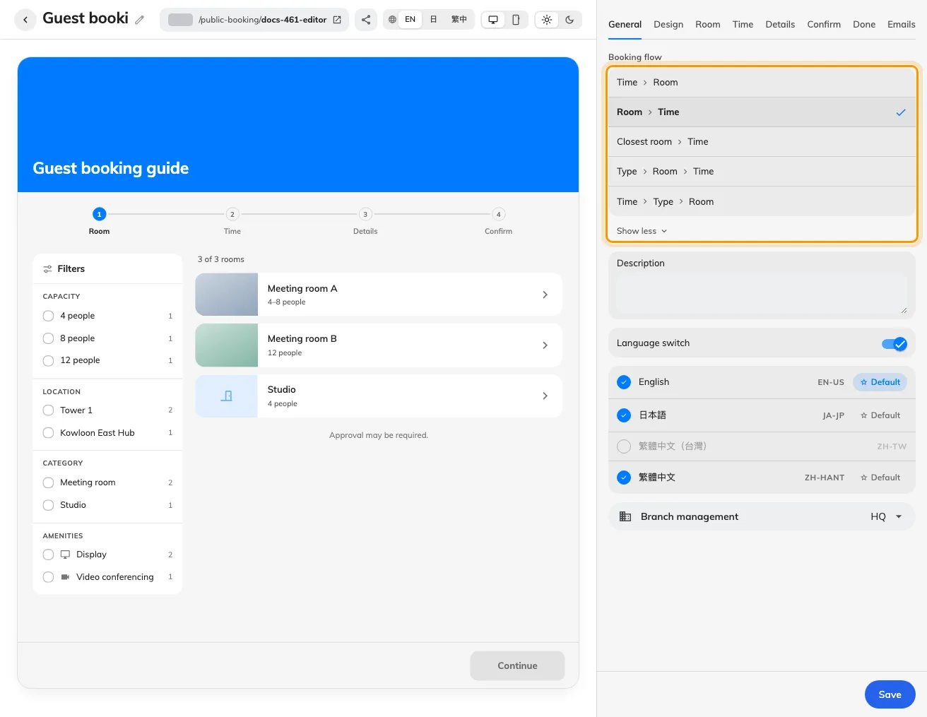
Let guests choose a booking type
Where in Offision: admin app → public-booking/overview (Overview)

Change selected fields across policies
Repeating the same edit in several policies took several forms. With Booking enabled and permission to edit policies, select the policies, choose Batch edit and add only the fields you want to change. Review current and proposed values for each policy before applying; if a save stops partway, successful changes stay applied and you can retry the remaining policies.
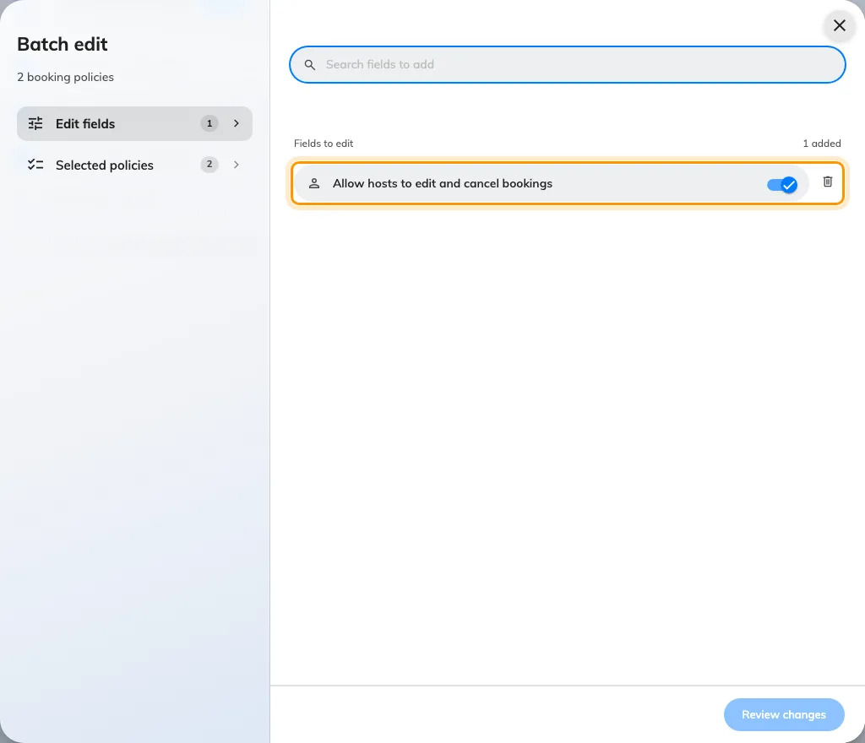
Change selected fields across policies
Where in Offision: admin app → booking/advance-policy (Booking policy)

Put service calls on the booking panel
People in a meeting had no dedicated panel button for room services. In the panel configuration’s Door & extras, turn on Show call service button, which is off by default. Call service appears on both panel designs only during an in-use booking, with touch interaction enabled and requestable services or an enabled support link configured for that room.
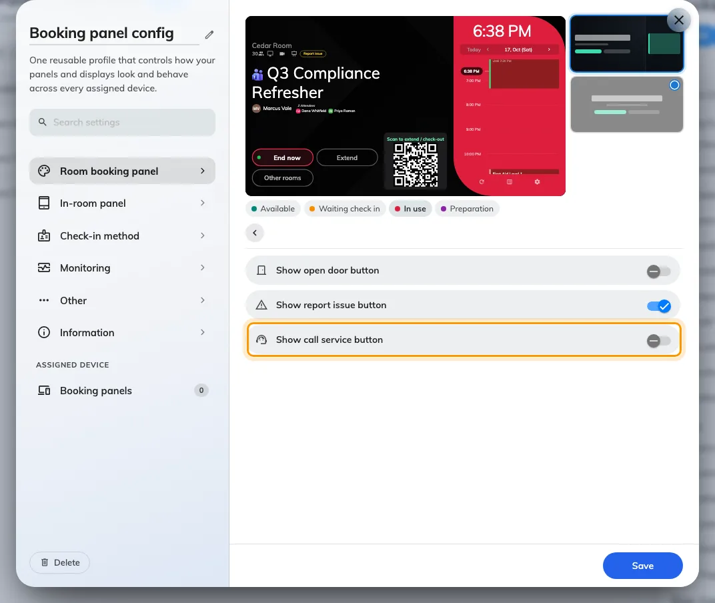
Put service calls on the booking panel
Where in Offision: admin app → device/booking-panel/configuration (Panel configurations)

Edit an email beside its preview
Moving between a template list and its settings interrupted email editing. With email-template edit permission at the root organization, open Email template, search the rail and select an email, then choose Edit to keep its preview beside the settings. Check each company email language and the desktop or phone view before saving; system account templates are marked System template and can only be previewed.
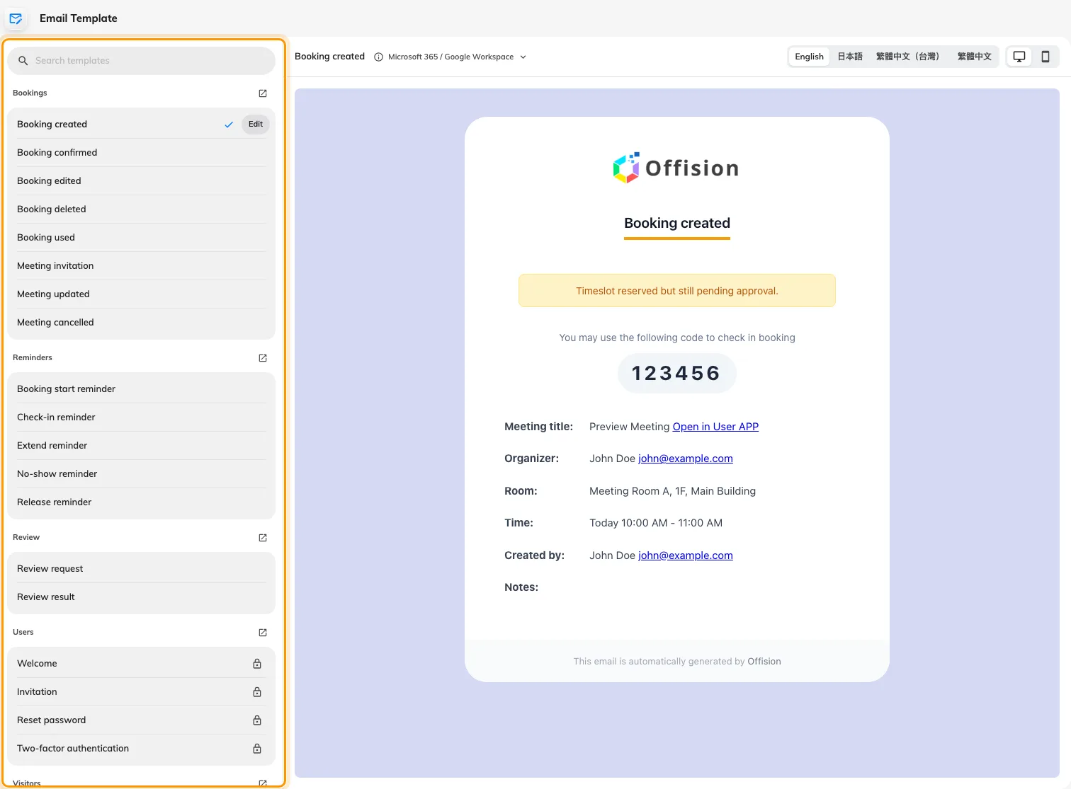
Edit an email beside its preview
Where in Offision: admin app → system-account/email-template (Email Template)

Write reminders with booking fields
Check-in and no-show reminders previously used fixed wording. In Email template, select either reminder, choose Edit and turn on Write your own to edit its multilingual subject and body, inserting real booking values with Fields. Choose the summary, booking-details button and sign-off, plus a cancel action for the check-in reminder, then inspect room and desk samples before saving. Delivery switches remain in Booking’s reminder settings, and check-in deadlines and automatic release remain in the booking policy.
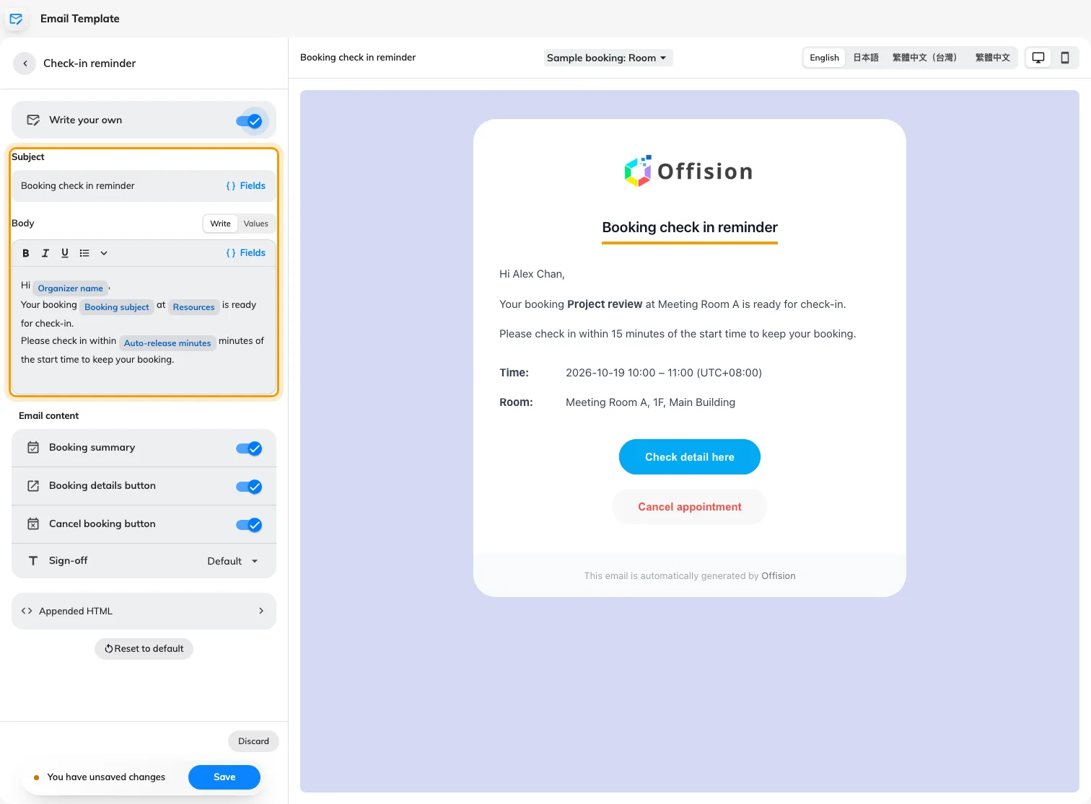
Write reminders with booking fields
Where in Offision: admin app → system-account/email-template (Email Template)

What changed

Map
- Finding the right map object meant browsing categories. Now you can search furniture, equipment, doors and templates in the Map 2.0 editor, with more seating, storage, booths and meeting pods to choose from.
- Adding repeated map objects took extra selections. Now you can drag furniture from the catalogue and keep placing or duplicating copies until you press Esc in the Map 2.0 editor.
- Moving several map objects meant selecting them individually. Now you can drag a selection box around furniture, devices and text in the Map 2.0 editor; an unlocked room joins only when its whole footprint is enclosed.
- Height and finish adjustments were harder to judge while editing. Now the Map 2.0 editor offers live wall-height controls, wall-mounted height handles, separate upper and lower wall finishes, and a whole-floor material and colour picker where the selected object supports them.

Guest booking
- Guests previously chose only a room or time first. Now you can offer Type › Room › Time or Time › Type › Room by choosing a type-based flow on a guest booking page and adding public booking types; rooms still need guest-booking licences and page membership.
- Guest-facing room order could not be arranged directly. Now you can drag a guest booking page’s selected rooms into the order guests see.
- Refreshing the guest booking editor could lose your place. Now its selected tab stays in the URL for refresh and browser navigation.

Booking
- Changing the same rule meant opening policies one by one. Now, with Booking enabled and policy-edit permission, you can select several policies, add only the fields to change and review each policy before applying; if saving stops partway, retry the policies that remain.

Device
- Calling a room service from the panel needed a separate route. Now you can enable Show call service button in the panel configuration; it appears during an in-use booking when touch interaction is enabled and the room has requestable services or an enabled support link, and it is off by default.
- External calendar changes could leave a panel showing an old booking state. Now bookings and cancellations synchronized from an external room calendar trigger a refresh on connected panels.
- Device monitoring previously lacked the Map 2.0 floor view. Now floors with a scene use it when the new map is enabled for the account, with device filters and room selection using the map’s resource assignments.

Email
- Editing an email meant moving between the template list and its settings. Now, with email-template edit permission at the root organization, you can search the template rail, edit beside a persistent preview, and check each language in desktop or phone view.
- Check-in and no-show reminder wording was fixed. Now you can turn on Write your own for either reminder in Email template to edit multilingual subjects and rich-text bodies with booking fields, optional summaries, action buttons and sign-offs; delivery still follows the reminder settings.
- System account emails could carry old custom wording. Now welcome, invitation, password-reset, verification and sign-in-code templates are preview-only and use the system wording.

Fixes
- The service-request dialog could collapse its content on a panel.
- The terms-and-conditions heading on a guest booking page could stay in the previous language after switching.
- Some Map 2.0 chairs and meeting pods had disconnected parts.
- Chairs could be spaced unevenly around curved tables in Map 2.0.
- Glass floor layers could render incorrectly in Map 2.0.
- Booking PINs could appear with inconsistent spacing in emails.

