Offision 4.5.20-20900
Import bookings straight from the app, and a sheet with a bad cell now stops before it books. Panels get a new console, announcements a simpler form.
2026-09-25 · https://offision.com/help/en/release-notes/4.5.20-20900/

Import bookings from the app
Only administrators could import a sheet of bookings, so everybody else sent their spreadsheet to one. The Offision app now has its own Import — on the Schedule header, in Home's quick actions and under Room in the footer — with the same template and the same checks, minus the Organizer column, because you are the organizer. It appears once Import bookings is on in UI customization › User booking form, and only for people who can book a room.
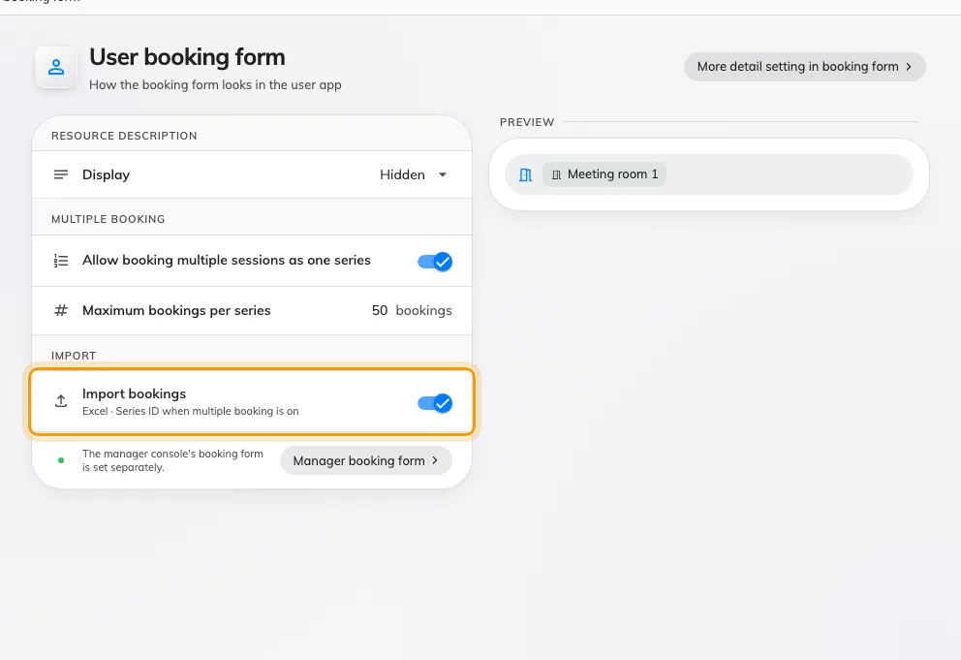
Import bookings from the app
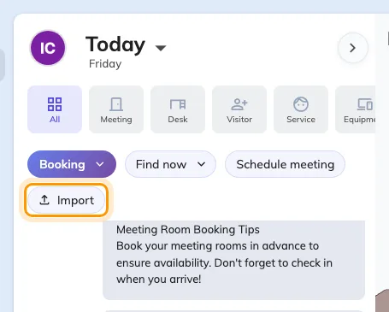
Import bookings from the app
Where in Offision: admin app → ui-customization/user-booking-form (User booking form)

A cell that does not fit stops at the import
An import used to book whatever the sheet said, so an answer that was not one of a Select's options — or one for a field the room's form does not even have — ended up on the booking. Now each of the form's own columns is checked against the form of the room the row books. A cell that does not fit turns the row red and it cannot be booked; a field the room's form lacks is listed in amber as Not in this room's form and dropped. Fix the sheet and upload it again — a sheet with only amber lines waits on Continue.
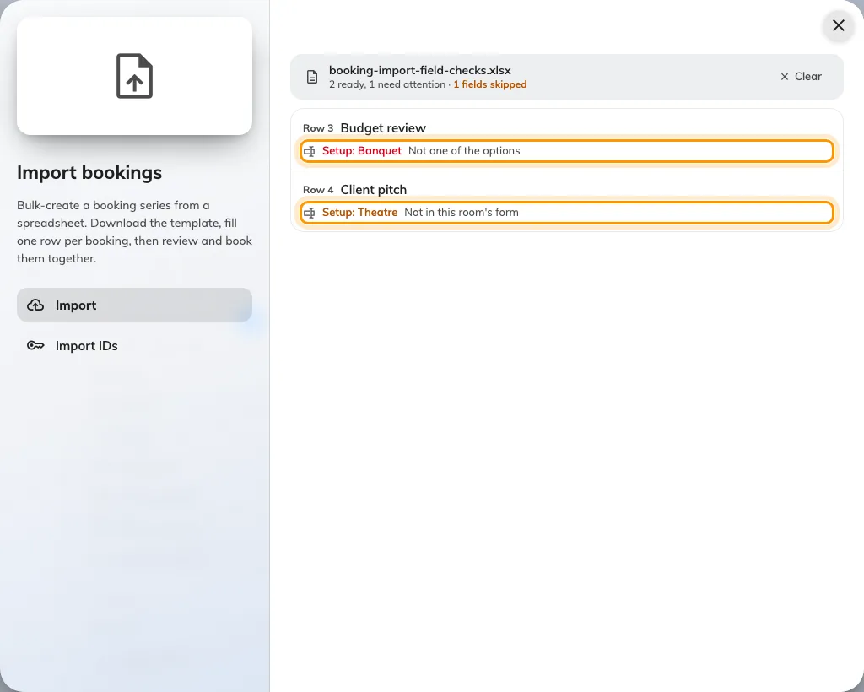
A cell that does not fit stops at the import
Where in Offision: admin app → booking/calendar (Management calendar)

Clear a list in one go
A data set, or a booking policy's time sectors, could only be emptied one row at a time. Every row now has a tick — Shift-click ticks a range, and the box at the top ticks every row the search shows — and Delete removes what you ticked, while Delete all empties the list after asking. Nothing is removed until you save. The same controls are on Booking › Data set, Visiting › Visiting data set and the time sectors of a booking policy.
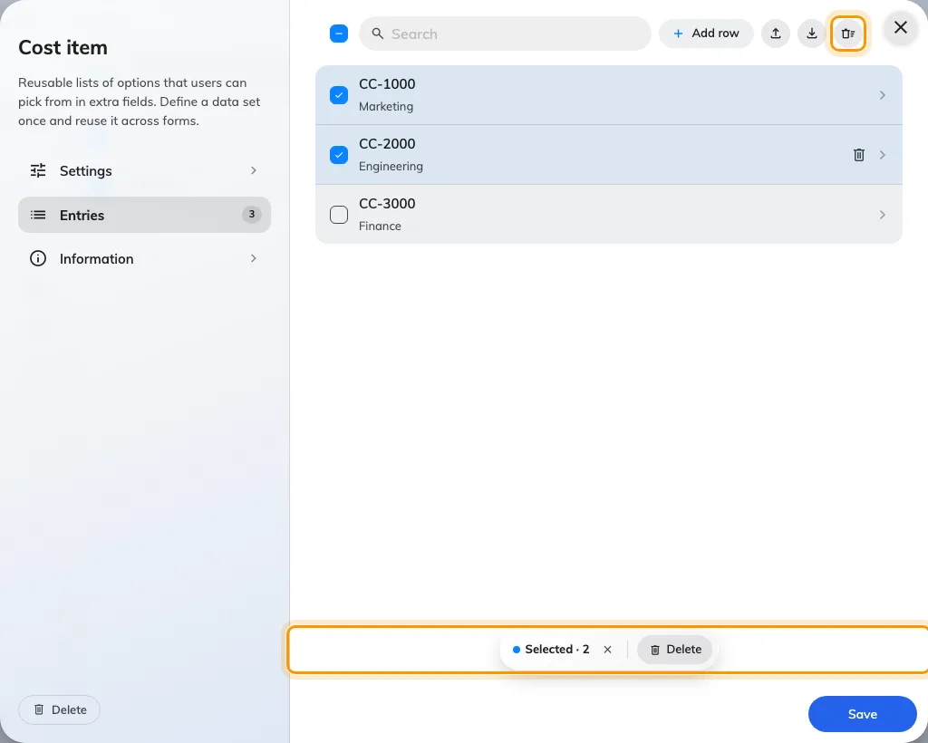
Clear a list in one go
Where in Offision: admin app → booking/booking-auto-complete (Data set)

Last quarter in one click
A quarter-end report meant typing the quarter's dates into the period picker. Last quarter and This quarter now sit under Last 30 days in every analytics period picker — calendar quarters, so on 23 September Last quarter is 1 April to 30 June. For a report of every room, pick Last quarter on Resource usage analytics and use Export on Resource ranking; to have it arrive by itself, set the booking record summary in Email report to Quarterly.
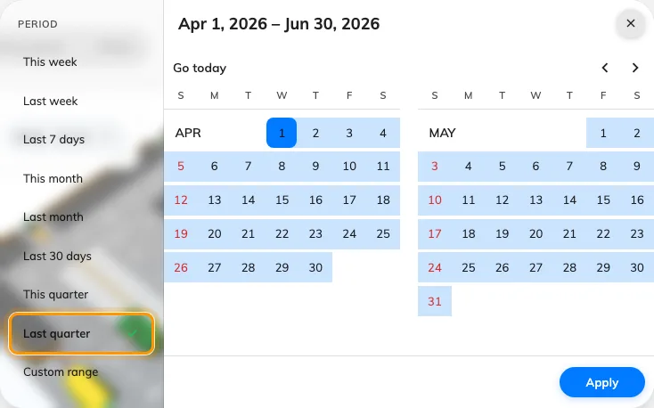
Last quarter in one click
Where in Offision: admin app → booking/usage-map (Resource usage analytics)

Choose who sees an announcement
Who saw an announcement was four switches, and a switch left off with nobody named meant everybody. Conditions is now two lanes side by side — User portal, with Everyone or Specific recipients, and Devices, with All or Specific locations picked as building and floor chips — over a Schedule that is Always or a Period. Specific with nobody picked cannot be saved, so a narrowed notice always names somebody.
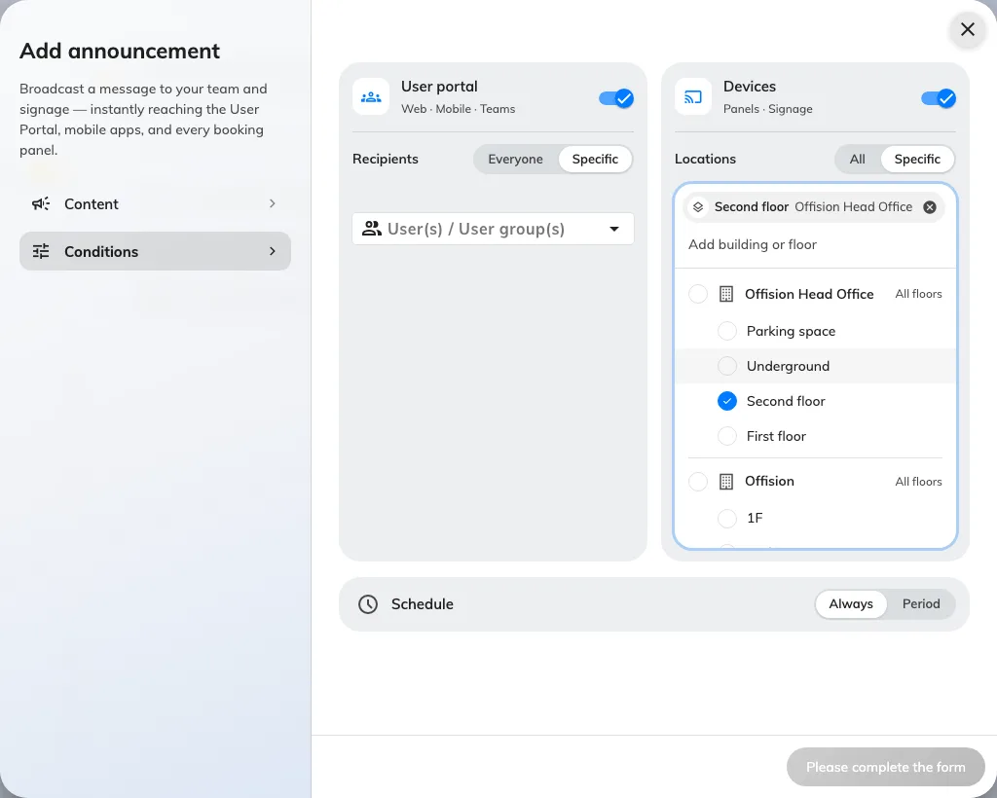
Choose who sees an announcement
Where in Offision: admin app → broadcast/announce/announcement (Announcements)

A console that opens over the room
The device console used to replace whatever the panel was showing, and closing it restarted the app. It now opens over the room — the panel keeps running underneath, so a remote session carries on — and × simply closes it. The rail reads Overview, Status, Device, Card test, Setting and Log; Reset is now Unpair device, and Leave Offision is Back to Android or Back to iPad. It still opens with the device pass code.
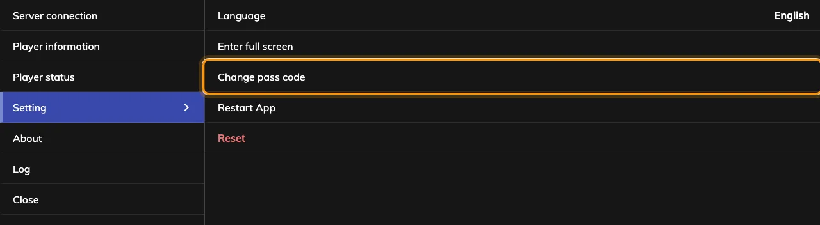
A console that opens over the room
Where in Offision: admin app → device/booking-panel/device (Booking panel)

Live view, whoever is at the panel
Force remote used to get you a screenshot a second, because a panel could not stream without somebody there to allow it. Devices on the 4.5.20 app — Android and iPad panels and the Windows app — now send a live view in both modes. Remote control asks Is anyone at this device?: Request accept on the device waits for somebody there to allow it, and Force remote starts after a 15-second countdown unless somebody taps Reject. It is on each device's page in the console, marked Beta.
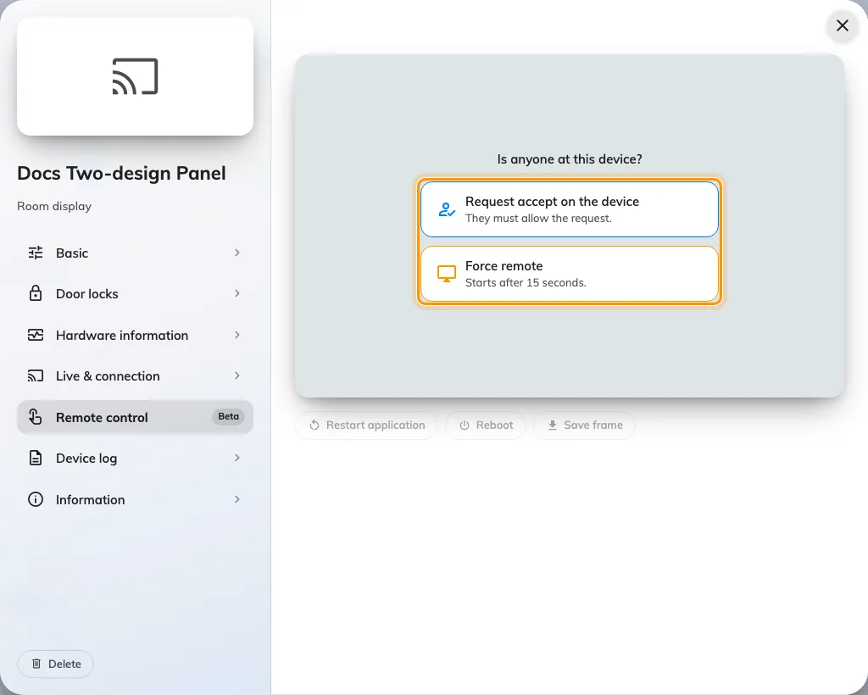
Live view, whoever is at the panel
Where in Offision: admin app → device/booking-panel/device (Booking panel)

A note under the room name
A panel had nowhere to say the one thing about a room people need before they walk in. Room note, in a panel configuration's Room details, puts a card under the room name with an Info, Reminder or Warning badge, showing the room's own description or text you write per language. It starts Off, and a room with no description shows nothing.
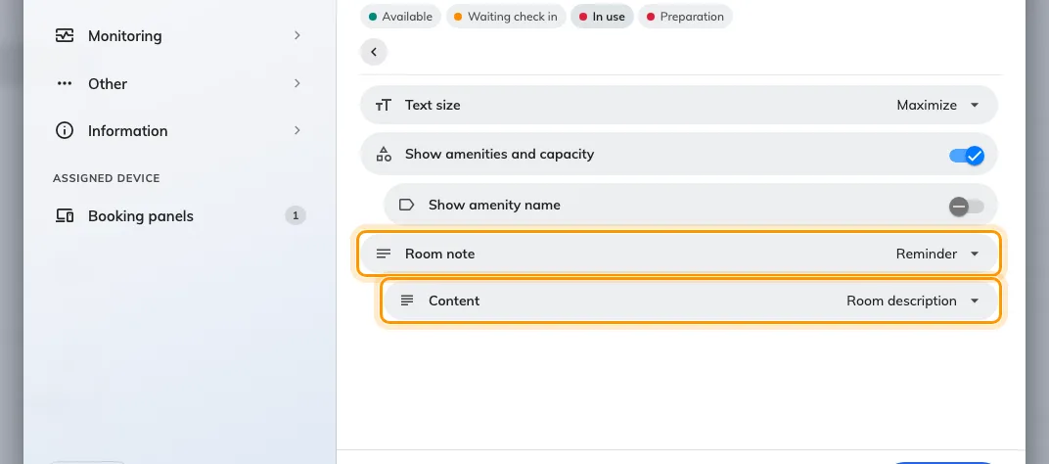
A note under the room name
A note under the room name
Where in Offision: admin app → device/booking-panel/configuration (Panel configurations)

What changed

Booking
- Only administrators could import a sheet of bookings. Now the Offision app imports too — from the Schedule header, Home's quick actions and the Room sheet in the footer — once Import bookings is on in UI customization › User booking form.
- An import booked whatever the sheet said, even an answer the room's form could not hold. Now a cell that does not fit its field — Required, Not in the data set, Not one of the options, Invalid value — blocks its row, and a field the room's form lacks is dropped with Not in this room's form.
- Data sets and a booking policy's time sectors could only be emptied a row at a time. Tick rows and Delete them, or use Delete all — in Booking › Data set, Visiting › Visiting data set and the time sectors of a booking policy.
- A quarter-end report meant typing the quarter's dates by hand. Last quarter and This quarter now sit in every analytics period picker, the calendar export offers a Quarterly grain, and Email report can send the booking and visiting record summaries every quarter.

Device
- The device console replaced whatever the panel was showing, and closing it restarted the app. It now opens over the room and closes with ×, laid out as Overview, Status, Device, Card test, Setting and Log; Reset is now Unpair device, and Leave Offision is Back to Android or Back to iPad.
- Force remote got you a screenshot a second. Devices on the 4.5.20 app — Android and iPad panels and the Windows app — now stream a live view whether you choose Request accept on the device or Force remote, and both wait 15 seconds for the person at the screen.
- A screenshot sat in a fixed frame with black bars round it. Screen monitoring and the device page now draw each screen in its own shape.
- A panel had nowhere to say what people should know before they walk in. Room note, in a panel configuration's Room details, shows the room's description or your own text as an Info, Reminder or Warning card under the room name. It starts Off.
- Hiding Android's navigation bar meant a trip into the device's own settings. The console's Setting › Display now has Hide navigation bar, on by default in Panel mode, and on a Qbic it sets the device's Fullscreen too. It needs the Android app from 4.5.20.
- Neat devices arrived without their network details. Sync and Resync now bring each Neat device's IP and MAC address, and a Neat panel running Offision reports its serial number, IP and MAC.

Broadcast
- Choosing who saw an announcement was a stack of switches, and one left off with nobody named meant everybody. Conditions is now two lanes — User portal with Everyone or Specific recipients, Devices with All or Specific locations picked as building and floor chips — over a Schedule of Always or Period.

Fixes
- Viewing a colleague's booking series in the app loaded forever.
- Extra fields on imported bookings were not linked to their data set until the booking was edited.
- The Data set and Time sector lists could not be scrolled to the end.
- A booking kept answers to extra fields its form did not have.
- The remote-control mode cards were unreadable in the dark theme.
- Long recipient names overflowed the announcement's recipient picker.

