Offision 4.5.17-20700
Signage now asks which device you are hanging and sizes itself to it. Logos take a white or black ground, and the calendar header stands aside for the grid.
2026-09-17 · https://offision.com/help/en/release-notes/4.5.17-20700/

Say which device, not which size
The Screen step used to ask two questions nobody answers in those terms: a size in inches, and a shape as a ratio. You knew you were hanging a Neat Frame; you did not necessarily know a Neat Frame is a 15.6-inch portrait 16:9. Now the step opens on the devices themselves — Android tablet, iPad, Neat Frame, Neat Board and Smart TV — drawn to relative scale on one baseline, so a tablet looks like a tablet beside a wall display. Pick one and it answers size, shape and orientation together; where a device ships in several sizes, a small menu on the tile carries them.
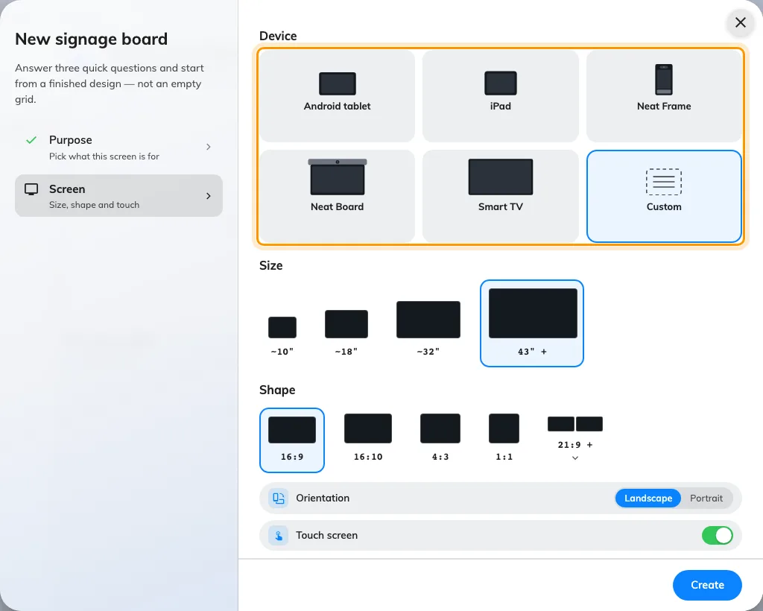
Say which device, not which size
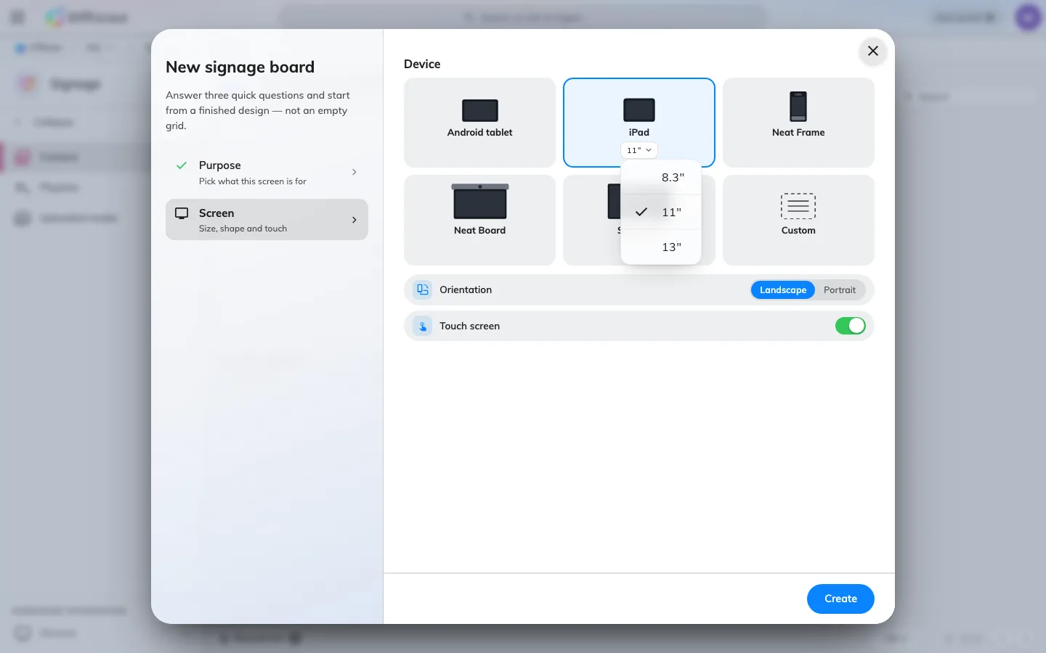
Say which device, not which size
Where in Offision: admin app → signage/signage-content (Signage)

Reopen a design and the same panel is there
Until now a design recorded only the canvas it produced, never the device you chose, so reopening its Screen page meant guessing the device back from a width, a ratio and a size class — and it guessed wrong in both directions. The choice now travels with the design: the caption under the preview names the device, and clicking that caption opens the very panel the wizard used, as a dialog rather than a separate page in the rail. A design saved before this release has no device recorded, so it opens on Custom with its size and shape exactly as you left them — pick the device once and it sticks.
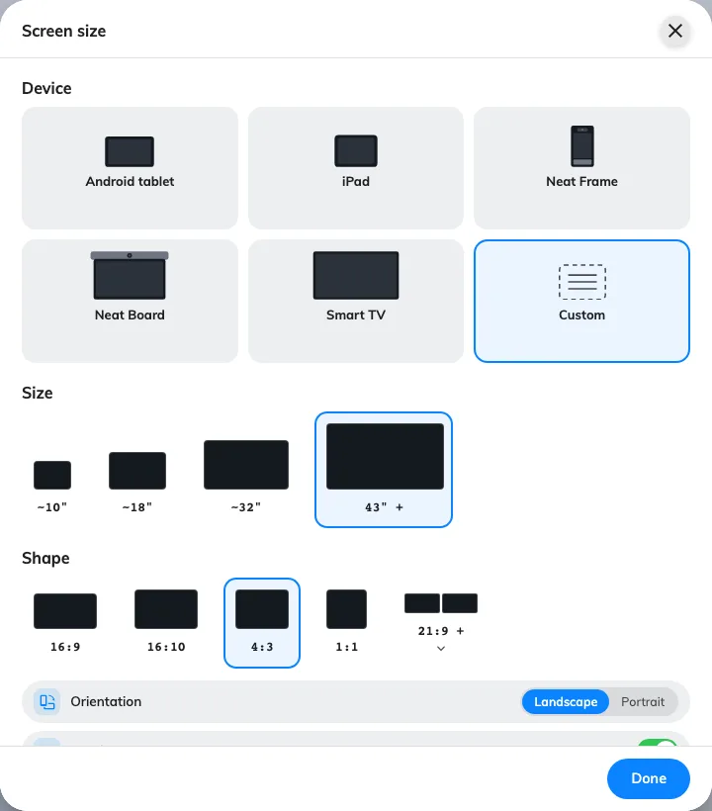
Reopen a design and the same panel is there
Where in Offision: admin app → signage/signage-content (Signage)

Give the logo something to sit on
A company logo is usually cut out on a transparent background, which is right until the panel behind it is dark — then the mark disappears and the only fix is to open the file again and re-cut it on white. Logo background now sits directly under the upload, offering Transparent, White and Black, and the preview above repaints on whichever ground you choose, so a logo that would vanish on the panel vanishes here first. The control lives with the rest of Background & logo on the Scheduling panel design; the Center design draws no company logo at all, so it is dimmed there.
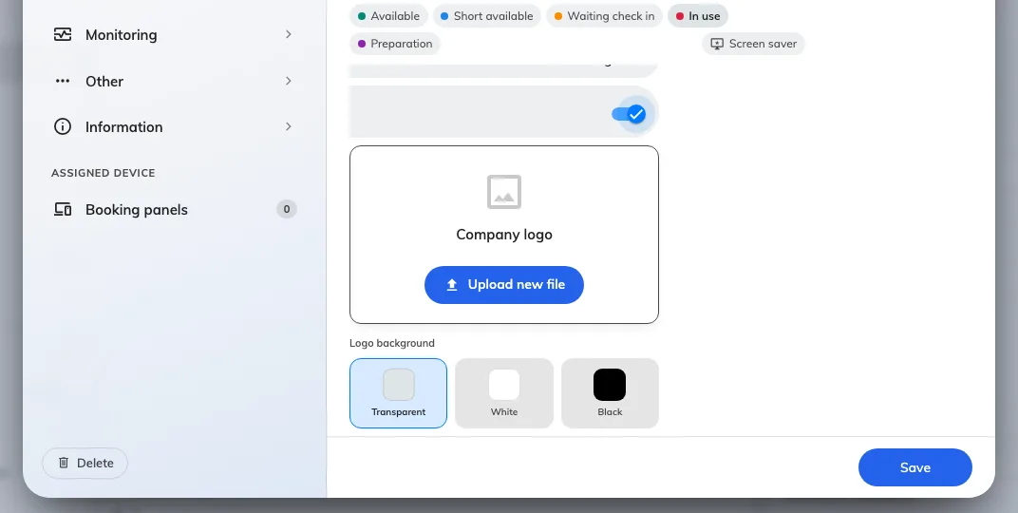
Give the logo something to sit on
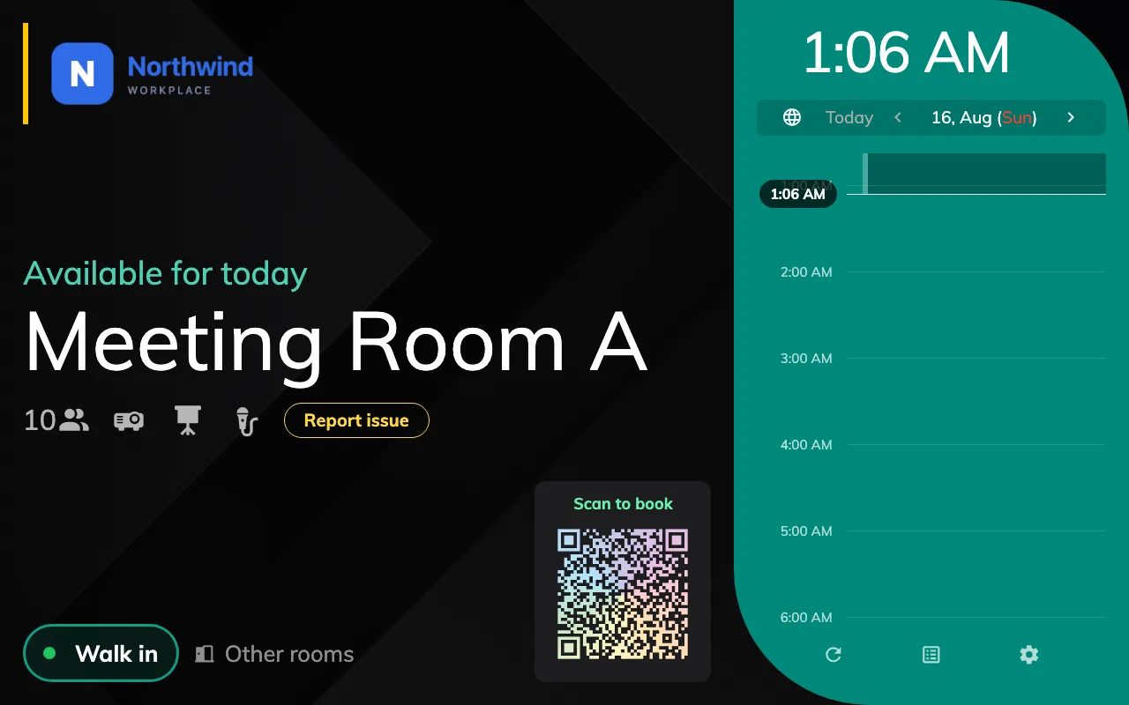
Give the logo something to sit on
Where in Offision: admin app → device/booking-panel/configuration (Panel configurations)

A calendar header that gets out of the way
The Management calendar and the visiting calendar both spent a line of their header on a description of the page you were already looking at. It is gone, and with it about a third of the header's height, which the grid takes back. What is left is ordered the way the page is used: the title and its search pill on top, then the working bar, where the date you are navigating is now the largest thing rather than a caption between two chevrons. Nothing moved between the two rows and nothing was removed but that line.
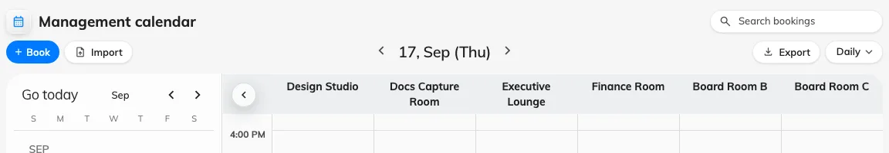
A calendar header that gets out of the way
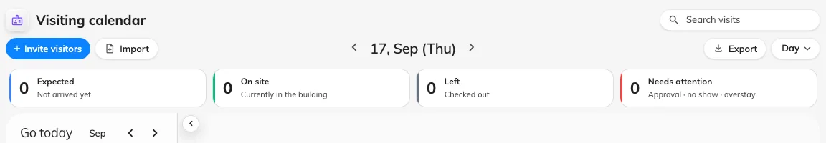
A calendar header that gets out of the way
Where in Offision: admin app → booking/calendar (Management calendar)

What changed

Signage
- Creating signage content asked for a size in inches and a shape in ratios, and left you to work out which pair meant the screen on your wall. Now the Screen step shows the devices themselves — Android tablet, iPad, Neat Frame, Neat Board, Smart TV — drawn to relative scale, with each one's models behind a small menu. Custom still opens the Size and Shape grids for anything that is not on the list.
- Reopening a design's Screen page guessed the device back from the canvas, and guessed wrong in both directions. Now the content remembers which device you picked and opens on it. A design saved before this release opens on Custom, with its size and shape intact.

Device
- A logo cut out on a transparent background disappeared into a dark panel background, and the only way out was to re-cut the file. Now Logo background sits under the upload with Transparent, White and Black, and the preview paints on the ground you choose. It is part of the Scheduling panel design — the Center design draws no company logo at all.

Booking & Visitor
- The Management calendar and the visiting calendar each gave a line of the header to repeating the page's own name. That line is gone. The header is a third shorter, the date you are navigating is now the loudest thing on the bar, and the grid keeps the height.

Fixes
- A Neat panel running inside the native shell was not always recognised as a Neat device, so booking status colours never reached its light bar.
- The visitor daily report listed Walk-in as a sentence rather than a column name in Chinese and Japanese.

