Offision 4.5.16-20627
Search the calendar at last — by subject, room or booking reference — then choose the columns you export and set a floor to read flat on every screen.
2026-09-15 · https://offision.com/help/en/release-notes/4.5.16-20627/

Find a booking without knowing its date
The management calendar draws one period at a time, which is the wrong shape for the booking somebody is emailing you about — you had to know the date before you could look. A search pill now sits at the top right of the header, and typing opens live suggestions under Booking, Organizer and Resource. Paste the reference a colleague quoted and it goes straight there: BK0042, bk42, #42 and 42 are read as the same booking, and a reference belongs to the whole series, so it finds every date. Press Enter and the grid gives way to the full list of matches, with filter chips and a count above it.
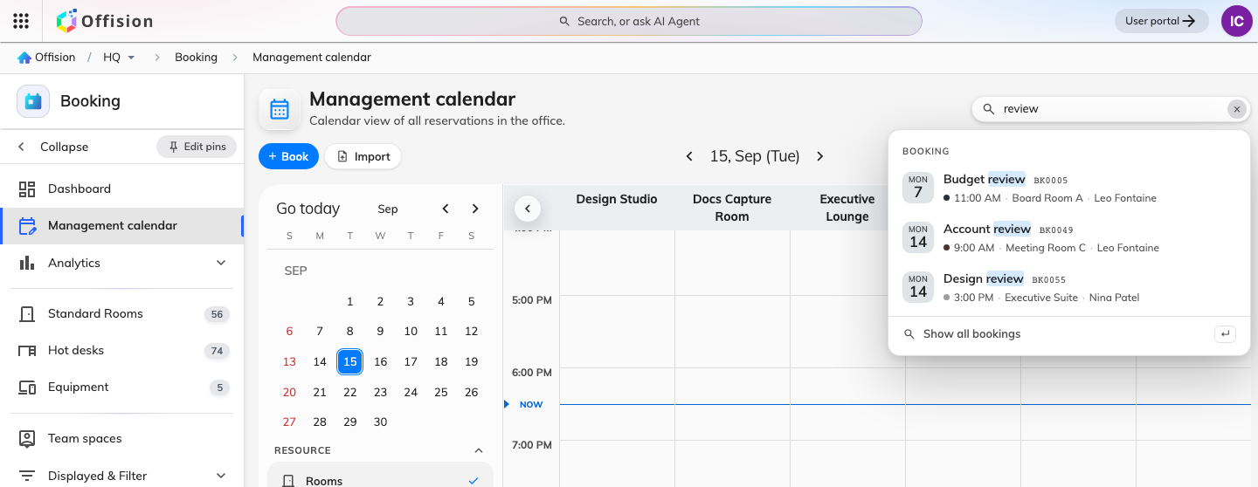
Find a booking without knowing its date
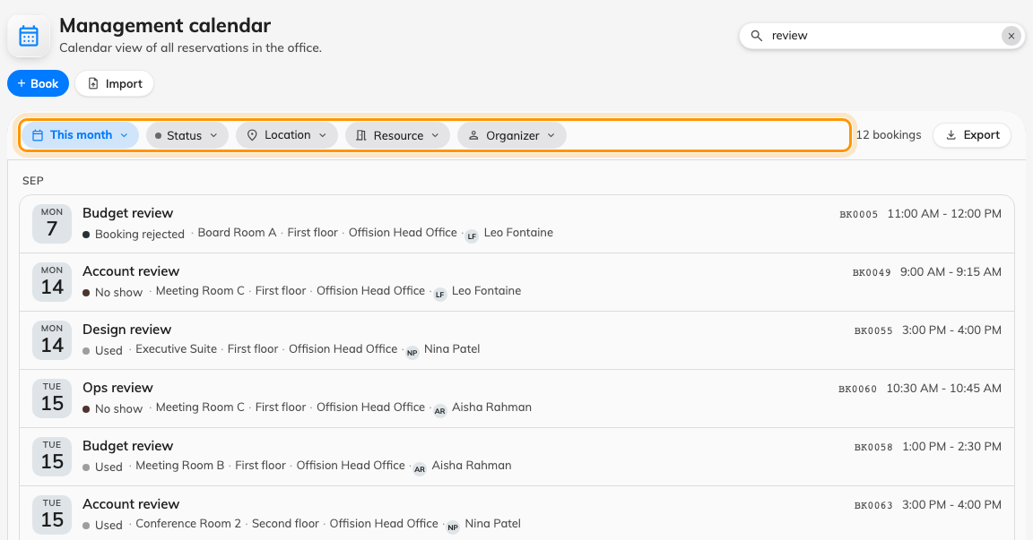
Find a booking without knowing its date
Where in Offision: admin app → booking/calendar (Management calendar)

Choose the columns before you export
A booking export handed you one fixed sheet, so anything you did not want was deleted afterwards. Export now opens with your choices down the left and a live sheet on the right, redrawn as you change your mind: group the rows by resource or by booking, take the period from a named range, and turn columns on and off under Booking, Resource, Time, Check-in, Organizer, Host, Attendees and the extra questions your own form asks. Drag a row to reorder it, or click a header in the sheet to drop that column — the choice is remembered per grouping. A report covers two months at a time, and that limit applies to the download rather than to the preview.
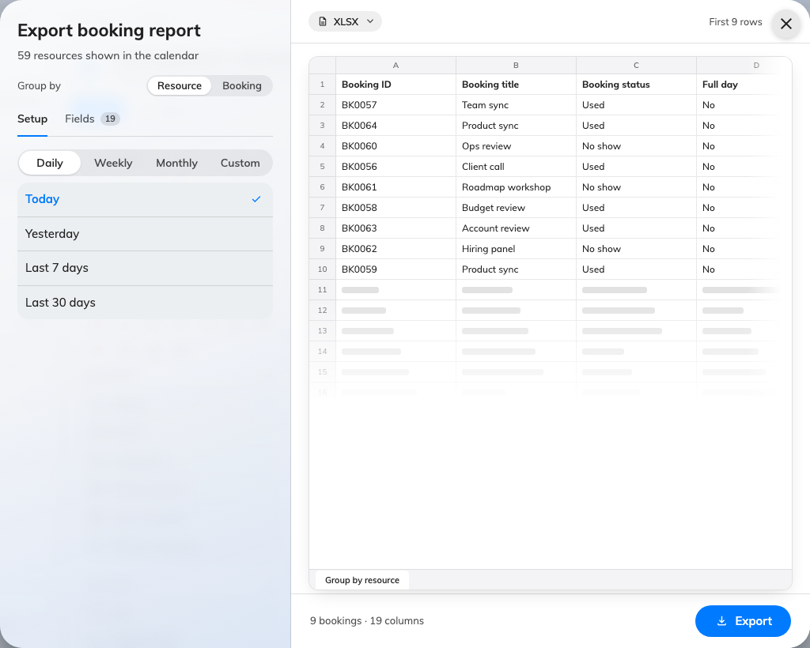
Choose the columns before you export
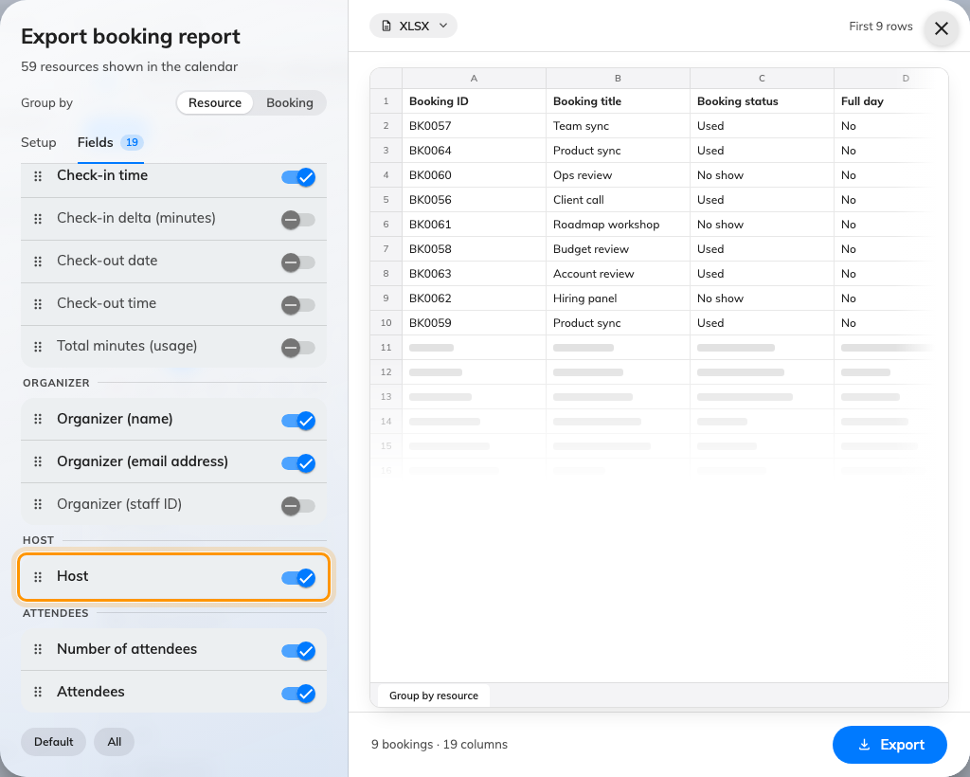
Choose the columns before you export
Where in Offision: admin app → booking/calendar (Management calendar)

The same search and export for visits
The visiting calendar had both of the same problems, and now has both of the same answers. Its search pill matches a visitor, the colleague who invited them, the building, the room or the visiting purpose — any one of those finds the visit — and Enter gives you the matches with chips and a count. Export groups the rows by building, by room or by visit, and offers the inviter, the visitors and your own visiting-form fields as columns. Searching first carries what you searched for into the dialog.
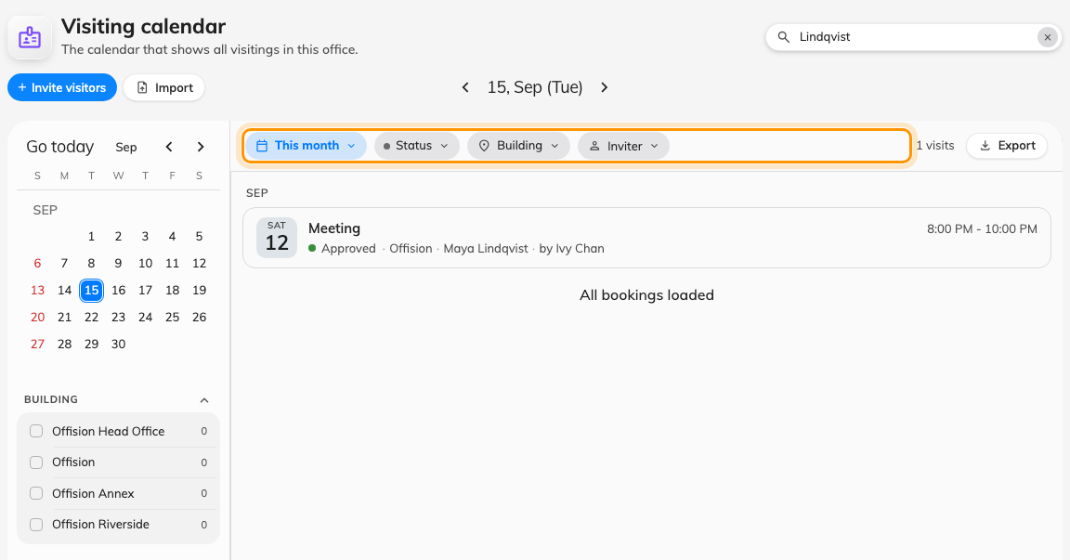
The same search and export for visits
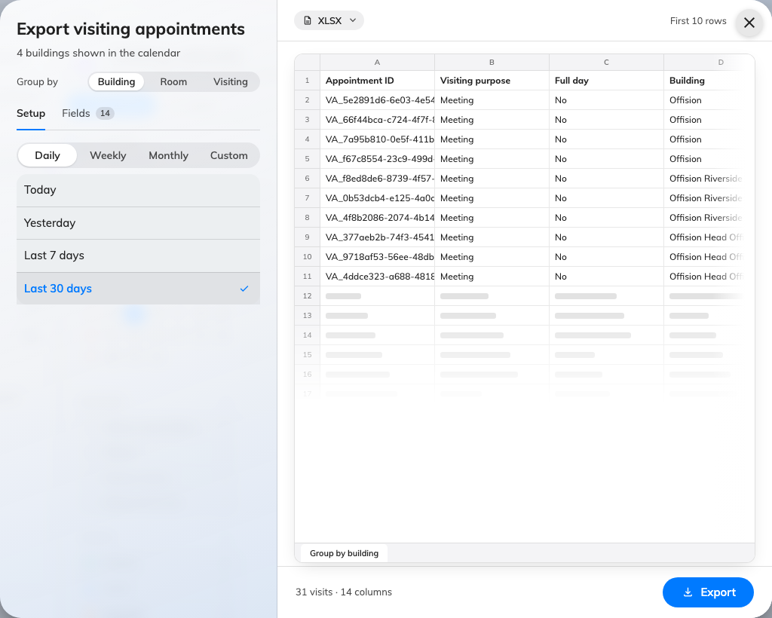
The same search and export for visits
Where in Offision: admin app → visiting/calendar (Invitation)

Flatten a floor and every map follows
A flat map arrived last release, but only as a choice on one signage widget: every other screen showing the same floor stayed in perspective, and a second screen meant setting it again. The answer now lives with the plan. Open the floor in the map editor, switch to View angle, and View mode offers 3D or 2D top-down; save it and every surface that draws that floor follows — the app, lobby boards, wayfinding screens and signage. A flat map has no camera to orbit, so the panel offers Turn left, Turn right and Recenter instead, which is how you square a plan with the wall a screen hangs on. A widget that already picked its own projection keeps it.
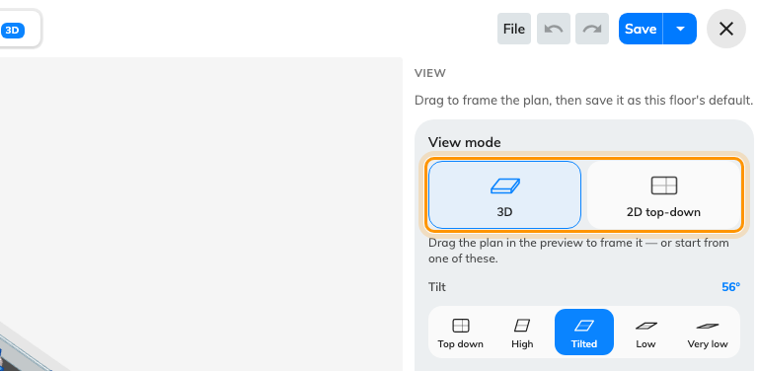
Flatten a floor and every map follows
Where in Offision: admin app → map/floor-plan (Map)

Cap a series, separately for each form
Series was capped at 50 by the app itself: nothing on the server held it, nobody could raise it, and the mode could not be switched off at all. Multiple booking is now a group on UI customization's booking forms, with a switch deciding whether Series is offered and a limit of 1 to 200 beneath it. Turning the switch off hides Series from the booking form, from the mobile mode menu and from the nudge that suggests it, rather than showing it greyed out. The portal's form and the manager console's are capped separately, so a console that needs longer series than the portal allows is a setting rather than a workaround.
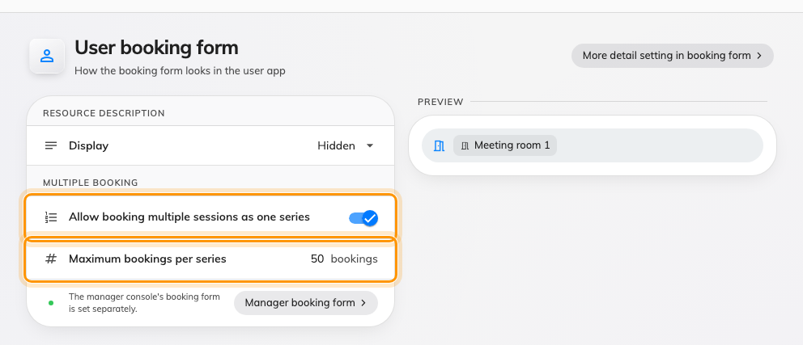
Cap a series, separately for each form
Where in Offision: admin app → ui-customization/user-booking-form (User booking form)

What changed

Booking
- The calendar drew one period at a time, so a booking you could not date was hard to reach. Now a search pill finds it by subject, by organizer, by room, or by the booking reference a colleague quotes — BK0042, #42 and 42 all reach the same booking, and every date of its series — and Enter swaps the grid for a list you can narrow with chips and export.
- Exporting bookings gave you one fixed sheet, so you deleted the columns you did not want afterwards. Now you group the rows by resource or by booking, take the period from a named range, and choose and reorder the columns — organizer, host, check-in times, your own form fields — watching the sheet redraw before you download it as XLSX or CSV.

Visiting
- The visiting calendar could only be read a period at a time as well. Now it carries the same search: a visitor, the colleague who invited them, a building, a room or a visiting purpose each find the visit, and the results take the same chips and count.
- Visits exported as one fixed sheet too. Now Export groups the rows by building, by room or by visit, takes a named period, and lets you pick and reorder the columns — the inviter, the visitors, your own form fields — with the sheet in front of you.

Map
- A floor plan could be drawn flat, but only on a signage screen, and only one screen at a time. Now the floor itself carries the answer: set View mode to 2D top-down in the map editor and every surface follows — the app, lobby boards, wayfinding screens and signage — with quarter turns to square the plan with the wall a screen hangs on. A signage widget that already picked its own projection keeps it, and a floor nobody has answered for stays in perspective. Needs a floor plan drawn.

UI Customization
- Series was capped at 50 by the app itself, with nothing on the server holding it and no way to raise it or to switch Series off. Now Multiple booking sits on both UI customization booking forms — User booking form and Management calendar — each with its own switch and its own limit of 1 to 200. Both start on at 50, the two forms are capped separately, and the limit is re-checked as each session is booked.

Fixes
- The booking import template kept its Host column after a room's booking policy stopped allowing a host, or the policy was deleted.

