Offision 4.5.15-20598
New this release: the in-room panel says when a meeting is nearly over, a Host column in the import sheet, pasted attendee lists, and an audit-trail export.
2026-09-13 · https://offision.com/help/en/release-notes/4.5.15-20598/

Name the host in the import sheet
A spreadsheet import had no way to name a host, so every booking arrived without one and somebody added it by hand afterwards. The template now carries a Host column — one address or several, separated by commas — sitting just after Organizer, and it appears wherever a room's booking form shows the Host field. The sheet is read by position rather than by heading, so a template downloaded before this release no longer lines up: take a fresh one from the dialog's first step.
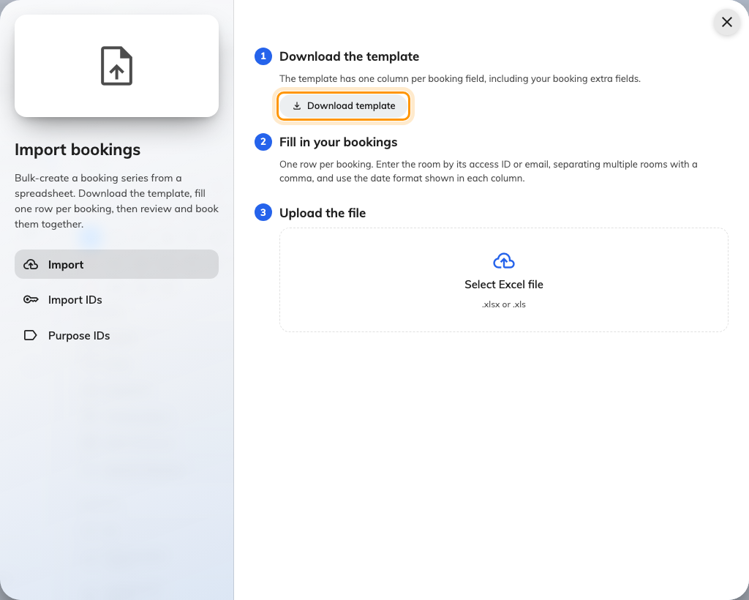
Name the host in the import sheet
Where in Offision: admin app → booking/calendar (Management calendar)

Paste the list you already have
Inviting a dozen people meant searching for them one at a time. Paste the recipient list instead — the field reads Outlook's Alex Wong &lt;alex@example.com&gt; form and splits on semicolons, commas, tabs or line breaks — and everybody is added at once. An address that matches no user is kept as an email-only attendee, and anything that is not an address stays in the box for you to fix.
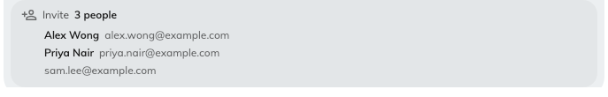
Paste the list you already have
Where in Offision: admin app → booking/calendar (Management calendar)

Take the Host field off a form
Whether the Host field appeared came entirely from the resource's host policy, so a tenant that wanted the policy but not the field had nowhere to turn it off — and a required host on a field nobody could remove made a resource unbookable. The booking form's Host row now carries a switch for each resource type: rooms, desks, equipment, parking and other. All five start on, the resource policy still has to allow a host, and a hidden Host is never required.
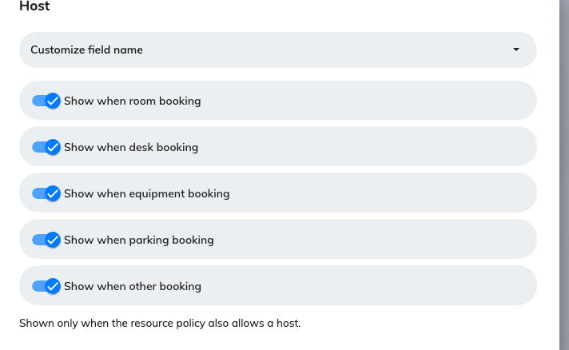
Take the Host field off a form
Where in Offision: admin app → booking/booking-form (Booking form)

Put a booking back in the right state
When a sync failed or a panel missed a check-out, a booking could sit in a state that no longer matched the room, and nothing in the console could move it. The booking history now offers Force change state, with Booked, Using and Used — the state it is in already is ticked and cannot be picked. It asks you to confirm, and records the change under your name instead of as an anonymous system row. Needs booking-manager write access.
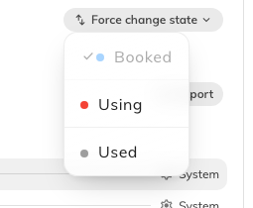
Put a booking back in the right state
Where in Offision: admin app → booking/calendar (Management calendar)

The panel says a meeting is nearly over
Nothing in the room told a meeting that had run long. An in-room panel can now speak — a few minutes before the end, at the end, or both — from Door & extras on its panel configuration. Both switches are off until you turn them on; the warning offers 1, 2, 3, 5, 10 or 15 minutes and starts at 3. The panel speaks its own display language, never says the subject or who booked it, and only the Meeting assistant designs speak at all.
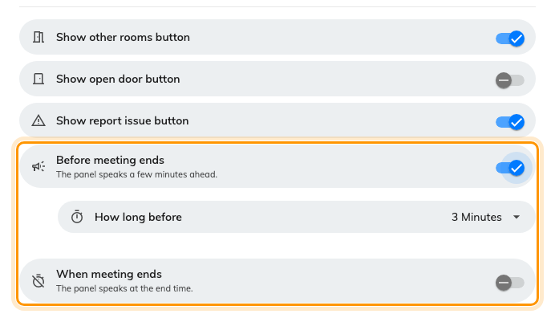
The panel says a meeting is nearly over
Where in Offision: admin app → device/booking-panel/configuration (Panel configurations)

Ask a walk-in for a subject and a headcount
One switch decided everything about the walk-in confirmation screen: the subject box was fixed to rooms, and the headcount it promised did not exist — every walk-in stored one person. Walk-in and advance booking now each carry Allow input subject and Allow input number of people, on rooms. The subject is on to begin with and the headcount is off, and turning a field off changes what the panel asks for rather than what it stores.
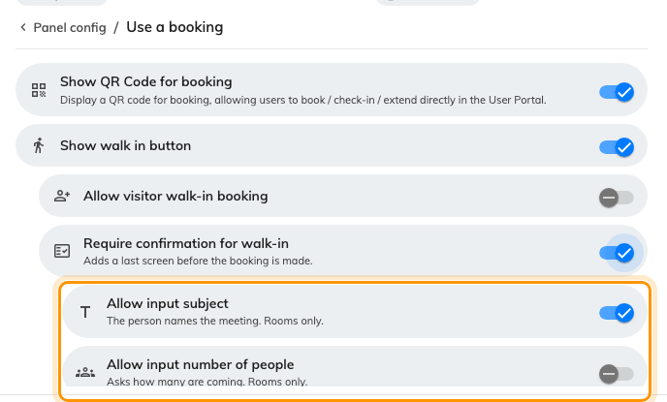
Ask a walk-in for a subject and a headcount
Where in Offision: admin app → device/booking-panel/configuration (Panel configurations)

Export the audit trail
The audit trail was the only log in Offision with no way to get the rows out, which made it awkward evidence for an audit. Download now sits in the page's menu with the same csv, xls and xlsx picker the other logs use. It takes two months at a time and keeps the most recent rows when the range is too wide, so a full 180-day retention is three pulls. It is a file you download, not a feed — there is no API and no log stream behind it.
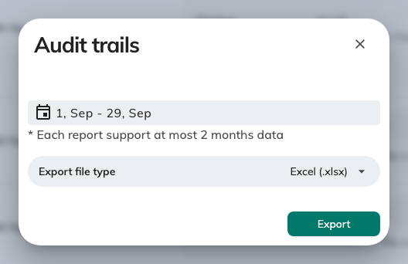
Export the audit trail
Where in Offision: admin app → system-account/audit-trail (Audit trails)

What changed

Booking
- A spreadsheet import had no way to name a host, so every booking arrived without one. Now the template carries a Host column just after Organizer, wherever a room's booking form shows the Host field — and the sheet is read by position, so download it again before your next import.
- Inviting a dozen people meant searching for them one at a time. Now you can paste the list straight from Outlook — semicolons, commas, tabs or line breaks — and everybody is added at once; an address matching no user stays as an email-only attendee.
- A booking left in the wrong state by a failed sync or a missed check-out could not be moved from the console. Now the booking history offers Force change state — Booked, Using or Used — to anyone with booking-manager write access, and records it under your name.
- Resyncing a room only ever fetched what was still to come, so a meeting deleted in the past week stayed wrong. Now a resource bound to an external calendar offers Resync past 7 days bookings on its Calendar row, beside the upcoming one.
- The Host field appeared whenever the resource policy allowed a host, and a required host on a field nobody could remove made a resource unbookable. Now the booking form's Host row carries a switch per resource type, all five on to begin with, and a hidden Host is never required.

Device
- Nothing in the room told a meeting that had run long. Now an in-room panel can speak a few minutes ahead and again at the end — both switches are off until you turn them on, under Door & extras, and only the Meeting assistant panel designs speak.
- One switch decided the whole walk-in confirmation screen, and the headcount it promised did not exist — every walk-in stored one person. Now walk-in and advance booking each carry Allow input subject and Allow input number of people, on rooms.

General
- The audit trail was the only log in Offision you could not export. Now Download sits in its menu with the same csv, xls and xlsx picker the other logs use, two months at a time — a file you download, not a feed.

Fixes
- The booking history logged every check-in as Booking PIN, whatever the person actually used.
- A booking sticker, calendar card and board chip left the host blank when the host was also the organizer.
- A room's usage rate could read over 100%.
- A walk-in booked at the panel came out titled with the automatic label welded to whatever was typed.

