Offision 4.5.12-20399
New this release: free times suggested before you pick a room, a live preview while you configure a panel, more board layouts, and a simpler app menu.
2026-08-27 · https://offision.com/help/en/release-notes/4.5.12-20399/

Pick a time before a room
Booking a room used to mean picking one, checking it for a free hour, then trying the next. Now we offer you free slots first, and the room list narrows to what is free at that time. Custom time is still one tap away; your suggestions come from Booking › Setting, and you can override them per room.
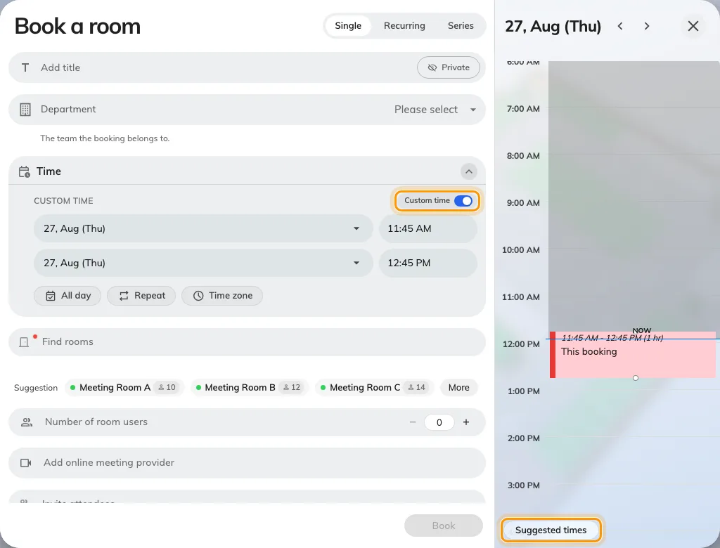
Pick a time before a room

Build the usage report by dragging fields
The usage report answered one question, and if you wanted another you exported it and rebuilt it yourself. Booking › Reports › User resource usage is now a pivot you build by hand: drag any field — department, floor, resource type, a booking-form answer — into Rows or Columns and we rebuild the table as you drop it, with hours and bookings in every cell. Save a layout you will come back to, or download what is on screen.
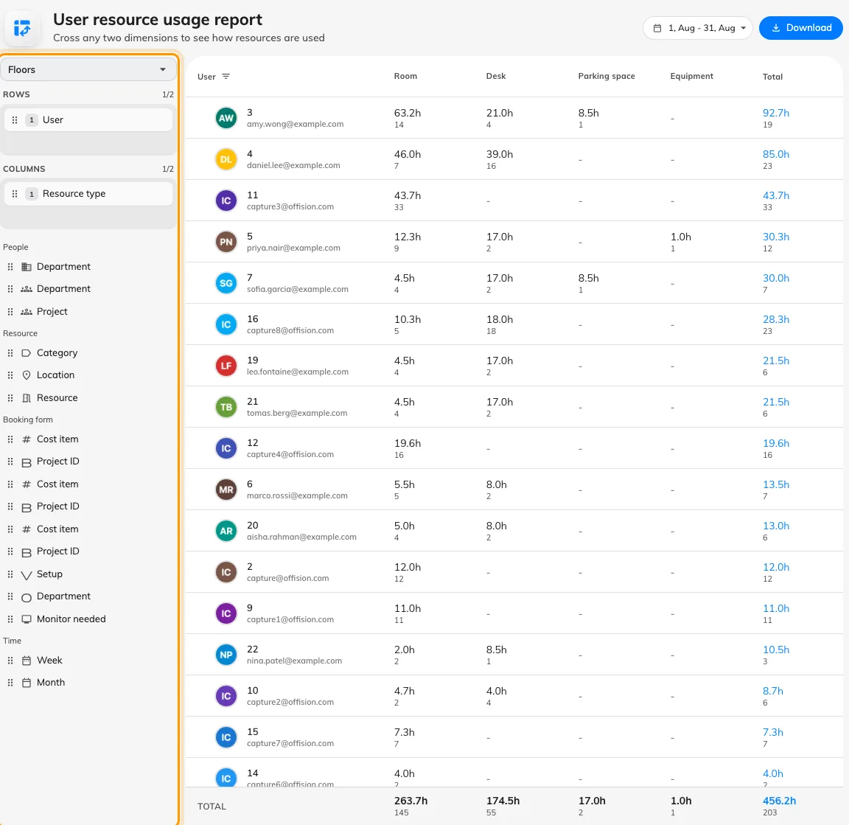
Build the usage report by dragging fields

See the panel change as you configure it
You used to change a panel setting, save it, then walk out to the wall to see what you had done. Now we draw the panel beside the form in Devices › Booking panel › Configuration. Every tile on the Design page — colours, languages, room details, the timeline — redraws it as you change it, so what you save is what you get.
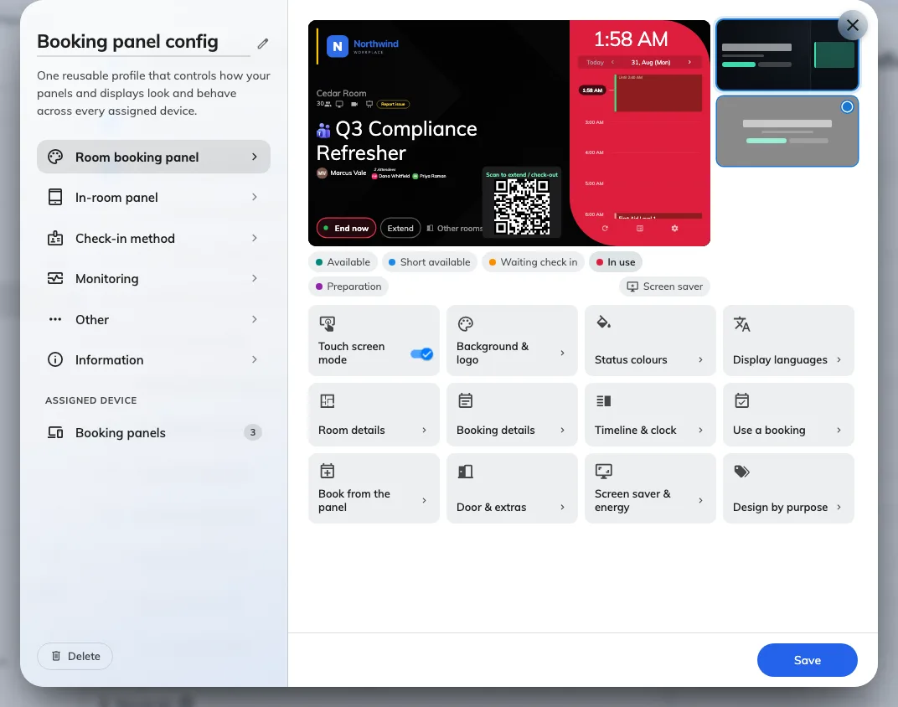
See the panel change as you configure it

Center design, and a design per purpose
On the wall, the day's schedule crowded out the meeting actually happening in the room. Center is a second panel design that leads with the current booking — its title, its organizer, how long the room is held. Design by purpose, on the same page, swaps the design for you when the booking's purpose matches, so a training room can look different during a class.
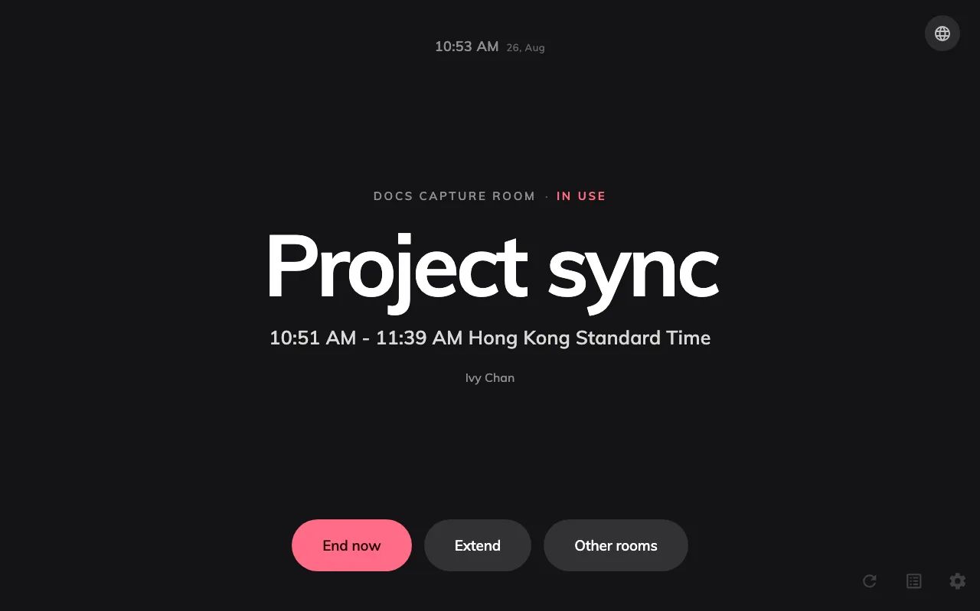
Center design, and a design per purpose
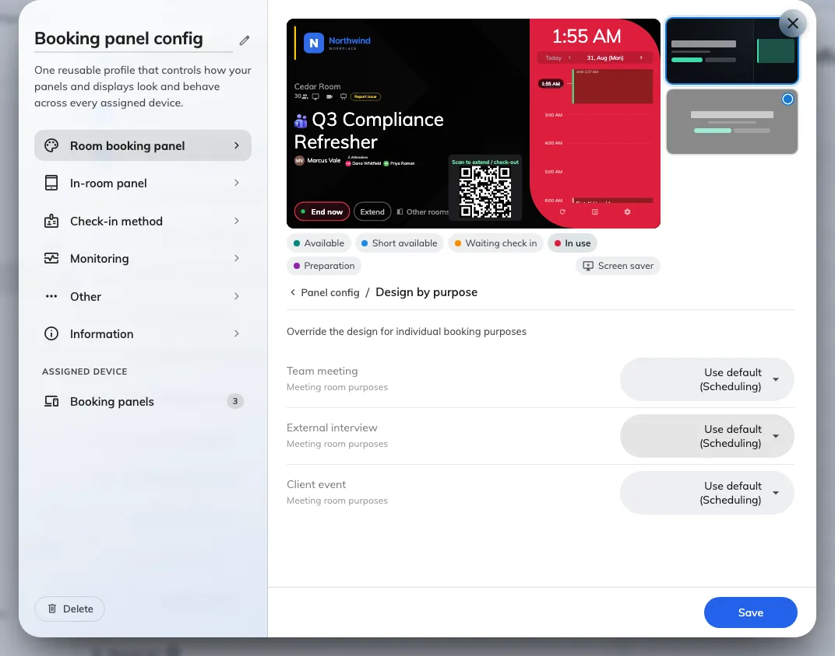
Center design, and a design per purpose

Bigger text on the timeline
A panel hung down the corridor left you squinting at the timeline. The Timeline tile now has a text-size setting, so you can scale it to the distance people read it from. On a portrait panel we fold the timeline into the side rail whatever the switch says, so the booking itself stays readable.
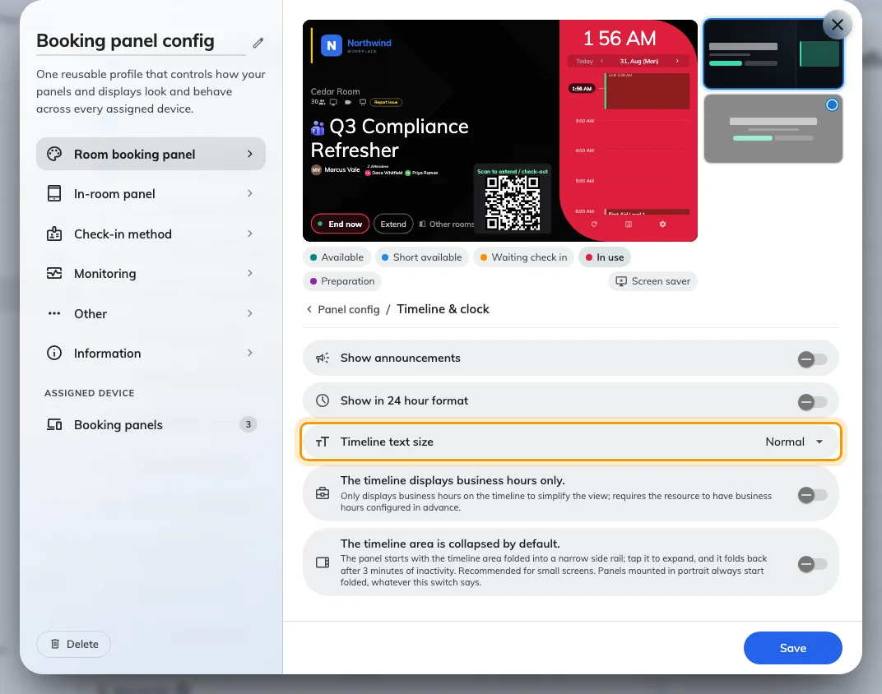
Bigger text on the timeline

Grid layouts, and a stage cut in two
One stage per board left you choosing what to leave off it. The Layout page now offers grids of three or four equal stages, and a landscape main stage can be cut in two — side by side or stacked — with the seam dragged to taste. Each half takes a widget of its own.
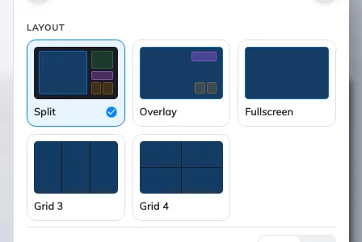
Grid layouts, and a stage cut in two
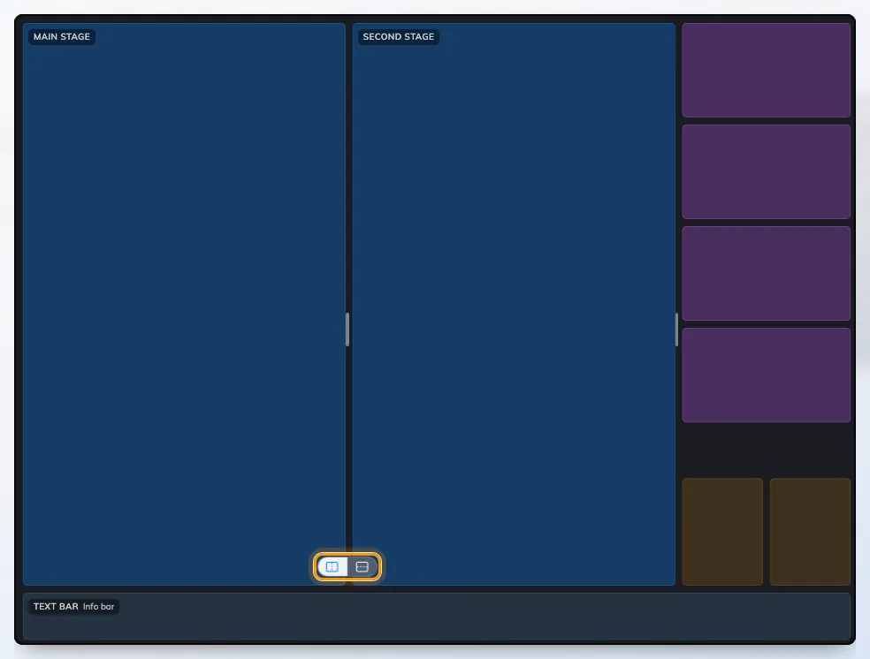
Grid layouts, and a stage cut in two

Choose a visitor badge from a gallery
Badge styles were drawn as placeholders, so you had to pick one before you could see what your guests would be handed. Visiting › Settings › Visitor badge now opens a gallery where every style carries your own logo and colours. Pick the one that fits, see what it prints, and turn it on — a Frame + Wi-Fi style that carries the guest network code is new in this release.
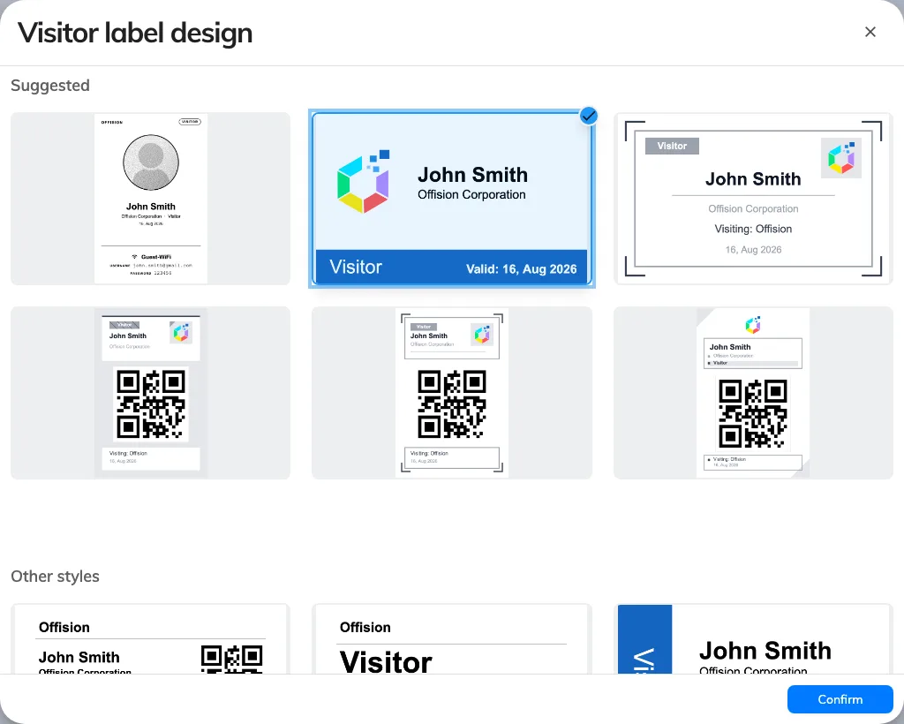
Choose a visitor badge from a gallery

Deleting a purpose moves its visits
Deleting a visiting purpose used to leave its upcoming visits stranded. We now tell you how many are ahead and offer to move them to another purpose — or delete them with it, if that is what you mean. Moved visits fill in the new purpose's form the next time you edit them or check them in.
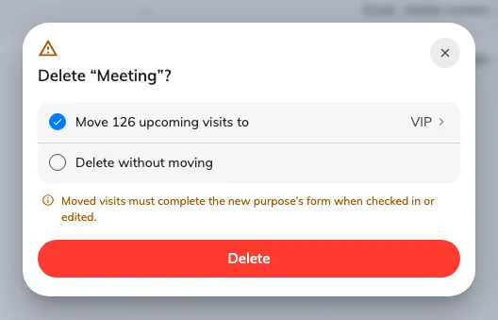
Deleting a purpose moves its visits

Import visits in two steps
Importing visits meant guessing which columns we wanted, and finding out you were wrong once the visits existed. Now it is two steps: choose the visiting purpose, download the template it needs — the columns follow that purpose's own form — fill it in, and drop the file back. We list every problem row before anything is created, and the location and purpose IDs the sheet needs are one click away.
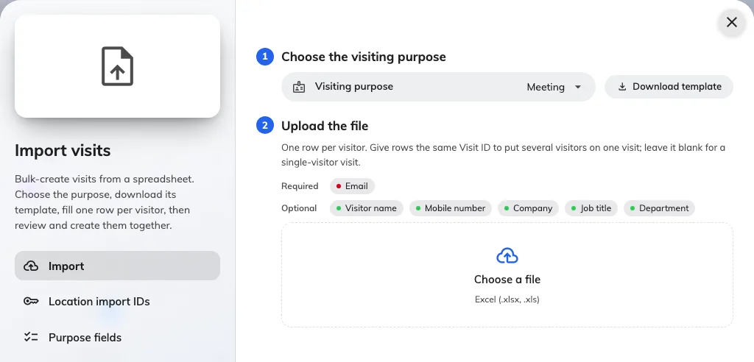
Import visits in two steps

Preview the login page as you brand it
Branding the login page meant saving it and signing out to see what you had done. Now we draw the real page beside the settings in UI customization › Login page, redrawn as you change a logo, an image or a switch. Flip it between desktop and mobile, light and dark, before you save.
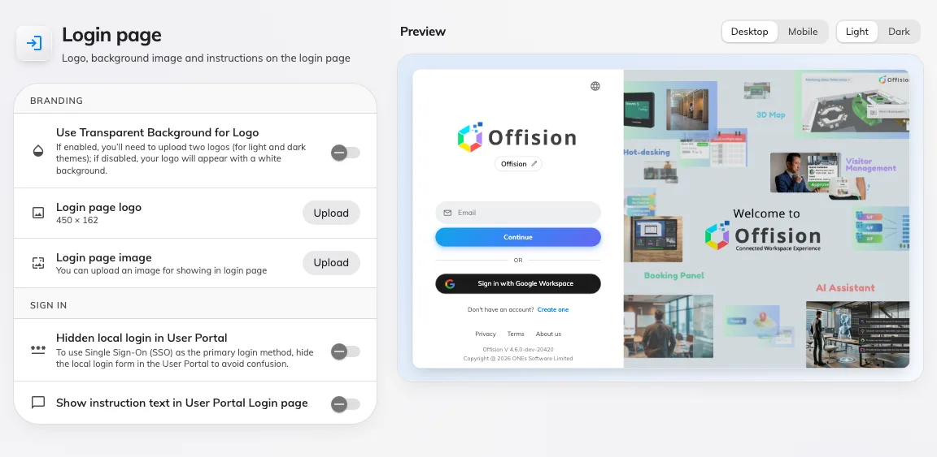
Preview the login page as you brand it

A simpler app menu
The app's side menu was one flat list, and inside Microsoft Teams you did not get it at all. It is now grouped — Workspace, Staff, Events — with plain glyphs and a count on any row that has something waiting for you, such as visitors to approve or tickets to pick up. In Teams we put the same pages and counts in the page switcher.
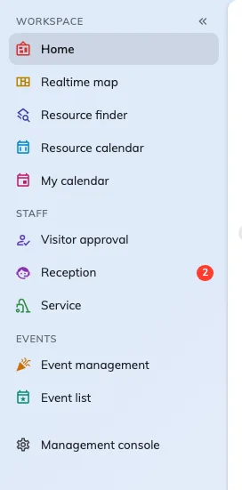
A simpler app menu

What changed

Booking
- You had to open room after room to find a free hour. Now we suggest free times before you pick a room.
- The usage report only answered one question. Now you drag in the fields you want, and we rebuild the table as you drop them.
- The booking form was slow to settle while you filled it in. We have made it quicker and steadier.

Device
- You could not see a panel change until you had saved it. Now we draw the panel beside the form.
- On the wall, the schedule crowded out the meeting itself. The new Center design leads with the booking in the room.
- A room looked the same whatever was happening in it. Now the design switches itself when the booking purpose matches.
- The timeline was hard to read from across the room. You can now set its text size.
- The timeline squeezed the booking on a narrow screen. We now hide it on portrait panels.
- Tapping a staff card left you unsure what to do next. The panel now walks you through it.

Signage
- One stage per board left you choosing what to leave out. New layouts give you three or four stages at once.
- A main stage could only hold one thing. You can now cut it in two and drag the seam to taste.
- Every request had to be typed on the board. You can now speak to the service and support widgets.
- A long booking list gave you no way to find your own floor. You can now group it by floor or by building.

Visitor management
- Badge styles were drawn as placeholders, so you had to pick one to see it. The gallery now shows each in your own logo and colours.
- Deleting a visiting purpose left its upcoming visits stranded. We now tell you how many are ahead, and offer to move them.
- Your export ignored the purpose you had filtered by. It now follows it.
- Importing visits meant guessing which columns we wanted. We now hand you the template your purpose needs, and list every problem row before anything is created.

Management console
- Console search buried what you were looking for. Results now sit closer to what you typed.
- Show more forgot itself every time you moved on. The rail now remembers it, per module.

User app
- The app menu was one flat list, and thinner still inside Microsoft Teams. It is now grouped, with a count on anything waiting for you — in Teams too.

UI customization
- Branding the login page meant saving to see it. Now we draw the real page beside the settings.

Fixes
- Room layouts could not be selected.
- The host field appeared only after a room was chosen.
- Overlapping suggested times went missing.
- Unlimited quotas showed as 9999999 on the booking form.
- The edit event wallet pass dialog opened outside the window.

