Write a visitor survey
Ask every guest a set of questions — a safety induction, a health declaration, an NDA, a safeguarding or background-check declaration — either before they travel or after they leave. The four answer types, the one that takes an acknowledgement, and where the answers can be read. An answer is recorded, never judged: it has no expiry date and refuses nobody.
2026-09-13 · https://offision.com/help/en/visiting/write-a-visitor-survey/
A survey is a short questionnaire every visitor on a given visiting purpose has
to answer. It is how a site puts a safety induction, a health declaration, a
safeguarding or background-check declaration, or an NDA in front of a guest
without anyone at the desk having to remember to ask.
Know what it is before building on it: a survey records an answer against
that one visit. It carries no expiry date, so nothing notices that last year's
induction is stale, and no answer ever blocks a badge or a check-in — where a
visit has to be refused on what somebody declared, a person decides that through
approval. The details are at the end, under What a survey cannot do.
Before:
A visiting purpose to attach the finished survey to.

1. Create it
Where in Offision: admin app → visiting/visitor-survey (Visitor survey)
Give it a Name and, if the questions need framing, a Description that
opens the survey and a Footer that closes it. Branch management limits
the survey to one branch of the organisation.
A survey is written in one language only:
Unlike a visiting form, a survey's name, description, footer and questions are
plain text with no per-language versions. Whatever you type is what every
visitor reads, on a Japanese or Chinese screen as much as an English one. Word
them for the audience that will actually meet them.

2. Choose when it is asked
Survey type is the decision the rest of the survey depends on, and it cannot
be half of both.
Survey type | When the visitor answers it
Before visiting | In the invitation flow, on the pre-registration page they open from their badge email, on the self-registration form, and at check-in — desk or lobby board
After visitior leave | In an email sent once they are checked out

Before visiting is the one an induction needs: it reaches the guest while
they are still at their own desk, and again at the door if they skipped it. The
after-visit email goes out only when the purpose actually carries an
after-visit survey — no survey, no email.
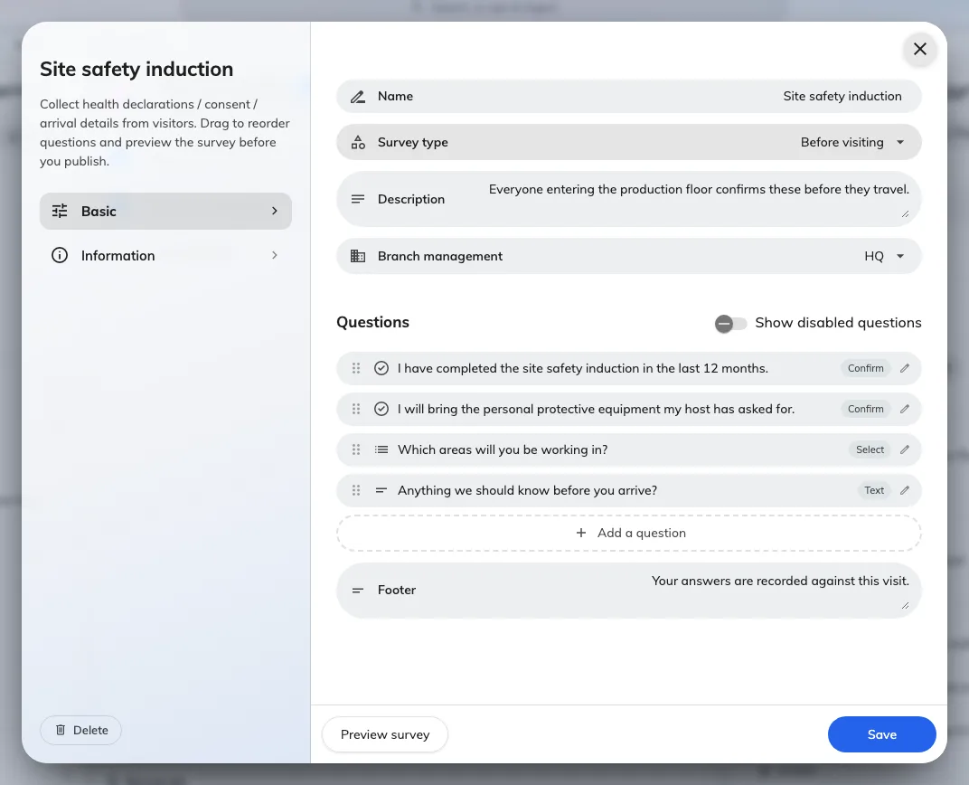
A survey, its type, and the questions under it.

3. Add the questions
Add a question, then set its Answer type.
Answer type | What the visitor does
Yes / No | Answers one switch
Select | Picks one of the Options you list
Text | Types a free answer
Confirm | Ticks an acknowledgement — the sentence they are agreeing to is Customize confirm text

Confirm is the type an induction or an NDA is built from: the question is the
statement, and the tick is the record that they accepted it.
Remarks puts a line of guidance under a question. Optional lets the
visitor leave it blank — leave it off for anything you intend to rely on later.
Drag the questions to reorder them, and use Preview survey to read the whole
thing the way a guest will.
A saved question can never be edited:
Once the survey is saved, its questions are frozen: This question is already
saved and can't be edited — you can disable it instead. You can always add new
questions and disable old ones, so a survey evolves by accumulation. Disabled
questions stop being asked and stay on past records; Show disabled questions
brings them back into view. Get the wording right before the first save.
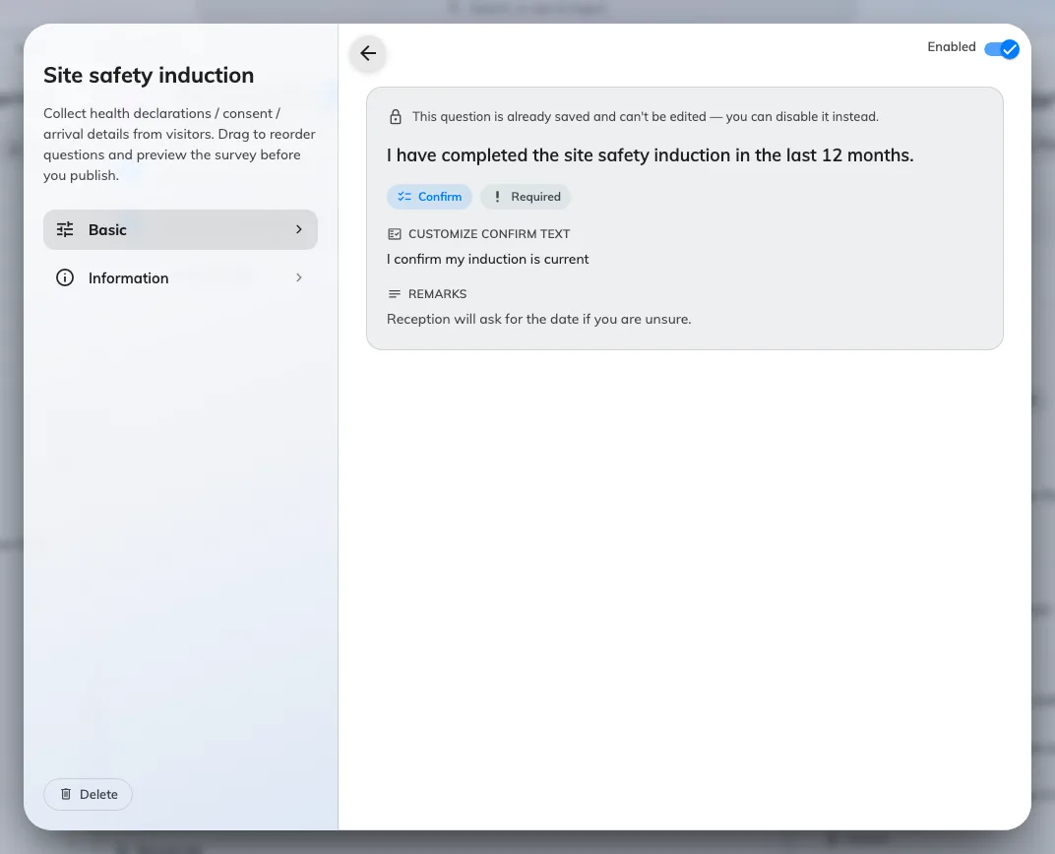
A question and its answer type. Saved questions can be disabled, not edited.

4. Attach it to a visiting purpose
A survey asks nobody anything until a purpose carries it. Open the purpose,
go to Self-registration & survey, and tick it — see
Set up a visiting purpose. A purpose can carry
several, and each becomes a step of its own.
Scoping is what makes "contractors only" work: put the survey on a Contractor
purpose and nobody visiting for a meeting is ever asked it.

5. Check it worked
Invite yourself under that purpose and open the pre-registration link in the
email. The survey should be a step, with your questions on it in order.

Reading the answers
- At the desk. The reception and lobby-board check-in dialogs re-show the
survey with the visitor's earlier answers already filled in, so the desk can
see what they said without leaving the arrival.
- In bulk. Export survey records on the survey's own menu downloads every
answer as a spreadsheet — one row per visitor, one column per question. The
list itself shows only Replied surveys, a count.
There is no survey column on the visitor list and no survey section in a
visitor's record. The export is the only place a whole history is readable.

What a survey cannot do
- It cannot take a file. The four answer types are the whole set — there is
no upload. A permit or an insurance certificate is not something a visitor can
attach anywhere in Offision; see
Visiting form reference.
- It has no expiry. An answer is recorded against one visit and carries no
validity date. Nothing notices that last year's induction is stale.
- It refuses nobody. No answer blocks a badge, triggers approval or stops a
check-in — answers are recorded, never judged. Where a visit has to be vetted,
use Require approval before a visitor is invited,
which a person decides.
- A long-term badge skips it. A standing-pass holder's arrival bypasses the
surveys and the terms entirely — see
Give a contractor a long-term badge.
A contractor who must keep re-confirming an induction should be invited
normally, not given one.

