Which visitor report answers which question
A map from the question you are asking — how many visitors came, who is on site now, who never showed up, which day's records to hand to security — to the one page that answers it, with what each page filters by and which of them can export.
2026-09-02 · https://offision.com/help/en/visiting/which-visitor-report-answers-which-question/
Half a dozen pages in the Visitor module look like "the visitor report", and
none of them is. Each answers a different question, so start from the question
and open the page built for it. Dashboard is the front door; the day-to-day
lists sit beside it in the menu, and Email report lives under Settings.
Where in Offision: admin app → visiting/dashboard (Visitor Dashboard)
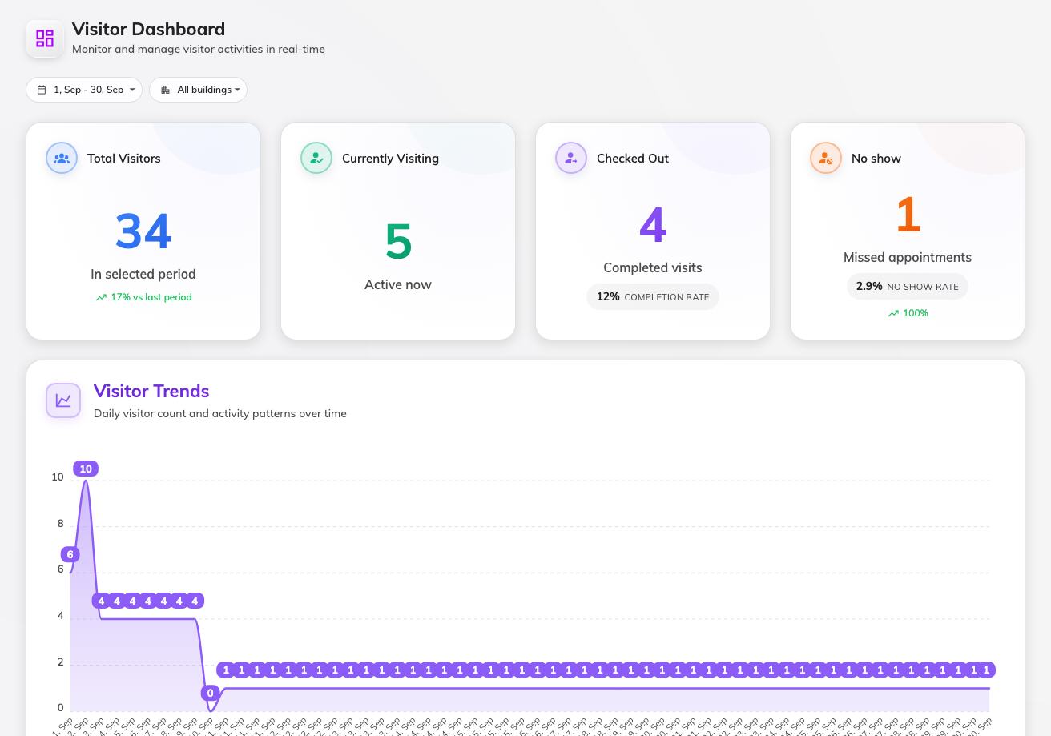
Dashboard — four numbers, then the charts.
The question you have | Open | What it gives you
How did visiting go this period? | Dashboard | Four numbers — total, on site, checked out, no-shows — with rates and a trend against the previous period, then charts: visits per day, a building breakdown, top visitors and hosts, purposes, invited vs walk-in. No export.
I need one day's visitor list as a file. | Visiting daily report | Every visitor of one day as a table — times, status, check-in and check-out, host, purpose — with Download as Excel or PDF.
What is happening right now? | Overview | The quick-view cards: who is on site (and overstaying), today's meter, this period's summary, long-term badges about to expire.
I need the raw visit records, searched and filtered. | Visitor badge | The list behind everything above — one row per badge, batch actions, and an Excel export. See Find a visitor's record.
Who did what to a visit, and when? | Log | Every action on every visit. Pick a date range and download it as Excel — the file follows the columns you have showing.
Send me the numbers, I will not log in. | Email report | Not a viewer: a subscription that emails an upcoming-visitor forecast daily, weekly or monthly.
How is today going, while I work the calendar? | Invitation | The calendar's own strip of tiles — Expected, On site, Left, Needs attention — which also filter the calendar below.

The reception desk has its own view of the day — and the one-click export of
everyone currently in the building — on the receptionist's home page. That is
covered in the Receptionist guide.
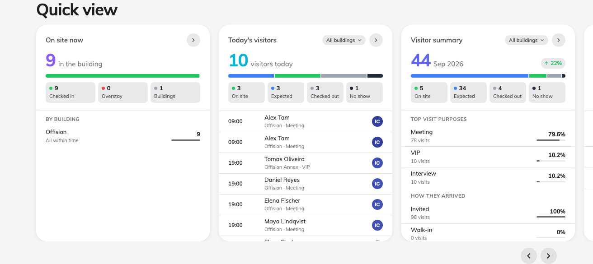
Overview — the quick-view cards are the &quot;right now&quot; report.

How the filters differ
Visitor pages filter by building, not by floor — a visitor belongs to the
building they were invited to. The Dashboard adds a date range (it opens on the
current month); the Daily report is deliberately one day at a time. When a
number looks wrong, check the period first, then whether a building filter is
still applied from last time.
The numbers all read the visitor badge — the same states the calendar
colours by. Visiting and Overstay are people on site, Left is a
completed visit, and No show is an invitation nobody checked in on, marked
automatically once its time has passed — where the visiting policy has that
change turned on. With it off, missed visits stay Await and the no-show
figures read zero.

What none of them show
- An export of the Dashboard. The charts are view-only. The same records
leave the system through the Daily report (one day, Excel or PDF), the
Visitor badge list (any period, Excel), or the Log.
- Visits still in progress are not "completed". Rates settle only after
the day ends, so this month's completion rate is always lower mid-month.
- Other companies' visitors. Every page here shows your tenant only, and
only the buildings enabled for visiting.

