What a visiting location is
A visiting location is not a separate thing you create — it is one of your buildings with visiting switched on, and the floors, rooms and parking under it opened one by one. What a location carries: its visiting policy, its opening hour and time zone, its receptionists and its monthly visitor count — and how a lobby screen knows which location it greets.
2026-09-02 · https://offision.com/help/en/visiting/what-is-a-visiting-location/
A visiting location is not a separate thing you create. It is one of your
buildings, with visiting switched on. The Visiting location page lists
every building in the company; the ones enabled there are your visiting
locations, and a guest can only ever be invited to one of them. A company with
ten buildings might open three — the other seven simply never appear when
somebody invites a visitor.
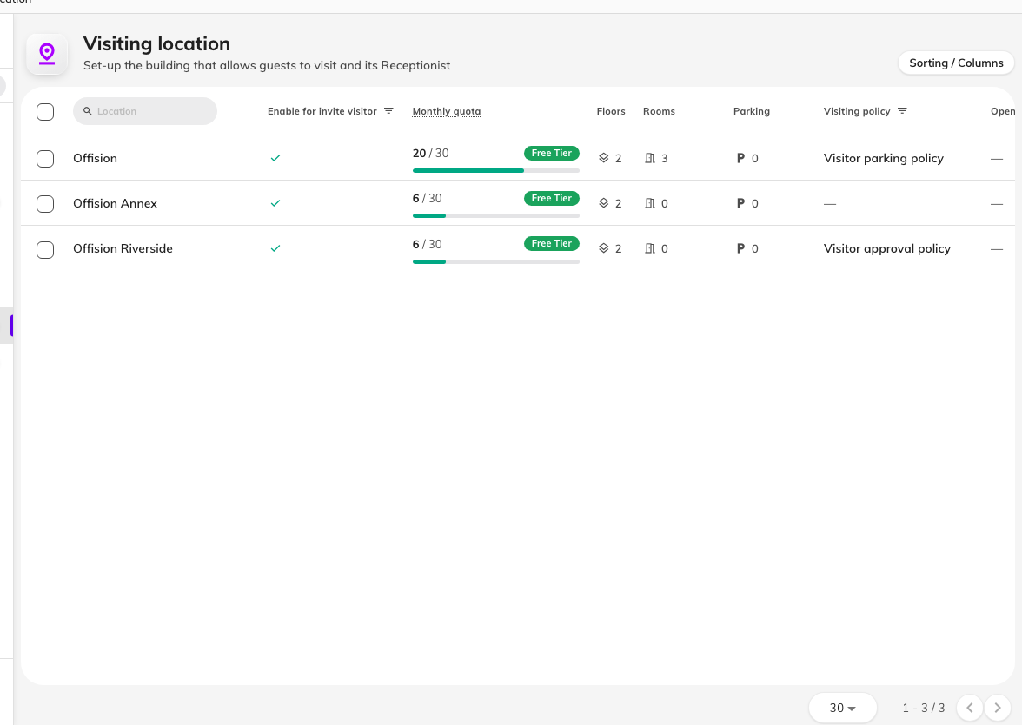
The Visiting location page is your building list — each row showing whether it is enabled, this month's quota, its floors, rooms and parking, and its visiting policy.

A location is as precise as you open it
Under a building sit its floors, and under those its rooms and
parking — each opened to visitors one by one. The invite form drills
exactly as deep as you opened: a building alone is a complete answer, a floor
narrows it, a room says precisely where the visit is. A room chosen as the
visiting location is where the visit happens, not a reservation of the room.
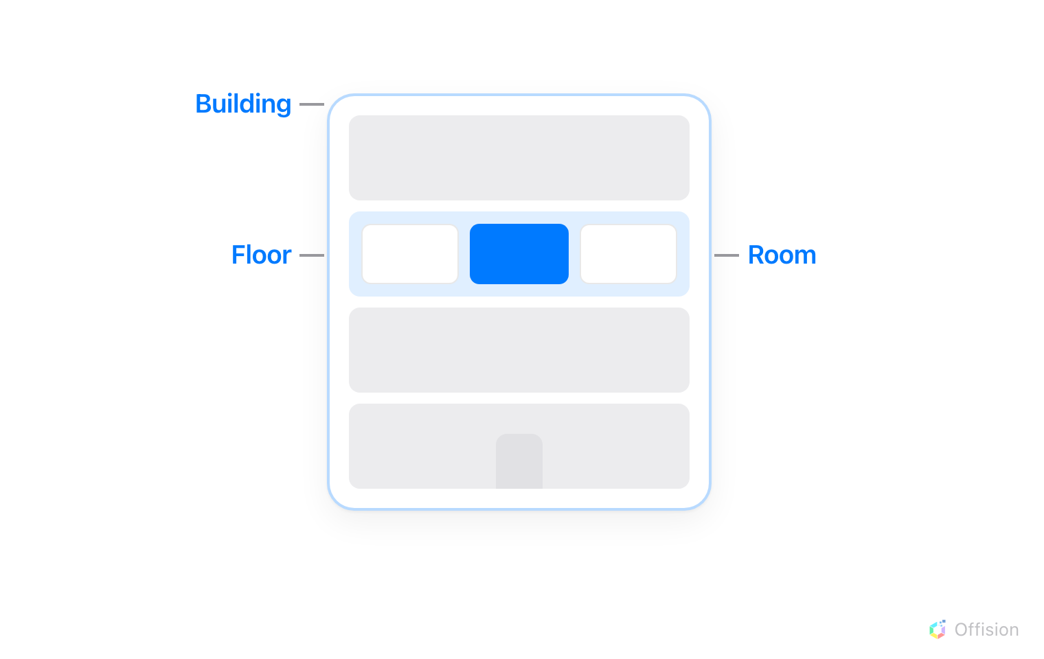
A visiting location can be the whole building, one of its floors, or one room on a floor — as precise as the visit actually is.

Several locations can be selected
A visit is not limited to one location — different places can be selected for
it, even across buildings. The visit then belongs to each of them: it appears
at each building's reception, and each place's rules apply to it.
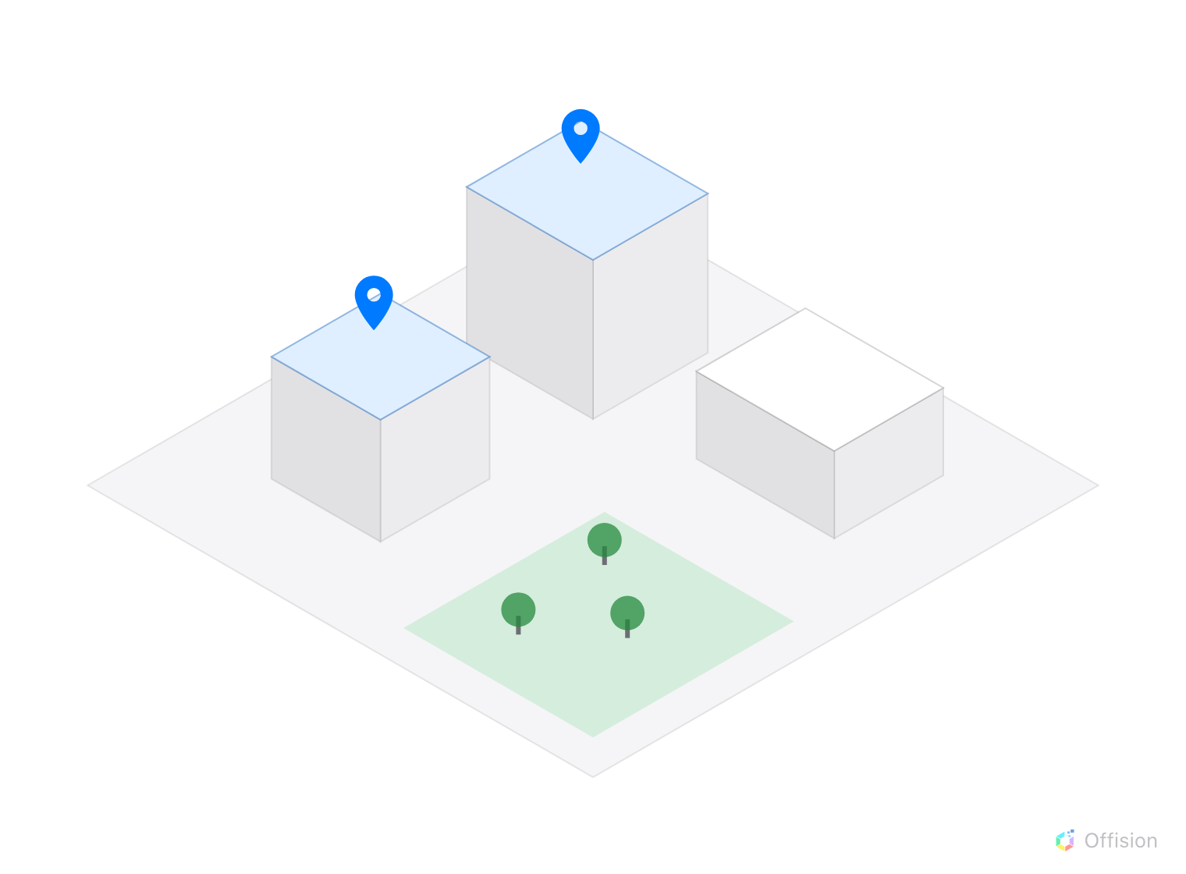
Different locations selected for visiting — two of the estate's buildings are pinned, the third is not.

What one location carries
Select a building's row and its panel shows everything the location decides:
- Visiting policy — the rules of a visit here: approval, vehicles, what the
badge code does. A policy attaches to a building, a floor or a room, and the
most specific one wins — see
Require approval before a visitor is invited.
- Opening hour and time zone — when visitors may be on site, and which
clock that is measured on.
- Receptionist — who staffs this building's desk. A receptionist sees only
the visitors of their own buildings, so a location with nobody named here has
a desk nobody can open.
- This month's visitor count — visitors are counted per location, each
badge created counting once against its building's monthly limit.
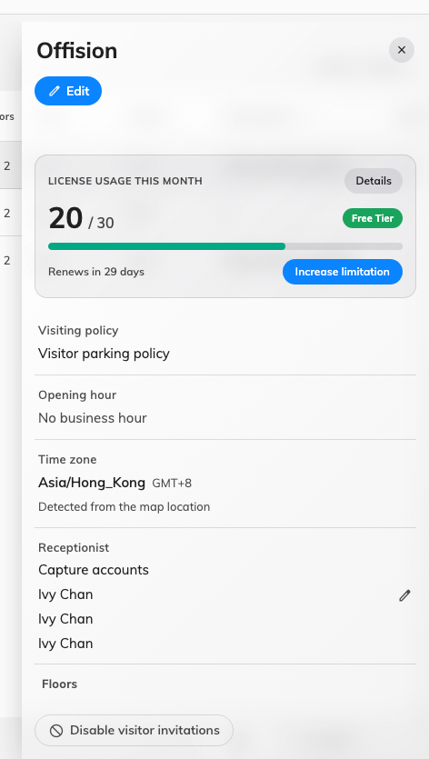
One location's panel: its visitor count for the month, visiting policy, opening hour, time zone, receptionists, and the floors, rooms and parking open under it.

Where its visitors are met
A location can meet visitors at any of three surfaces: a reception desk
staffed by its receptionists, a lobby screen guests use themselves, and the
panel outside a room. A lobby screen names the buildings it serves in its
own visitor widget — left unset, it greets every visiting location, so on a
multi-building site set it. The screen's position on the floor plan is a
different setting and has no effect on which visitors it greets.

What a location does not decide
- What a visitor is asked for. The questions, the photo and the survey come
from the visiting purpose, not the place.
- What the badge looks like. Badge design
is set once for the whole company.
- The country codes on the invite form. Those are
company-wide too.
Where in Offision: admin app → visiting/visiting-location (Visiting location)

