What happens when a visitor checks in
[Map family: shared] The three places a visitor can be admitted — the reception desk, a lobby screen or kiosk, and their own phone — and what each one does at the moment they arrive: whether the guest is shown the room they are going to, and whether the host is told. The panel outside the room is not one of them.
2026-10-03 · https://offision.com/help/en/visiting/what-happens-when-a-visitor-checks-in/
Map family: shared
A visitor can be admitted in three places, and the panel outside the room is
not one of them. A room booking panel can let a visitor who is already checked
in take a free room, and it can open a door for them, but nothing on a panel
admits anybody to the building. That is worth saying first, because it is where
most people look.
The three that do admit a visitor are the reception desk, a lobby screen or
kiosk, and the visitor's own phone. They create the same record. They do
not show the guest the same thing.

What each surface does
Where they check in | Shown the room | Floor plan | You are here | Host told
Reception desk — a receptionist scans their code | no | no | no | yes
Lobby screen or kiosk — the guest checks themselves in | yes, when the visit names a room | yes, that room lit up | when the screen is placed on a plan | yes
The visitor's own phone — from a link or a QR on the screen | no | no | no | yes
Room booking panel | cannot check a visitor in at all

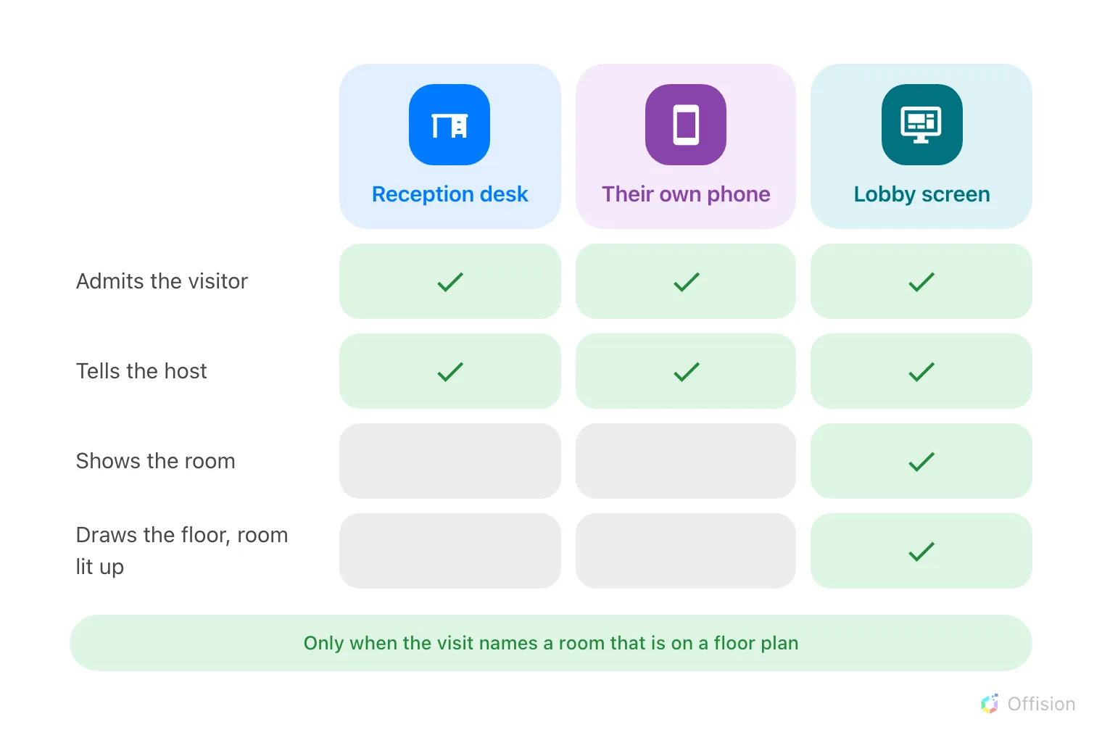
Wherever a visitor is admitted, the host is told. Only the lobby screen also shows the guest the room they are going to.

The guest who is shown the room
At a lobby screen, a successful check-in interrupts the welcome content with the
destination: the room's name, its floor and its building, and a plan of that
floor with the room lit up. Where the screen itself has been placed on a floor
plan, the guest also gets a You are here pin and can see both ends of the
walk. It closes itself after a minute.
It is not unconditional. The visit has to name a room that is open to visitors,
and that room needs a floor and a position on the floor plan; without those the
guest gets a plain confirmation instead. The four conditions, and what to check
when the map does not appear, are in
Show a visitor the way to the room they are visiting.
The reception desk's own check-in wizard shows no plan — the receptionist is
standing next to the guest, and the room is on the visitor's badge. A guest
checking in on their own phone is told to collect that badge at reception.

The host who is told
Every surface tells the host, and it is on out of the box. The moment the badge
is admitted the host gets an email, a push notification where they use the
mobile app, and a Teams message where Teams is connected. The host is whoever invited them — for a visit
created from a booking, that is the booking's organiser.
The message names the visitor, not the room. Turning it off is a policy setting
per location, and a visit governed by two locations keeps the notification until
both have turned it off. Both facts are in
Tell the host their visitor arrived.

What this does not decide
- Whether the guest is admitted at all. A visit awaiting approval has sent no
invitation and has no code to check in with — see
Require approval.
- What the badge says, which is set once for the whole company.
- Whether a door physically unlocks. Checking in at a screen can trigger the
doors linked to that screen; everything else about a lock is access control.
- Who works the desk. That is the Receptionist permission, and the desk has
a guide of its own.

