What appears on a visitor badge
A printed badge is assembled from four different screens, and only one of them is the design you picked. This explains which part comes from where.
2026-09-02 · https://offision.com/help/en/visiting/what-appears-on-a-visitor-badge/
A visitor badge is the label printed at reception when a guest arrives, and
attached to the badge email they were sent beforehand. It identifies the guest to
your staff and, on most designs, carries the code they check in with.
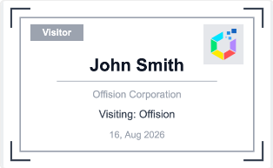
A badge: the visitor role (1), their name (2), their company (3), your logo (4).
Designs differ in what else they carry. Several print the QR code the visitor
scans at the lobby; one puts a photo and the guest Wi-Fi credentials on the same
label.
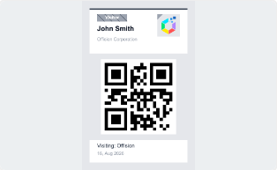
Another design, carrying the QR code the visitor scans at the lobby.
So the badge looks like one thing, and people reasonably assume it is configured
in one place. It is not. Four screens each contribute a part of it, which is why
changing the design does not always change what someone is complaining about.

The four sources
The part | Comes from | Scope
The layout — where the name, photo and code sit | Visitor label design, on the visiting settings page | One design for the whole company
Name, company, photo, visitor code | The visit itself, and what the visiting type asked the visitor for | Per visit
Whether the QR code and the visitor code are printed at all | The visiting policy attached to the location | Per location
The Wi-Fi network and password block | Visitor WiFi | Per building, or company-wide

Where in Offision: admin app → visiting/visitorManagementSetting (Visitor management)

The design is company-wide
There is one badge design, and every visitor gets it — every location, every
visiting type, every building. A visiting type decides what the visitor is asked
for and when they may check in; it does not carry a design of its own.
The design is chosen from a fixed gallery. Each entry is a complete layout, not a
starting point: there is no field-by-field editor, no colour picker, and no page
where you rearrange what sits where. Choosing a different design is the only way
to change the arrangement.

The design adapts to what it is given
The designs are drawn at print time from whatever that visit actually has, so the
same design produces different badges for different visitors. The photo and
Wi-Fi design is the clearest case: it drops the photo when the visitor never
supplied one, drops the credential block when there is no visitor Wi-Fi
configured, and prints a plain badge when it has neither. Nothing warns you —
the badge simply comes out simpler than the preview.
This is worth knowing before judging a design by one printed sample. A badge
that "lost" its photo is usually a visit without a photo, not a broken design.
Note:
The photo and Wi-Fi design does not print a company logo at all. Its layout has
no room for one.

It applies to the printed label only
The design covers the badge that is printed at reception and attached to the
badge email. Two other things a visitor may be holding look different by
construction:
- The badge page on the visitor's phone — the web page a visitor opens from
their invitation. It has its own fixed layout and ignores the design.
- The Apple or Google wallet pass — its artwork is set separately, on the
Apple pass / Google pass settings page. See
The Apple and Google wallet pass.
So a visitor arriving with a phone in their hand is not looking at the design you
chose, and a mismatch between their screen and the printed label is expected.

What the location policy can remove
Two options on the visiting policy attached to a location override the design's
own idea of what to print:
- Hide QR code on visitor badge — for buildings whose own gates issue a QR
code. The badge prints without one, and visitors check in at reception using
the visitor code instead.
- Show external badge code — when off, the visitor code is removed from the
badge email, the badge image, the mobile pass and the visitor's badge page,
leaving only the QR code. It only applies where Require external badge
code is on — an Offision-generated code is the check-in credential itself
and always shows — and every location on the visit must be covered by a
policy that hides it. See Show or hide the visitor code.
Between them, these two settings can strip a badge down to a name and a photo
without anyone touching the design — though never below one credential: a badge
always keeps its QR code or its visitor code.

