Visiting form reference
The screen that decides what a host is asked when they invite a guest and what a visitor is asked at the door — the six questions you cannot change, every setting on a field you add yourself, and which form a given visit ends up using.
2026-09-01 · https://offision.com/help/en/visiting/visiting-form-reference/
A visiting form is the set of extra questions asked about a visit. Unlike the
booking form, you do not compose it from the built-in questions — those six are
fixed. What you build here is everything on top of them, and where each
answer travels afterwards.
Where in Offision: admin app → visiting/visiting-form (Visiting form)
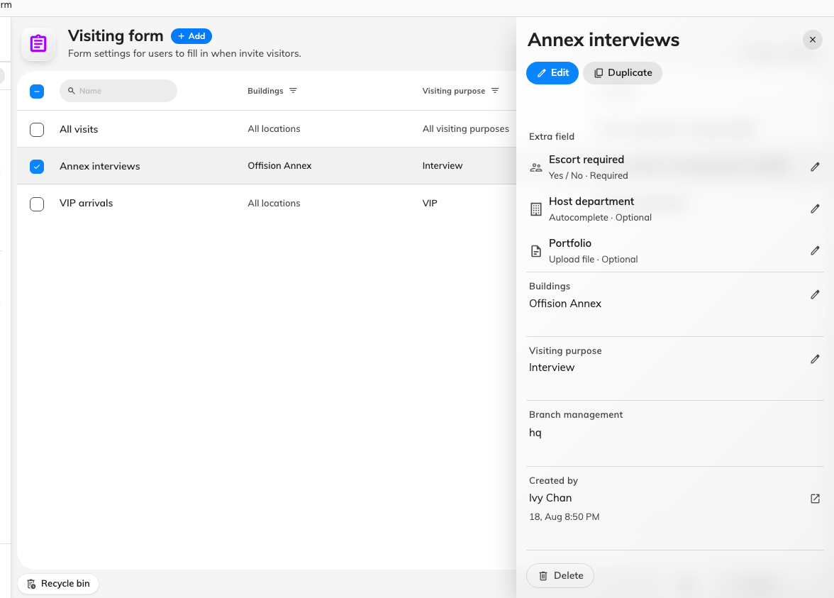
The forms on this site, with one selected. The panel lists its fields and where it applies.

The form itself
Setting | What it does | When to change it
Name | Names the form in the list and in the picker on every other screen | Name it after the group of visits it serves — a site, a purpose, a tenancy — not after its fields
Branch management | Limits the form to one branch of the organisation | Only on a multi-branch site where each branch runs its own forms

Below those sits the field list: the six built-in questions, then every field you
have added, in the order they appear on the form. Drag your own fields to reorder
them, select one to configure it, and choose Add field for a new one.
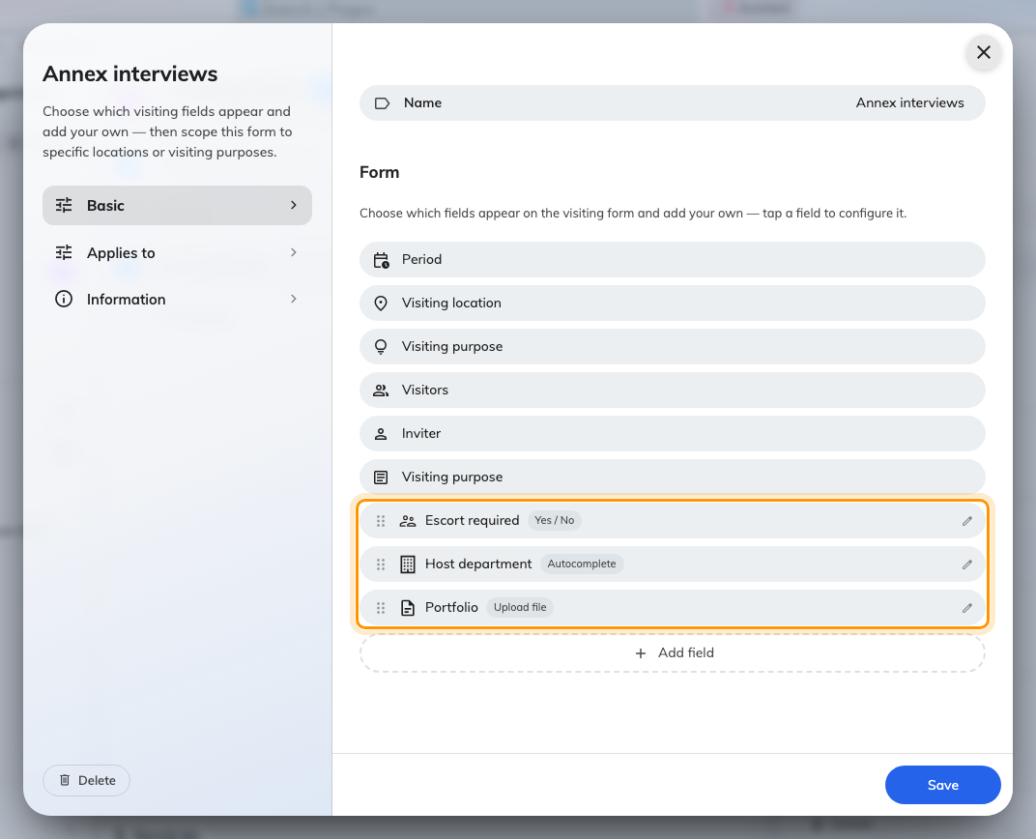
The field list. Only the fields you added — ringed — can be moved or opened.

Built-in fields
These six exist on every visiting form and none of them can be renamed,
reordered or switched off. They have no editor: selecting one does nothing.
What each of them asks for is decided elsewhere — see
Set up a visiting purpose.
Field | What it collects
Period | When the visit starts and ends
Visiting location | The building, and the room where one is booked
Visiting purpose | Why they are coming
Visitors | The guests themselves — name, address, and whatever their visiting purpose asks for
Inviter | The person in your organisation who is expecting them
Visiting purpose | The free-text note about the visit

The list really does say Visiting purpose twice. The third row is the
category the visit is filed under; the last is the free-text note beside it. They
are separate questions that share a name.

Fields you add yourself
Every field you add carries the same settings.
Setting | What it does | When to change it
Name | What the person filling the form sees | Always fill it in for every language your site uses — a name given only in English renders in English on a Japanese screen
Description | A one-line hint under the field | Use it for the rule people get wrong, not to restate the name
Icon | The mark beside the field | Pick something recognisable; it is how people find the field in a long form
Field type | What kind of answer is accepted — see the table below
Select option | The choices, for Select and Multiple select | For a short fixed list. A long or shared list belongs in a data set
Data set | Which reusable list backs an Autocomplete field
File type | Limits an upload to images, videos, PDFs, or anything | At least one type must be chosen
Required | The form cannot be submitted without an answer | Turn on for anything you intend to reconcile or report on later

Where a field appears
Five switches, and they do not divide the way their labels suggest. The first
three decide which form asks the question; the last two decide who reads
the answer afterwards.
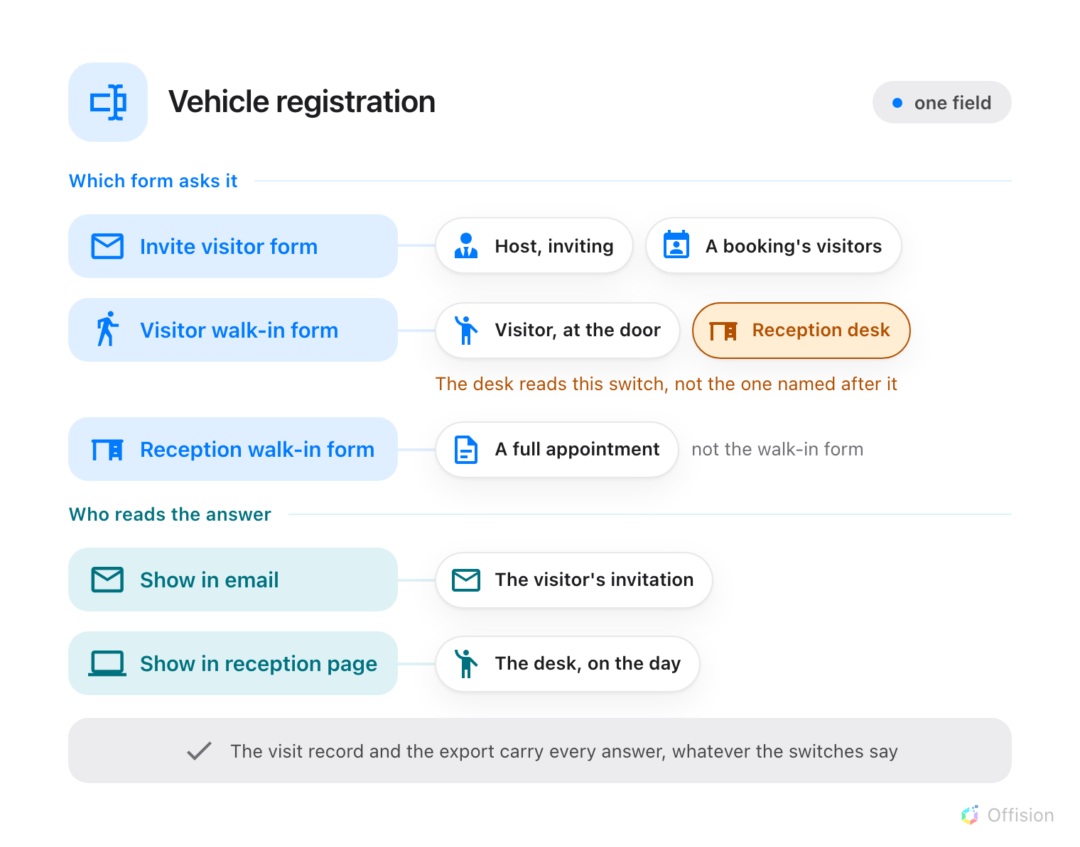
The first three switches decide which form asks. The last two decide who reads the answer.
Setting | What it does | When to change it
Enable input in invite visitor form | Asks the question on the host's invite screen, and in the visitor section of a booking | The default place to ask. Note the booking's visitor section shows only fields with this switch on — a field turned on for reception alone never appears there
Enable input in visitor walk-in form | Asks it on the visitor's own self-registration screen — and on the receptionist's walk-in form | This is the switch the reception desk actually reads, despite its name. Turn it on for anything you need from an unexpected arrival
Enable input in reception walk-in form | Asks it only when a receptionist books a full appointment on someone's behalf | Leave it alone unless your receptionists create appointments rather than register arrivals. It does not drive the walk-in form its name describes
Show input value in email | Puts the answer in the visiting invitation and its update and cancellation notices | Leave off for anything the visitor should not be sent in writing
Show input value in reception page | The desk sees the answer beside the visitor on the day | Turn on for anything reception has to act on — a vehicle, an escort, a delivery

Whatever these switches say, the answer always reaches the visit's own record and
the visitor export — one column per field.
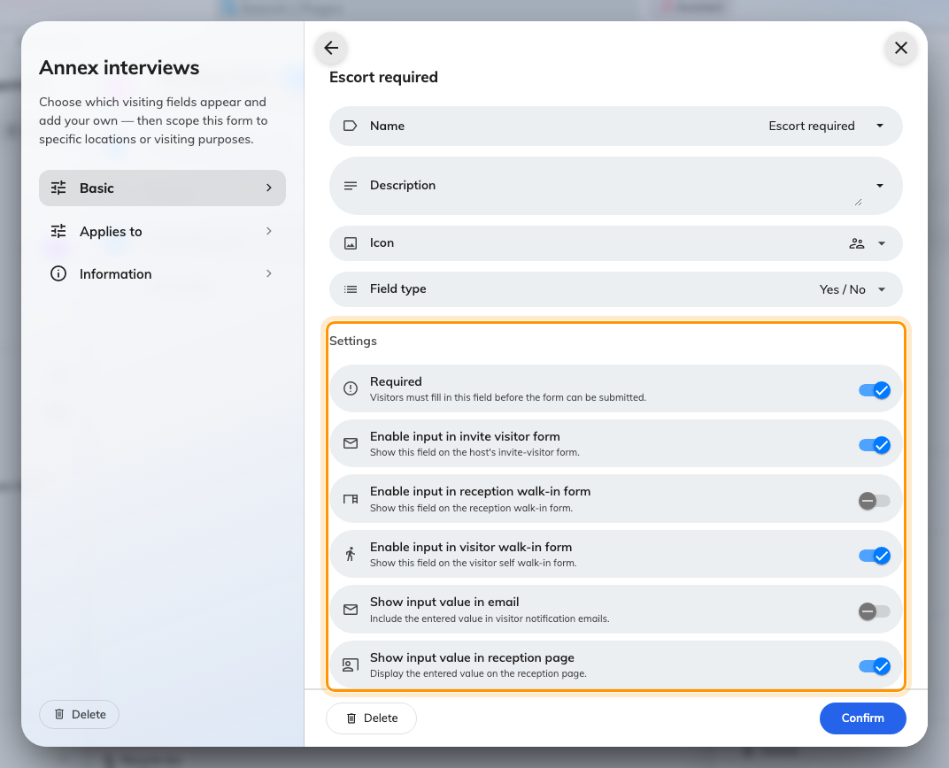
A field's five switches, under its name, icon and type.
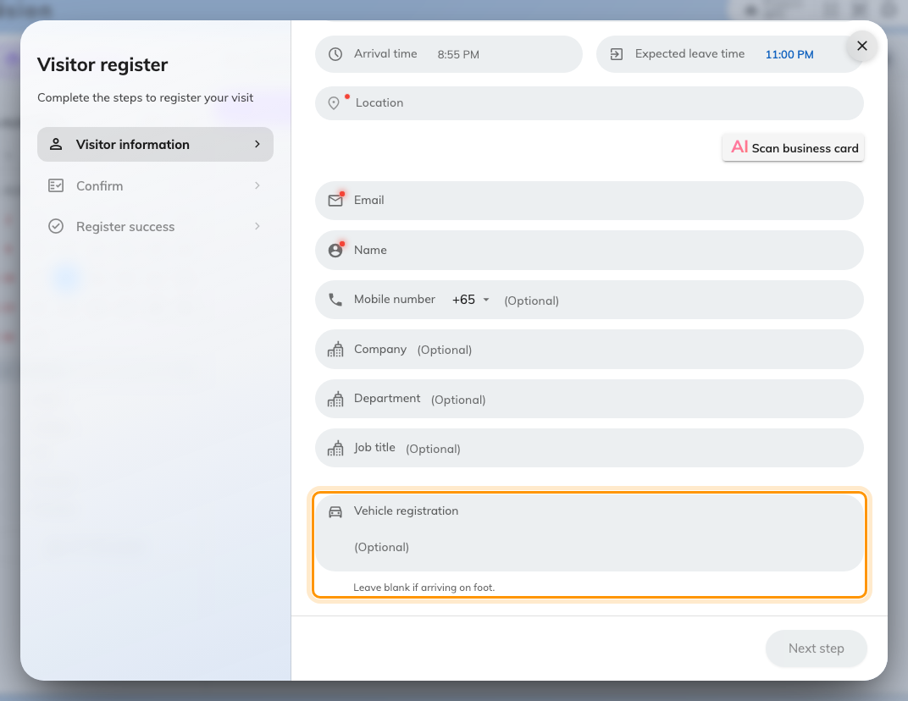
A field with the visitor walk-in switch on, asked at the reception desk.
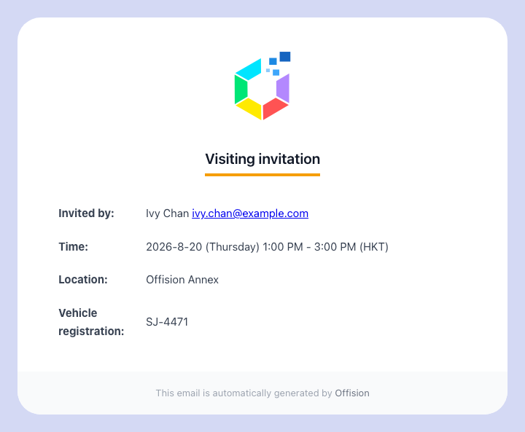
The visiting invitation, carrying a field set to show in email.

Field types
Field type | Accepts
Text | One line of free text
Number | A number. Drops leading zeros and prefixes, so not for identifiers like AB-0042
Rich text | A formatted paragraph
Yes / No | A single switch
Phone number | A telephone number
Date | A calendar date
Time | A time of day
Select | One choice from the options set on the field
Multiple select | Several choices from those options
Autocomplete | One entry from a data set, searched as the person types
Upload file | One file, of the accepted types
Upload multiple file | Several files

There is no combined date-and-time type. A visit that needs both already has
Period.

Data sets
A data set is a reusable list of options that Autocomplete fields read from.
Define it once and every visiting form can use it — which is what separates it
from Select, whose options live on the one field that declares them.
Visiting keeps its own catalogue. A data set built for booking does not appear in
the picker here, and the two never share entries.
Where in Offision: admin app → visiting/visiting-auto-complete (Visiting data set)
Setting | What it does | When to change it
Name | Names the data set in the picker on a field
Entries | The rows themselves
Key | The code stored alongside the answer | Set it to whatever your other system reconciles on. Renaming the display text later then leaves past visits intact
Display text | What the person filling the form reads | Fill it in for every language your site uses
Import from Excel | Loads the rows from a spreadsheet | For any real list — a tenancy register is not worth typing
Export | Writes the rows back out | Take one before a bulk change, so a bad import can be undone

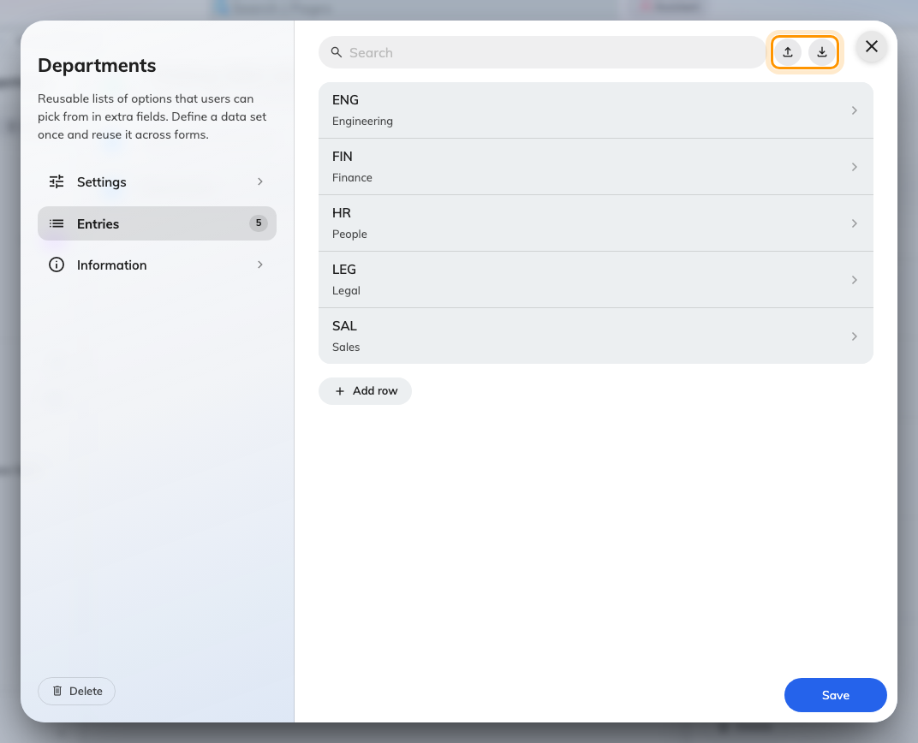
A visiting data set and its entries.

Which form a visit uses
Applies to carries two independent scopes, and a form has to pass both.
Setting | What it does | When to change it
Specify location | Limits the form to certain buildings and rooms | Leave off to apply everywhere. On a multi-site estate, on
Specify visiting purpose | Limits the form to certain visiting purposes | Leave off to apply to every purpose. Turn on for questions only contractors or interviewees should meet

A scope left off matches everything rather than nothing — which is why a form
with both switches off is asked on every visit on the site. And every form that
passes is used: they are merged, not ranked, so a visit that satisfies two
forms is asked everything both of them ask.
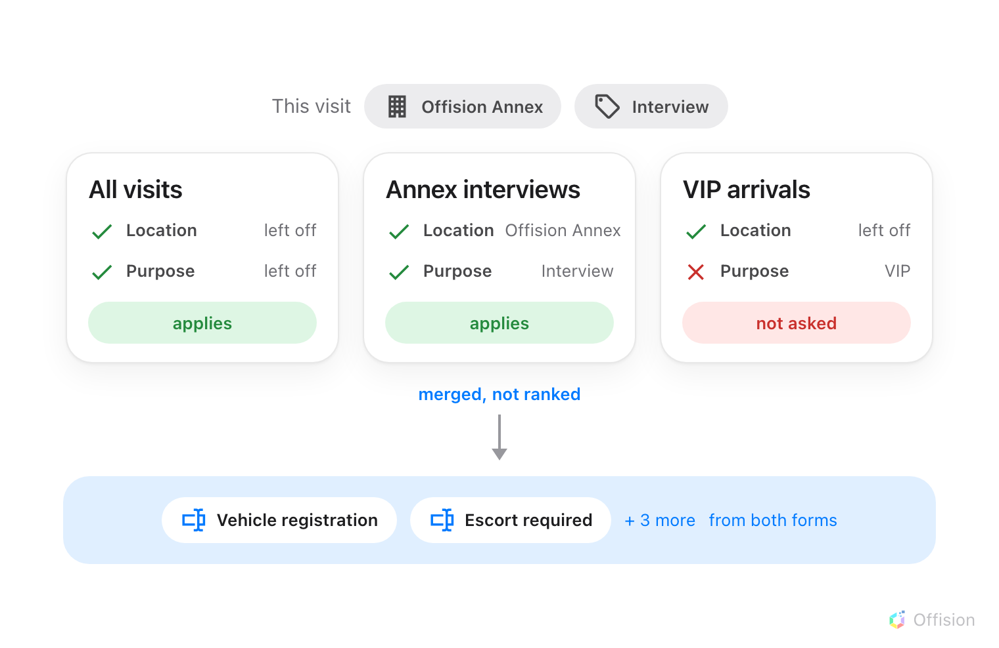
A form applies when both its scopes match or are left off, and everything that applies is merged.
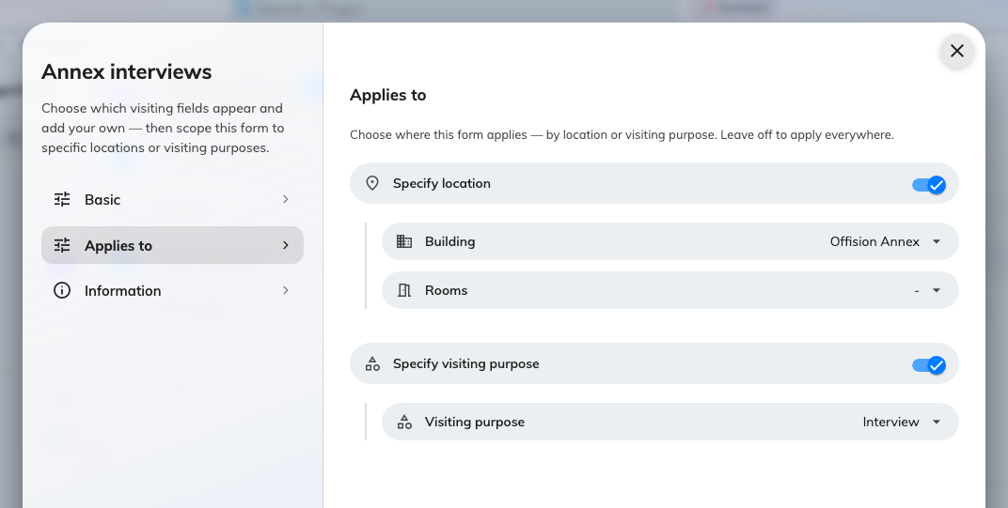
A form scoped to one building and one visiting purpose.
There is no default form and no override. Nothing on a visiting purpose can
replace the form the way a booking purpose can replace a booking form.

What this does not control
- What a visitor is asked about themselves. Name, address, company, photo and
terms belong to the visiting purpose — see
Set up a visiting purpose, where a field can
also be demanded of the host when they invite. This screen asks about the
visit, not the person.
- Visitor attributes. Those are a separate set of fields kept against a
person, on their own screen, and they persist between visits. A field here is
answered once per visit.
- Visitor surveys. A survey is attached to a visiting purpose and answered
after the visit.
- Who may invite anyone at all. Permissions and visiting policies decide that.
- What appears on the badge. That is the badge design, not the form.
- Booking forms. Booking has its own form builder on its own screen, and the
two never share fields or data sets.

