Visiting data set reference
Create a data set, the reusable list of options a visiting form's Autocomplete fields read from — a key, a display text, and an import. Every setting on the screen, and when to use one instead of a Select field.
2026-09-25 · https://offision.com/help/en/visiting/visiting-data-set-reference/
A data set is a reusable list of options that Autocomplete fields on a
visiting form read from. Define it once and every visiting form can use it —
which is what separates it from Select, whose options live on the one field
that declares them.
Reach for a data set when the list is long enough that scrolling a Select is
a chore, when more than one field asks the same question, or when the answers
have to reconcile with a code another system already uses.
Where in Offision: admin app → visiting/visiting-auto-complete (Visiting data set)

Every setting
Setting | What it does | When to change it
Name | Names the data set in the picker on a field | Name it after the list, not after the field that first needed it
Entries | The rows themselves
Key | The code stored alongside the answer | Set it to whatever your other system reconciles on. Renaming the display text later then leaves past visits intact
Display text | What the person filling the form reads | Fill it in for every language your site uses — text given only in English renders in English on a Japanese screen
Import from Excel | Loads the rows from a spreadsheet | For any real list — a tenancy register is not worth typing
Export | Writes the rows back out | Take one before a bulk change, so a bad import can be undone
Select, Delete, Delete all | A tick on each row, with Shift-click for a range and a box to tick them all; Delete removes the ticked rows and Delete all empties the list. Nothing is removed until the data set is saved | For clearing out stale entries, or emptying the list before a fresh import

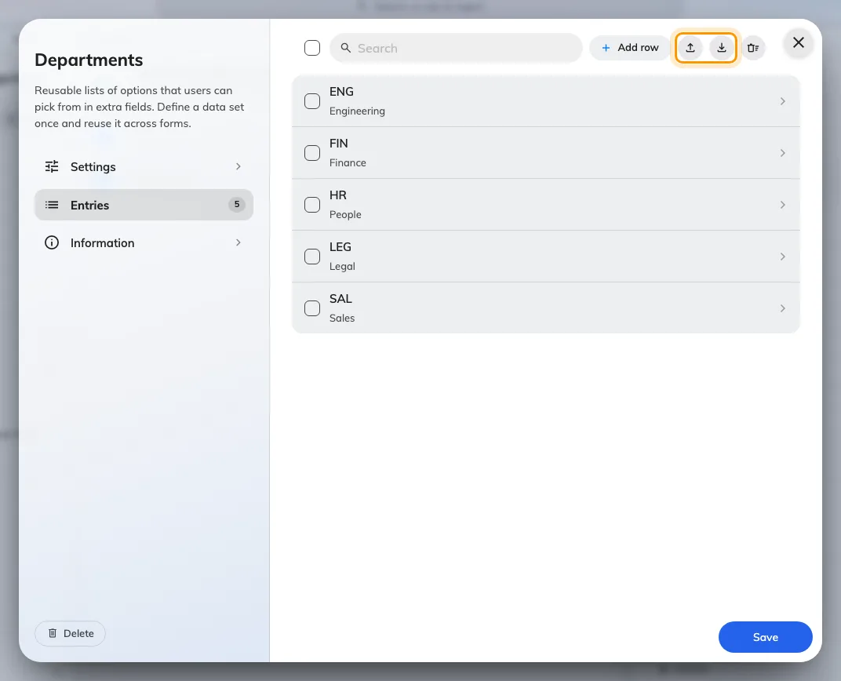
A visiting data set and its entries. Import and Export are the two icon buttons above the list.

What this does not control
- Which fields use it. A data set is offered to a field only once that field's
type is Autocomplete — see
Visiting form reference.
- Booking's data sets. Visiting keeps its own catalogue. A set built for
booking does not appear in the picker here, and the two never share entries.
- Visitor attributes. Those are a separate set of fields kept against a
person, on their own screen.

