The Apple and Google wallet pass
A visitor's badge can travel as a pass in Apple Wallet or Google Wallet. This explains what the pass carries, where the download buttons appear, and which settings switch it on and brand it.
2026-08-19 · https://offision.com/help/en/visiting/the-apple-and-google-wallet-pass/
A visitor pass is the visitor's badge as a card in the wallet app their phone
already has — Apple Wallet on an iPhone, Google Wallet on Android. It carries the
same QR code as the badge, so a visitor who saved it checks in at reception the
same way, from their lock screen, with nothing to install and nothing to search
for.
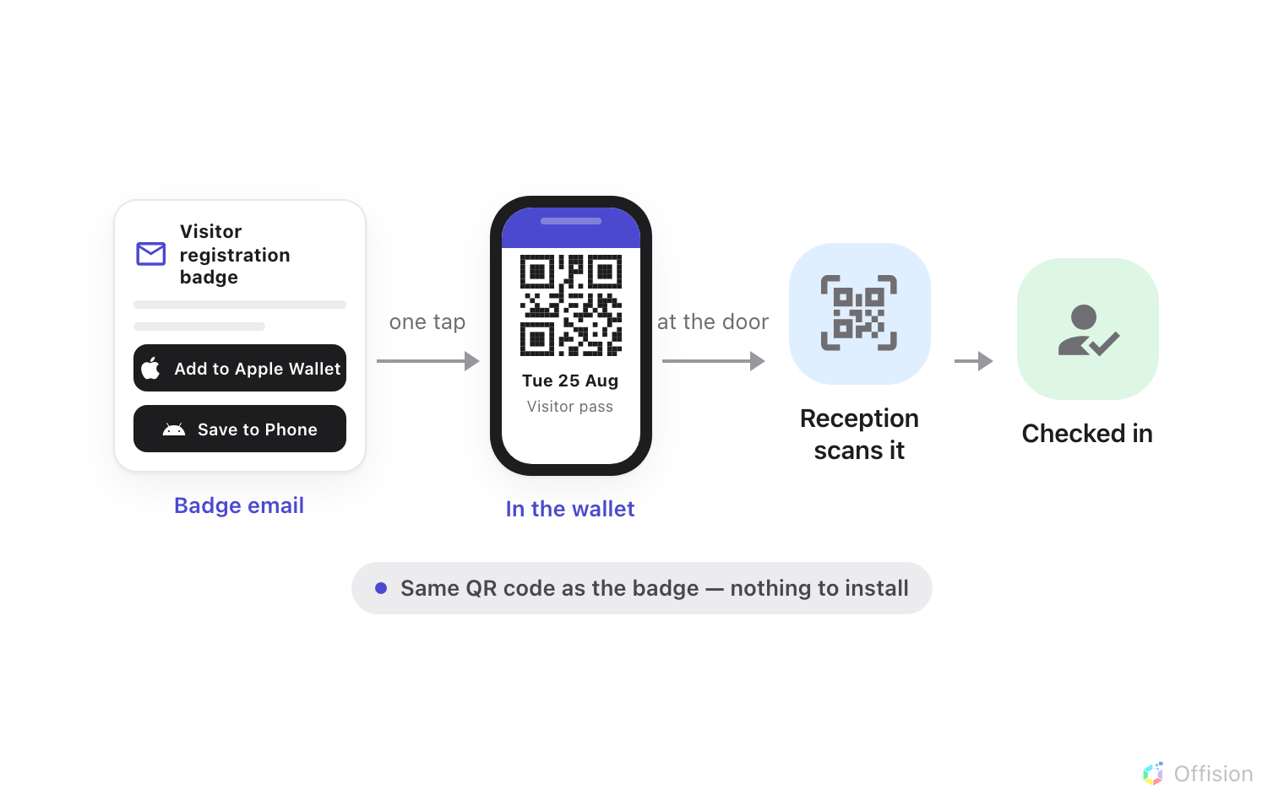
The pass rides in with the badge email; one tap puts it in the wallet, and reception scans it like any badge.
The pass is created together with the badge — when the visit is saved, not when
the visitor arrives — so it is already in the email that invites them.

Where the download buttons are
In the badge email. Both buttons — Add to Apple Wallet and Save to
Phone for Google Wallet — sit stacked in the middle of the badge email, above
the visitor code. An email cannot tell what phone will open it, so it always
offers both.
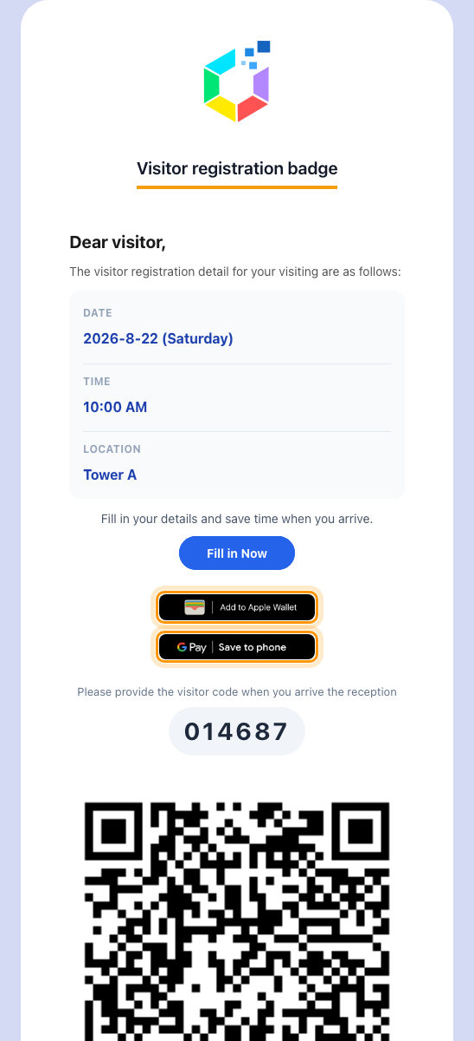
The badge email, with both wallet buttons above the visitor code.
On the visitor's badge page. The web page a visitor opens from that email
does know the device, so it shows one button, under the QR code: Apple's on an
iPhone, Google's on Android. On a computer neither appears — the page offers
Save visitor badge, which downloads the badge as an image instead. The same
buttons appear on the confirmation screens of pre-registration and self
check-in.
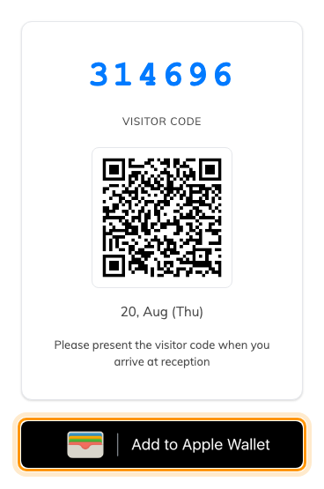
The badge page on an iPhone, with the wallet button under the QR code.

What the pass carries
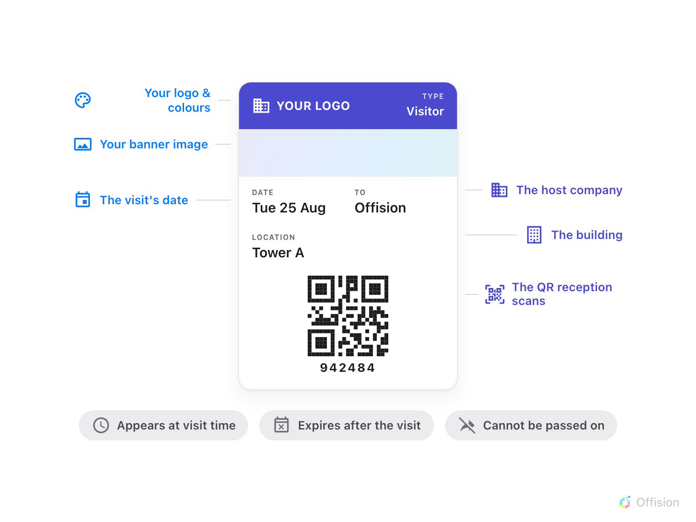
One card: your branding, the visit's details, and the QR code reception scans.
Beyond what is printed on it, the pass knows when it is for. It surfaces on the
phone around the visit's start, and it expires on its own when the visit ends —
a visitor cannot check in next month with last month's card. An Apple pass also
refuses to be shared on to another phone.

Why it beats keeping the email
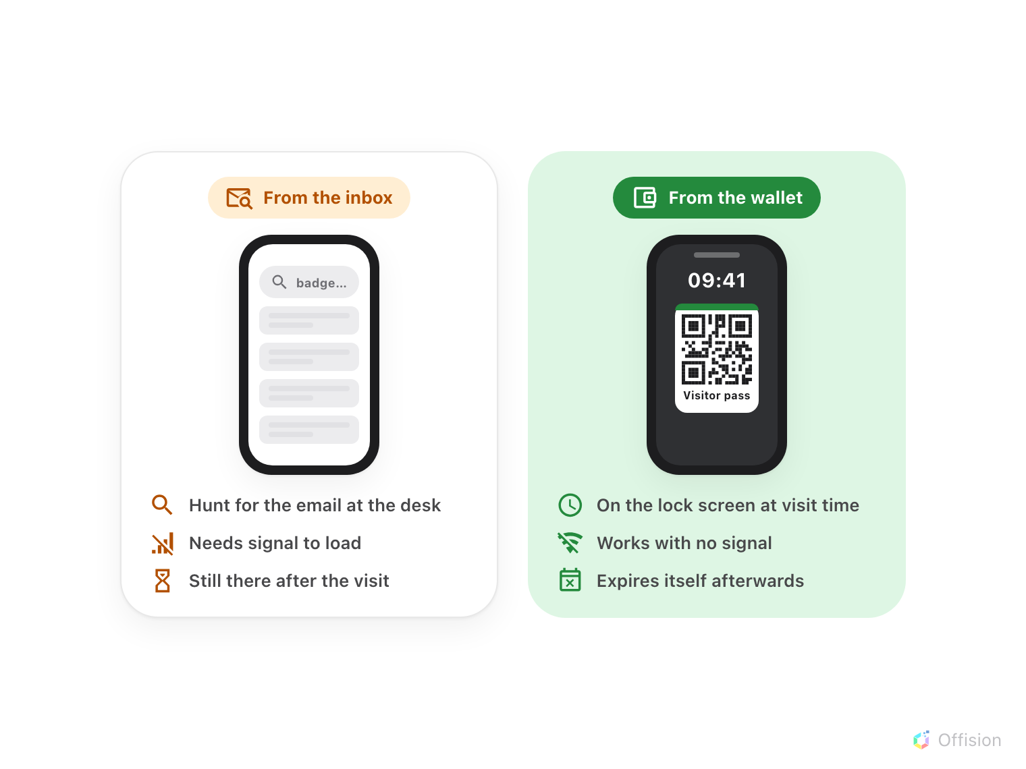
The same visitor, arriving twice: hunting the inbox for a QR code, or lifting a phone that already shows it.
The email still works — the pass is the faster copy of it. It opens from the
lock screen without signal, it is on screen at the moment the visitor walks in,
and it cleans itself up when the visit is over.

Turning it on and branding it
The pass has one switch and one artwork set, on the Apple pass / Google pass
settings page. Enable visitor pass attaches the pass to every badge email
from then on; nothing else is required.
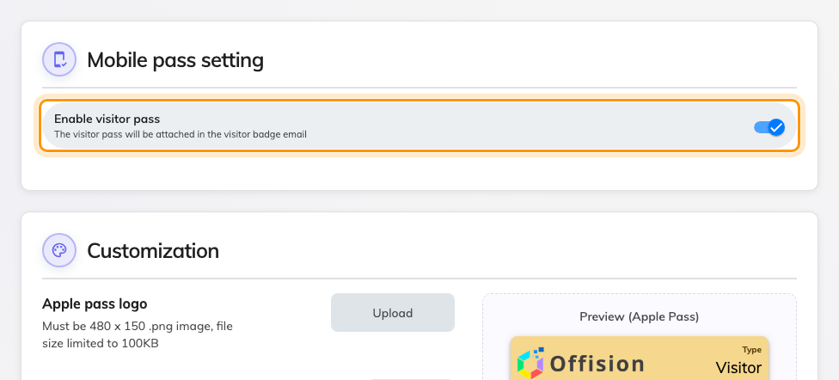
The switch. Turning it on reveals the customization card below.
Customization sets what the card looks like in the wallet: the Apple pass
logo (480 × 150), the Google pass logo (512 × 512), the Banner image
(1125 × 294), and the pass background, text and label colours. A live preview
of both passes sits beside the fields, and Send testing email
mails you a real pass to try on your own phone before any visitor sees one.
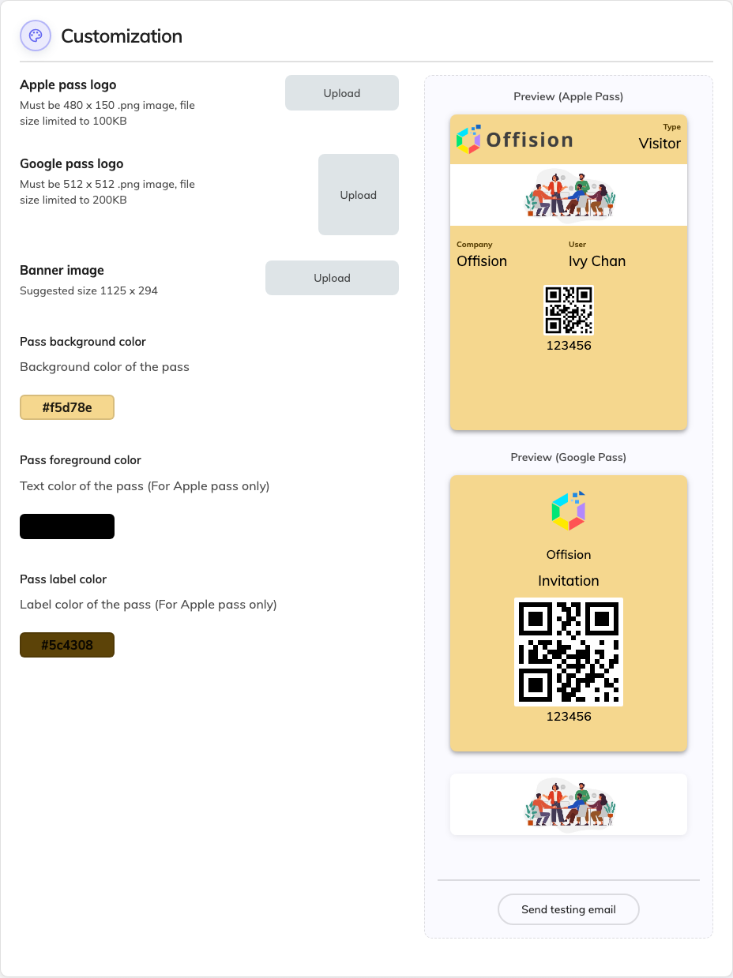
Customization: logos, banner and colours, with a live preview of both passes.
Where in Offision: admin app → visiting/mobile-pass (Apple pass / Google pass)

What this does not control
- The printed badge. Its layout comes from the visitor label design, not
from here — see What appears on a visitor badge.
- The badge page. The web page has its own fixed layout; this artwork only
dresses the wallet card.
- Locations that hide the QR code. A visiting policy that hides the QR code
suppresses the pass entirely for that location — a pass without its barcode
would have nothing to scan.
- Event passes. Passes for event registrations have their own switch and
their own artwork, under the events module.
- Long-term badges. Contractors' badges carry a pass of their own kind — see
Give a contractor a long-term badge.

