Show or hide the visitor code
The visiting policy can remove the QR code or the six-digit visitor code from everything the visitor receives — but the code only hides on badges whose code came from an external system, and every location on the visit must agree.
2026-09-02 · https://offision.com/help/en/visiting/show-or-hide-the-visitor-code/
A visitor's badge carries two credentials: the QR code reception scans, and the
six-digit visitor code they can read out at the desk. Two settings decide which
of the two the visitor actually sees — on the badge email and text message, the
printed badge, the wallet pass, and the badge page on their phone.
Both live on the Visiting policy attached to the location, in the visitor
badge group on its Others page. They are per location: a policy governs
the buildings and floors it is attached to, and nothing else.
Where in Offision: admin app → visiting/visiting-policy (Visiting policy)
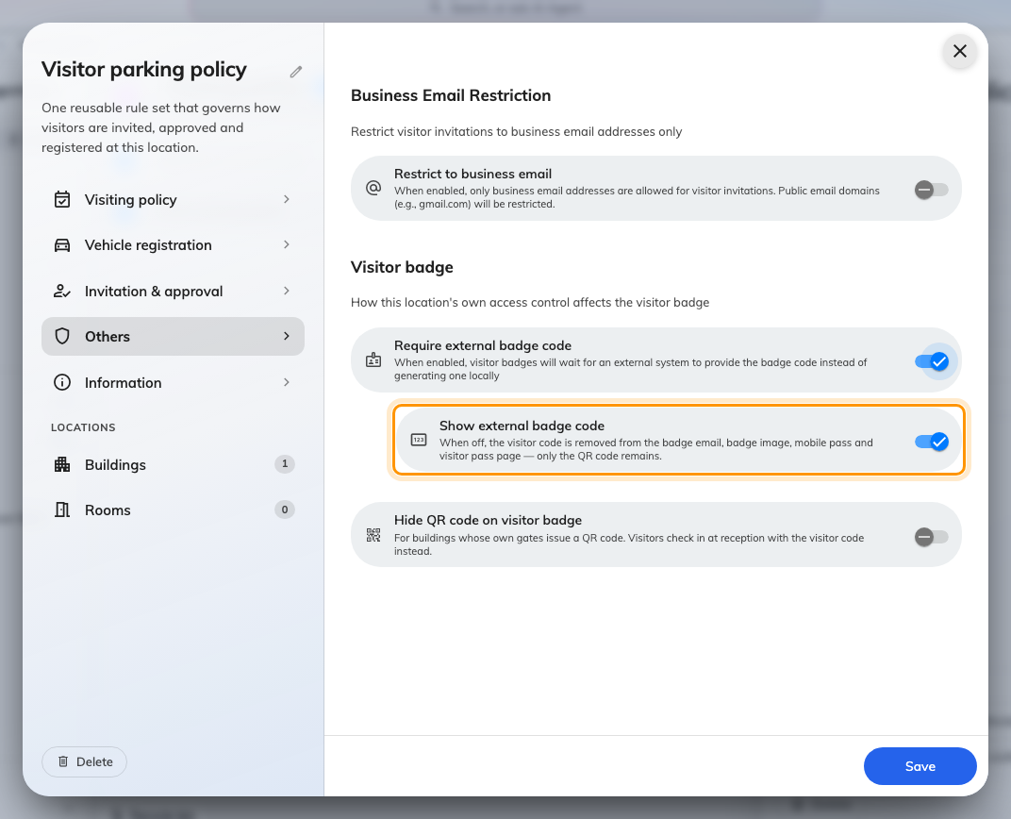
The visitor badge group on a policy's Others page. Show external badge code appears once Require external badge code is on.

Hiding the QR code
Hide QR code on visitor badge removes the QR from everything the visitor
receives. It exists for buildings whose own gates issue a QR of their own — two
codes on one badge and visitors present the wrong one. The visitor checks in at
reception with the visitor code instead.

Hiding the visitor code
Show external badge code, turned off, removes the code the same way and
leaves only the QR. But it is a sub-setting of Require external badge code,
and that is the part that catches people out: it only applies to badges whose
code was issued by your own visitor management system — see
Let your own system issue the visitor badge code.
An Offision-generated code cannot be hidden. On an ordinary badge the six
digits are the check-in credential — the QR encodes a badge id reception
cannot read out — so removing them would leave the visitor with nothing to say
at the desk. The toggle does not even appear on the policy form until
Require external badge code is on, and a value saved earlier has no effect
while it is off.
Note:
Do not turn on Require external badge code just to hide the code. From that
moment every badge at the location waits, unsent, for an external system to
supply its code — with no integration, no badge email goes out at all.
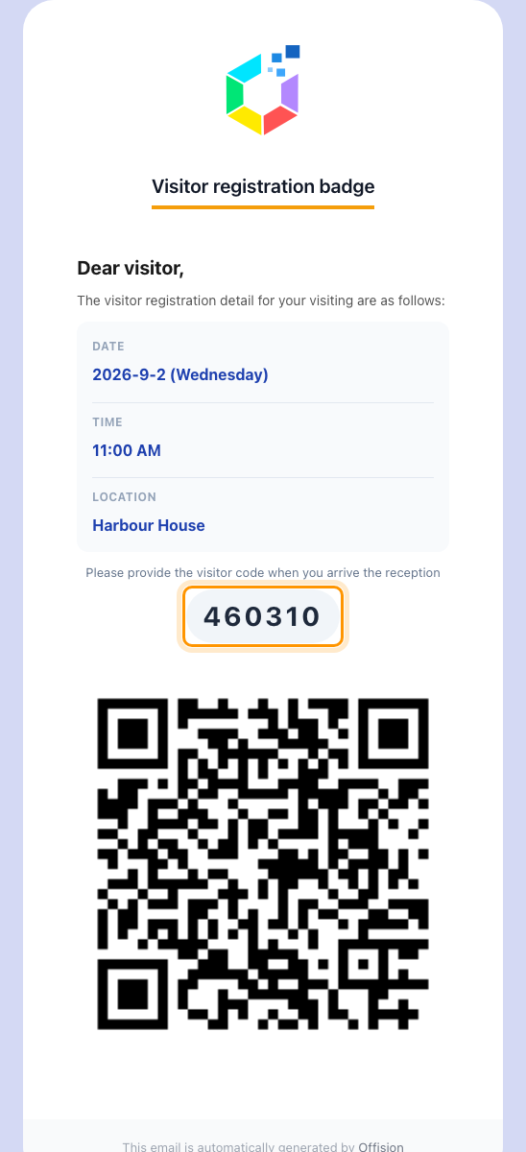
The badge email as most visitors get it: the visitor code, then the QR.
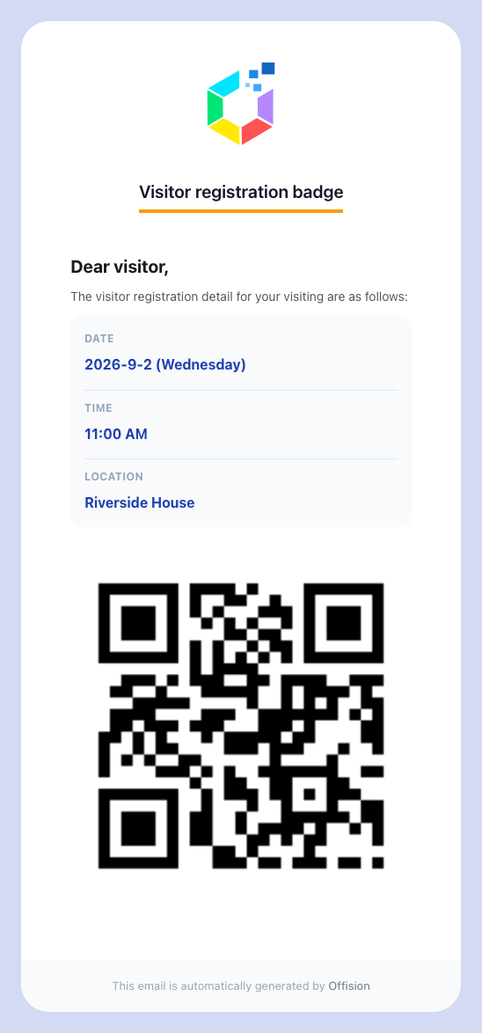
The same email with Show external badge code off: QR only.

Every location must agree
A visit can span buildings, and one badge covers all of them. The code — or the
QR — disappears only when every location on the visit says so: each one
governed by a policy, and every one of those policies opted out. One location
with no policy, or one whose policy still shows the code, keeps it on the whole
badge.
One thing can never happen: a badge with neither credential. If the two
settings between them would remove both, the code stays.

If the code still shows
- Require external badge code is off on the policy — the usual cause. The
code is Offision's own, and an Offision-generated code always shows.
- Another location on the visit is not opted out, or has no visiting policy
at all.
These settings change what the visitor sees. Reception still sees the code on
the visit record, and a hidden code also stops the visitor's lost-code resend —
there is nothing to resend.

