Put visitors on a secured WPA-Enterprise network
Create a Visitor WiFi entry for Cisco Meraki, UniFi, TP-Link, Ruckus or any standard access point, point the access point at Offision's RADIUS server, and have visitors join with the username and password on their badge.
2026-08-20 · https://offision.com/help/en/visiting/set-up-radius-visitor-wifi/
Before you start:
You need admin access to your WiFi controller, a Visitor WiFi Integration
license for the network, and access points that can reach Offision's RADIUS
server — UDP port 1812, or RadSec over TCP 2083.
Done looks like this: a test visitor checks in, joins your guest SSID with the
username and password on their badge, and is refused after checking out.

1. Add the network entry
Open Visitor WiFi, choose Add, and pick the brand that matches your
controller from the menu — Cisco, Ruckus, TP-Link, Unifi, or
Generic for any standard RADIUS access point. The brand cannot be changed
after the entry is created.
Where in Offision: admin app → visiting/visitor-wifi (Visitor WiFi)
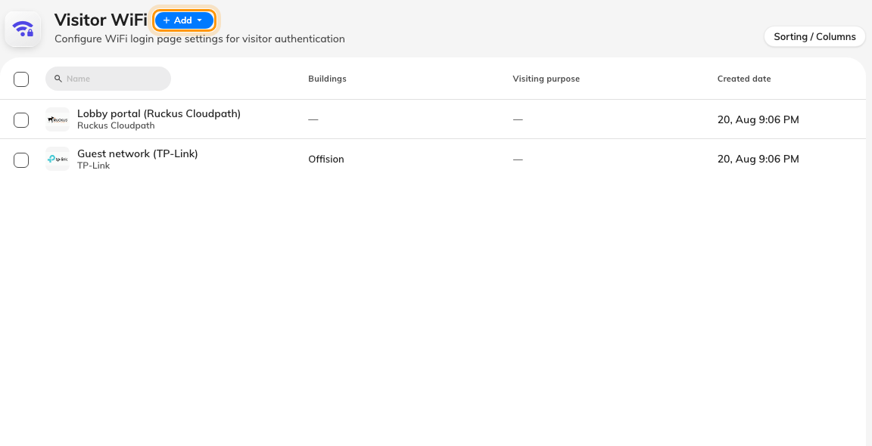
The Visitor WiFi page — one row per guest network.
The Marketplace also carries a tile per vendor under Visitor WiFi; a tile
opens this same list with the brand already chosen.
Note:
Picking a brand creates the entry immediately, so its RADIUS values exist from
the start. Closing the dialog without saving leaves the entry in the list —
rename it, or delete it.

2. Fill in the Basic page
Name the entry, decide the sign-in rules — Username type and
Password type — and, if this network is for one site only, link its
buildings.
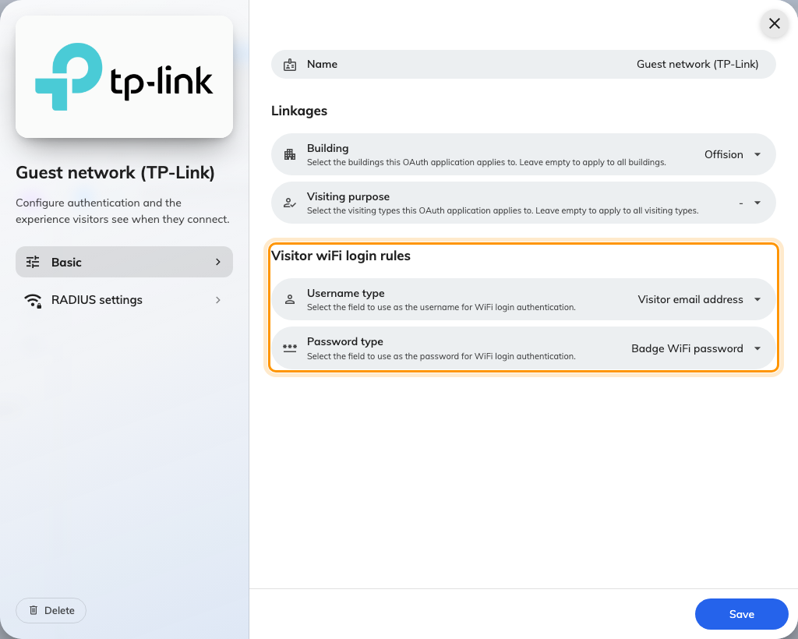
A RADIUS entry's Basic page — the sign-in rules, and no network-name field.
Every field is explained in
the settings reference. There is no
network-name field on this page: a secured network is named on your controller,
and its security comes from the per-visitor sign-in, not a shared password.

3. Copy the RADIUS values into your controller
Open RADIUS settings, the second page of the dialog. Everything on it is
generated for you: Host IP or FQDN, Auth port, Secret, and the
NAS identifier.
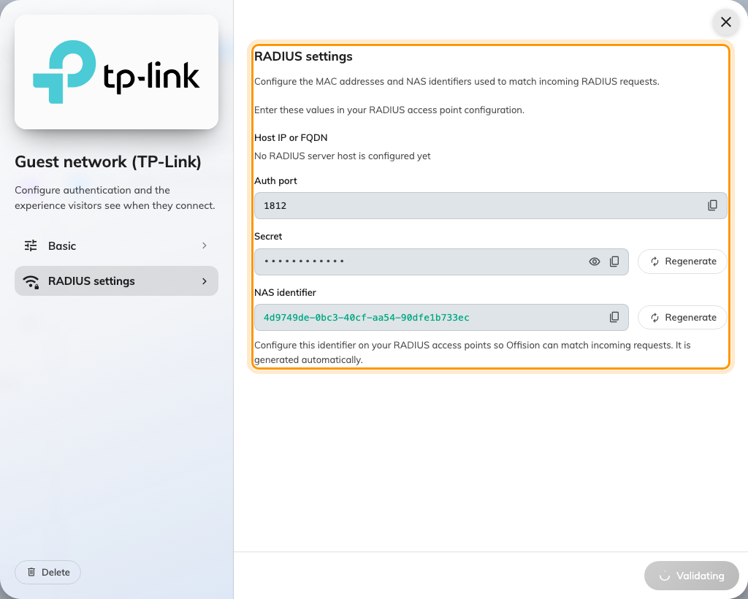
The RADIUS settings page — values to copy into the controller.
Two brands differ:
- Unifi authenticates by access point instead: enter your access points'
MAC addresses, one per line, rather than a NAS identifier.
- Cisco shows the same values arranged as a step-by-step Meraki guide.

4. Create the SSID on your controller
On the controller, create a WPA-Enterprise (802.1X) guest SSID pointing at the
values from step 3. Offision's RADIUS server answers PAP, EAP-TTLS/PAP and
PEAP/MSCHAPv2 — the methods phones and laptops use out of the box.

5. Check it worked
Invite yourself, check in at reception, and join the SSID with the username and
password printed on your badge. Then check out — and confirm the same details
are now refused. Both results matter: the second one is the security story.

When it goes wrong
What you see | Usual cause
Sign-in refused for a real visitor | They have not checked in yet, or their visit period has ended
Every sign-in refused | The entry has no Visitor WiFi Integration license, or the controller's shared secret no longer matches — regenerating the Secret without updating the controller does this
The controller never reaches Offision | The NAS identifier (or a Unifi MAC address) is missing or mistyped on the access points, so requests cannot be matched to the entry
The badge prints no WiFi details | Expected for RADIUS brands — see what the badge can print

