Set up a visiting purpose
A visiting purpose is the form every visitor meets — which details are asked for, whether a photo is taken, which terms and surveys they answer, and the key their record is stored under. About fifteen minutes.
2026-09-01 · https://offision.com/help/en/visiting/set-up-a-visiting-purpose/
A visiting purpose is the reason someone is coming, and it carries the form that
comes with that reason. An interview, a delivery and a contractor visit are the
same mechanism asked different questions: the purpose decides which details are
collected, whether a photo is taken, which terms have to be agreed to, which
surveys are answered, and which of those a visitor may leave blank.
It is chosen once — by the employee sending the invitation, or by the
receptionist registering a walk-in — and everything downstream reads from it.
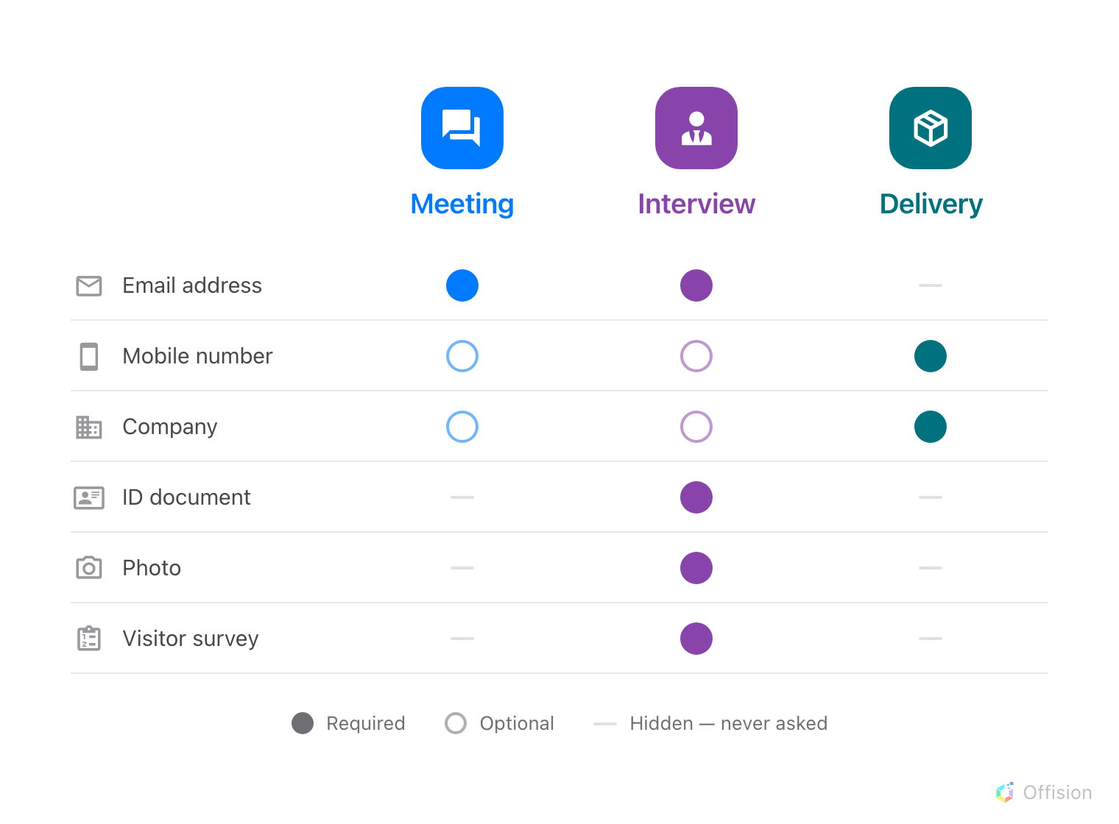
One mechanism, three sets of questions. Every purpose starts from the same list and decides which of it to ask for, and how insistently.
Before you start:
You need write access to Visitor Management. Every organisation already has
Meeting, VIP and Interview, with Meeting marked Default, so this
is usually a matter of adjusting one rather than starting from nothing.

1. Open Visiting purpose
It is under Invite visitor settings in the Visitor Management menu, beside
Visiting form, Visitor attributes and Visitor survey.
The list shows each purpose with its Required fields and Optional fields
spelled out, and the surveys attached to it — enough to compare two purposes
without opening either. One row carries a Default badge: that is the purpose
pre-selected on every invitation and every walk-in.
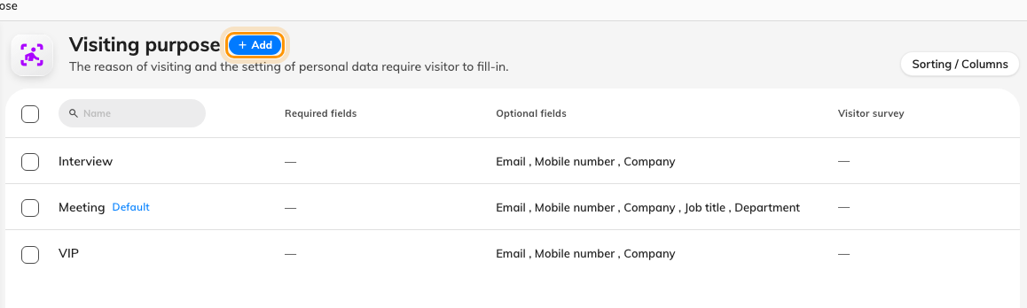
The purposes on this tenant, with what each one asks for shown on the row.
Where in Offision: admin app → visiting/visiting-type (Visiting purpose)

2. Name it
Add opens the editor on Basic information. Name is what an employee
picks from when they invite someone, so name it for the visit rather than for
the paperwork — Contractor, not Photo and ID required. It is multilingual:
fill in every language your organisation uses, because a name left blank in one
language silently falls back to the primary one.
Two fields underneath are optional and easy to skip on purpose:
- Scope — the organization unit that owns this purpose. Present only where
organization units are enabled.
- Access ID — a stable short code so a spreadsheet import can name this
purpose. Leave it blank if visits of this kind are never imported. It has to
be unique across the whole organisation, and a duplicate is refused on save.

3. Confirm the key visitors are stored under
A new purpose starts on Email address, and for most organisations that is
the right answer. This key decides whether the person at the desk today is the
same record as last month — so if visitors here arrive without a work address,
or an outside number already identifies them, change it before the first visit.
It is one setting worth reading about first:
How Offision knows two visits are the same person.

4. Choose which details to ask for
Visitor fields is the form itself. Every row carries one requirement, and
this is what an invited visitor, a walk-in at the desk and someone registering
at a lobby screen all see:
- Required when inviting — the employee sending the invitation has to supply
it as well, not only the visitor.
- Required — the visitor cannot finish without it. The page says as much
above the list: Required applies when the visitor fills in the form.
- Optional — asked for, may be left blank.
- Hidden — never asked for, and never stored.
Only Email address, Mobile number and Company offer that top rung.
Every other row has three values, because the invite panel gives a host nowhere
to type a job title or an ID document — demanding one there would block the
invitation over a detail only the visitor can supply.
Field | On a new purpose
Email address | Optional
Mobile number | Optional
Company | Optional
Job title | Optional
Department | Optional
Phone number | Hidden
Address | Hidden
ID document | Hidden
Photo | Hidden

The row for the field your identity key is stored under is fixed at Required
when inviting and cannot be moved, captioned Identity key — always asked for
when inviting: a visitor record cannot be created without its key, so every
form already holds that field to it.
Three settings on this page are not requirements at all:
- Separate first and last name splits the visitor's name into two inputs
instead of one. On by default.
- Reception can view the photo appears only once Photo is not Hidden.
Turned off, the photo is still captured and still printed on the badge, but
reception staff cannot open it.
- Custom attributes lists whatever extra visitor fields your organisation has
defined, each with the same three lower values and each starting Hidden. Add or
rename them on Visitor attributes; this page only decides whether this
purpose asks for them.
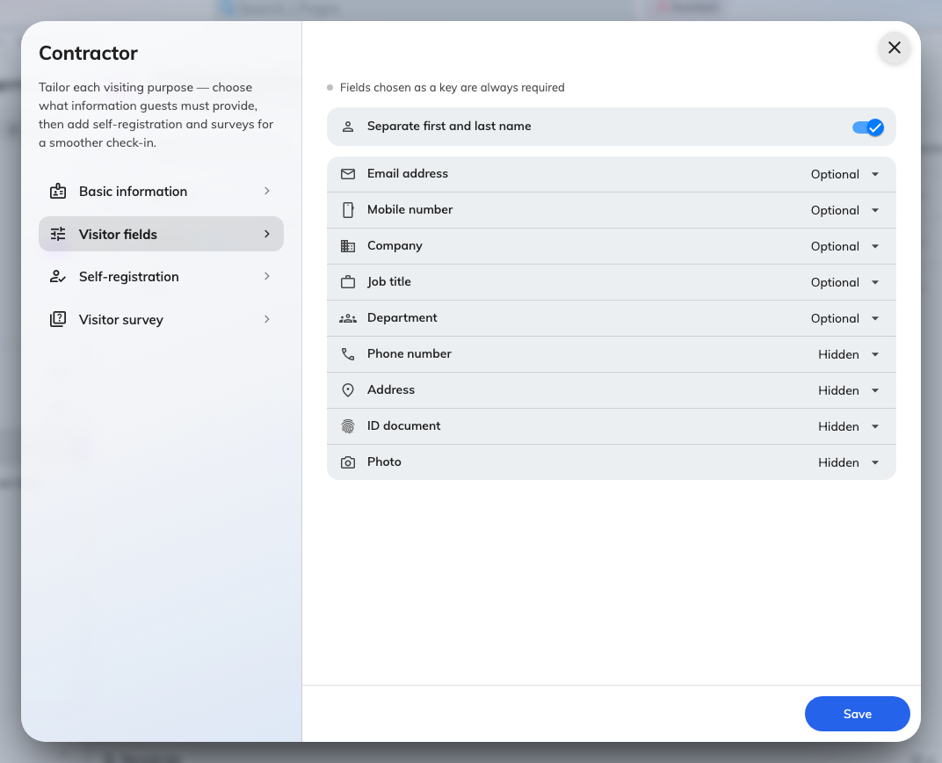
Visitor fields, with the requirement of each one on the right.
Where in Offision: admin app → visiting/visitor-attribute (Visitor attributes)

5. Add terms, if this purpose needs them
Self-registration carries two separate bodies of text, and they are shown at
different moments:
- Visitor self-registration terms — shown to someone registering themselves
on arrival, at a lobby screen or at the desk.
- Visitor pre-registration terms — shown to an invited visitor filling in
their own details before the day.
Each has its own Terms and conditions / Message editor and its own Require scrolling
to the end, which is on for a new purpose: the visitor cannot agree until they
have reached the bottom. Leave a toggle off and nothing is shown at all.
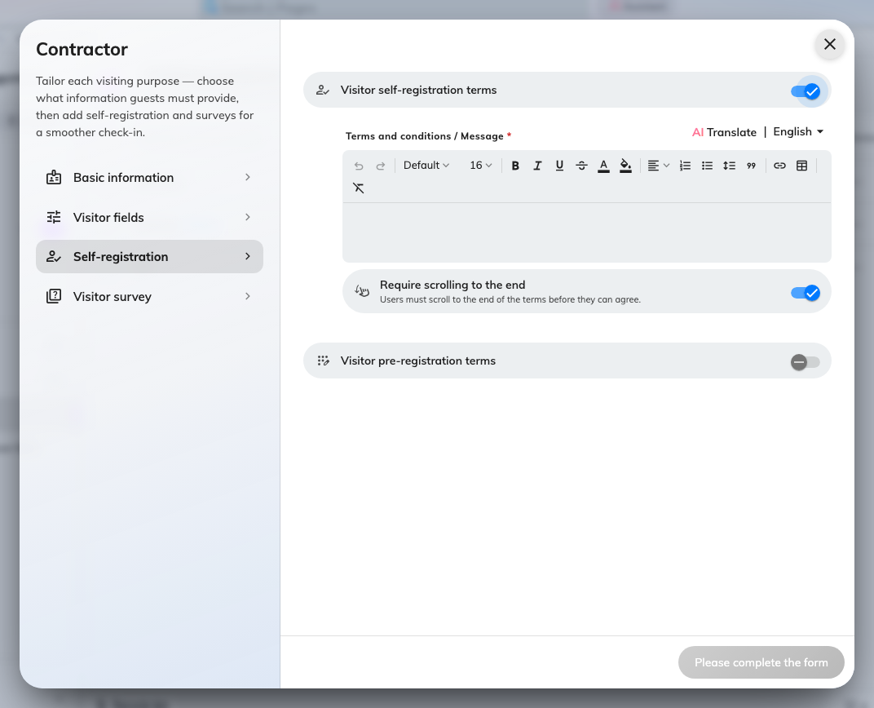
Self-registration terms switched on, with the editor and the scroll rule underneath.

6. Attach any surveys
Visitor survey is a tick list of the questionnaires already written for your
organisation — a health declaration, a site-safety question, an NDA. Each one
you tick becomes a step the visitor has to answer, in the invitation flow and at
the desk alike.
No visitor surveys means none have been written yet; they are created on
their own page, not here.
Where in Offision: admin app → visiting/visitor-survey (Visitor survey)

7. Save
Save closes the editor and the purpose is live immediately — it appears on the
next invitation anybody opens.
Selecting the row afterwards opens a panel with the rest of the actions on it:
making this the default purpose, copying it, and what happens to upcoming
visits when one is deleted.

8. Check it worked
Invite somebody using the new purpose, or open reception's walk-in form and pick
it. The fields you marked Required should be the ones marked as unskippable, the
photo step should appear only if you asked for one, and each survey you ticked
should be a step of its own.
If a field you set to Required is not being asked for, check that you edited the
purpose the form actually selected — the default is chosen for you, and it is
easy to configure one purpose and test another.

What a visiting purpose does not control
Nearly everything people look for here and cannot find is on the visiting
policy instead, which is attached per location rather than per purpose. The
split is deliberate: what a visitor is asked for should not change between
buildings, and what a building allows should not change with the reason for the
visit.
What you are looking for | Where it is
Whether a visit has to be approved before a badge is issued | Visiting policy
How far ahead visits may be booked, and how long they may last | Visiting policy
All-day, cross-day and recurring visits | Visiting policy
Emailing the host on invitation, on arrival, on a walk-in arrival | Visiting policy
Restricting who may invite, or which email domains are accepted | Visiting policy
Whether visitors may register a vehicle | Visiting policy
Hiding the QR code on the badge, or taking the badge code from another system | Visiting policy
Which fields the employee fills in about the visit itself | Visiting form
What the printed badge looks like | Visitor badge settings — one design for the whole organisation

Where in Offision: admin app → visiting/visiting-policy (Visiting policy)
A badge covering several purposes:
Where one visitor badge spans visits with different purposes — the same person
here twice in a day for two different reasons — the requirements are merged and
the stricter one wins. A photo hidden from reception on either purpose stays
hidden, and the identity key is only applied where every purpose involved agrees
on it.

