Require approval before a visitor is invited
A visit that needs approving reaches the guest as nothing at all until somebody decides. Where the approver is named, what they see, and what the host and the guest are each told.
2026-09-04 · https://offision.com/help/en/visiting/require-approval-before-a-visitor-is-invited/
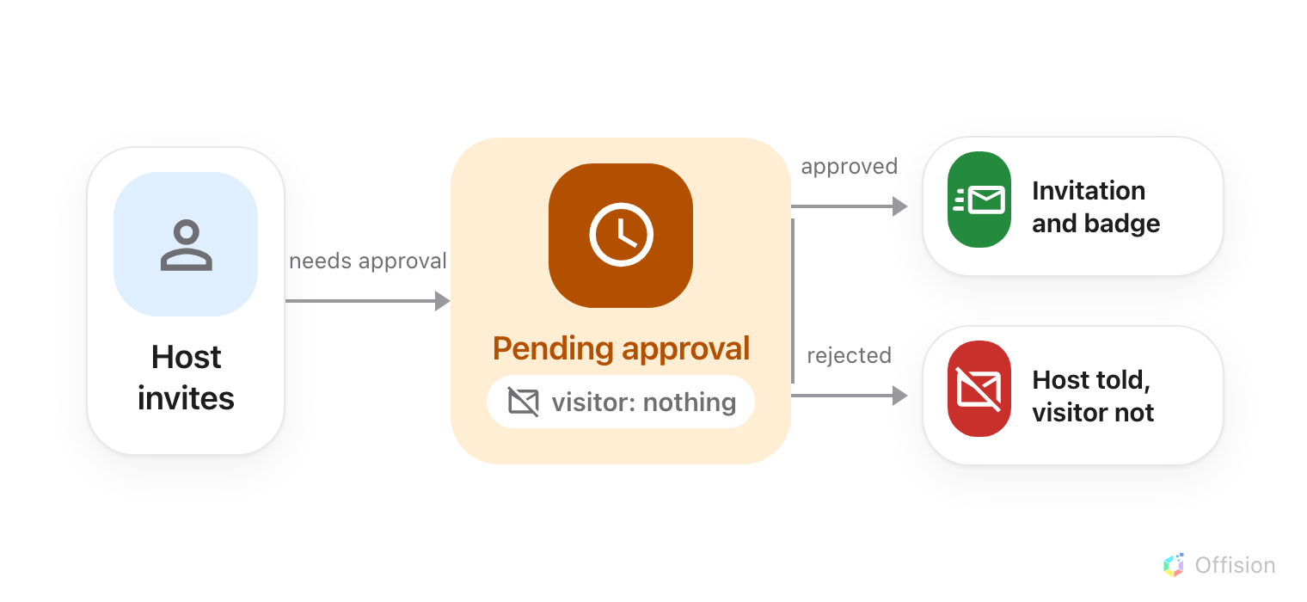
Until somebody decides, the guest gets no email, no badge and no code. A rejection reaches the host only.
Before you start:
You need write access to Visitor Management, and the building or room must
already be on a visiting policy. Approval is a policy setting — there is no
switch on the room itself, and none on the visiting purpose.

1. Work out which policy the visit will use
A visiting policy is attached to a building, a floor or a room, and
the most specific one wins: a room's own policy beats its floor's, which beats
its building's. Turning approval on at the building therefore covers everything
under it, which is usually what you want.
Two consequences are worth knowing before you choose where to put it:
- A visit that touches more than one location needs approving if any one of
those locations requires it.
- Every approver on every policy involved is emailed, and any one of them
decides for the whole visit. There are no approval levels and no second
signature.
Where in Offision: admin app → visiting/visiting-policy (Visiting policy)

2. Open Invitation & approval
Select the policy and open it for editing. Its settings are split into pages down
the left — Visiting policy, Vehicle registration, Invitation &
approval, Others — and approval is the third. The policy's name is the
title above them rather than a field on a page of its own.
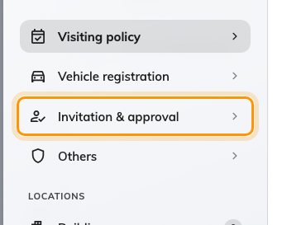
Invitation and approval, the third page of the policy.

3. Turn it on
Turn on Visitor approval and the approver field appears underneath it; until
then there is nothing to configure. The page carries more than approval now —
who may invite a visitor at all, and which organisation unit their invitations
belong to — described in
the visitor invitation settings.
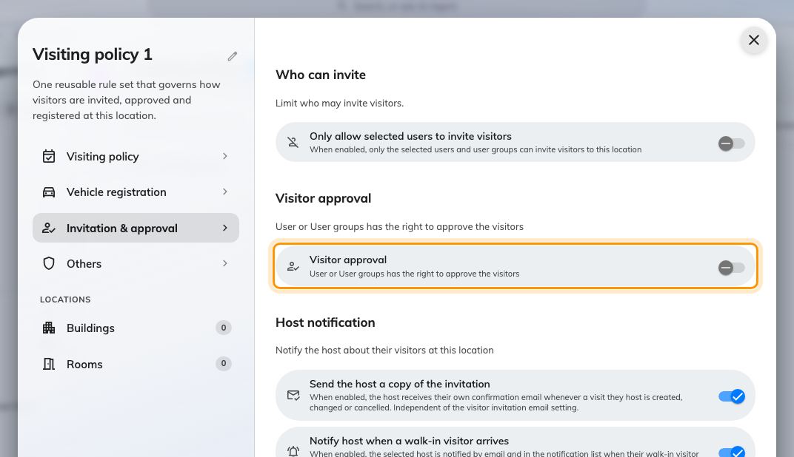
One switch. The rest of the page appears only once it is on.

4. Name the approvers
Visitor approval user(s) or user group(s) is who gets asked. It takes people
and user groups together, and everyone named is emailed about every visit the
policy covers.
Name a user group rather than individuals wherever one exists. Approval named
on a person fails silently the day they change role, and there is nothing to
catch it: a visitor request has no deadline, so it does not bounce and does not
expire. The invitation simply never goes out, and the host is left assuming it
did.
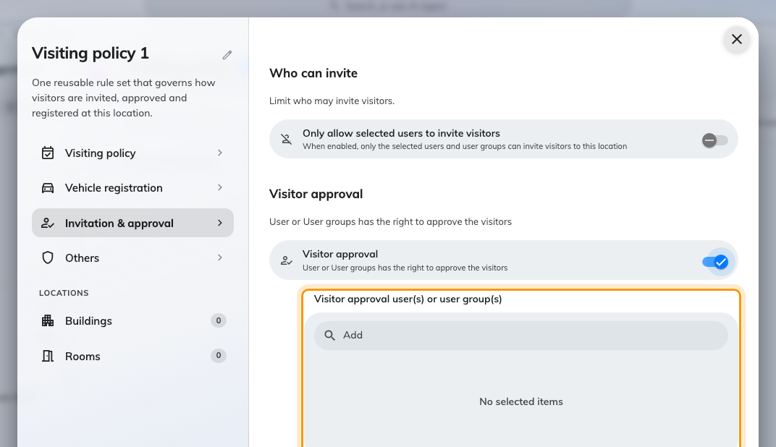
Approvers for this policy. Prefer a user group over named people.
Save the policy. It applies to the next invitation anybody creates.

5. What the approver gets
Two things reach them, and both end up on the same screen.
- An email, Visiting approval request. It carries a link that opens the
request in the app — there are no approve and reject buttons in the message
itself.
- A Visitor approval page in the app, carrying a count of what is waiting.
That page exists only for someone named on a policy. A colleague who cannot
find it has not been named on one, and that is the first thing to check when
requests appear to be reaching nobody.
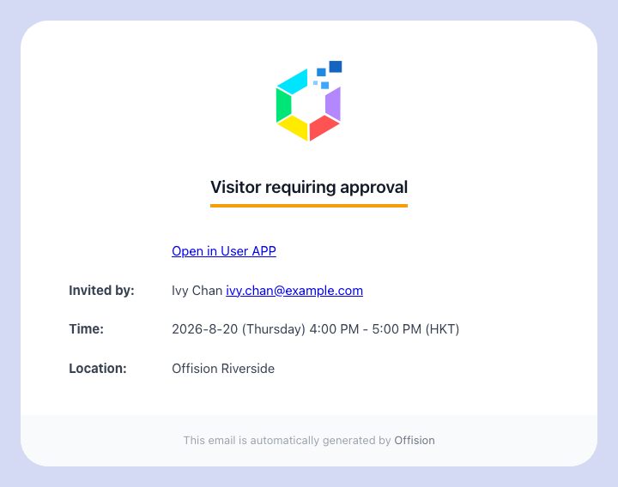
The email an approver receives.
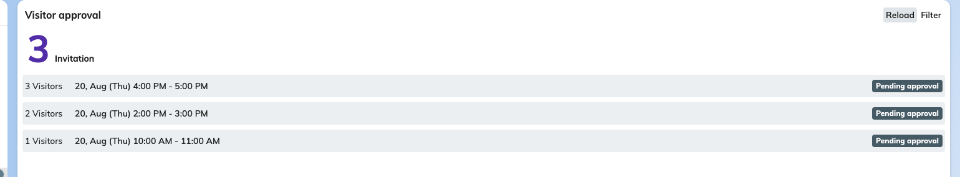
Visitor approval in the app, with what is waiting to be decided.

6. Decide, one guest at a time
Opening a request shows who invited them, where, when and under which visiting
purpose — then every guest on the visit, each with a tick and a cross of their
own. Approve all and Reject all set them in one pass. A guest on your
Black list is flagged in this list, which is the point of flagging them.
Two things about this screen catch people out:
- Nothing is applied until you press Confirm. Ticking a guest changes
nothing on its own.
- Confirm stays disabled until every guest has been decided. A visit cannot
be half-answered and left for later.
Approval is recorded per guest, so a visit with several guests can end up in a
state no single guest is in.
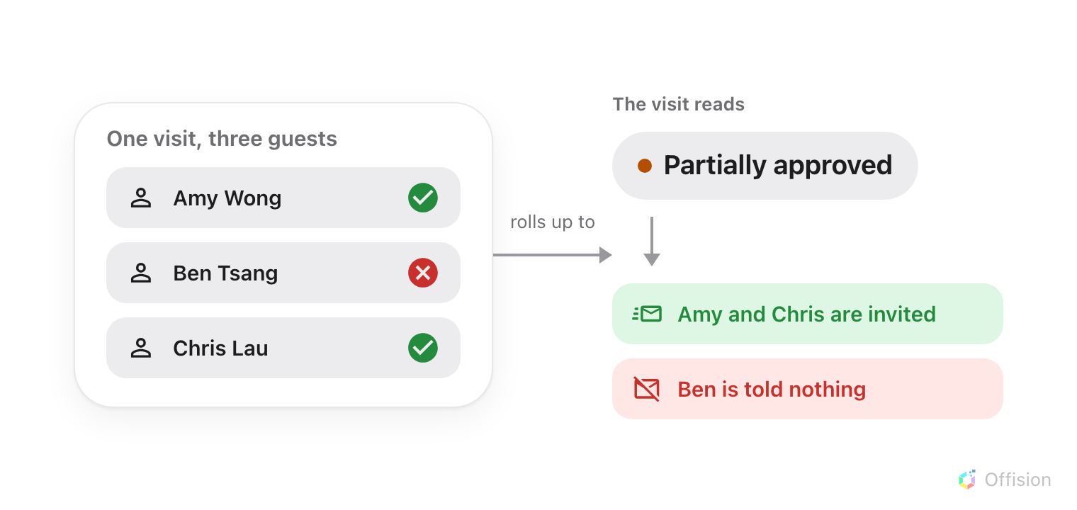
The visit's status is whatever its guests add up to, and only the approved ones are emailed.
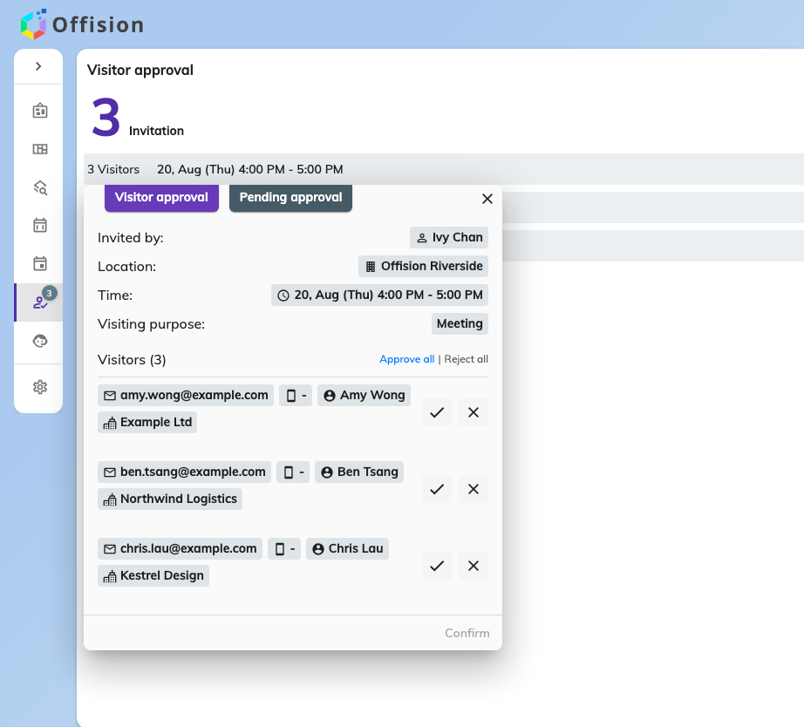
One request, with a decision to make on each guest.

7. If you administer Offision
There is no approval queue in the admin console. Administrators change a guest's
state from the Invitation calendar instead: open the visit, and each guest
carries Change to approve, Change to reject and Change to waiting
approval.
The third is the one worth remembering. A decision is not final — putting a guest
back to waiting is how a mistake gets undone, and it is the only route back.
Where in Offision: admin app → visiting/calendar (Invitation)

8. Check it worked
Invite a guest to a covered room, as somebody other than the approver, then look
at three mailboxes:
- The guest should have nothing at all.
- The approver should have Visiting approval request.
- Approve it, and the guest should now receive Invited visitor while the host
receives Visiting invitation approved.
If the guest was emailed straight away, the location the visit landed on is not
covered by the policy you edited. That is the commonest mistake here, and the
reason step 1 is about where the policy is attached rather than what it says.

What approval does not do
- It asks for no reason. Rejecting a guest records no explanation and sends
none — unlike a rejected vehicle, which does carry one. If the host needs to
know why, tell them yourself.
- It never expires. There is no auto-reject after so many days. A request
nobody answers waits indefinitely, and nothing anywhere reports that it is
waiting.
- It does not survive an edit. Changing a visit that was already approved
puts every guest back to Pending approval and sends the request again. A
corrected time or an added guest costs the whole visit its approval.
- It never writes to the guest. A rejected guest is told nothing, then or
ever. If they had already been approved, their badge stops working and they
find out at the door.
- It is not a chain. One flat set of approvers, one decision, no escalation
and no routing to the guest's host.
- It does not change what a guest is asked for. That is the visiting
purpose — see Set up a visiting purpose.
A waiting visit at the door:
Approval outranks everything at the entrance. A guest whose visit is still
waiting is refused with This visit is still waiting for approval, whatever
their timing says, and somebody registering themselves at a lobby screen ends on
Visiting request has been submitted and is currently awaiting approval.
rather than a printed pass.

