Read the visitor dashboard
What each of the Visitor Dashboard's four numbers counts, how the trend arrows compare against the previous period, and what the building breakdown, top insights, purpose and walk-in charts are telling you — plus the two filters that change all of it at once.
2026-09-02 · https://offision.com/help/en/visiting/read-the-visitor-dashboard/
The Dashboard is the period view of visiting: pick a stretch of time and it
says how that stretch went — how many people, how many made it, how many never
showed — and where they went. It is view-only; when you need the same records
as a file, that is the
Visiting daily report or the Visitor
badge list's export.
Before you start:
You need Visitor manager permission, and visitor management must be
enabled. The dashboard reads visitor badges, so a period before you started
using visiting shows zeroes — that is missing history, not a broken page.

The two filters
Everything on the page obeys the same two controls at the top. The date
range opens on the current month; the buildings picker starts at
All buildings and only shows buildings enabled for visiting. A filter you
applied last visit stays applied — when a number looks impossibly low, look
here first.
Where in Offision: admin app → visiting/dashboard (Visitor Dashboard)

The four numbers
Tile | Counts
Total Visitors | The period's headline count
Currently Visiting | Badges checked in right now — Active now is live, not historical
Checked Out | Completed visits, with the Completion rate — their share of the total
No Show | Missed appointments, with the No show rate

The small arrows under Total Visitors and No Show compare against the
previous period of the same length — a two-week range is compared with the
two weeks before it. There is no arrow when the previous period had nothing to
compare with.
No-shows are only counted where the visiting policy marks them: an invitation
nobody checked in on flips to No show automatically once its time passes,
and with that change turned off the rate reads zero however many people failed
to arrive.

Visits per day
The chart under the tiles plots visitors per day across the range. Spikes are
usually one event's guest list; a flat zero inside an otherwise busy month is
worth checking against the building filter before against reality.

Building breakdown
One row per building with six counts: Total, In now, Checked out,
No show, Invited and Walk-in. Busiest building first. This is the
table to read when deciding where reception cover is thin — a building with a
high walk-in share is one where visitors arrive unannounced.
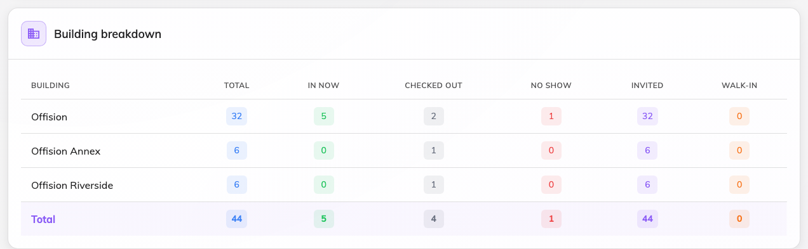
Every building in the filter, busiest first.

Top insights
Two top-five lists: Frequent visitors — the people who came most often,
with their company and visit count — and Top inviting users, the employees
who invited the most. Frequent visitors is where a contractor who should have a
long-term badge shows up; top
inviters is who to talk to before changing a visiting form they use daily.
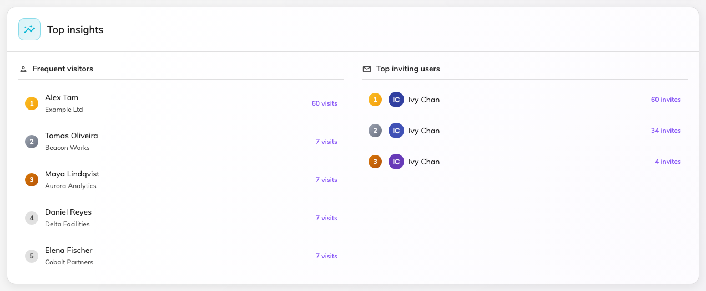
Who keeps coming, and who keeps inviting.

Purposes, and invited vs walk-in
The last row splits the same visits two ways: Visiting type distribution
shows which purposes the period's visits used, and Invited vs walk-in
splits announced from unannounced arrivals, week by week. A purpose that never
appears here is a candidate for
deletion; a rising walk-in
share means invitations are being skipped, not that visiting is growing.
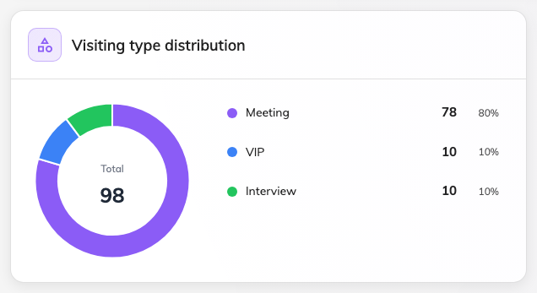
Which purposes the period's visits actually used.

What this page does not do
- Export. The dashboard has no download. The
Daily report exports one day; the
Visitor badge list exports any period.
- Name individuals beyond the two top-five lists. Person-level questions
belong on the Visitor badge list or in
a visitor's record.
- Live occupancy. Currently Visiting is the one live number here; the
fuller "right now" picture is the Overview page's quick-view cards.

