Download a day of visitor records
The Visiting daily report is one day's visitors as a table — who came, when they checked in and out, hosted by whom — downloadable as Excel or PDF. How to pick the day, choose the columns, and what each download actually contains.
2026-09-02 · https://offision.com/help/en/visiting/read-the-visiting-daily-report/
One row per visitor, for one day — the sheet to hand security after an
incident, or to file for a compliance check. Done means: the day you were asked
about is on screen, and the file is downloaded.
Before you start:
You need Visitor manager permission. The report reads visitor badges, so a
visit that never got as far as a badge — one still waiting for approval — has
no row here.

1. Open the report and pick the day
Where in Offision: admin app → visiting/visiting-daily-report (Visiting daily report)
The report shows one day at a time — today, until you change it. The
arrows either side of the date step a day at a time; the date itself opens a
picker for anything further back. There is no range: a week means seven
downloads, or the Visitor badge list's export instead.
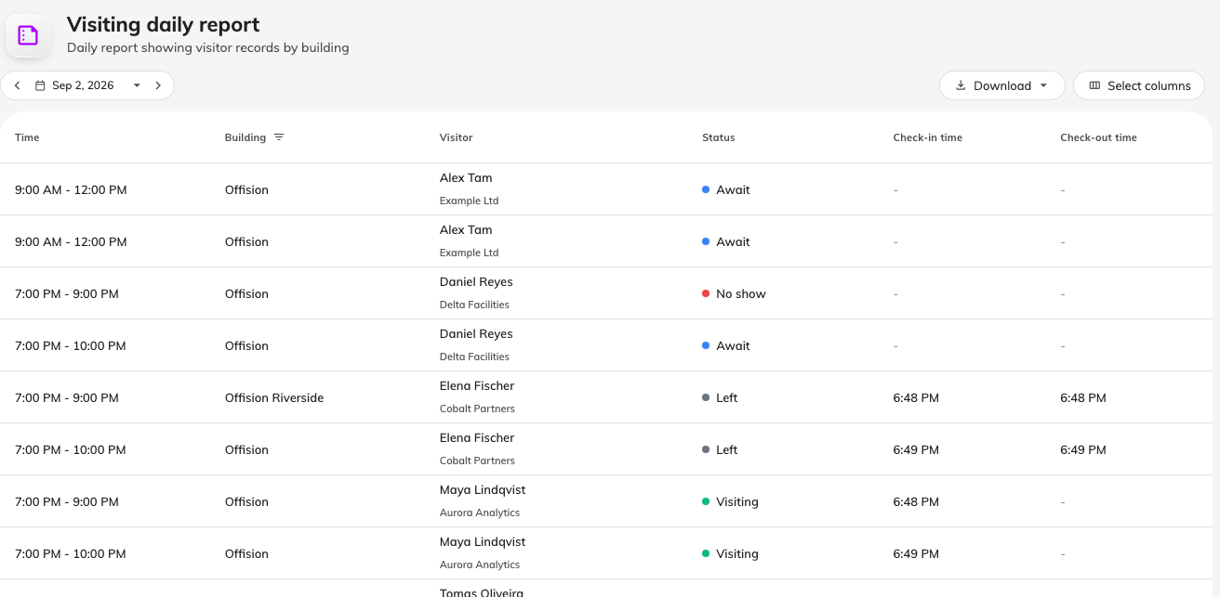
One day's visitors, with the total in the footer.
Each row carries the visit's time, the visitor and their company, and a status
pill — Await, Visiting, Left, No show, Overstay — in the
same colours the visiting calendar uses.

2. Filter by building
The building filter hides inside the Building column header — the funnel
icon beside the word. It is the same picker the Dashboard uses, and it sticks
until you clear it with the cross that replaces the funnel.

3. Choose the columns
Select columns opens a panel on the right. Time, visitor and status are
always shown; building, check-in and check-out start visible; the host, visit
purpose, room, walk-in flag, registration code, memo and the two notes start
hidden. Your choice and order are remembered on your account, so set it up
once for the report you file regularly.
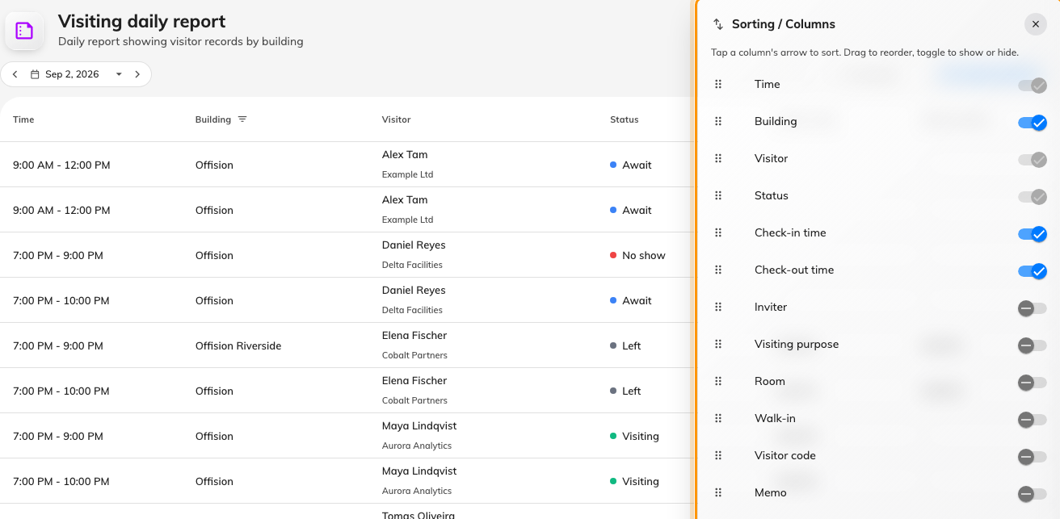
Hidden columns wait in the Select columns panel.

4. Download it
Download offers two formats, and they differ in more than file type:
- Download as Excel — always the full record: every column, including
the ones you have hidden, one sheet named for the day.
- Download as PDF — a print of the table as you see it: your columns,
your order. This is the one to hand over when the memo and notes columns are
nobody else's business.
The button is disabled while the day is empty — an empty day downloads
nothing, which is also how you know "no visitors" from "wrong filter".

Check it worked
Open the file and compare its last row against the footer's total. If the file
has fewer rows than you expected, the building filter from step 2 is the usual
cause — it applies to the download too.

