Print the WiFi code on the visitor badge
Put the guest network, username and password on the printed badge — which badge design does it, how the details are chosen, and the reasons a badge comes out without them.
2026-08-20 · https://offision.com/help/en/visiting/print-the-wifi-code-on-the-badge/
Before you start:
A Visitor WiFi entry must exist with a
WiFi SSID filled in. The badge design is company-wide — changing it changes
every location's badge.
One badge design prints WiFi details: the photo and Wi-Fi layout. Its footer
carries the network name, a Username row and a Password row — everything
a visitor needs, on the label reception hands them.

1. Pick the photo and Wi-Fi design
On the visiting Settings page, choose Customize next to
Visitor label design and pick the photo and Wi-Fi layout. Save the page.
Where in Offision: admin app → visiting/visitorManagementSetting (Visitor management)
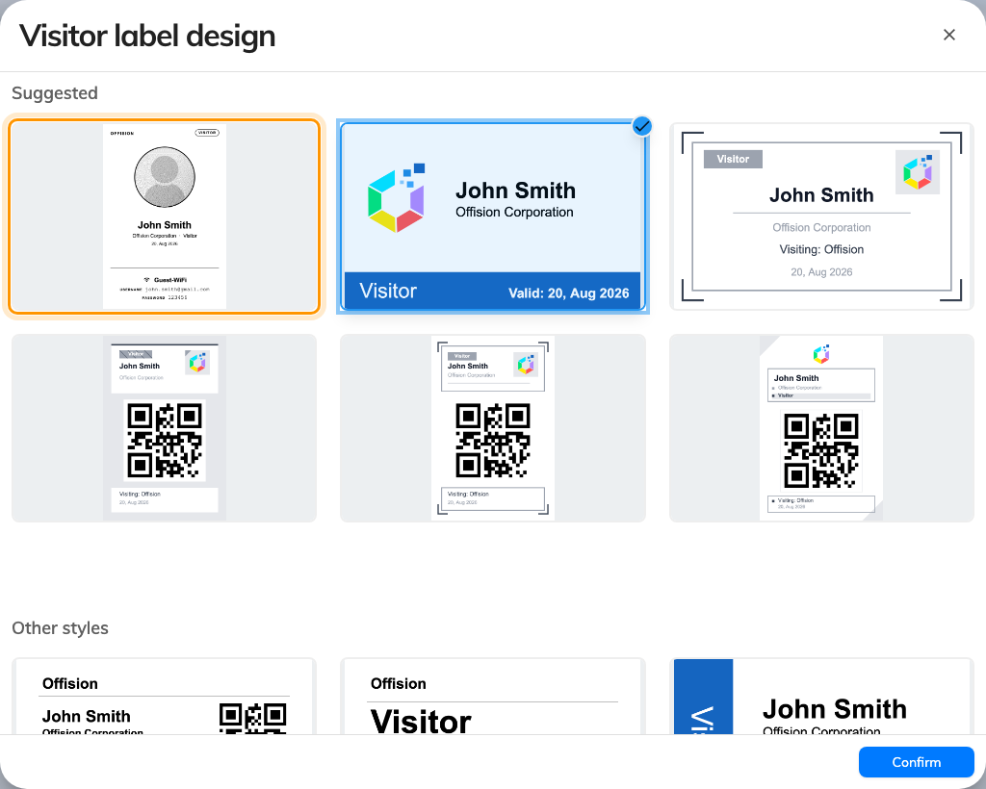
The design gallery, with the photo and Wi-Fi layout.
The full picking walkthrough — logo first, then design, then save — is in
Change the visitor badge design.
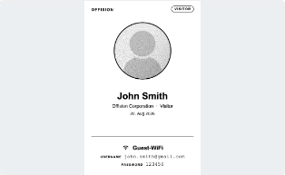
The WiFi block on the badge: network, username, password.

2. Choose what the rows say
The Username and Password rows print whatever the network entry's
Username type and Password type say — the same values the network
itself accepts. With Badge WiFi password, the password is a code minted for
that visit at check-in; with Not required, the badge prints the network's
shared password instead.

3. Check it worked
Register a walk-in at the lobby or check in an invited visitor, and read the
printed label: network name, username, password. Join the network with exactly
what is printed.

When the badge prints nothing
The design adapts to what a visit actually has, so a badge can come out without
the WiFi block and nothing warns you. In order of likelihood:
- The badge design is not the photo and Wi-Fi layout. No other design has a
WiFi block.
- The network is a RADIUS brand. A secured-network entry stores no
WiFi SSID, so there is nothing to print — visitors join the network your
controller names. See the WPA-Enterprise guide.
- No entry covers the visit's building. The badge prints the entry linked to
one of the visit's buildings, or failing that an entry linked to no building
at all. A visit outside every linked building gets nothing.
- The visit does not have the chosen field. A Mobile number username
prints blank for a visitor who never gave one, and the Badge WiFi password
only exists from check-in — a badge printed or emailed before then has no
password to show.
A badge that prints correctly but is refused by the network is a different
problem — the visitor has checked out, the visit period has ended, or the entry
has no Visitor WiFi Integration license.
Note:
Re-issuing a badge can mint a new WiFi password, which invalidates the one on
the previously printed label — reprint after re-issuing. Lobby boards can also
show a scan-to-join QR code at check-in, so a visitor who lost the label is not
stuck.

