Open a building to visitors
From a building that merely exists to one guests can be invited to: enable visitor invitations, give it a visiting policy and an opening hour, name its receptionists, open its floors, rooms and parking, and know where the monthly visitor count sits.
2026-09-02 · https://offision.com/help/en/visiting/open-a-building-to-visitors/
Before you start:
The building — and any floors and rooms you mean to open — must already exist
in the directory: see
Add a building and its floors.
You need write access to Visitor Management.

1. Enable visitor invitations
The Visiting location page lists every building, open to visitors or not.
Tick the building's row and its panel opens on the right; on a building not
yet open, the one action there is Enable visitor invitations — press it.
The same panel is where a building is later taken back out of service:
Disable visitor invitations, at the bottom.
Where in Offision: admin app → visiting/visiting-location (Visiting location)

2. Give it a policy and an opening hour
With the building enabled, press Edit on its panel. The dialog's settings
are split into pages down the left — Settings, Receptionist,
Floors, Rooms, Parking, Information — and it opens on the first.
- Visiting policy is the rule set for visits here: whether they need
approval, whether
vehicles are registered, what the
badge code does. Policies are shared —
pick an existing one or add one from here.
- Opening hour is when visitors may be on site. Underneath it a line shows
the time zone the choice results in, and where that zone came from: the
hour's own zone if it names one, otherwise the building's position on the
map, otherwise the system zone.
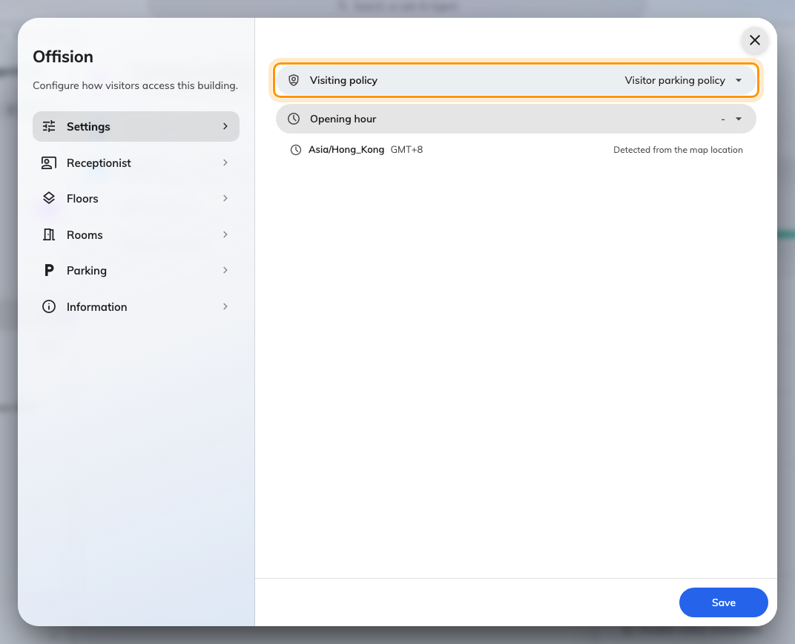
Settings: the visiting policy and the opening hour, with the resulting time zone spelled out underneath.

3. Name the receptionists
Receptionist, the second page, takes people and user groups together.
Everyone named here can open this building's desk in the app and sees its
visitors — and only its visitors. Prefer a user group where one exists, for
the same reason as everywhere else: a person named directly stops working the
desk the day they change role, silently.
A receptionist with no building named anywhere sees
You have not been assigned to any reception setting instead of a desk — the
first thing to check when someone cannot open Reception. See
Sign in to your reception desk.
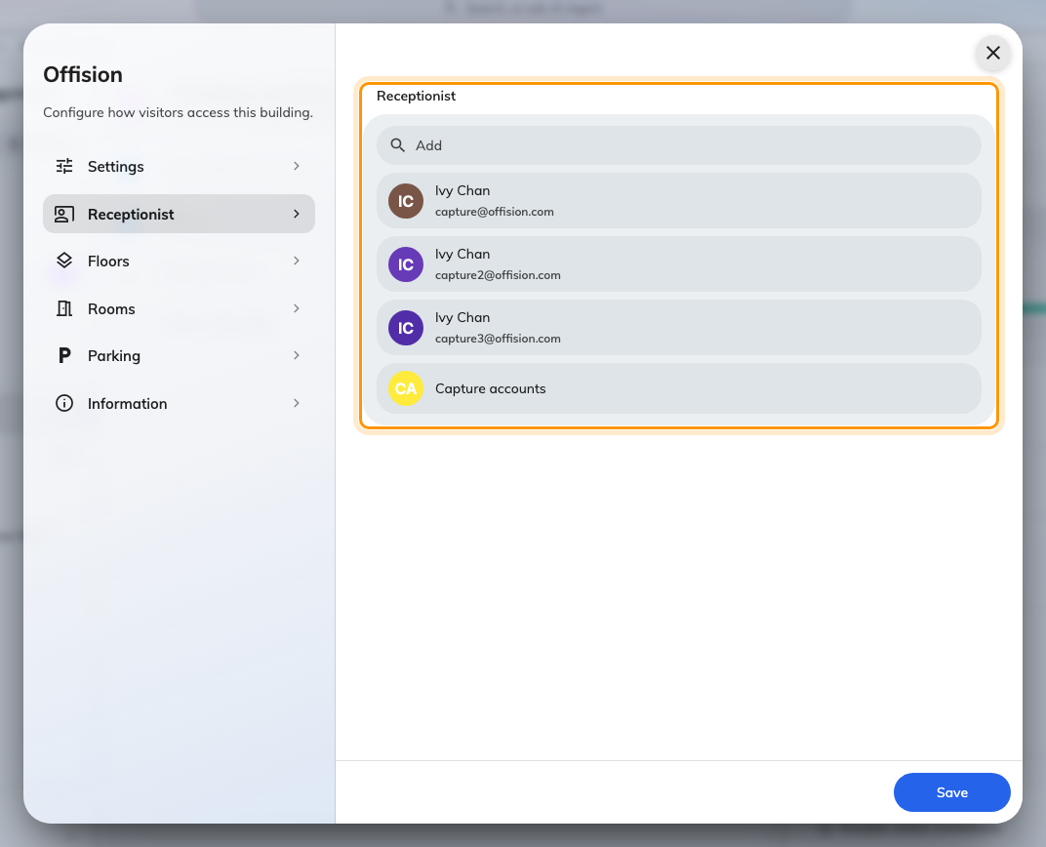
Receptionist: the people and groups who staff this building's desk.

4. Open floors, rooms and parking
The next three pages — Floors, Rooms, Parking — are tick lists of
what the building already has. Whatever you tick becomes offerable when
somebody invites a visitor: the building alone, a floor on it, or one room.
A room chosen as a visiting location says where the visit is — it does not
reserve the room.
Opening nothing here is fine. The building itself is then the only answer the
invite form offers, which suits a site where precision inside the building
does not matter.
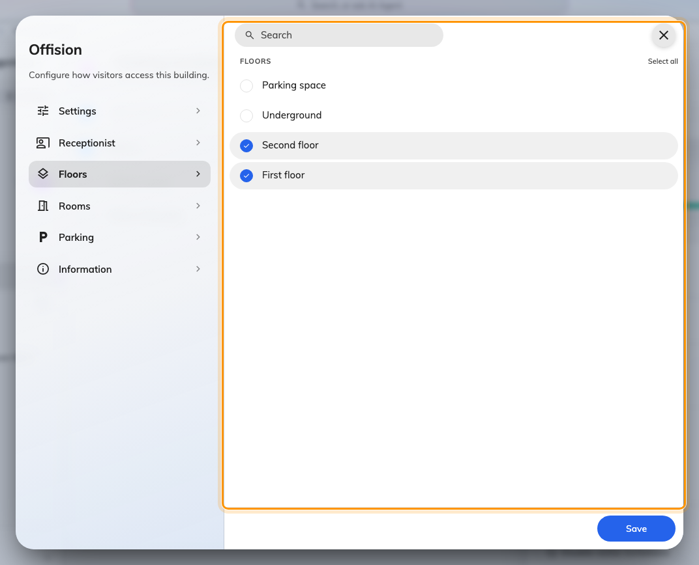
Floors: tick what visitors may be invited to. Rooms and Parking work the same way.
Press Save — one save covers every page of the dialog.

5. Know where the visitor count sits
Back on the building's panel, License usage this month counts this
location's visitors: each visitor badge created is one against the building's
monthly limit, and the card says when the count renews. Increase
limitation is where a visitor licence is assigned to this building when the
limit is reached — visitors are licensed per location, not per company.

6. Check it worked
Invite a guest yourself. The building should now appear under Visiting
location on the invite form, with the floors and rooms you opened one tap
deeper. Then have one of the named receptionists open Reception in the
app — the desk exists, and the guest you just invited is on its list for the
day of the visit.
If the building is missing from the invite form, it is not enabled — step 1,
not step 4, is the switch.

