Make a purpose the default, or delete one
Which purpose is pre-selected on every invitation, how to copy one instead of building it again, and what happens to visits that are still ahead when the purpose they were made under is deleted.
2026-09-01 · https://offision.com/help/en/visiting/make-a-purpose-the-default-or-delete-one/
Three things are decided on the list rather than inside the editor: which
purpose an employee gets without choosing, how to copy one that is nearly right,
and what happens to visits that are already booked when the purpose they were
made under goes away.
Before you start:
You need write access to Visitor Management, and at least two purposes — the
default cannot be deleted, and there is nothing to promote until a second one
exists.

1. Open the purpose's panel
Selecting a row on Visiting purpose opens a panel with the actions on it.
The row already carries a Default badge where one applies, so you can see
which purpose is the pre-selected one without opening anything.
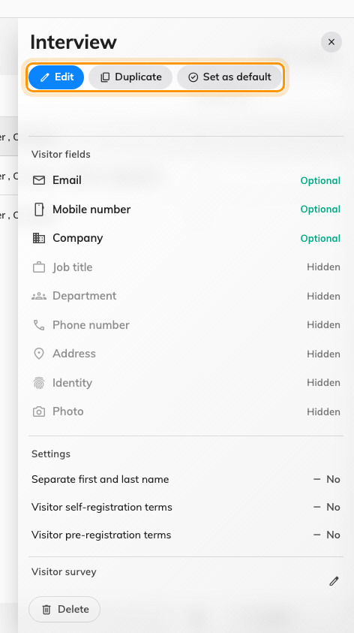
The detail panel, with Set as default beside Edit and Duplicate.
Where in Offision: admin app → visiting/visiting-type (Visiting purpose)

2. Make it the default
Set as default makes this the purpose pre-selected on every invitation and
every walk-in. It appears only on a purpose that is not already the default, so
the action is missing from exactly one row.
The default is a fallback, not a restriction: an employee inviting somebody can
still pick any other purpose. What it decides is what happens when nobody
chooses — which is most of the time.

3. Duplicate one instead of starting over
Duplicate copies every setting into a new purpose. It is the fastest way to
make a strict variant of a permissive one — copy Meeting, then raise the
fields the stricter visit needs. The copy gets its own name and no Access ID, so
a spreadsheet import cannot address it until you give it one.

4. Delete a purpose, and move the visits it still has
The default purpose cannot be deleted at all — Cannot delete default — so
promote another one first if you want it gone.
Deleting a purpose that still has visits ahead of it does not just delete it. A
dialog opens naming how many are affected — Move n upcoming visits to —
with another purpose already chosen, the default one where it can be. Accept it
and those visits carry on under the new purpose.
Delete without moving is still offered, and the dialog says plainly what it
costs: "Those n visits can't check in or be edited." That is the whole reason
the dialog exists, so read the count before choosing it.
Only visits that have not finished and are not cancelled are counted. Past
visits are never moved — they keep the purpose they were made under, so the
record of what somebody visited for stays true.
Deleting a purpose with nothing upcoming is a plain confirmation and no move.
The same dialog appears whether the delete is started from the detail panel or
from the toolbar with several purposes ticked. It arrived in 4.5.12; before
that, upcoming visits were left stranded.
A moved visit answers the new purpose's questions:
The visit keeps its date, its host and its visitor, but not the form it was
made under. A moved visit has to complete the new purpose's form when it is
checked in or edited — so moving into a purpose that asks for more is a change
the visitor will meet at the desk.

5. Check it worked
Open an invitation and look at the purpose it offers before you touch it: that
is the default. Then open the purpose you deleted from — the visits you moved
should now be listed under the purpose you moved them to, with their dates
unchanged.

