Import visits from a spreadsheet
Bulk-create visitor invitations from an Excel file on the Invitation calendar: one row per visitor, a shared Visit ID to group visitors onto one visit, and a preview that flags only the rows needing attention before anything is created.
2026-09-02 · https://offision.com/help/en/visiting/import-visits-from-a-spreadsheet/
One row per visitor, one file for the whole delegation: the Invitation
calendar's Import takes an Excel sheet and creates the visits — invitations,
approval, badges and check-in all behave exactly as if each visit had been
created by hand. It is the way to load a conference's guest list, and to bring
your scheduled visits with you when
moving in from another system.
Before you start:
You need write access to visitor management. Locations are named in the sheet by
their import ID — so the buildings and rooms must exist first, and any visiting
purpose you want to assign needs an Access ID of its own.

1. Open Invitation and press Import
Import sits beside Invite visitors at the top of the calendar under
Visiting › Invitation — the page itself is titled Visiting calendar.
Where in Offision: admin app → visiting/calendar (Invitation)
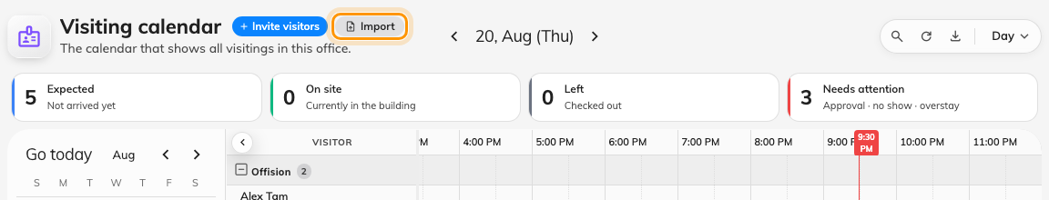
Import, next to Invite visitors on the Invitation calendar.
The dialog has pages down the left: Import, Location import IDs, and —
when a visiting purpose carries an Access ID — Visiting purpose import IDs.
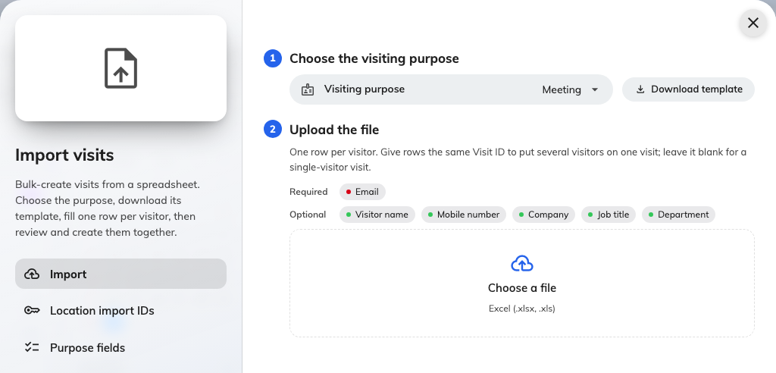
The Import page: download the template, fill in your visits, upload the file.

2. Check locations and purposes have import IDs
The sheet names a building or room by its Access ID, never by its display
name. The Location import IDs page lists every building and visiting room
with its ID and a copy button; Download takes the table as an Excel file to
keep beside the template. A location without an import ID cannot be used in the
sheet — point at a building's row and a pencil appears, so you can assign one
without leaving the dialog.
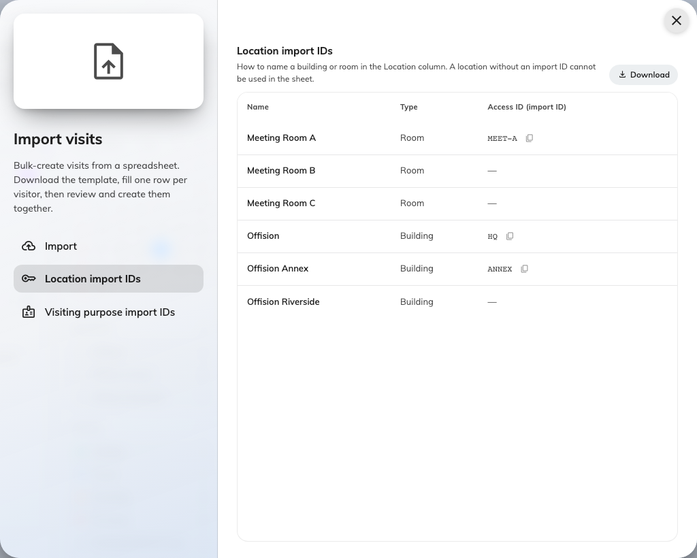
Location import IDs: how the sheet names a building or room.
The Visiting purpose import IDs page does the same for purposes. A purpose's
Access ID lives on the purpose itself; the row's pencil opens it.
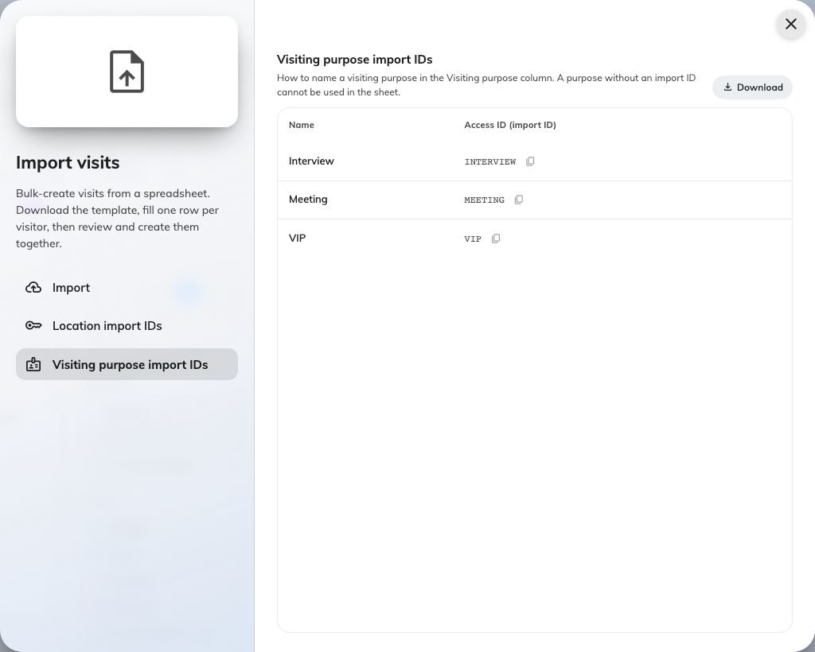
Visiting purpose import IDs: the code the Visiting purpose column expects.

3. Download the template
Download template builds the file from your own tenant — your visiting
purposes and your visiting form's extra fields — so the columns below are the
general shape, not necessarily your exact sheet. The sample rows it ships with
are two visitors sharing one Visit ID, to show the grouping rule in action.
Column | What goes in it
Visiting purpose (import ID) | Only present when a purpose has an Access ID. From the Visiting purpose import IDs page
Visit ID | Optional. Rows sharing a Visit ID become one visit with several visitors; blank means a visit of its own
Start / End | YYYY-MM-DD HH:mm, read as local time at the location
All day | yes or no
Location (import ID) | A building or room's Access ID. Several locations: separate them with commas
Host | A user's email address. Leave it blank and the visit is hosted by you
Visitor name | Required on every row
Email / Mobile number / Customize key | How the visitor is identified — at least one, whichever your visiting settings accept. Mobile numbers need a country code
Company / Job title / Department / Phone number | Optional visitor details
Remarks (to receptionist) | Shown to the front desk, not to the visitor
One column per extra field | The header carries the format it wants — YYYY-MM-DD, HH:mm, yes/no, 123, or the option names

Extra fields that take a file or formatted text cannot ride in a spreadsheet
and are not in the template.

4. Fill in your visits
One row per visitor — a visit with four guests is four rows sharing one
Visit ID. The grouped rows must agree on the visit itself: same purpose,
location, host and times. Only the visitor columns may differ.
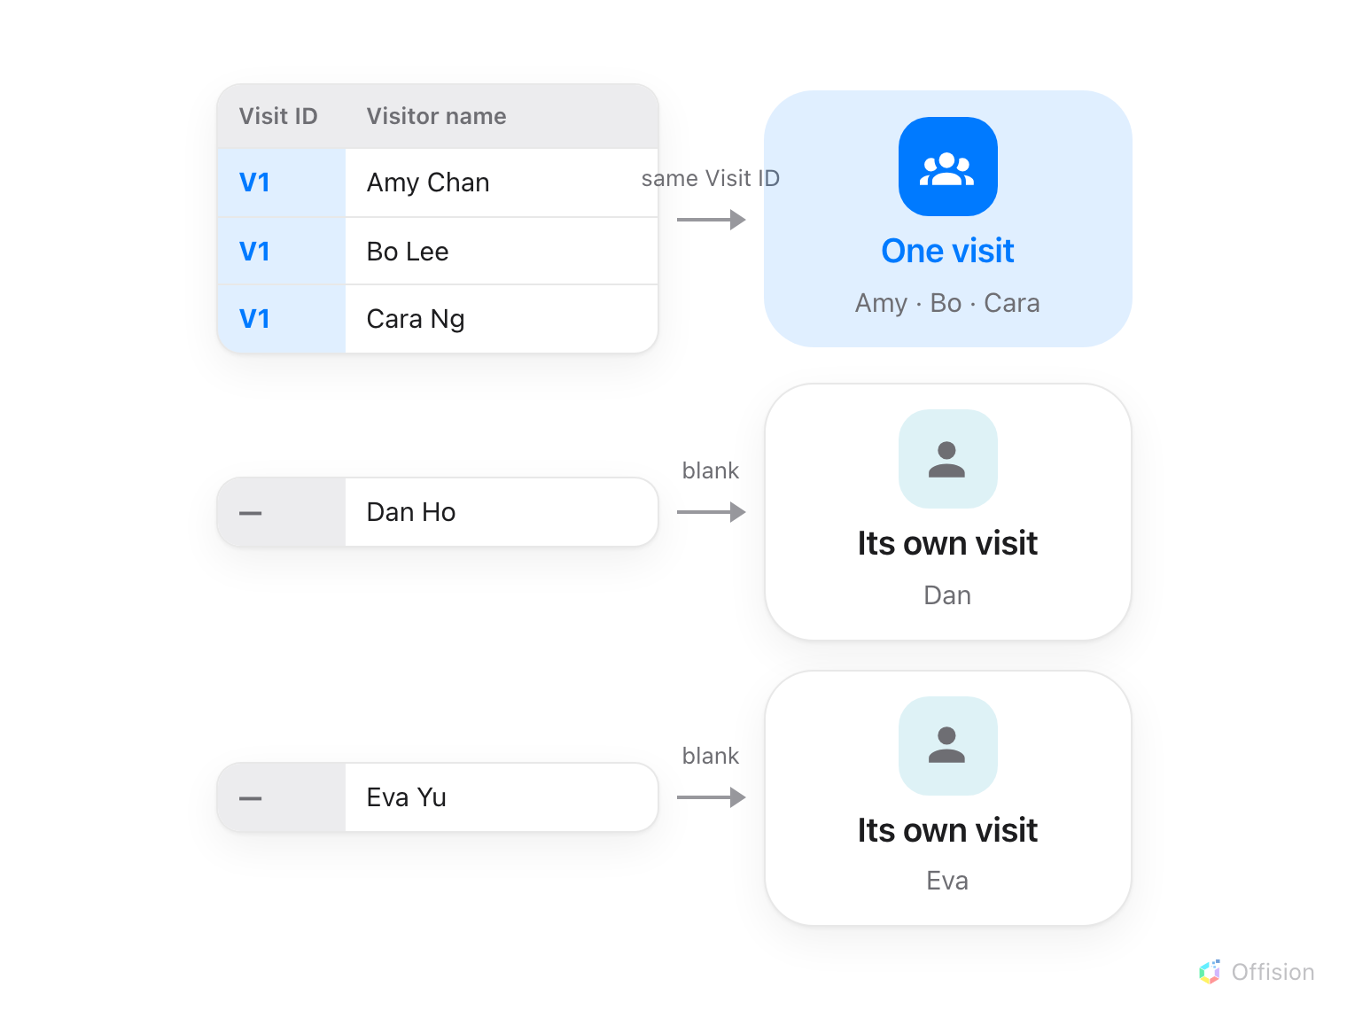
Rows that share a Visit ID become one visit with several visitors; a blank Visit ID makes a visit of its own.
Times are wall-clock times at the location: 09:00 for a Tokyo building
means 09:00 in Tokyo, whatever time zone you are importing from. The review
screen states which zone it read the sheet in, so a surprise there means the
wrong location, not a broken clock.

5. Upload it and fix what it flags
Drop the file on Choose a file (.xlsx or .xls). The dialog answers with
one line — ready and need attention counts — and lists only the visits
with a problem, each showing just the field that failed, with the Excel row
numbers it came from:
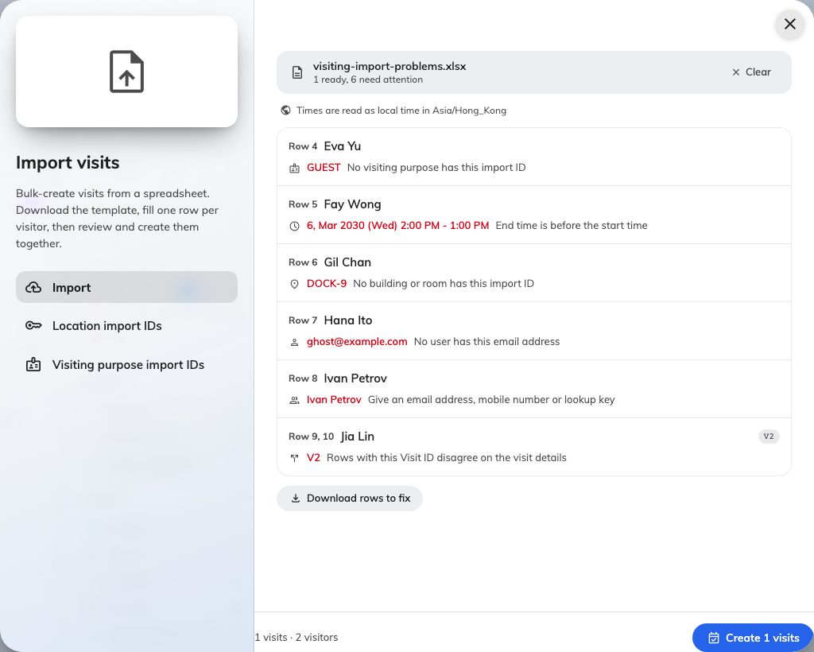
Only the problem visits are listed — the field that failed, and the rows it came from.
What it says | What it means
No visiting purpose has this import ID | The purpose cell matches nothing on the Visiting purpose import IDs page
Start or end time is missing or unreadable | A time cell is empty or not YYYY-MM-DD HH:mm
End time is before the start time | The two cells are swapped
No location given | The Location column is empty
No building or room has this import ID | A location key matches nothing on the Location import IDs page
This building has used up its visitor quota for this month | Your licence meters visitors per building, and this building's month is spent
No user has this email address | The Host cell does not belong to any user
This user cannot invite visitors (missing permission or license) | The host exists but cannot invite — fix their permission, or host it yourself
Visitor name is required | A row has no name in the Visitor name column
Give an email address, mobile number or lookup key | The visitor has no identifier your visiting settings accept
Add a country code to the mobile number | The number could not be resolved to an international one
This country code is not enabled in the visitor management settings | The number's country is not in your accepted list — add it
Rows with this Visit ID disagree on the visit details | Grouped rows differ on purpose, location, host or time — they must only differ on the visitor
Same visitors, place and time as an earlier visit | The sheet contains the same visit twice; only the first is kept

Download rows to fix re-exports just the flagged rows, in the template's own
columns, so you correct those in Excel and upload the smaller file — the clean
visits from the first file can be created first.

6. Create the visits
The footer counts what is ready — visits · visitors — and Create visits
makes them, one by one, with a running count. Valid visits are created even
while others are still flagged above.
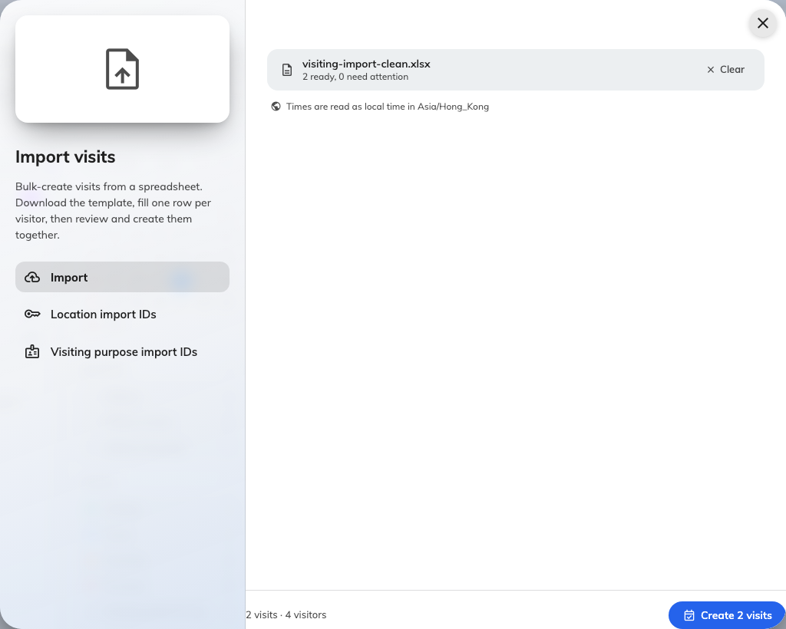
The review footer: how many visits and visitors the sheet is worth, and the button that creates them.
If a visit fails at creation — the one check the preview cannot make — the
closing message names its rows: … could not be created. Those rows go back
into the sheet for another pass; everything else is already in.

7. Check it worked
The new visits are on the Invitation calendar behind the dialog. From here they
are ordinary visits: approval
runs where your rules require it, invitations go out on approval, and the
visitor arrives at reception like any other
guest.

What this does not cover
- The visitor directory. This imports visits — appointments with times and
hosts. The Visitors list keeps its own import for visitor records and
long-term badge holders.
- The app-side group invite. Employees inviting their own guests have an
Import on the invitation form in the Offision app — see
Invite a visitor.

