Give a contractor a long-term badge
A standing pass for people who come back — contractors, cleaners, an agency engineer. It carries no appointment and no host, and at the lobby board it turns the walk-in form into a single screen the visitor barely has to fill in.
2026-08-25 · https://offision.com/help/en/visiting/give-a-contractor-a-long-term-badge/
Some visitors are not really visitors. The contractor who is in three mornings a
week, the cleaning firm, the engineer an agency sends whenever a lift sticks —
registering each of them from scratch every time is the wrong shape of work. A
long-term badge is a standing pass issued once against an email address. It
carries no appointment, no host and no building, and it is the visitor's own to
keep: the same code works on every arrival until it expires or you disable it.
What it buys is the arrival. A holder scans their code at the lobby board and
gets Quick walk in — one screen, already filled in — instead of the full
walk-in form.
It is also the only badge that works on more than one day. The badge attached to
an invitation admits its holder on the day of that visit and no other, whenever
the email was sent — see
When a visitor badge starts and stops working.
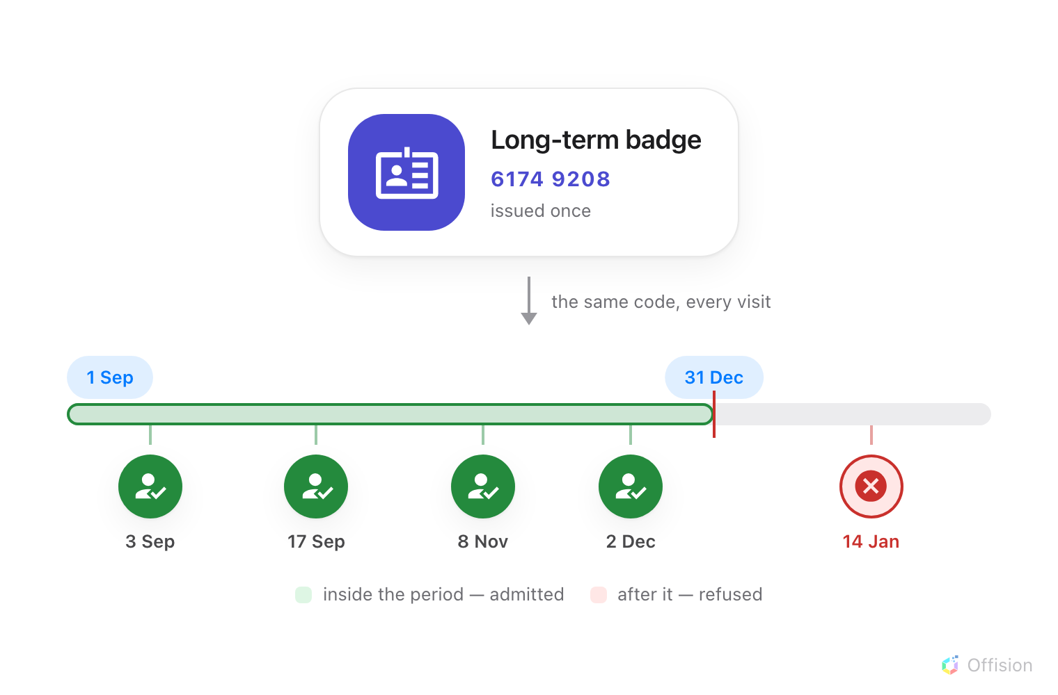
One badge, used as many times as the holder comes back — until the day its period ends.
Before you start:
You need the Visitor manager permission, and visitor management must be on
your licence. Wallet passes are a separate switch — see the last section.

1. Create the badge
Open Visitor Long-Term Badge from the Visiting menu, then Create
Long-term Badge.
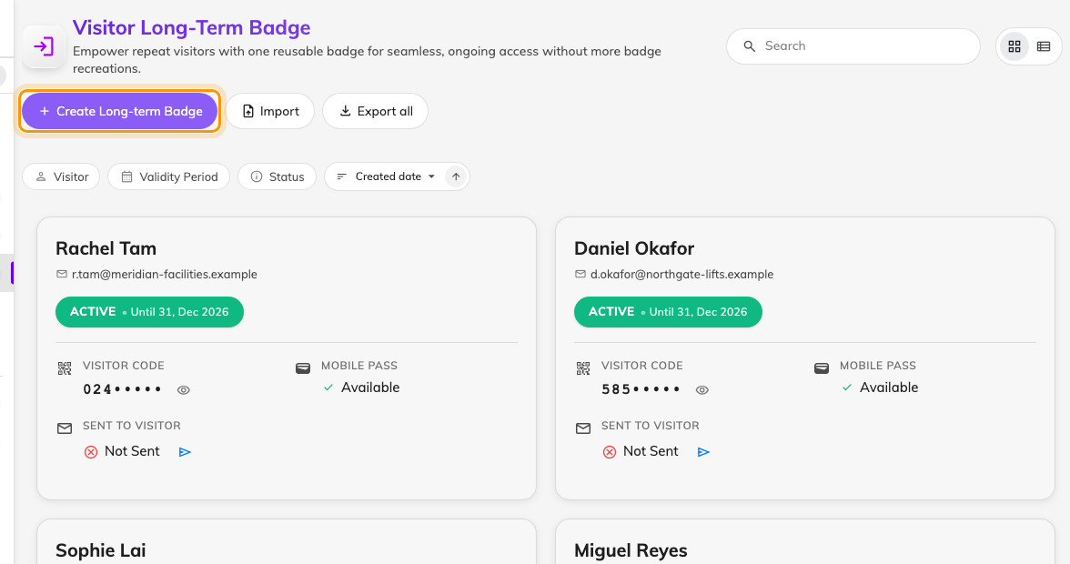
The long-term badge list, with Create Long-term Badge beside Import.
The form is deliberately short:
- Email — required, and the only thing that identifies the holder. Issuing a
second badge to the same address updates the one that exists rather than
creating a duplicate.
- Validity Period — either No Time Limit, or Limited Period with a
date range. A new limited period defaults to today through the same date next
year.
- Send Email to Visitor — on by default, at the bottom left. Leave it on
unless you are preparing badges ahead of announcing them; you can send later.
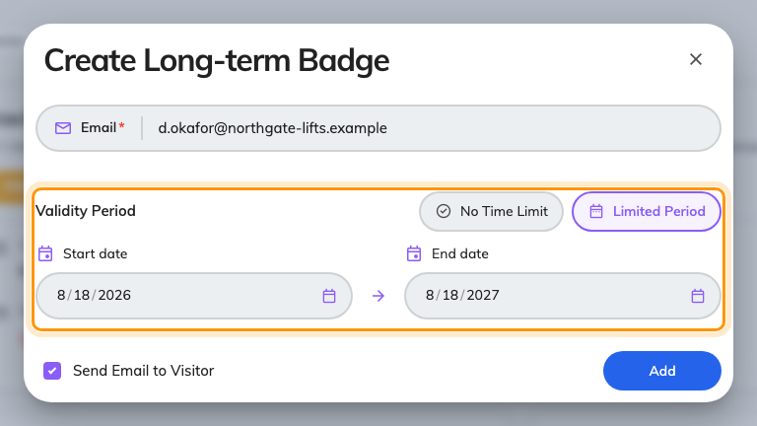
Create Long-term Badge, on Limited Period. No Time Limit hides the date range.
Note what the form does not ask for: no building, no floor, no visiting
purpose, no host. A long-term badge is not scoped to a place — it identifies a
person, and where they may go is decided at the board when they arrive.

2. Or import a batch
Import takes a spreadsheet, which is the sensible route for a contract that
starts with thirty names. Download the template from the dialog and keep its
column order:
Column | Contents
1 | Email address — required
2 | Display name
3 | Company
4 | Job title
5 | Department
6 | Phone number

Only the first column is compulsory, and a row without one is dropped silently —
there is nothing to address a badge to. Give phone numbers their country code:
a bare local number is stored as a dial code with no number after it.
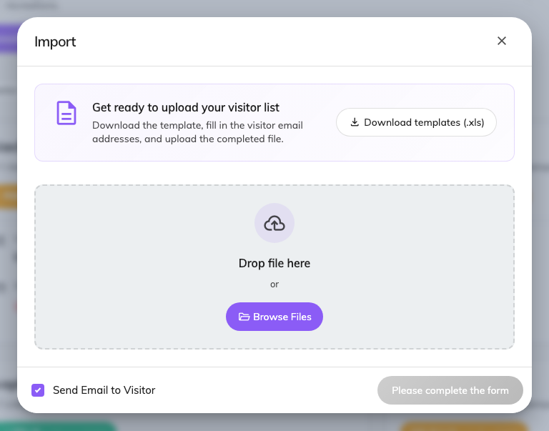
The import dialog, with the template download.

3. What the visitor receives
The email arrives as Visitor long term Badge and carries everything the
holder needs:
- the valid period, shown only when the badge has one — an open-ended badge
says nothing about dates rather than saying "forever"
- Add to Apple Wallet and Save to Phone, when a mobile pass was generated
- an eight-digit code, printed large
- a QR code of the same badge
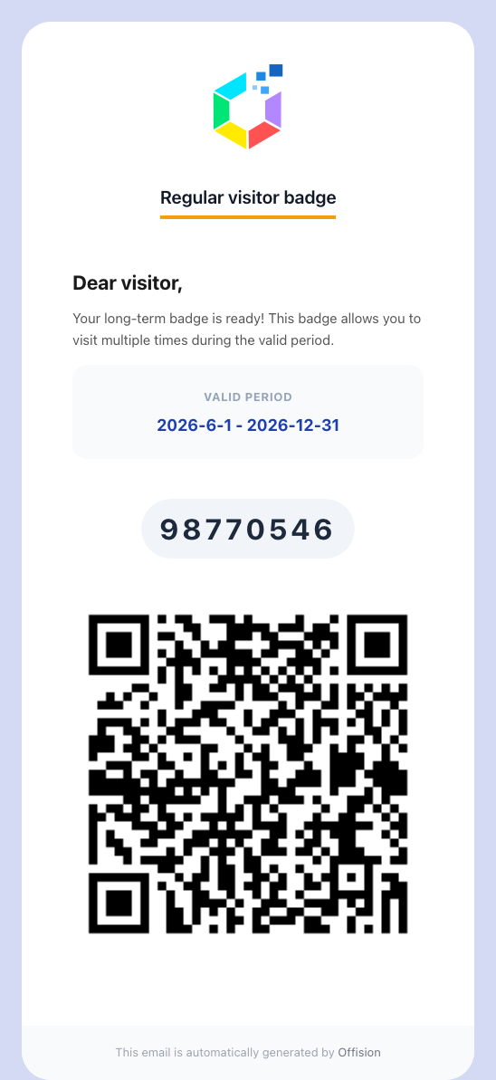
The long-term badge email. The period card is absent on a badge with no time limit.
Two details worth knowing. The eight digits are what tells a long-term badge
apart from an ordinary visitor code, which is six — so a code's length tells you
which kind of pass you are looking at. And the QR does not encode those
digits; it carries the badge's own identifier. Both work at the board, so it
makes no difference which one the visitor shows.
The holder can also find the badge themselves in the visitor app, under
Regular passes, where it shows as Active, Pending, Invalidated or Expired.

4. Walking in with it
At the lobby board the visitor chooses Check in and presents their code —
scanned, or typed at the keypad. What opens is Quick walk in: one page, no
wizard, with their name and company already on it and no way to edit them.
They are asked for three things, and all three are already answered:
- Visiting purpose — the first one is selected for them
- Visit time — 1 hour, 2 hours, 3 hours or Full day, and
Full day is the default. Custom opens a date picker for anything else
- Location — the first building is filled in, and on a board bound to one
building there is nothing to choose
Anything the visiting purpose adds as an extra field appears under those. In the
ordinary case the visitor reads the screen and submits it.
Everything else the walk-in form would ask is skipped, because the badge already
answers it: the identity fields, the photo, the business-card scan, the visitor
surveys, the terms and conditions, the vehicle section, and the confirmation
step. No badge email or SMS goes out either — the holder is already carrying the
pass this would have sent them.
A label printer attached to the board still prints a badge, exactly as it does
for an ordinary walk-in.

5. Check it worked
The badge should be on the list, and the visitor should appear as an ordinary
visiting record with today's arrival on it — a quick walk-in creates a real
visit, the same as any other.
If the board answers Visitor record not found, the code was not recognised at
all: check the badge is not disabled or past its period.

Managing badges afterwards
Selecting one or more rows swaps the Add and Import buttons for the actions
below. Most of them make more sense in bulk than one at a time — a contract that
ends is a batch of thirty badges to disable.
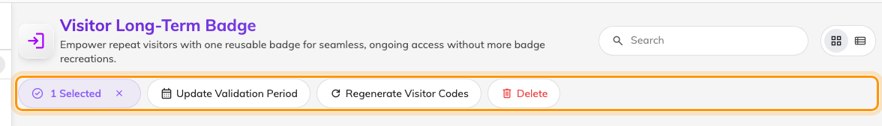
Selecting rows swaps Create and Import for the badge actions.
Action | What it does | When to use it
Update Validation Period | Sets a new period, or removes the limit | A contract is extended, or a badge was issued open-ended by mistake
Regenerate Visitor Codes | Issues a new code and rebuilds the mobile pass | A code has been shared or a phone was lost. The old code stops working
Generate mobile passes | Builds the Wallet pass for badges without one | Badges created before Wallet passes were switched on
Send Emails | Sends the badge email again | The visitor never received it, or the code was regenerated
Disable | Blocks the badge without deleting it | Someone is off site for a while, or under review. Reversible
Enable | Puts a disabled badge back in service | The reason for disabling it has passed
Delete | Removes the badge entirely | Housekeeping. Prefer Disable where you may need the record

Export all writes the whole list to a spreadsheet, which is the quickest
answer to "who from that firm still has access".
Where in Offision: admin app → visiting/visitor-regular-badge (Visitor Long-Term Badge)

What a long-term badge does not do
This is the section to read before promising one to a customer.
It does not open doors. A long-term badge identifies a person at the lobby;
it grants no access control on its own. Door access is a separate arrangement.
It does not skip the visit. Every arrival still creates a visiting record.
The badge shortens the form, it does not bypass it, so the site always knows who
is in the building.
It cannot check anybody out. A long-term code presented to Check out
answers Visitor record not found unless the holder has a visit open at that
moment — a standing pass has no visit of its own to close. Check out is a
property of the visit, not of the badge.
It is not a Wallet pass by itself. The Apple and Google buttons appear in the
email only where the mobile pass feature is switched on; without
that, the badge is the code and the QR, which is enough.
A badge with no period is always active:
Leaving No Time Limit set means exactly that: the badge works until somebody
disables or deletes it. For a contractor engaged for a fixed term, set the period
to match the contract — an expiry that looks after itself is better than one that
depends on being remembered.

