Find, blacklist and delete a visitor's record
Where a visitor's stored details live, how to find one person by name, email or company, what blacklisting and deleting each actually do, and the purge that is the only real erasure — for a data request or a person you no longer want on site.
2026-09-02 · https://offision.com/help/en/visiting/find-and-delete-a-visitors-record/
Every person who has ever been invited has a row on Visitor data — created
the first time someone invites them, reused every visit after. This is the page
for "please delete my details", for the contractor you never want back, and for
fixing a misspelt email. It is not where the visits themselves are.
Before you start:
Visitor data is a root-level page: it needs the visitor manager permission at
the top of the organisation, not on a branch. Visitors have no self-service way
to see or delete their own record — a request always comes to you.

1. Open Visitor data
In the Visiting menu, open Visitor data — "Details of your visitors, such as
email, mobile number and company name."
Where in Offision: admin app → visiting/visitor (Visitor data)

2. Find the person
There is one search box, in the Name column header, and it matches more
than the name: email, phone and mobile number, company, job title, department
and the Customize key. Type any of them. There is no date filter — this list
is people, not visits — and the newest record sits at the top. The toggle above
the list switches between Normal and Blacklisted; a blacklisted person
is only in the second view. Sorting / Columns shows hidden columns such as
phone, department and identity number.
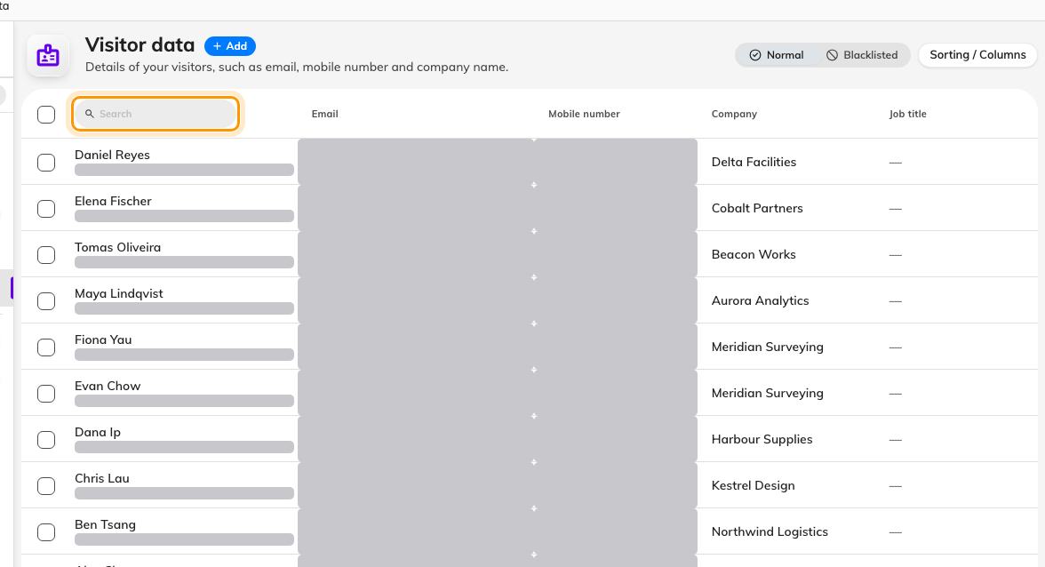
Visitor data, with the one search box in the Name column header.

3. Read the record
Selecting a row opens a side panel: Contact information (email, mobile,
phone) and Professional information (company, job title, department,
customize key, identity number — always masked). What it does not show is visit
history. Their visits are on the Visitor badge list and their actions on the
visiting Log; the record here is only who they are.

4. Edit, duplicate or blacklist
Edit corrects the details for every future invitation. Duplicate makes a
second record from the same details — for the same person with a second email,
say. Add to black list asks "Confirm adding to black list"; from then on the
person appears only in the Blacklisted view, and if
Enable blacklist visitor warning email is on in Visitor management settings,
the visitor manager is emailed the moment they check in. Remove from black
list reverses it.

5. Delete — and what stays
Delete at the foot of the panel asks "Confirm to delete following item(s)?"
and removes the row from the list. That is all it removes: the person's visits,
badges and invitations stay exactly as they were, and nothing is anonymised.
The record goes to the Recycle bin — the toggle at the foot of the list —
where Restore brings it back. Because the deleted record no longer claims
the email or number, the same person can be invited again and simply gets a
fresh record.
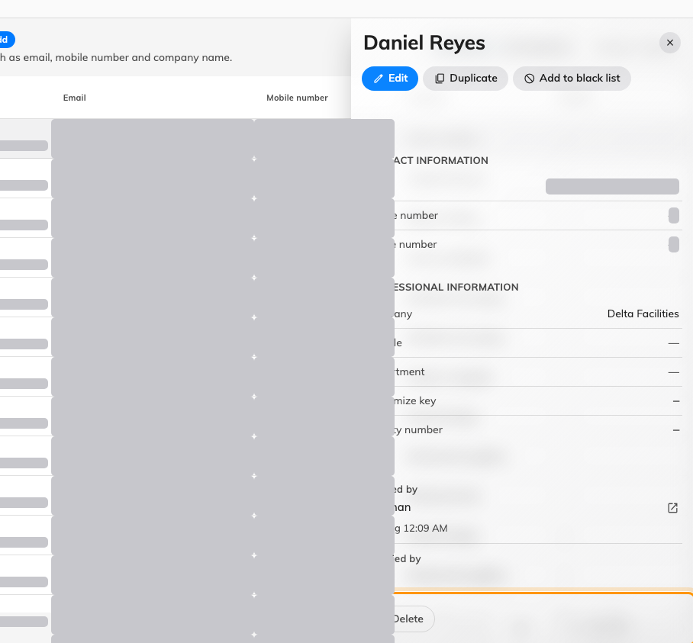
A visitor's record, with Delete at the foot of the panel.

6. Erase for real
Actual erasure is the purge in Visitor management Settings. Purge visitor
record information hard-deletes visits, badges and visitors that have been
inactive past the retention you set there, and Purge visitor identity
information masks identity numbers on the same schedule. Each has a
Purge now button; the confirmations give the count first — "… visitor data
record(s) will be permanently deleted. This action cannot be undone. Continue?"
and "… visitor identity record(s) will be permanently masked. This action cannot
be undone. Continue?". A person with a recent visit is not old enough to
purge — "No visitor data is old enough to be purged right now." means the
retention has not passed.
Where in Offision: admin app → visiting/visitorManagementSetting (Visitor management)
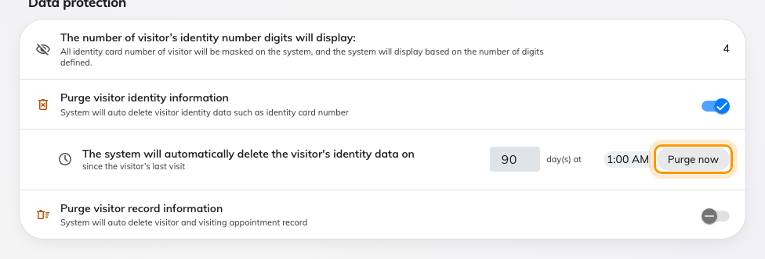
Data protection in Visitor management settings, with Purge now on each schedule.

7. Check it worked
Search for the person again. After a delete they are gone from Normal and
present in the Recycle bin; after a purge they are in neither, and their
visits have gone from the Visitor badge list too.
Exporting visitors:
This page has no export. To get visits into a spreadsheet, use Download on
the visiting Log — it asks for a date range and writes the columns you have
visible — export from the Visitor badge list, or take one day as Excel or
PDF from the Visiting daily report.

