Stop a long-term badge that should no longer work
Cancel a contractor's standing pass when the contract ends — disable it and keep the record, delete it outright, or set a period and let it expire by itself. The badge actions one by one, and the access none of them closes.
2026-10-03 · https://offision.com/help/en/visiting/end-a-long-term-badge/
A long-term badge is the one visitor
credential that outlives the visit, so it is also the only one somebody has to
end. There are exactly three ways it happens:
- its period runs out — the badge stops working at the end of the last day,
and nobody has to remember anything
- somebody disables it — blocked at once, reversible, and the record stays
- somebody deletes it — gone, along with the row
Nothing else ends a badge. It carries no employment status and belongs to a
visitor rather than to a staff account, so nothing that happens to somebody's
Offision account, their access card or your directory reaches it — see
Can access be revoked automatically when somebody leaves?.

The badge actions
Selecting one or more rows swaps the Create, Import and Export all buttons for
the actions below. Most of them make more sense in bulk than one at a time — a
contract that ends is a batch of thirty badges to disable.
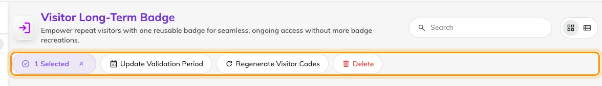
Selecting rows swaps Create and Import for the badge actions, Disable and Delete among them.
Action | What it does | When to use it
Update Validation Period | Sets a new period, or removes the limit | A contract is extended, or a badge was issued open-ended by mistake
Regenerate Visitor Codes | Issues a new code and rebuilds the mobile pass | A code has been shared or a phone was lost. The old code stops working
Generate mobile passes | Builds the Wallet pass for badges without one | Badges created before Wallet passes were switched on
Send Emails | Sends the badge email again | The visitor never received it, or the code was regenerated
Disable | Blocks the badge without deleting it | Someone is off site for a while, or under review. Reversible
Enable | Puts a disabled badge back in service | The reason for disabling it has passed
Delete | Removes the badge entirely | Housekeeping. Prefer Disable where you may need the record

Four of them appear only when they apply, which is why the bar is a different
length from one selection to the next: Disable and Send Emails need a
live badge in the selection, Enable needs a disabled one, and Generate
mobile passes a badge without a pass. Select a mixture and you get both
Disable and Enable at once.
Export all writes the whole list to a spreadsheet, which is the quickest
answer to "who from that firm still has access".
Where in Offision: admin app → visiting/visitor-regular-badge (Visitor Long-Term Badge)

Let the period do it instead
Update Validation Period is the action to reach for when there is a date
rather than a decision. It opens Edit Validity Period, and setting the period
to match the contract ends the badge on its own — an expiry that looks after
itself is better than one that depends on being remembered.
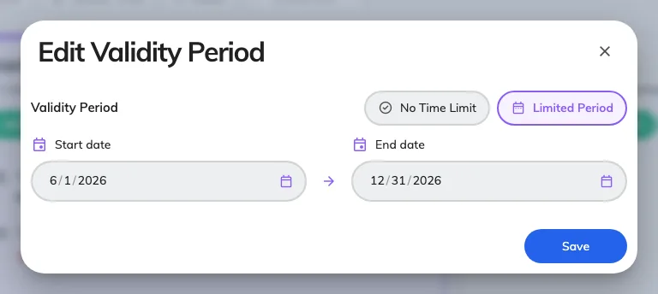
Edit Validity Period, applied to every badge selected. No Time Limit removes the dates again.
It applies to the whole selection, so thirty badges from one firm take one edit.
The same dialog removes a limit: switch to No Time Limit and the badge works
until somebody disables or deletes it.

Disable, or delete
Disable is the everyday one and the safe one. The badge stops working
immediately, the row stays on the list, and Enable puts it back with the same
code — so a contractor between engagements keeps their pass rather than being
re-issued one.
Delete removes the badge outright. Use it for housekeeping, not for
withdrawal: a deleted badge cannot be put back, and the visiting records that
holder already has are the only trace left that they ever had a pass. Deleting a
badge does not delete the visitor, whose record and visit history are removed
separately — see
Find, blacklist and delete a visitor's record.
The holder sees the result themselves, in the visitor app under Regular
passes, where a stopped badge reads Invalidated or Expired rather than
disappearing.

Check it worked
Present the code at a lobby board. A badge that has been disabled or has run out
of period is not refused with an explanation — the board answers Visitor record
not found, exactly as it would for a code it has never seen. That is the check:
a code that still opens Quick walk in is still live.
Stopping a badge does not close a door:
A long-term badge identifies a person at the lobby and grants no access control
of its own, so disabling one takes nothing away at a door your own
access-control system releases. Withdraw that where the credential was issued.
It also leaves an arrival already checked in alone: the visit is open until it is
checked out, badge or no badge.

What happens to the Wallet copy
Disabling or deleting the badge also invalidates its issued Wallet pass. Re-enabling a disabled badge restores the existing pass. Updating the validity period or regenerating the visitor code refreshes the pass contents. A phone can show the previous card until it receives the update; the current badge state is still what the lobby validates.

