Email a forecast of upcoming visitors
Schedule a recurring email that counts the visitors expected in the coming day or week and attaches the full list as a spreadsheet — who receives it, what the counts include, and how to send one immediately to check it arrives.
2026-09-02 · https://offision.com/help/en/visiting/email-a-visitor-forecast/
A subscription, not a viewer: this forecast, this often, to these people,
about these buildings. The email counts the visitors expected in the coming
window and attaches the full list as a spreadsheet, so a facilities manager
knows tomorrow's load without opening the console.
Before you start:
You need Setting manager permission to create the subscription, and email
sending must already work — the report goes out through the same sender as
every other Offision email.

1. Open the email report page
In the Visitor module the page sits under Settings, behind
Show more — it is not one of the pinned entries.
Where in Offision: admin app → visiting/email-report (Email report)
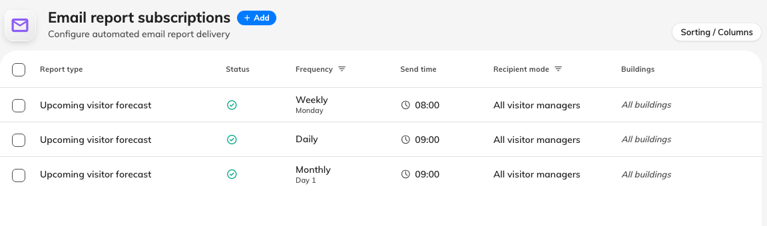
Each row is a standing instruction with its own recipients and schedule.

2. Add a subscription
Choose Add. Report type is already Upcoming visitor forecast — the
only report the visitor module publishes. Leave Enabled on; turning it off
later pauses the sending without losing the recipients.
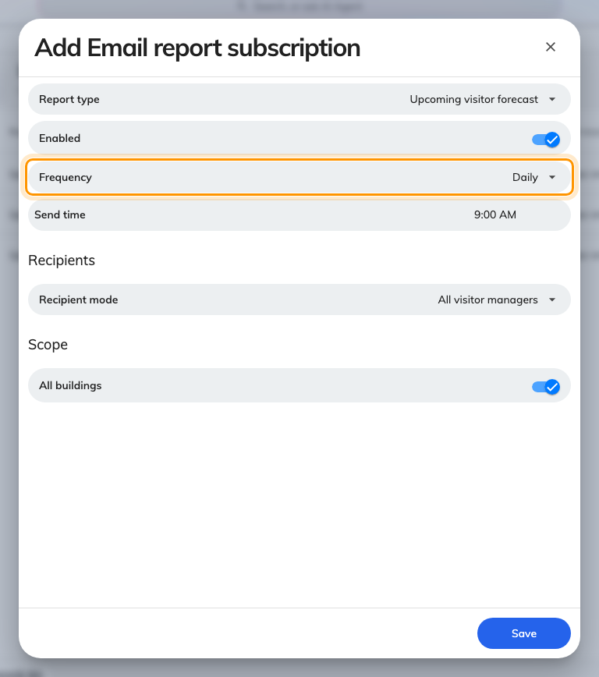
Frequency and send time decide when the email goes out.

3. Choose the schedule
Frequency | Arrives | Covers
Daily | Every day | The next day
Weekly | The day of week you pick | The next seven days
Monthly | The day of month you pick, 1 to 28 | The next day

Every forecast starts tomorrow — today's arrivals are never in it. Only
Weekly widens the window; a monthly email still covers a single day.
Send time is honoured to the hour, in the system time zone.

4. Choose who receives it, and which buildings
Under Recipients, All visitor managers sends to everyone holding
Visitor manager or Global administrator, resolved fresh at each send;
Specify recipients names people or user groups. Either way the list is
filtered to people who hold Visitor manager or Global administrator —
naming anyone else, directly or through a group, silently drops them. A
subscription addresses managers; it never grants sight of visitor data.
Leave All buildings on, or turn it off to scope the forecast to the
buildings one recipient runs. Then Save.

5. Send one now to check
Select the subscription and choose Send now in the panel on the right.
This is a live send to the real recipients, not a preview — check a
recipient's inbox, not just the confirmation.

What arrives
The email leads with the day (or week) it covers, then four counts — total
visits, distinct visitors, hosts, and buildings involved — a View details
link into the Visitor badge list, and the full list attached as
visitors- .xlsx, named for the day the forecast covers, not the day
it was sent.
If it does not arrive: the recipients most likely lack Visitor manager — if
nobody on the subscription qualifies, nothing is sent at all. Then check
Enabled, then whether the schedule has simply not come round yet
(Send now distinguishes the two), and last whether any Offision email
reaches anyone. An email of zeroes with an empty spreadsheet is the schedule
working on a quiet day, not a failure.

