Email your managers a summary of visiting records
Schedule a recurring email that counts the visits of the past week, fortnight, month or calendar quarter — or the ones coming up — and attaches a one-page PDF and a spreadsheet of every visit. About ten minutes, and you can send one immediately to check it arrives.
2026-09-23 · https://offision.com/help/en/visiting/email-a-summary-of-visiting-records/
The visiting module publishes two reports from one page. Visiting record
summary looks back — the visits of the past week, fortnight, month or quarter, who
came, who received them, and how many never showed. Upcoming visitor
forecast looks ahead at the visits already invited. Both arrive on a schedule
you set, with a one-page PDF and a spreadsheet attached.
Before you start:
You need Setting manager permission — read to see the page, write to save a
subscription or send one. Email sending must already work; the report goes out
through the same sender as every other Offision email.

1. Open the email report page
In the Visiting module, the page sits under Settings in the list down
the left — but it is not one of the pinned entries, so you have to choose
Show more before Email report appears.
Where in Offision: admin app → visiting/email-report (Email report)
A subscription is a standing instruction: this report, this often, to these
people, about these buildings. A weekly summary for the reception lead and a
daily forecast for the security desk are two subscriptions, not one compromise.
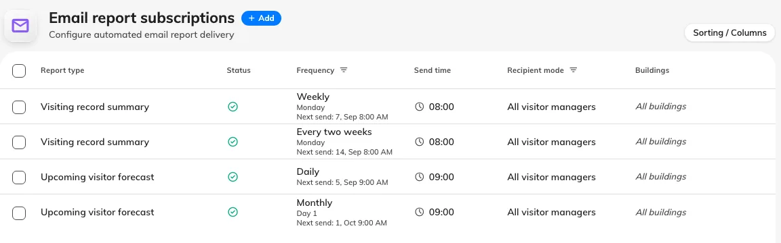
Every subscription on the page, with its report type, how often it sends and who it goes to.

2. Add a subscription
Choose Add. The dialog opens on Report, where the two reports sit as
cards side by side: Visiting record summary, the period just gone, for the
figures a manager reads after the fact, and Upcoming visitor forecast, the
days ahead, for the desk that needs to know who is expected. A new
subscription starts on the summary.
Everything else is on the rail down the left — Schedule, Recipients and
Scope — under a pill reading Active. Choosing that pill pauses the
report: it keeps every setting and every recipient and sends nothing until you
turn it back on, which is how you stop a report for a month without losing who
it went to.
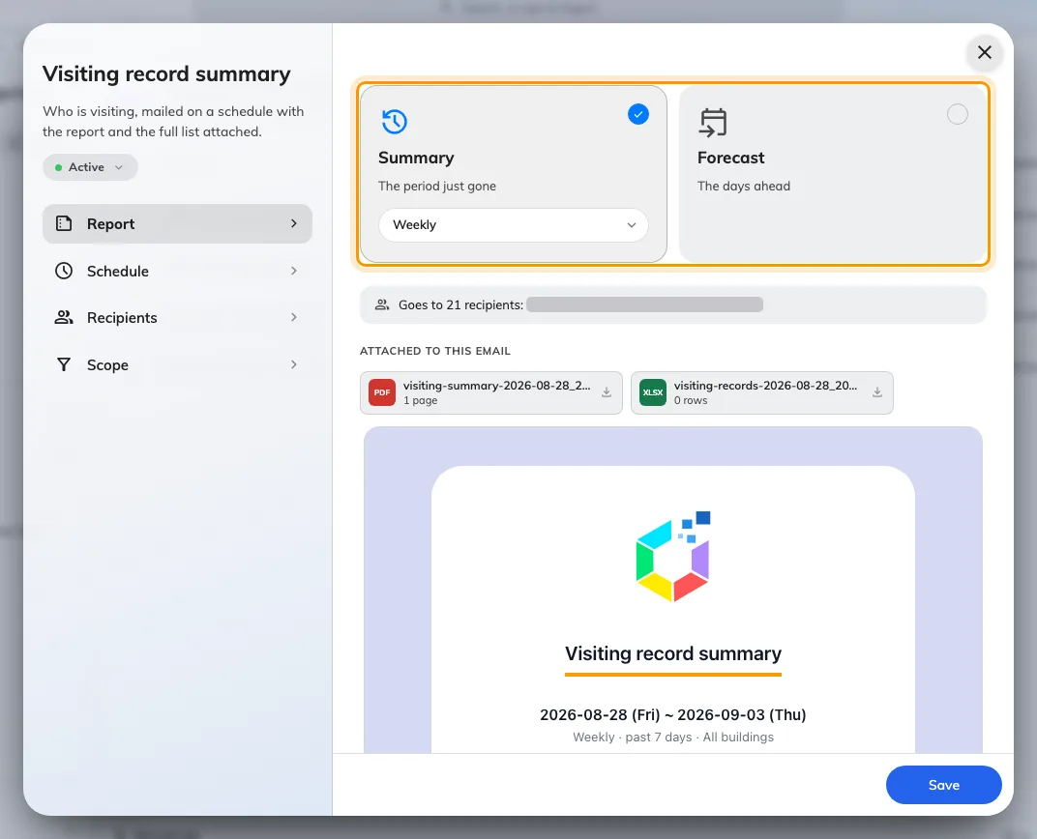
The Report page: the two cards, and under them the mail this subscription would send.

3. Choose how often it arrives
The frequency sits on the selected card, as a pill under its name. It decides
both when the email arrives and how much it covers, and the two reports read it
differently. A summary ends at midnight at the start of the day it is sent, so
it never includes a half-finished day.
Visiting record summary
Frequency | Arrives | Covers
Weekly | The day of week you pick | The past 7 days
Every two weeks | The day of week you pick, every second week | The past 14 days
Monthly | The day of month you pick, 1 to 28 | The past month — one month back from the send date, ending yesterday
Quarterly | The day of month you pick, in January, April, July and October | The last full calendar quarter, even from Send now

Daily is not offered for the summary; Quarterly is offered for nothing else.
Sent on the 1st, a monthly summary covers the previous calendar month exactly.
Upcoming visitor forecast
Frequency | Arrives | Covers
Daily | Every day | Tomorrow
Weekly | The day of week you pick | The next 7 days
Every two weeks | The day of week you pick, every second week | The next 14 days
Monthly | The day of month you pick, 1 to 28 | Tomorrow

Every two weeks starts from the day you create it:
The first send is the first chosen weekday on or after the day the subscription
was created, then every 14 days from there. Schedule lists the next four
sends and the period each one reports on, so you can see which week it landed
on before you save. If it is the wrong week, recreate the subscription on a day
that gives you the other one — there is no setting to shift it.
Changing the day of week later re-anchors from the creation date with the
new weekday, so read the list of sends again after editing. Send now never
shifts the cadence. Weekly and Every two weeks refuse to save without a
day of week, and Quarterly without a day of month.
Schedule lists the next four sends and the period each one covers.
Send time is honoured to the hour, in the system time zone — minutes
are ignored, so 09:30 and 09:00 both send during the 9 o'clock hour. If the
server is down for that whole hour, the occurrence is skipped rather than sent
late. Day of month stops at 28 because 29, 30 and 31 do not exist in every
month.

4. Choose who receives it
Recipients, on the rail, offers two modes:
- All visitor managers — everyone holding Visitor manager or Global
administrator, resolved fresh at the moment each report is sent, so people
joining or leaving that role are picked up without anyone editing the
subscription.
- Specify recipients — name individual people, user groups, or both. A user
group is expanded to its members when the report is sent.
Either way, recipients are filtered to people who hold Visitor manager or
Global administrator. Naming someone without those rights, directly or
through a group, does not add them — a subscription addresses managers, it
never grants sight of visitor records to somebody who cannot otherwise see them.

5. Choose which buildings it counts
On Scope, leave All buildings on and the report covers every visiting
location. Turn it off to pick specific buildings — a site lead's report about
their own building rather than the whole estate.

6. Read the mail before you save
Go back to Report. Under the two cards the dialog builds the email this
subscription would actually send — real figures, both attachments, and
Goes to N recipients naming the list that survives the manager filter — and
rebuilds it whenever you change a setting.
No one would receive this report is the first cause at the foot of this page,
caught before the first send.
Finish the schedule to see the mail this report sends means the schedule is
still incomplete — a weekly report with no day of week, say.
Then choose Save.

7. Send one now to check
Select the subscription, and choose Send now in the panel on the right. The
report goes out immediately, to its real recipients — a live send, not a
preview. It confirms the report was requested, not that it was delivered, so
check a recipient's inbox.

What arrives
Both reports share one layout. The email leads with the period it covers, then
a headline count — visits for the summary, expected visits for the
forecast — with the change against the comparable period: the previous 7, 14,
30-odd or 90-odd days for a summary, the same number of days just gone for a forecast.
Then:
- Visits per day, with the busiest day picked out
- Visitors, Hosts and Buildings — how many distinct ones
- A status bar — Checked in against No-show on the summary, Approved
against Awaiting approval on the forecast
- Top hosts — the people who received the most visitors
- Attached — the two files that ride along
View records on the summary, or View upcoming visits on the forecast,
opens the visiting record page with the same period already selected.
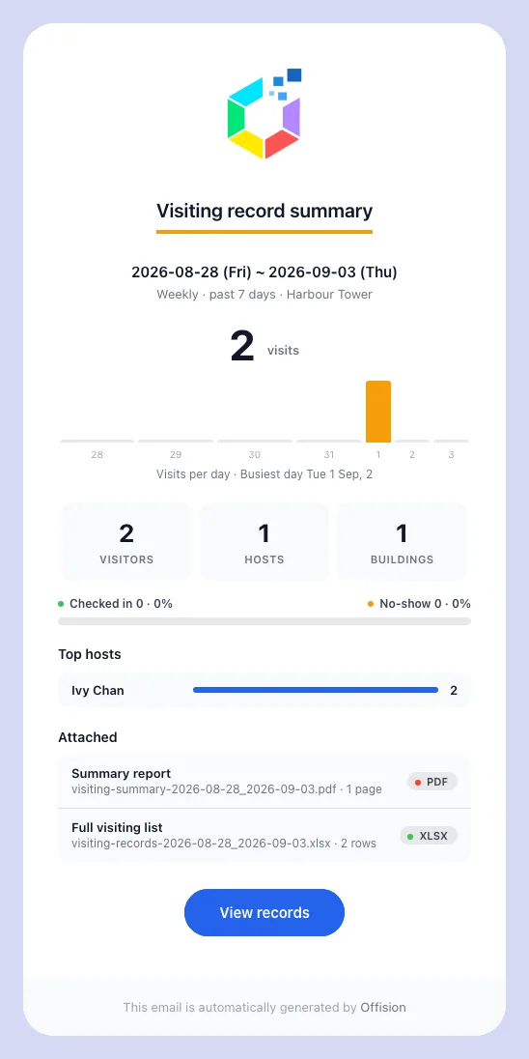
A weekly Visiting record summary, as it lands: the period, the headline count and the change on it, then the breakdowns.
Every report carries a one-page PDF of the summary above and a spreadsheet
listing every visit in the period. Its Invited / walk-in column names each
visit in words, and a visit deleted from the console drops out of the
spreadsheet — and out of the totals — with it.
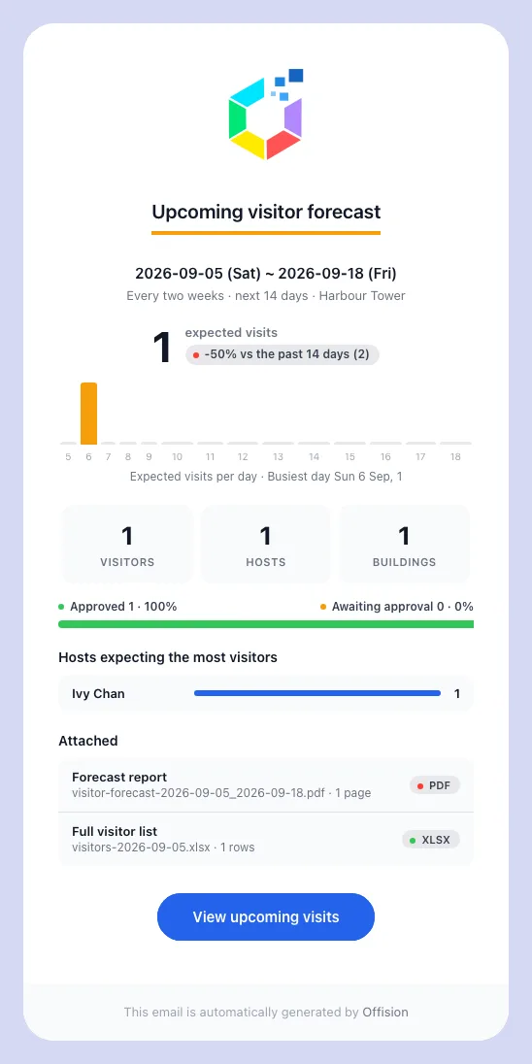
The forecast of the same shape, looking the other way: the visits already invited for the days ahead.
Report | PDF | Spreadsheet
Visiting record summary | visiting-summary- _ .pdf | visiting-records- _ .xlsx
Upcoming visitor forecast | visitor-forecast- _ .pdf | visitors- .xlsx

The dates are yyyy-MM-dd and name the days covered, not the day the report
was sent — a weekly summary sent on 8 September is called
visiting-summary-2026-09-01_2026-09-07.pdf.
The report inherits your email branding, and its wording is edited under the
template types Visiting record summary and Upcoming visitor forecast —
see Change the wording of an Offision email.

If the report does not arrive
Work through these in order:
- The recipients are not visitor managers. The commonest cause by far.
Everyone named, directly or through a group, must hold Visitor manager or
Global administrator; anyone else is dropped silently, and if nobody
qualifies nothing is sent at all.
- The subscription is paused. The list shows its status as Disabled.
Open it and choose the Paused pill on the rail to start it again.
- The schedule has not come round. Check Next send. If Send now
arrives and the scheduled send never does, the schedule is the problem, not
the recipients.
- Email sending is not set up. If no Offision email reaches anyone, the
problem is the sender rather than this report.
An empty report is not a failure. When nobody visited in the period the report
still arrives, showing zeroes and carrying an empty spreadsheet — that is how
you tell "nobody came last week" apart from "the report stopped coming".
Still need help:
Note the report type, frequency and Next send, the recipient mode, whether
the people named hold Visitor manager, and whether a Send now test arrived.

