Why a room refuses your booking
Book is greyed out, or a red line sits above it. Each refusal is a rule somebody set on purpose — what the five you are most likely to meet actually mean, and who can change them.
2026-08-30 · https://offision.com/help/en/user-guide/why-a-room-refuses-your-booking/
Book stays greyed out until the form is both complete and allowed: something
required is still empty, or the booking is being refused just above the button.
The refusals you are most likely to meet:
What it says | What it means
Conflict with … | The room is taken for part of your period.
"you have another booking" | You are the clash, not the room.
"…only allows bookings within 60 days" | Too far ahead — see Limit how far ahead people can book.
"This resource only supports walk-in bookings." | This room is taken at the door, not in advance.
"…is not allowed to book as out of business hour" | Outside the hours the room is available.

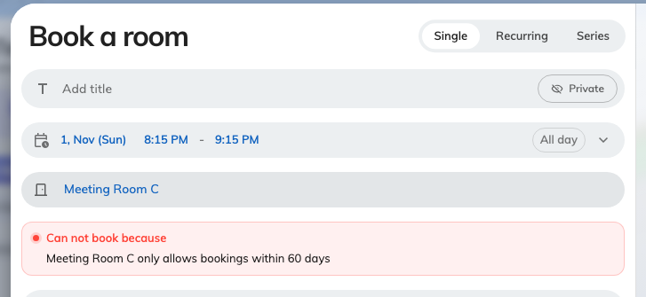
A booking placed past the room's window, with Book unavailable.
A refusal is not a fault to report — every one of them is a rule somebody set on
purpose, and the room's own settings decide which apply. The form that produces
them is walked in Book a meeting room.

