Take a free room at the panel outside it
The room is free, you are already standing at the door, and the meeting starts now. Walk in on the panel holds the room from this minute until the length you pick — no form, no app, and nothing to check into afterwards.
2026-09-13 · https://offision.com/help/en/user-guide/take-a-room-at-the-panel/
A free room's panel offers Walk in. Press it and the room is yours from this
minute until the length you pick — without opening the app, without the booking
form, and without checking in afterwards, because standing at the door is the
proof a check-in would have asked for.
Before you start:
A room that is free right now, and a panel with buttons on it. You will usually
need something that identifies you — your card, your phone, or your passcode —
though some panels are deliberately set to ask for nothing.

1. Tap Walk in
Walk in is on the panel of any room that is free. A room already in use shows
End now and Extend instead, and a room waiting for somebody to arrive
shows Check in — so the button you see tells you what the room is doing.
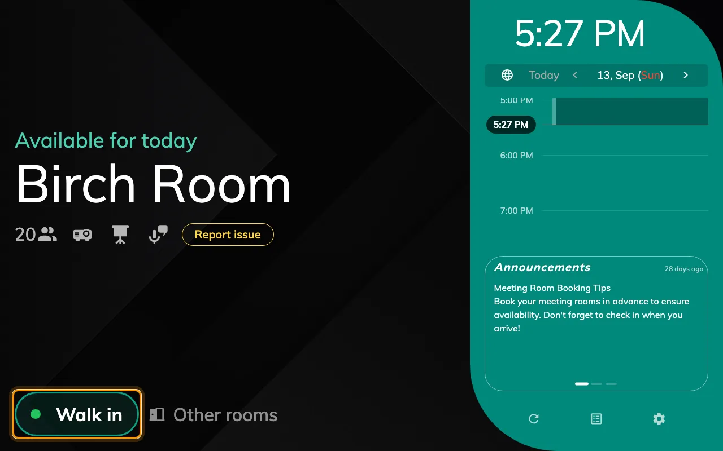
Walk in, on a free room. A room in use offers End now and Extend instead.

2. Pick how long you need it
A column of lengths, each showing the time it would end at, with a
Duration / Time switch above them. It only ever offers what the room can
actually give: the list stops at the next booking, and the row underneath says
when that is.
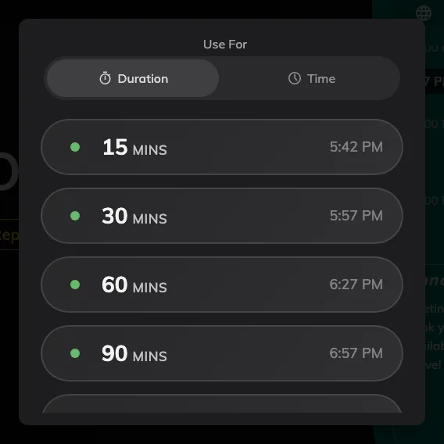
The lengths this room can give, ending before whatever is booked next.

3. Say who you are
The panel then asks who is taking the room. Which ways it offers is set on that
panel — a staff card, the QR code in your Offision app, your own passcode, or
your face — so two panels in the same building can ask for different things.
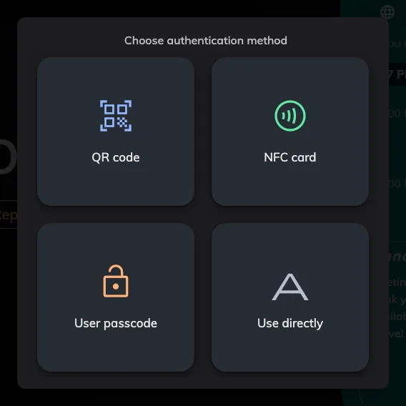
The ways this panel accepts. Use directly is the panel asking for nothing at all.
If you have no card and no phone on you,
set your user passcode once and it works at every
panel afterwards. The full list of methods, and what each needs in place, is in
How somebody proves who they are at the panel.

4. Confirm, where the panel asks
One last screen. What it asks for is up to whoever set the panel up — a name for
the meeting, how many are coming, both or neither. The name box starts empty,
showing Walk in booking in grey as a suggestion: type over it, or leave it
and that is the title you get. Anything you leave blank is left alone, and an
unasked headcount counts as one. Panels set up for one tap skip this screen
altogether, and the room is yours as soon as you have identified yourself.
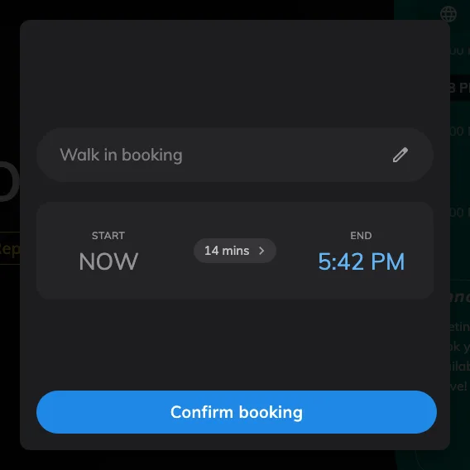
The confirmation screen, asking for a name. Where it is turned off, the walk-in ends one step earlier.
Rooms that ask you to accept terms and conditions put that screen before the
identification step, and a walk-in cannot skip it.

5. It is yours, and there is nothing to check into
The panel goes straight to in use. A walk-in never needs checking in afterwards —
that is the difference between taking a room at its door and booking one in
advance from your desk.
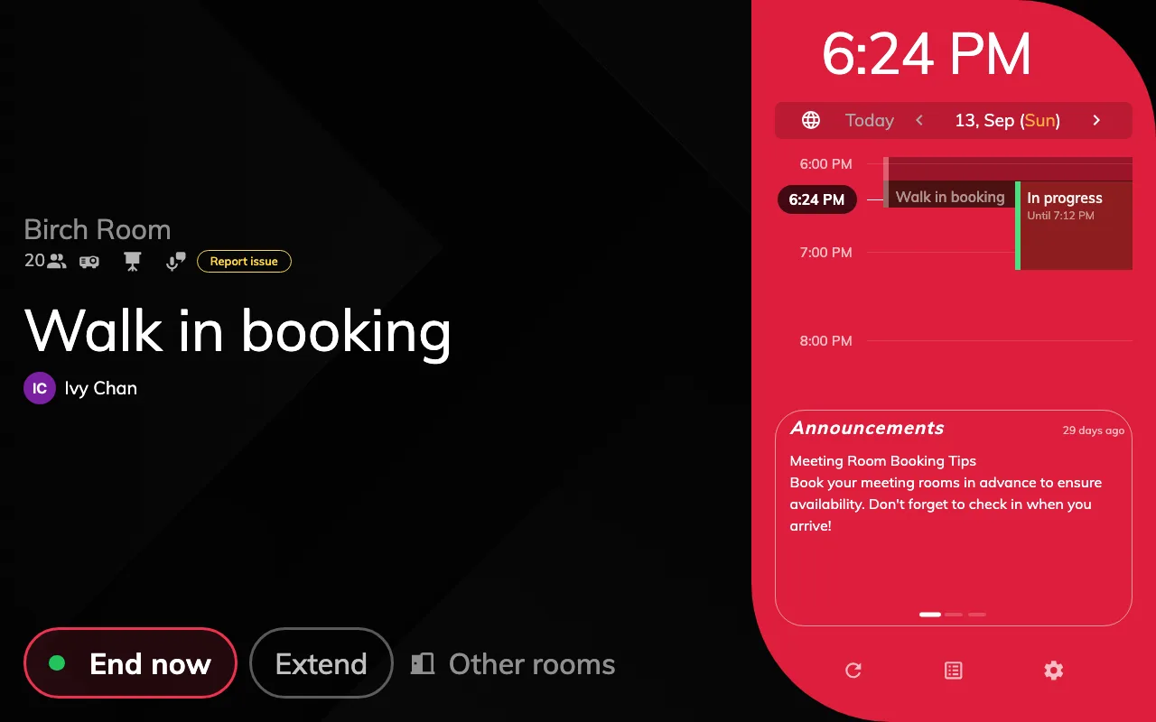
Straight to in use. No check-in step, and the room is held for the length you picked.
The booking appears in the room's calendar under your name, and on your own
schedule with everything else. Where the panel let you identify as nobody, it is
recorded with no organiser instead — the room is held, but nothing says who took
it. From here the same panel will
extend it or end it early.

When there is no Walk in button
Two of these you can see for yourself, and the rest are settings somebody
administers:
- The room is not free. Walk in exists only on a free room.
- The next booking starts within five minutes. The button goes rather than
offering you a room somebody is about to walk into.
- The room takes no bookings for today — some rooms have to be booked at
least a day ahead.
- The room does not accept bookings made at its panel, or the panel is set to
show status only, with no buttons at all.
A busy room can still find you one:
Where the panel is showing a room that is taken, Other rooms lists what else
is free in the building and books it in two taps — see
Finding another room from the panel.
Away from the door, Find a room right now does the
same job in the app.

