Ask for tea, cleaning or help
Two moments to ask for something to be done for your meeting — ordered with the booking, or called for while it is running — what each one asks you, how to follow the request afterwards, and why the list of services in front of you is not the same as anybody else's.
2026-08-25 · https://offision.com/help/en/user-guide/request-a-service/
A service is something a person does for your meeting: bringing the tea in,
clearing the room afterwards, coming to look at a screen that will not wake up.
You do not arrange it — you ask, and it reaches whoever does that work.
There are two moments to ask, and they are not interchangeable. Which one a given
service belongs to was decided when somebody built it, so tea waiting for you at
the start and a fresh pot at half past three may well be two different services,
each asked for in a different place.
Before you start:
You need a room that has services attached to it. Nothing here is set up by you,
and a room offering nothing is the normal state of most rooms.

1. Order it with the booking
Anything that has to be ready before people walk in — tea, a layout, cleaning
afterwards — is ordered on the booking form, at the same time as the room.
Fill the form in as usual, then look near the bottom for a row reading
Request service. It counts what this room offers — (2 Options) — and
carries a grey dot while you have chosen nothing.
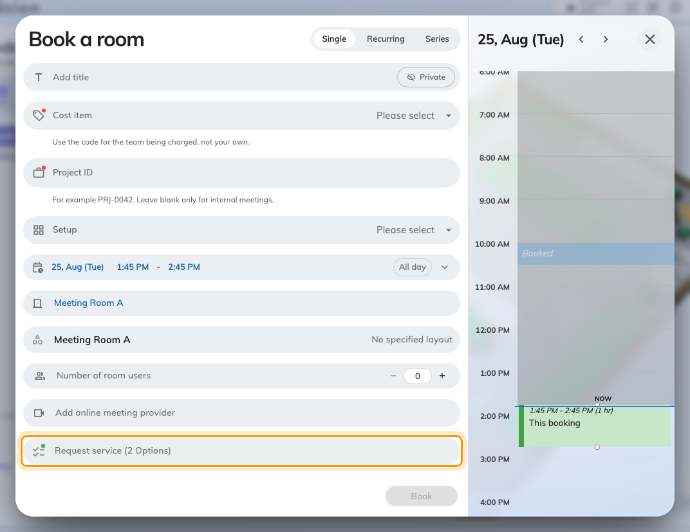
The Request service row, closed. The count is what this room offers, not what you have taken.
It is not there until you have picked a room. Services hang off the room
rather than off the form, so an empty form has nothing to show you. If you were
expecting it, choose the room first and look again.
Open the row and tick what you want.
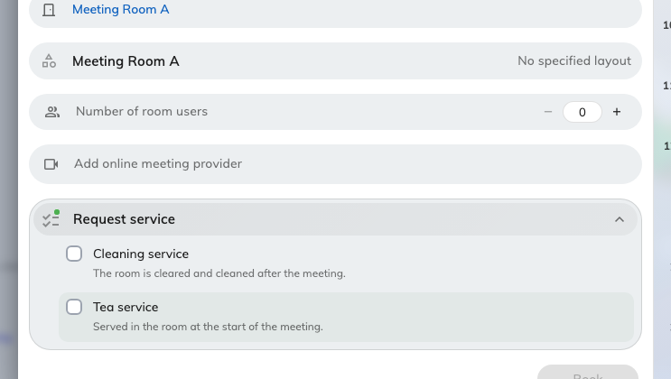
Open: this room's services. The names here are one company's — yours will be different.
- Some services ask a follow-up question — how many cups, hot or cold, what is
wrong. A red dot marks an answer that is still missing, and the form will
not let you book until it has one.
- Remarks takes anything the question did not cover. It is headed Remarks
for service staff, and that is exactly who reads it.
- A service marked (Default) comes with the room and cannot be unticked.
- Where a service has conditions, you are asked to read them — Please confirm
terms for service — before it can be taken.
Then book as normal. The request goes out when the booking is saved, not before.
Ordering tea can make the room busy for longer than your meeting. A service
that needs laying out beforehand, or clearing afterwards, takes that time out of
the room's day — so a meeting until five with cleaning after it can hold the room
until quarter past. See
How a service request works.

When the form refuses a service
The service stays on screen and says why underneath it:
What it says | What it means
Only allowed to select at … before the booking start | Too late to order it. There is a cut-off, and your meeting is inside it
… is not allowed to select out of service hour | The people who do it are not working then. The hours are shown beside the message
… does not have enough preparation time | It needs longer to get ready than the gap before your meeting
Conflict with other service preparation time | Two things you have ordered want the room at once
… is not allowed to select since resource are out of service | The room is closed for that period

Moving the meeting later clears most of these.

2. Or ask while the meeting is running
Nobody plans a spill. Anything you only discover once you are in the room is
asked for from the in-use bar — the dark pill at the top of the app on a
computer, along the bottom of the home screen on a phone.
Open it, and Service sits beside Extend and End.
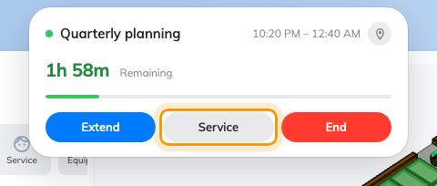
The in-use bar, open. Service sits beside Extend and End.
It is there only once the meeting is actually under way. A booking that has
started but has not been checked into does not offer it yet.
Press it, and the request takes three taps.
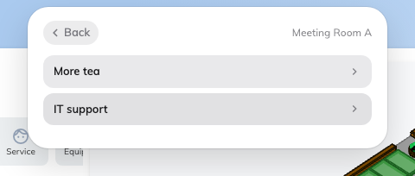
The room's services. One already asked for is marked instead of opening.
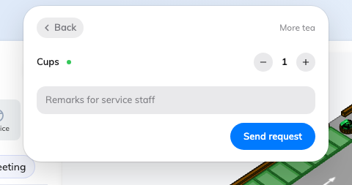
The service's own page: what it asks, a line for the staff, and Send request.
- Pick the room, if your booking holds more than one. Where it holds one,
this step is skipped.
- Pick the service. Something you have already asked for this meeting is
marked Requested instead of opening again. Where the room offers exactly
one service, it opens straight away.
- Answer what it asks — a count on a plus-and-minus stepper, a choice to
tap, a line of text — add anything else under Remarks for service staff, and
choose Send request.
A tick and Send Success confirm it. The room goes with the request
automatically, so nobody has to say where you are.
The same request can also be made at the panel outside the door, and from a QR
code on the table where the room has one — see
Request service at the room panel.

What you can actually ask for
The services in the pictures above are one demo company's — yours will not
match them. What you are offered is your own organisation's list, and only the
part of it that somebody attached to the room you picked. Two rooms on the same
floor can offer completely different things, or one of them nothing at all.
Three more things change the list in front of you:
- A service belongs to one moment or the other. Something you can order with
the booking will not appear during the meeting, and the reverse. If you cannot
find it in one place, look in the other before reporting it missing.
- Choosing a booking purpose can replace the whole list. Where a purpose
carries its own services, they stand in for the room's — so changing the
purpose can change what is on offer, or leave nothing on offer at all.
- Service hours are the service's own, not the room's. Outside them it is not
listed, which is better than a request nobody answers.
An empty list, or no Request service row at all, is the normal state of a
room nothing has been attached to. It is not a fault.

Following it up
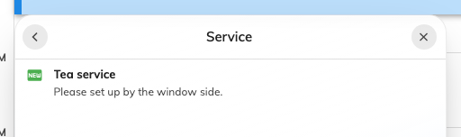
A service on a booking, carrying the status it has reached.
Open the booking and look at its services. Each one carries where it has got to —
New request, In progress, Finished, or Rejected. Staff response
appears against a request where the person doing it wrote something back.
You are emailed about a change only when they choose to tell you, so a status that
has moved quietly is normal rather than a fault. For the queue behind those
statuses, see
How a service request works.

Cancelling
The two routes differ, and this is the part worth knowing before you need it.
- Something you ordered with the booking is removed by editing the booking
and unticking it — see Edit a booking. A (Default)
service, one that came with the booking purpose, or one already past its
cut-off cannot be taken off that way.
- Something you asked for during the meeting cannot be withdrawn. There is no
button for it. Tell the person who turns up, or ask at the panel.
Cancelling the booking removes everything ordered with it, and tells whoever was
going to do the work.

When there is no Service to press
Why | What to do instead
The room has nothing attached to it | Nothing in the app. Ask whoever looks after that room
It is outside the service's own hours | Wait until they start, or use the room's own contact route
The meeting has not been checked into yet | Check in first; the control appears once the room is in use
The booking is not yours | Ask the organiser
A booking purpose replaced the room's list | Try the booking's other purpose, if it has one that suits
Service is not switched on for your organisation | Nothing in the app

What this is not
A hold on your booking | A booking that needs approving does not wait for the tea, and approving the booking does not approve the tea
A way of booking the room longer | A service ordered with the booking can block the room afterwards, but it is not extending your meeting — see Extend a meeting, or end it early
A message to a person | It joins a queue. Who picks it up is decided by how the service was set up, not by you

