Join an event, or register for one
Some events take one tap and some open a form — what decides which, and what the button says when you cannot sign up at all.
2026-08-27 · https://offision.com/help/en/user-guide/join-an-event-or-register-for-one/
Signing up is one of two things, and the event decides which.
Join is a single tap in the list, confirmed with a second. Nothing opens and
you stay where you are — this is what you get when the organiser needs nothing
from you beyond your name.
Register opens the event, because the organiser is asking you something: a
question of their own, or which sections of a course you want. Answer it and
confirm.
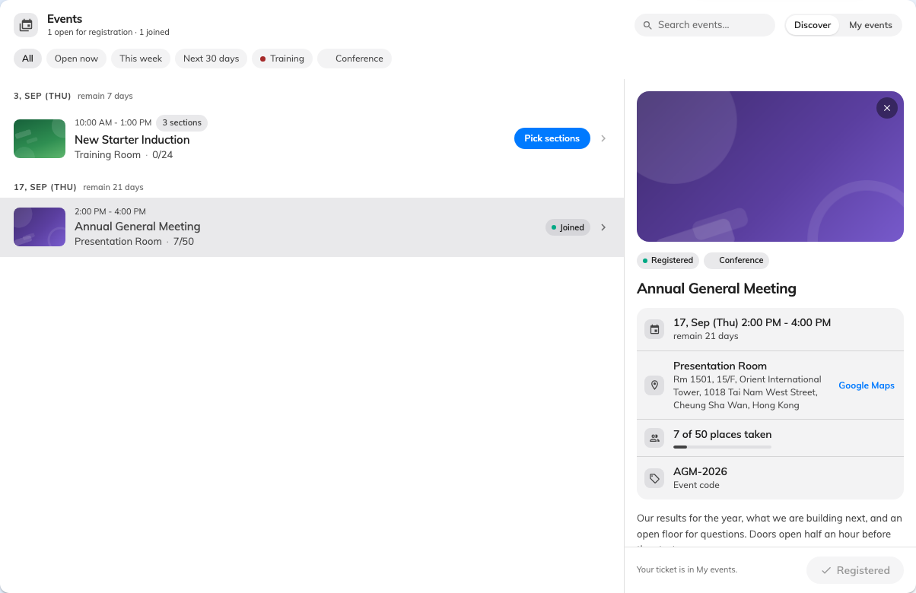
Picking an event opens its details beside the list, with the button that joins it.

When the button is something else
The control tells you what is going on before you press it:
It says | What it means
Joined / Registered | You are already in. Your ticket is under My events
Full | Every place is taken
Open now is missing, and sign-up is closed | The registration window has ended, or has not opened yet
Nothing to press | The event is shown for information only — the organiser is not taking sign-ups here

That last one catches people out. An event with no sign-up control is not broken;
it is being advertised rather than filled, and anyone attending is being invited
by name instead.
You will not get an email:
Signing yourself up sends nothing — no confirmation, no wallet pass. That is
normal and nothing has failed. Your ticket and its QR code are in My events
in the app, and Your ticket is in My events is what the app tells you at the
time.

Changing your mind
There is no cancel button. The app says so plainly — To withdraw from this
event, contact the organiser — so tell whoever is running it and they will take
you off the list. See you can't cancel your own registration.

