Invite a visitor
Booking a guest in from your own account: one form, reached three ways, the same on a computer and on a phone. What each field decides, and why the pass with the QR code usually arrives later than the invitation.
2026-08-17 · https://offision.com/help/en/user-guide/invite-a-visitor/
Anyone with an Offision account can book a visitor in for themselves — no admin
console, no request to reception. It is one form, and the whole thing is four
answers: when they arrive, where they are going, what kind of visit it is, and
who is coming.
Before you start:
Two settings decide whether you can do this at all. Allow staff to invite
visitors from the user app must be on, and at least one building must be
marked for visiting — with no such building, nobody in the company is offered
the button.

1. Open the invite form
On a computer, pick Visitor from the row of filters on the home page. The
panel below it becomes the visitor day: whoever you have invited for that date,
and Invite visitors above them.
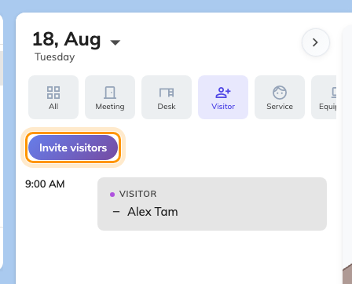
The Visitor filter: the day's visitors, and the button that starts a new invitation.
On a phone, tap + at the bottom right and choose Visitor. It opens the
same form.
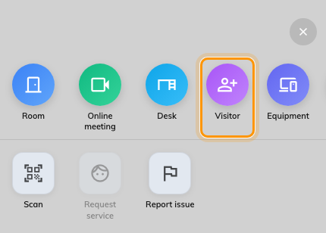
The phone's + sheet. Visitor is the fourth tile.
The form opens with today's date and your company's default visiting purpose
already chosen. Where the company has one building open to visitors, the location
is filled in too; with several it starts empty — the row carries a red dot, and
opening it says No location yet until you pick one. Each row expands when you
tap it and collapses to a summary when you move on, so the form always shows the
answers you have given so far.
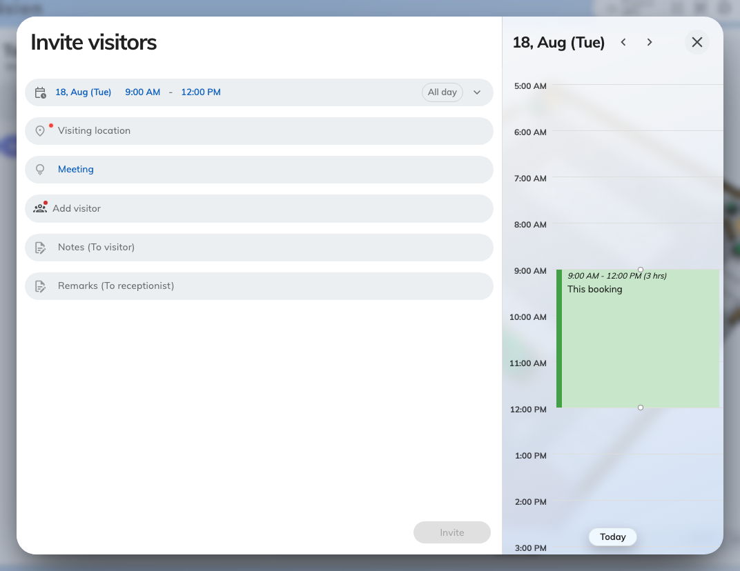
The invite form. Every row shows its own answer once you have given it.

2. Say when they arrive
The top row is Time: when they arrive and when they leave, with three pills
under it. All day is for a guest who is around all day rather than at an
appointment, Repeat turns the visit into a series for a contractor who comes
every Tuesday, and Time zone is for a visitor whose day is in another one.
The times are not free-for-all: the building's visiting policy can limit how far
ahead you may book, how long a visit may last, and whether a visit may cross
midnight. When something you have chosen breaks one of those rules, the form
says so under this row and Invite stays greyed out until it is fixed.
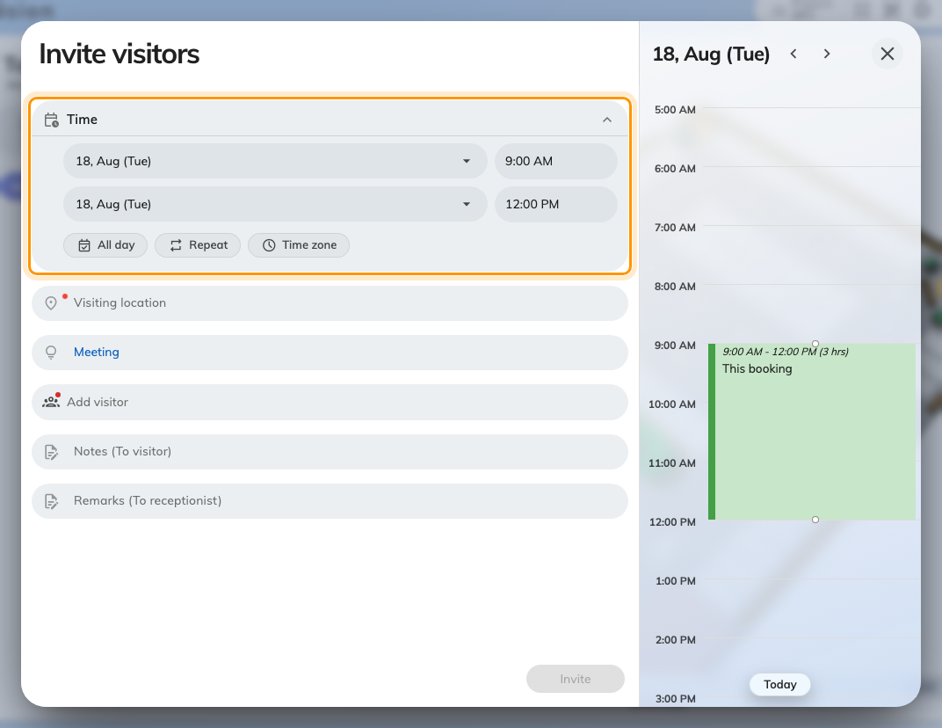
The visit period. On a computer the day beside it shows what else is on.

3. Choose where they are going
Visiting location is the place the visit belongs to, and it decides which
reception desk sees the visitor when they arrive. Only buildings open to visitors
are listed here — a company with ten buildings may put guests in three of them.
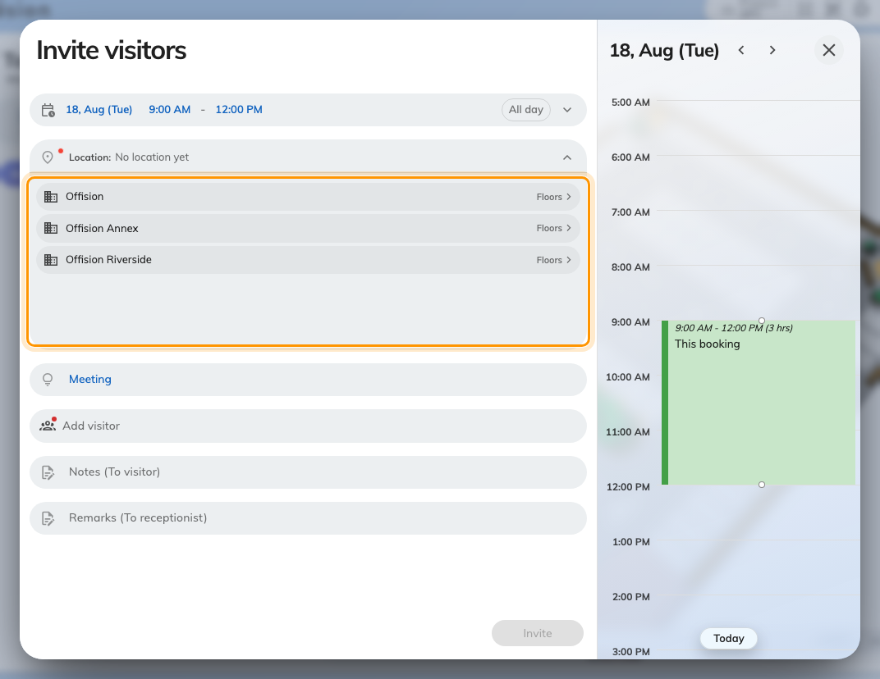
Visiting location. Only the buildings open to visitors appear.
A building on its own is a complete answer: tap its name and you are done. Where
it has floors or rooms open to visitors, Floors on the right of the row drills
in instead, and Rooms goes one level deeper — so you can be as precise as the
visit actually is, and No specific floor keeps it to the whole building.
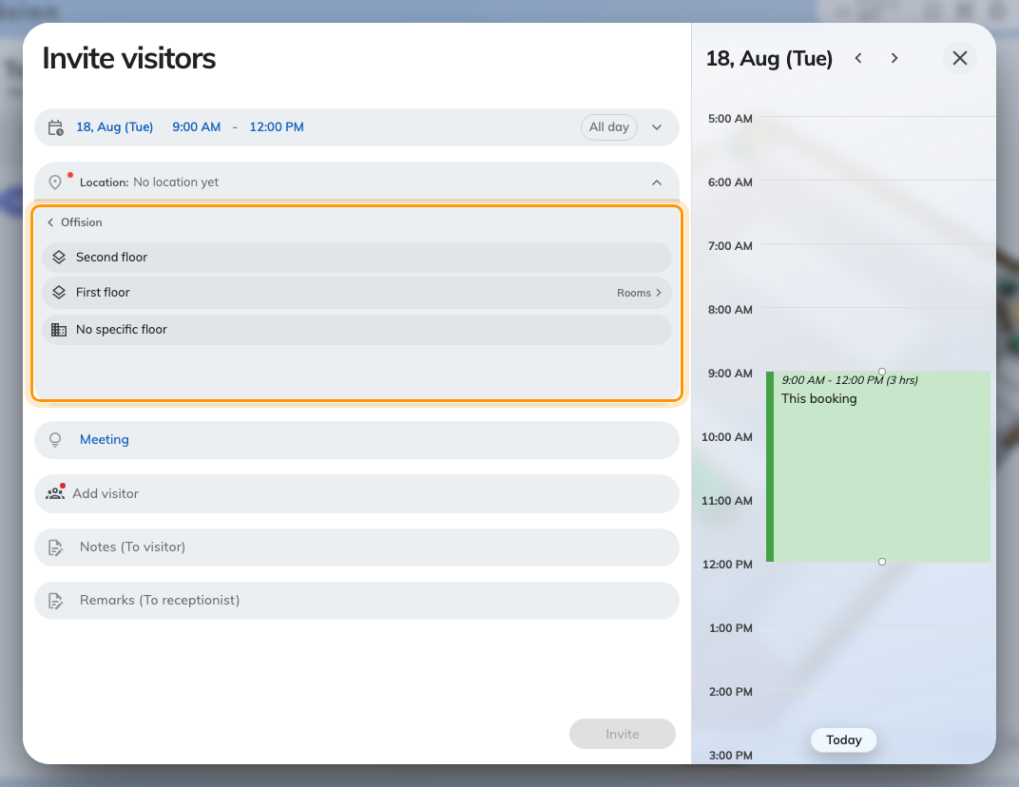
One level down: the building's floors, with the whole-building answer still offered.
Choosing a room here does not book that room. If you also need the room, book
it as a meeting and invite the visitor from the booking instead — see Invite a
visitor while booking a room.

4. Pick the visiting purpose
The purpose is the most consequential field in the form, and the one people skip
past. Your company defines a small set — Meeting, Interview, VIP and
so on — and each one carries its own rules: what you must know about a visitor
before you can invite them, whether the visit needs approving, and what
reception asks for at the desk, including a photo and any visitor survey.
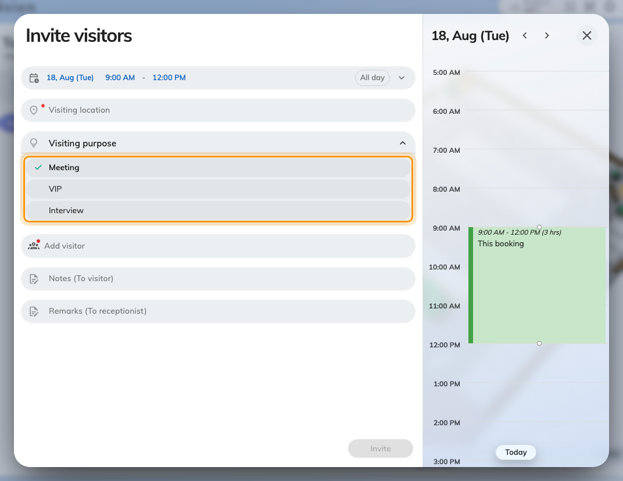
The visiting purposes your company has defined. One is the default.
Change what a purpose asks for in the admin console.
Where in Offision: admin app → visiting/visiting-type (Visiting purpose)

5. Add the visitors
Add opens one visitor at a time. Email address is normally the field that
matters: it is both who the person is and how the invitation reaches them, which
is why the form will not let you finish without it. Visitor name and
Company are what reception and the badge show.
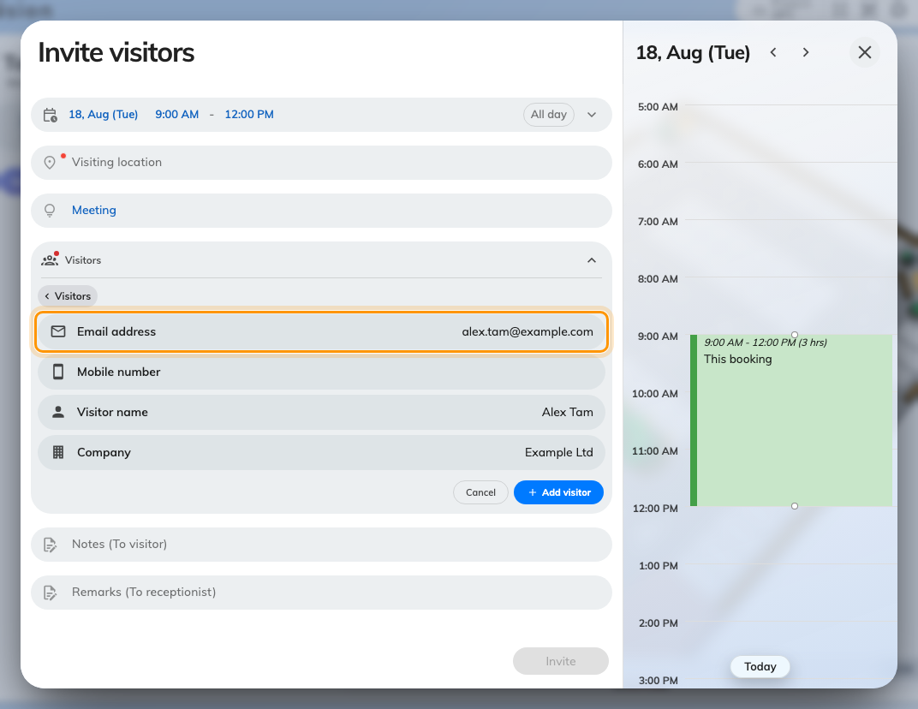
One visitor. The address is both who they are and how the invitation reaches them.
Which field is mandatory comes from the purpose. A purpose can be set to identify
people by mobile number instead — the invitation then goes by text message — or
by name and company for visitors who have no contact details you are allowed to
hold, or by a Customize key such as a contractor number. When a purpose
offers more than one of those, a row of choices appears above the fields and you
pick one per visitor.
A visitor Offision already has on file fills in as you type their name, and
their identifying field arrives locked: you can correct their company, not who
they are.
For a group, Import takes a spreadsheet — the menu also has a sample file
worth downloading first, because the columns are positional.
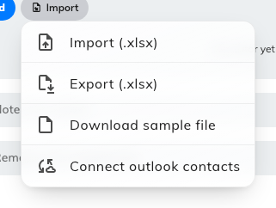
Import, export, and the sample spreadsheet. Computers only.

6. Anything else the visit needs
Three optional rows sit below the visitors, and two of them are more useful than
they look:
- Visitor Vehicles — a plate number and a vehicle type. The row appears only
where the location you chose allows it, so if you cannot see it, that is the
answer. See Collect a visitor's vehicle plate.
- Notes (To visitor) goes out in the invitation, so it is the place for
"come to the west entrance".
- Remarks (To receptionist) is never shown to the visitor. Put "they are
bringing equipment" here.
- Inviter appears only if you can act for someone else, and names the person
the visit belongs to.

7. Send it
Invite sends the invitation and closes the form. A card confirms it —
Invitation sent, or Waiting for approval where the purpose you chose
needs someone to approve the visit first. Until it is approved, nothing reaches
the visitor.

8. Check it worked
Go back to the Visitor filter and pick the day of the visit. The visitor
should be listed at the start time; tapping the row opens the visit, and that
panel is also where you Edit it, Delete it, share it, or send it to your
own calendar.
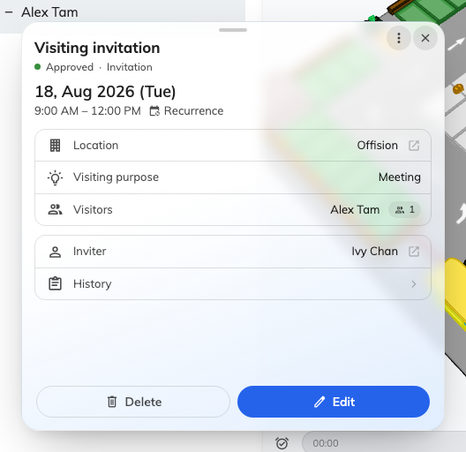
The visit after it is booked: its state, its purpose, and who it belongs to.
Approved on that panel means the visitor has been told. That is the
confirmation worth trusting — not the fact that the form closed.

What the visitor receives
Two separate messages, and the gap between them is the thing people ask about:
- The invitation, straight away. It carries a calendar invitation they can
accept, your Notes (To visitor), and where to come.
- The visitor pass — the QR code they show at reception — on your company's
badge schedule, not straight away. If that schedule says "the day before", a
visitor asking where their code is has simply been invited early. Invited by
mobile number, they get it as a text message instead.
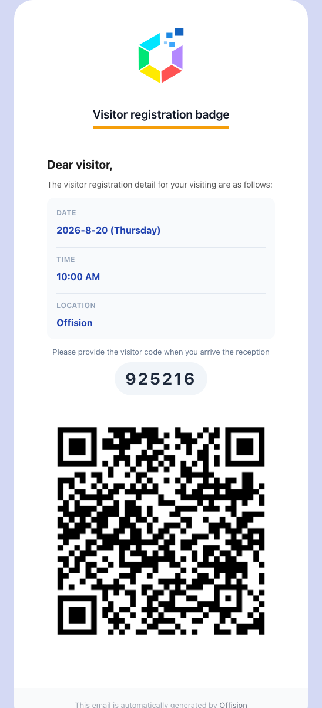
The visitor pass: when and where to come, the registration code, and the QR code reception scans.
Both the schedule and what the pass looks like are company-wide settings — see
What appears on a visitor badge.
Where in Offision: admin app → visiting/visitorManagementSetting (Visitor management)

What the desktop app and a phone change
Nothing about the invitation itself: the desktop app and the mobile app are both
shells around these same screens, and the form, the rules and the emails are
identical in all three. Four things differ in practice:
Where | What changes
On a phone | The day panel beside the form is hidden, and so are the date arrows in its header — there is not room for them
On a phone | Import, Export and Connect outlook contacts are gone; a spreadsheet of visitors is a computer job
On a phone | The visit panel gains Share, which hands the details to your normal share sheet
In the desktop app | Nothing, for inviting. Its extra trick is printing badges at reception, which is a receptionist's screen and not this form

What this does not control
- Whether the visit needs approving, and who approves it. That belongs to the
visiting purpose, not to you.
- What reception asks for on arrival. Photo, surveys and the check-in itself
are the desk's, and are set on the purpose — see
Check a visitor in by scanning their code.
- What the badge looks like, and when it is sent — see
What appears on a visitor badge.
- Booking the room. A room chosen as the visiting location is where the visit
is, not a reservation of it.
No Invite visitors button?:
It is one of the two gates above, and they fail identically — the button is
simply absent. Either Allow staff to invite visitors from the user app is
off, or no building has been marked for visiting yet.

