I can't sign in to Offision
Every message the sign-in screen can refuse you with, what each one actually means, what you can do yourself, and the one-line fix to pass on to your administrator when you cannot.
2026-08-26 · https://offision.com/help/en/user-guide/i-cant-sign-in/
How far do you get?:
If you reach the password box and a message appears after you press
Continue, this page is for you — find the message below. If the page never
loads or says it cannot connect to the server, that is your network, not your
account. If you are simply unsure of the password, go straight to
Reset a forgotten password.
The sign-in card refuses in a handful of distinct ways, and each one names a
different fix. Some of the messages appear in English whatever language you
use — that is expected, and the wording is quoted here exactly so you can match
it. Each solution ends with what your administrator does on your account.
Where in Offision: admin app → directory/user (Users)
Solution 1 — Username or Password Incorrect (most common)
The password is wrong — or the email is not on this Offision at all. Both
produce this same message on purpose, so nobody can use the sign-in page to
discover which addresses exist. The button flashes Login fail. Please try
again for a moment and turns red.
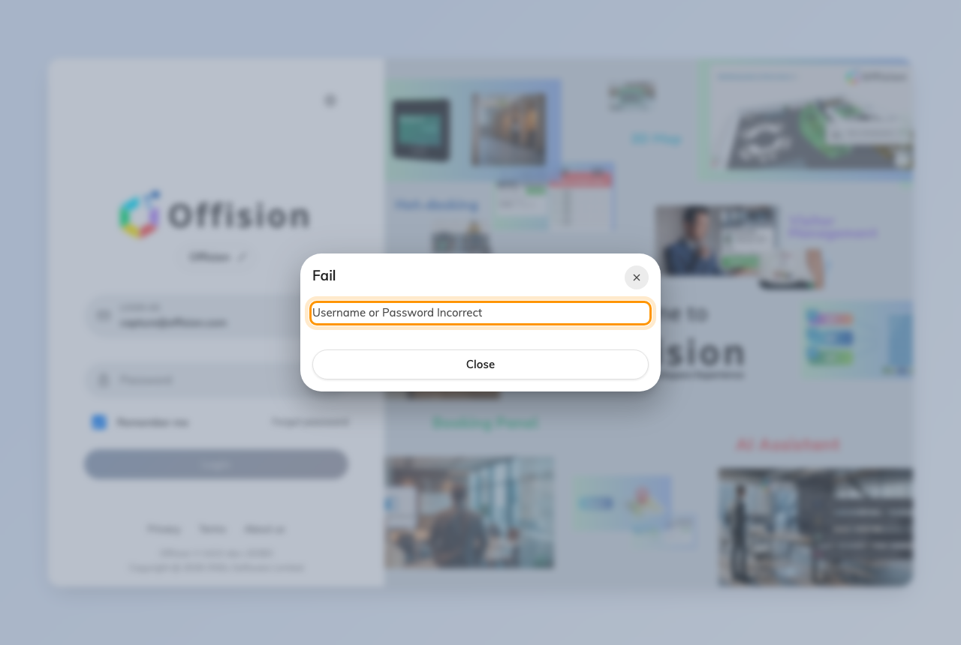
The sign-in card refusing a wrong password.
Check Caps lock is on is not showing, then try once more. If you are not
sure, press Forgot password and follow
Reset a forgotten password. If you have more
than one work email, try the other one.
Every wrong attempt counts towards a lockout, so do not keep guessing.
Administrator: Manually reset password on the person's panel, or Send
reset password email.
Solution 2 — Email not found, or Sorry, we cannot find your account (common)
Email not found appears after the first step of the card: the address you
typed has no account on this company's Offision. Sorry, we cannot find your
account is the same thing said by the Enter your work email screen that
looks up which Offision you belong to.
Either you have not been invited yet, or you are on the wrong company's sign-in
page. Ask whoever invited you for the address they used, and check the invitation
email for the right link.
Administrator: add the person and send the invitation; see
How account status works.
Solution 3 — Identity Locked Out (common)
Too many wrong passwords in a row. The line under it says how long remains:
This account is locked out for N minutes. Nothing you type during that time
will work, even the right password.
Wait it out, then sign in. If you had forgotten the password anyway, use
Forgot password now so the next attempt is a correct one.
Administrator: there is no unlock button. Either wait with them or
Manually reset password; how many attempts and how long the lock lasts are
set on Global password policy.
Solution 4 — Deactivated User Cannot Login, or Not Allowed To Login (less common)
Your account exists but has been switched off. Deactivated User Cannot
Login means it was deactivated; Not Allowed To Login means it was deleted
and sits in the recycle bin. Both usually happen when someone leaves or changes
role, and both are reversible.
There is nothing to do on your side except ask.
Administrator: Re-enable user on the person's panel, or open Recycle
bin and Restore them — see
How account status works.
Solution 5 — Invalid Two Factor Code, or Two Factor Session Expired (less common)
The six-digit code was wrong, or you ran out of time. A code is good for five
minutes and five attempts; after that the session is dropped and you see Two
Factor Session Expired. Start again from the email and password, and if the
code came by email use Resend Code rather than an old message. If you use
an authenticator app, check the phone's clock is set automatically.
Administrator: if the phone or the app is gone, Reset two-factor
authentication on the person's panel lets them sign in with the password alone
and set it up again.
Solution 6 — There is no password box, or you got in and were sent straight out (rare)
Only a Sign in with Microsoft 365 or Sign in with Google Workspace button.
Your company signs in through its own directory and has hidden the password
form. Use that button with your usual work account; a password you set for
Offision will not be asked for.
No Permission to login User App after that button worked. The directory
knows you, but your Offision account has no right to use the user portal.
Access Restricted, with a line such as You are not allowed to access the
Offision web portal, please contact your admin. You signed in, but your
account is not allowed from this kind of device — browser, phone browser, the
app, or the Outlook / Teams add-in. Try the kind your colleagues use.
Administrator: the first is Login page under UI customization; the second
is the User switch on the person's Permissions page; the third is the
Allow user access from … switches on their User security profile.
What to tell your administrator:
Three things separate every cause above: the exact message on screen, the
email address you typed, and which app you used — browser, phone,
desktop app, or Outlook / Teams. With those, the fix is usually one click on
your account.

