Find a room right now
The meeting starts in a minute and nobody booked anything. Find now skips the form: pick how long you need, and Offision takes the first room that is free for it.
2026-08-30 · https://offision.com/help/en/user-guide/find-a-room-right-now/
For the meeting that starts in a minute, Find now sits beside the Booking
button and skips the form entirely: pick a duration, and Offision lists the rooms
free for it. Each row has its own Book button, and one tap takes the room.
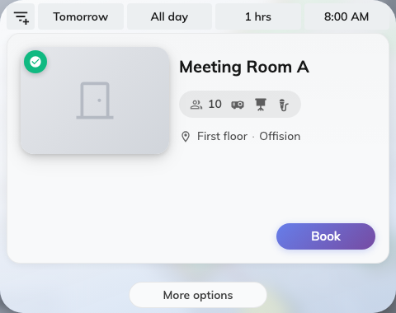
Find now: rooms that are free for the length of time you asked for.
If nothing comes back — "No available resource found, you may change the filters
to check the other time slots" — widen the filters or move the time. More
options hands the same booking over to the full form, with everything you have
chosen so far carried across.

