Compare room schedules and move a booking
Put several rooms side by side on one calendar to see which is free, then drag your own booking to a different time or a different room. What the coloured blocks mean, what the confirmation asks you, and the dozen reasons a booking refuses to move.
2026-09-02 · https://offision.com/help/en/user-guide/compare-schedules-and-move-a-booking/
The booking form shows you one room's day. The resource calendar shows you
several rooms' days at once, side by side — which is how you answer "so which of
these is actually free at three". And once your own booking is on that grid, you
can move it by dragging it: to another time, or onto another room.
Before you start:
Only bookings you organised can be moved, and not once the meeting is under
way. You cannot drag a colleague's booking at all.

1. Open the calendar
There are three doors, and which one you take decides how many rooms you get:
- Resource calendar in the app's navigation — every room you are allowed to
book, always in comparison mode. This is the one to use when you do not yet
know which room you want.
- In the resources list, select several rooms, then Compare schedule(s) —
the same grid, narrowed to the rooms you picked.
- Select a single room and choose Check schedule to see just that one.
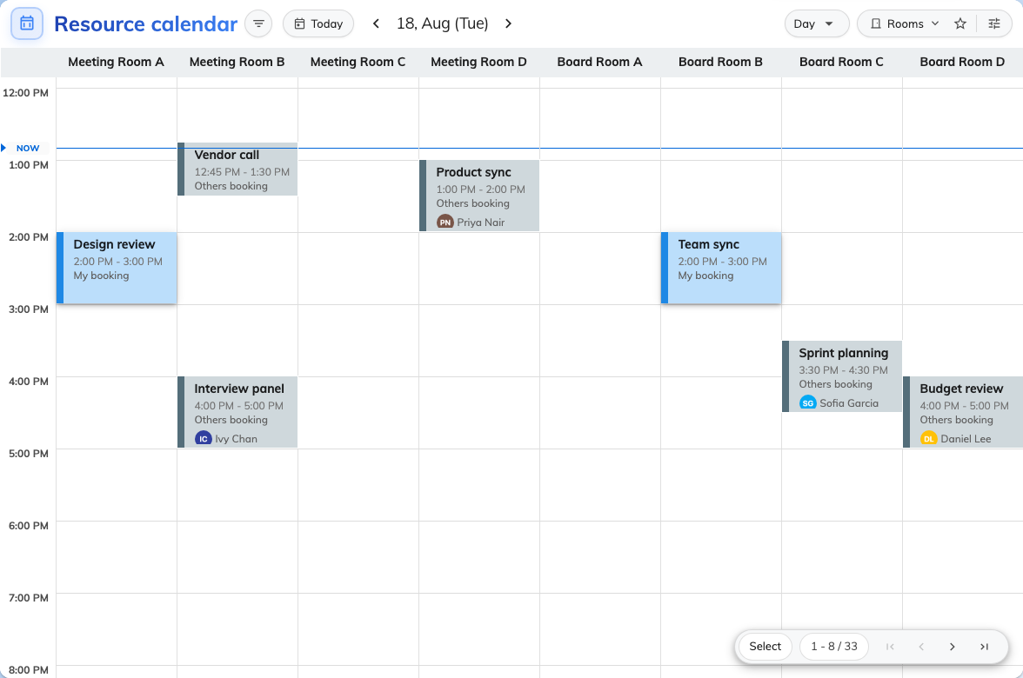
Several rooms on one grid. Each column is a room; the blocks are the bookings already on it.

2. Choose how to lay it out
The view menu holds three layouts, and they trade rooms against days:
- Day — one column per room, one day. The most detail, the fewest days.
- Week — one row per room, one column per day. Good for "is this room free
any time on Thursday".
- Month — a whole month, with two layouts of its own: Resource keeps a
row per room, Calendar drops the rooms and gives you the familiar month
grid with the room name printed under each booking.
Two switches under them widen what the grid covers, each where it makes sense:
Show full day opens the hours outside business hours, and Show weekend
adds Saturday and Sunday to the week and month views.
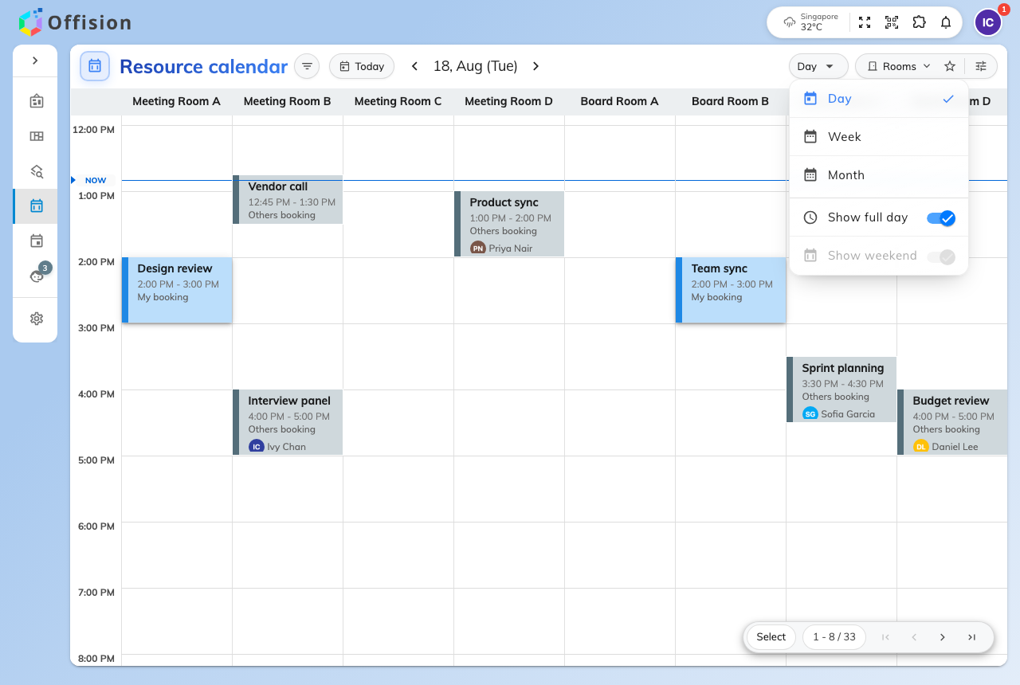
The view menu, on Day. Show weekend is greyed because a single day has none.
Note:
These choices are remembered by the browser, not by your account — so the
calendar opens differently on your laptop and on your phone.

3. Narrow what you are comparing
A handful of rooms fit across a screen; a whole building does not. The counter
in the bottom corner says how many you are looking at out of how many there are,
and pages through the rest — but filtering down to the rooms you would actually
book beats paging through the ones you would not. Two panels do that.
The filter panel on the right narrows the rooms: by type and category, by
Location, by how many people they seat, by what is in them, and by whether
you have starred them. Order, at the top, sets the room order — see
Sort the room list.
The Booking filters panel on the left narrows the bookings: Booking
status — Pending approval, Booked, Waiting check in, In use, Used, No show —
and Only my bookings, which is the fastest way to find the one you came to
move. Go today and the date picker move the whole grid.
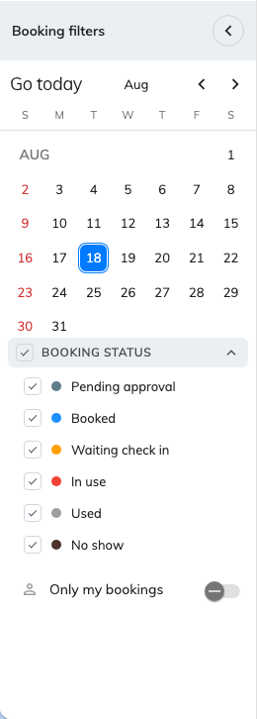
Booking filters. Only my bookings leaves just the ones you can drag.

4. Read the grid
Solid blocks are bookings, and each says whose it is: My booking stands
raised in blue and is the only kind you can pick up, Others booking is flat
and inert. A block reading Reserved instead of a subject is somebody's
booking your company has chosen to keep private, and one reading Waiting
approval is still with a reviewer.
Everything behind the bookings is the room telling you when it can be used:
What you see | What it is
Tinted background bands | The times this room can be booked
A grey band | Outside business hours
A red block | A business holiday
A green band | Preparation time before or after a meeting
A hatched Split or Combined block | The room is unavailable because a combinable room that shares it is booked. It is a consequence, not a booking — it cannot be opened or moved

The line across the grid is the current time. Other people's bookings appear as
they are made; you do not need to refresh.

5. Move it
Pick up your booking and drop it where you want it:
- Drop it higher or lower in its own column to change the time.
- Drop it on another room's column or row to change the room.
- Drag its bottom edge to make the meeting longer or shorter.
It snaps to fifteen minutes. On a phone or a tablet, press and hold the booking
for a moment before dragging — a quick swipe scrolls the calendar instead.
If your booking holds more than one room, dragging it onto a new column swaps
only the room you dragged. The rest of the booking is untouched.

6. Confirm the change
Letting go does not save anything. Edit Booking opens instead and shows you
what you just did, as before → after: Resource change, Time change, or
both.
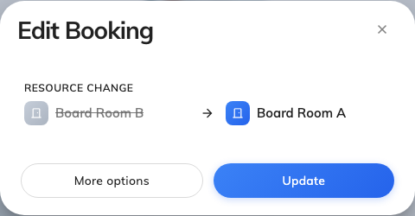
Edit Booking, after dragging a meeting to another room.
- Update applies it.
- More options opens the full booking form with the new time and room
already filled in — take this route when you want to change the attendees, the
services or anything else at the same time.
- Closing the dialog puts the booking back where it was. Nothing is saved.
If the room you moved to has terms and conditions, you are asked to accept them
before the change goes through.

7. Check it worked
The block stays where you dropped it and a confirmation tells you the booking's
new state. Read that state rather than assuming: a room that requires
approval turns your move back into a request, so the answer there is waiting
approval, not booked.

When a booking will not move
Most of these are the product refusing on purpose. They are listed with the ones
you will meet most often first.
What happens | Why
The block will not lift at all | It is not yours, or it is no longer editable — a meeting in progress is fixed, and so is one that has finished. Change a meeting under way from the room panel instead
This resource is read-only | You may see that room's schedule but not book it
This resource is walk-in only. Not allow booking from here | That room is taken by turning up at it, not by reserving it
Please select a future time | You dropped it somewhere that has already passed
You are asked about the series first | It is a repeating booking. Choosing this booking keeps the quick confirmation; this and after or the whole series opens the full booking form instead of applying the drag directly
An error appears only after Update | Clashes, quotas and booking rules are checked when you save, not while you drag — so a drop that looked fine can still come back refused, and the booking returns to where it was
Nothing happens on a hatched block | Split and Combined blocks are not bookings

What this does not do
Dragging changes the time and the room. It does not touch the subject, the
attendees, the services or anything else on the booking — for those, use More
options and edit the form.
It also never moves somebody else's booking. If a colleague is in the room you
need, the calendar can show you that, but the change is theirs to make.
And it is not the only place you can drag. If you already know which booking you
want to move and just need it at a different time, your own calendar does the
same gesture without the other rooms in the way — see
Reschedule a booking on My calendar.
One layout is weaker than the others: the Month view's Calendar layout has no
room columns, so a booking dropped there can only change date, never room.

