Clock in and out
Signing in when you arrive and out when you leave — from the app or a kiosk at the door — what the dialog's checks mean, why it may ask for your location, a reason or a selfie, and where your own records live.
2026-09-02 · https://offision.com/help/en/user-guide/clock-in-and-out/
If your company tracks attendance, your app's home screen carries a My
attendance action, and the footer menu an Attendance group with Sign
in, Sign out and Records. Sign in when you arrive, out when you
leave — each punch takes a few seconds, and the dialog tells you everything
it is checking before it takes one.
Don't see the buttons?:
The buttons appear only when you are on a working schedule that allows
signing in from the app. If a colleague has them and you do not, ask your
administrator to check your schedule — there is nothing to enable on your
side.

Sign in from the app
Tap Sign in. The dialog runs your company's checks live and shows each
one as it passes — Within working hours, and depending on your schedule
Location verified and Network verified. When your location is
checked, a small map shows Your location against the Allowed area, so
you can see where you stand — literally. Then Confirm Sign In, and you
are done; a notification confirms the time.
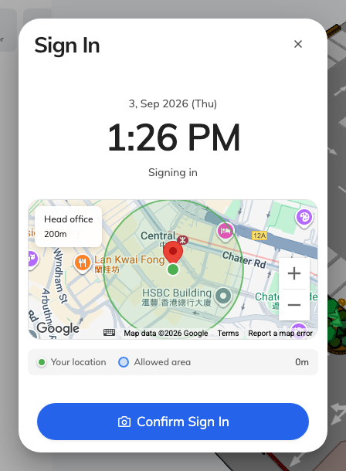
The Sign In dialog: each check ticked as it passes, your position on the map against the allowed area, and Confirm at the bottom.
Three extra asks, depending on your schedule:
- Your location — the app needs the location permission. Allow it when
the phone or browser asks; refused once, it must be re-allowed in your
device settings. Inside Microsoft Teams location never works — the app will
offer to open in your browser or the mobile app instead.
- A reason — arriving late or leaving early, the Remarks required box
may refuse to let you confirm without one. One line is enough; your manager
sees it against that punch.
- A selfie — Take a selfie to continue means your company verifies
who is signing in. The photo is stored with the punch and deleted
automatically after your company's retention period.
If a check fails — You are outside the allowed area, Outside of
working hours, Already signed in today — the punch is refused, and the
message names the rule. Move inside the area or check the time and try
again; if it still refuses, the schedule is a question for your
administrator.

Sign out
Same button, other direction: Sign out, then Confirm Sign Out. Do
not skip it — a day with a sign-in and no sign-out cannot be counted, and
your worked hours for the day show as zero.

At a kiosk
Some offices put attendance on a screen at the door instead. Tap the Take
attendance tile, identify yourself the way the screen offers — scanning
your QR code, tapping your staff card, entering your PIN, or by face — and
confirm. The same rules apply; the screen shows the same checks.

Your records
My attendance › Records lists every punch, grouped by month, newest
first. Open one to see its details — and where your location was checked, a
View on map link shows exactly where the punch was accepted. If a punch
is missing or wrong, tell your manager or administrator: records can only be
corrected on their side, and the correction shows up here.
A month of your own records can be saved as a PDF to print or send on — see
Download your attendance record as a PDF.

