Cancel a booking
Giving a room back: the choice between calling the meeting off and keeping it without the room, what a repeating booking asks before it deletes anything, what cancelling does to the calendar invitations and your quota, and why it is not the same as ending a meeting early.
2026-09-04 · https://offision.com/help/en/user-guide/cancel-a-booking/
Cancelling gives the room back. The booking leaves your calendar and everyone
else's, the room shows free again from that moment, and whatever quota the
booking used is returned to you. Where the room or your own calendar is synced
with Outlook or Google, the meeting is withdrawn there too — so the people you
invited are told by the calendar system, not by you.
Before you start:
You can cancel only bookings you organised, and only before they start. If the
meeting is already under way you are looking for End now, which is not the
same thing — see the last section but one.

1. Open the booking
Click the booking wherever you can see it — My bookings on the home screen,
My calendar, or the resource calendar. They all open the same card, and
Cancel is along the bottom of it. Edit a booking shows
that card.

2. Choose Cancel
Where the booking holds a room, or is one of several made together, Cancel
opens a menu. Otherwise it starts the cancellation straight away — at step 3 if
the booking repeats, at step 4 if it does not.
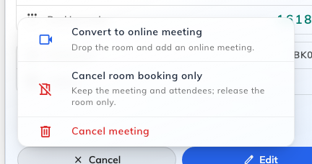
The cancel menu on a room booking. Only the last row calls the meeting off.
Convert to online meeting | Drop the room and add an online meeting. The meeting stands and everyone keeps their invitation; it just stops being in a room. Offered when your company has an online meeting provider connected and the booking has no meeting link yet
Cancel room booking only | Keep the meeting and attendees; release the room only. The room goes back into the pool and the meeting carries on without one. Offered on bookings that hold a room
Cancel meeting | Calls the whole thing off

The first two are the reason this is a menu rather than a button. A meeting that
has moved online does not need the room, and giving it back is worth doing even
though the meeting itself is going ahead — which is a different intent from
cancelling, and easy to miss when the obvious button says Cancel.
Cancel room booking only asks you to confirm first: "Remove the room and
keep the meeting? Attendees will be notified." Convert to online meeting
does not — it opens the booking form instead, with the room taken off and the
online meeting switched on, and nothing changes until you save it there.

3. If it repeats, choose what to cancel
Cancel meeting on a repeating booking asks the scope first, under Delete
recurring booking — "Choose what to delete".
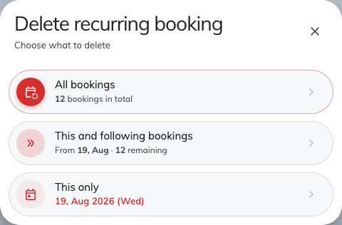
The scope question. Each choice says how many bookings it covers.
All bookings | The whole series, from the first to the last
This and following bookings | This one and everything after it. Earlier dates are left standing
This only | Just this date. The rest of the series is untouched

A Series booking — several bookings made together rather than one repeating
pattern — asks the same question in two words on the menu itself: Cancel this
only, or Cancel all in serial, which confirms with the count first:
"Cancel all 12 upcoming bookings in this series? Attendees will be notified."
Only the ones that have not started yet are cancelled; sessions already held stay
in the record.

4. Confirm
The last step is a plain confirmation, headed Delete, whose wording repeats
the scope you chose — Confirm delete this booking only, Confirm delete this
and following bookings, or Confirm delete all bookings. Delete carries it
out; Cancel here closes the dialog and leaves the booking alone.
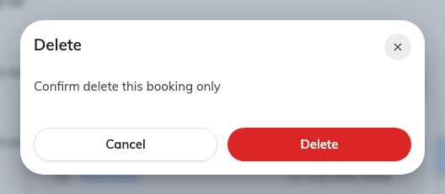
The confirmation, worded for the scope chosen in the previous step.
Nothing is cancelled until this point. Read the wording rather than the button:
it is the only place that tells you whether you are about to remove one date or a
year of them.

5. Check it worked
The booking should be gone from your calendar, and the room free in the resource
calendar for that period. Attendees are notified, and so are the people who look
after that room where an administrator has asked for it.
Where the room is synced with Microsoft 365 or Google Workspace, check the
meeting has also gone from Outlook or Google Calendar. That withdrawal is the
calendar system's own, so it can lag the app by a moment.

What cancelling is not
Three other things also free a room, and none of them is this.
End now | Ends a meeting that is under way early and hands the room back for the time left. The booking still happened and still counts as used. It is the only one of these that works on a meeting in progress
Extend | The opposite — pushes the end time out while the meeting is running
Being released for a no-show | Where a room requires check-in, nobody checking in releases it automatically. That is counted, and cancelling is not: see What counts as a no-show

Cancelling ahead of time is therefore the tidy option: it gives the room back
early enough for somebody else to use it, and it leaves nothing against your name.
Your quota comes back. A cancelled booking refunds in full — unless the room
sets a deadline for it, after which a cancellation refunds nothing.
That deadline is a per-room setting, described in
the resource policy reference.

When there is no Cancel button
Cancel reaches one step further than Edit: a booking can be past the
point of editing and still be cancellable, and from 4.5.14 how far it reaches is
the room's decision rather than a fixed rule.
Why it is missing | What to do instead
The booking is not yours | Only the organiser can cancel. Ask them
The meeting has finished | There is nothing left to give back
Check-in has opened, and the room does not allow cancelling from then on | Let it run, or check in and use End now. The room sets this
You have checked in, and the room does not allow cancelling a meeting under way | Use End now — from the card, or at the room panel
It is too close to the start | A room can stop people editing or cancelling in the run-up to a booking. Ask whoever looks after that room

Both check-in rules are per-room, and the shipped defaults keep the behaviour
people are used to: you may cancel while the booking is waiting to be checked
into, and not once you have checked in. Whoever looks after the room can change
either, in
the resource policy reference.
Where cancelling while in use is allowed, Cancel joins Extend and
End now on the card of a meeting already under way.
You can also cancel at the room panel outside the door, where the booking's
details carry a Cancel booking button, and from a lobby board.

