Add Offision to Outlook
Offision as an app in Outlook's own tab rail — the same package that runs in Teams, who has to allow it before you see it, what changes inside the host, and what became of the ribbon add-in people remember.
2026-08-21 · https://offision.com/help/en/user-guide/add-offision-to-outlook/
In Outlook, Offision is an app in the rail down the side — all of Offision,
in a tab of its own, beside Mail and Calendar. It is the same app that runs in
Teams: one package, one decision by your administrator, both hosts.
Before you start:
In most companies you cannot add this yourself. Offision has to be allowed for
the organisation first, and until it is, Add does nothing.

1. Find it in Outlook
Choose Apps in Outlook and search for Offision.
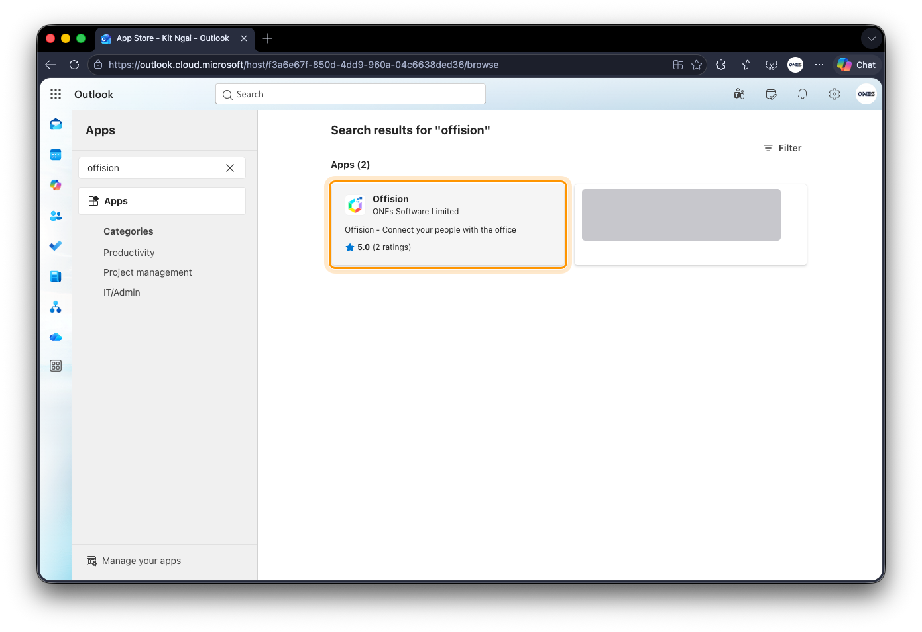
Apps in Outlook, searched for Offision.
Open the listing and choose Add.
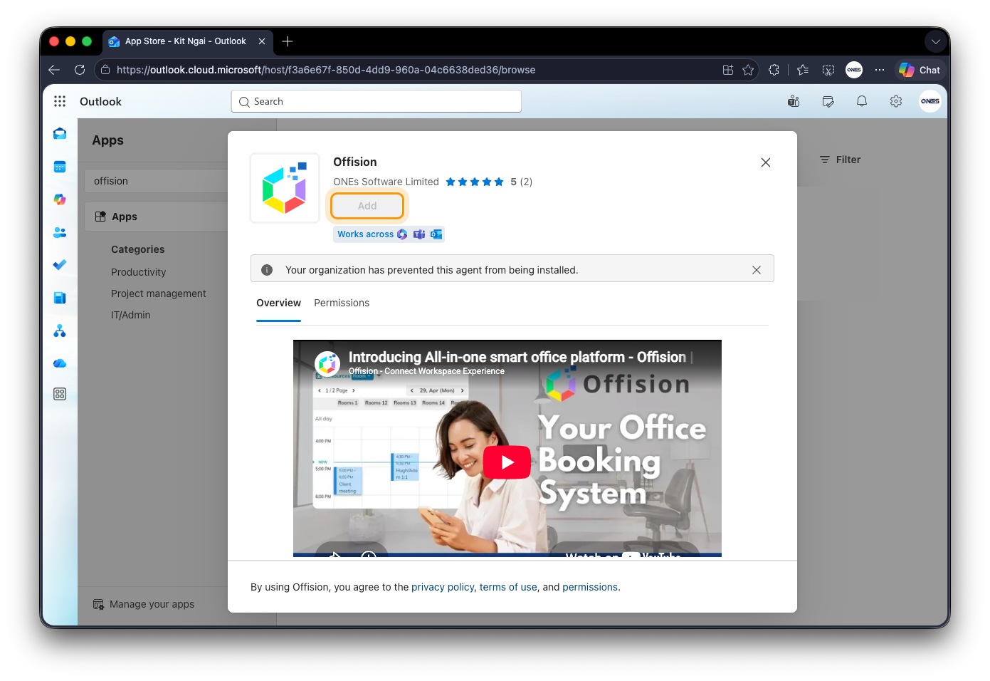
The Offision listing in Outlook, with Add greyed out.
A greyed-out Add, or "Your organization has prevented this agent from
being installed", is your administrator's decision and not something to fix on
your machine. Allowing it is the same job as allowing it for Teams, because it
is the same app — see
Add Offision to Microsoft Teams.

2. Sign in
The tab asks you to sign in the first time, using your work email as usual —
see Sign in to Offision. Afterwards it opens straight
to your home screen.
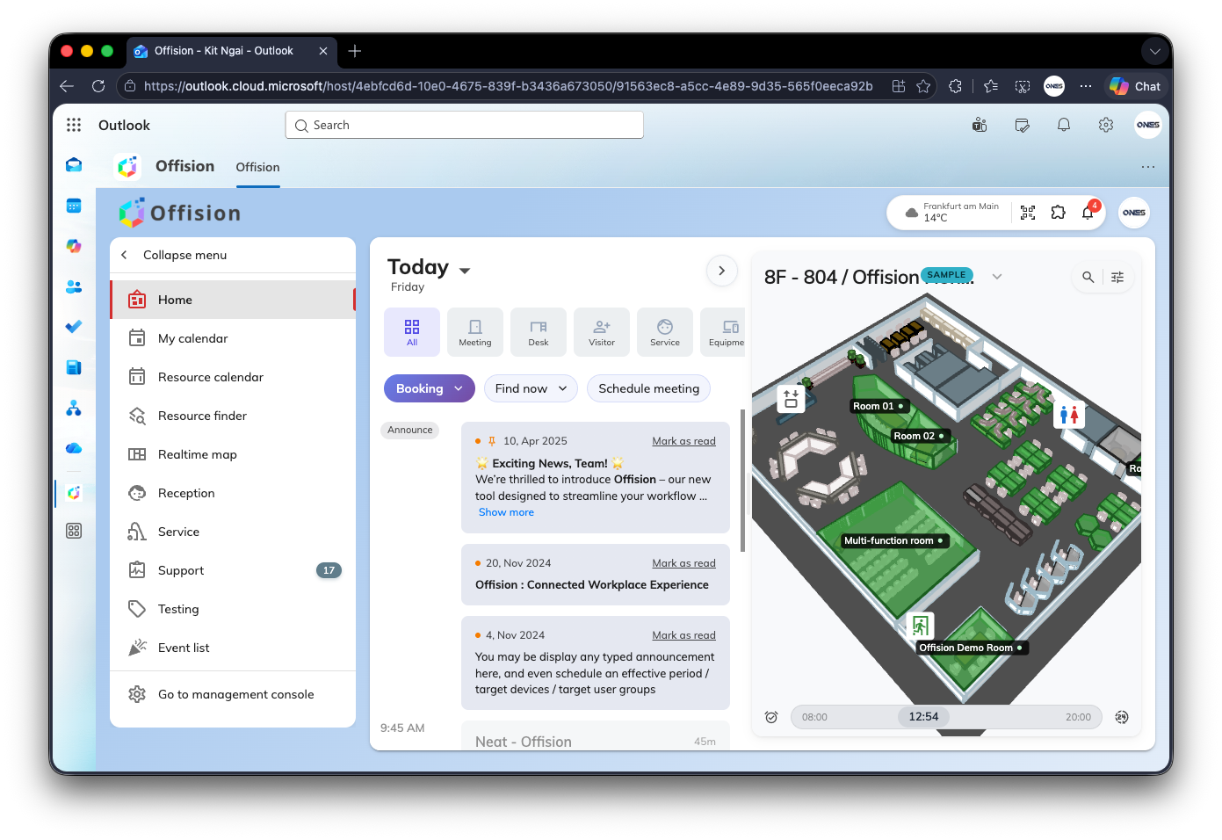
Offision open as a tab in Outlook. The same home screen, inside Outlook.

What is different inside Outlook
Outlook hosts Offision the way Teams does, so the same two things are true:
- Location check-in does not work here. A page inside Outlook cannot see
where you are, so a room that requires a location check-in has to be checked
into from a browser or the phone app instead. See
Check in by QR code and GPS.
- The theme follows Outlook, light or dark.
Everything else behaves as it does in a browser.

The ribbon add-in is gone
Offision used to put buttons on the ribbon of the meeting you were writing —
Room booking, Room finder, Desk booking and the rest — which opened Offision
with that meeting's subject and attendees already filled in. That add-in is no
longer part of Offision. There is nothing to install and nothing to repair:
bookings start in Offision itself now, in this tab or anywhere else you use it.
Two habits go with it. Writing an Outlook meeting no longer creates an Offision
booking, and the buttons are not coming back, so waiting for them is not a plan.

Where it runs, and where it does not
Every Outlook has the Apps rail except one: Outlook for Mac. On a Mac, open
Outlook on the web in a browser and Offision is in the rail there — the
account and the bookings are the same either way. The Offision desktop and
phone apps are another way in again, covered in
Where you can use Offision.
If Offision is not there:
Ask whether a colleague has it. If nobody does, it has not been allowed for the
organisation yet. If they have it and you do not, your account may be held back
by Allow user access from Outlook / Teams Add-in in its security profile.
Either way the fix is a conversation with your administrator, not a reinstall.

