Add Offision to Microsoft Teams
Putting Offision in the Teams sidebar as a personal tab, why your Teams admin usually has to deploy it for everyone, what that deployment unlocks besides convenience, and the one check-in that cannot work inside Teams.
2026-09-04 · https://offision.com/help/en/user-guide/add-offision-to-microsoft-teams/
In Teams, Offision is a personal tab — your own Offision, in the Teams
sidebar, alongside Chat and Calendar. It is not a bot and it does not join
meetings; it is the app you already know, without leaving Teams to reach it.
Before you start:
In most companies you cannot add this yourself. Offision is deployed to Teams
by an administrator, and until they have done it the app does not appear in your
search results at all. If that is where you are, the section on deploying it
below is the one to forward.

1. Find it in Teams
In Teams, choose Apps at the bottom of the sidebar and search for
Offision.
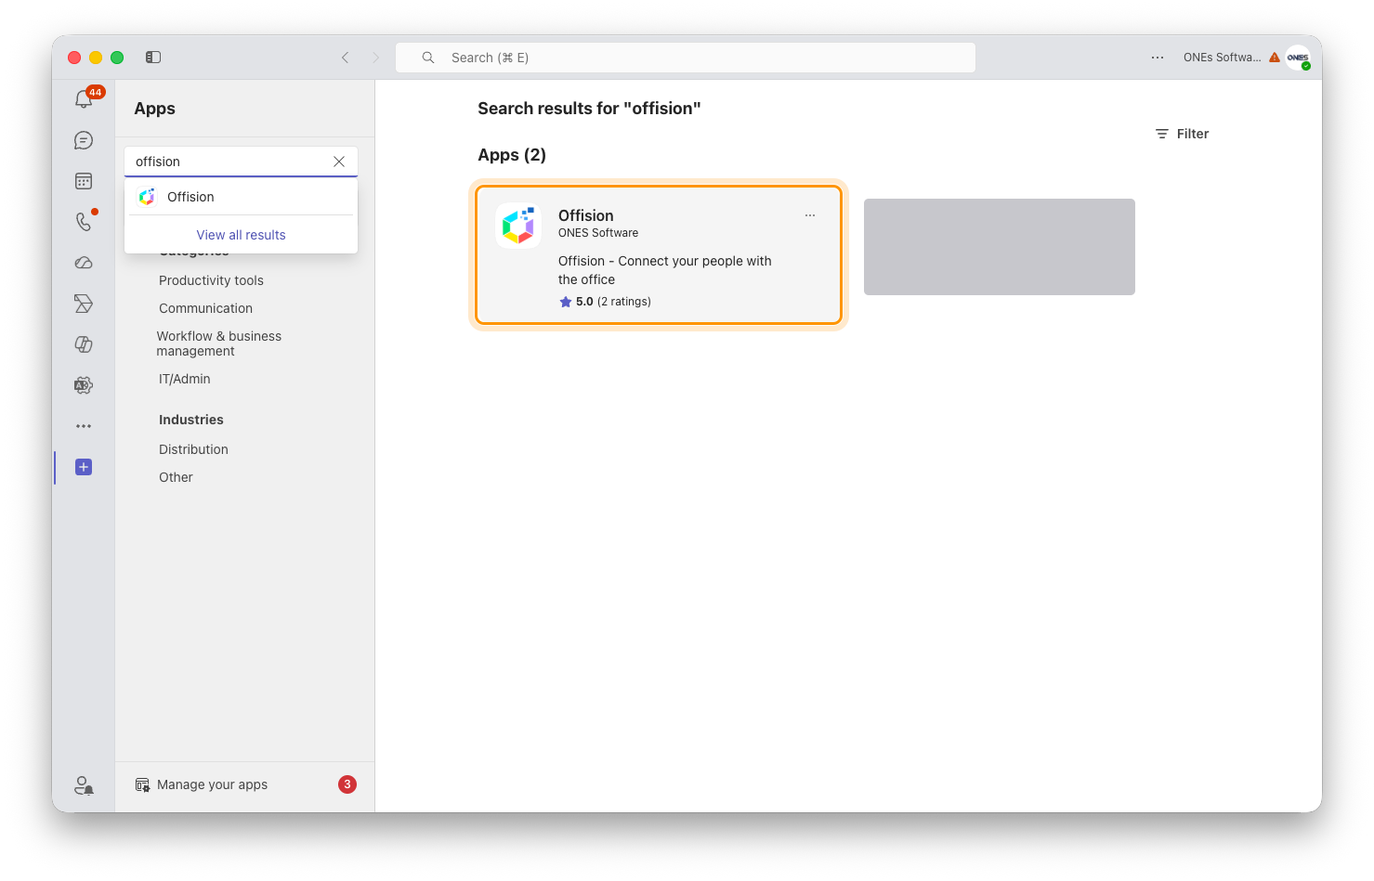
Apps, then search. The listing is there once your administrator has deployed it.
Choose Add. Offision opens as a tab, and right-clicking it in the sidebar
lets you Pin it so it stays there.
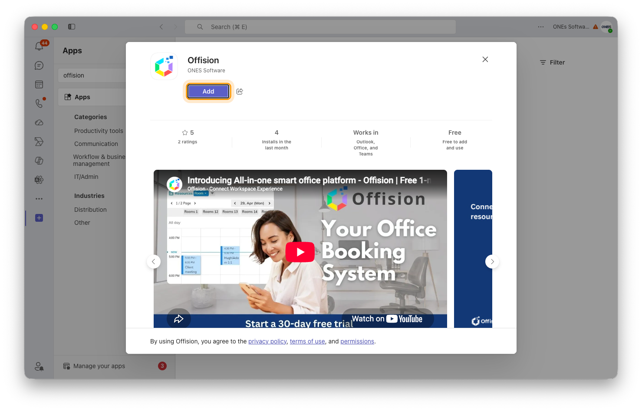
The Offision listing in Teams. Add puts it in your sidebar.

2. Sign in
The tab asks you to sign in the first time, using your work email as usual —
see Sign in to Offision. Afterwards it opens straight
to your home screen.
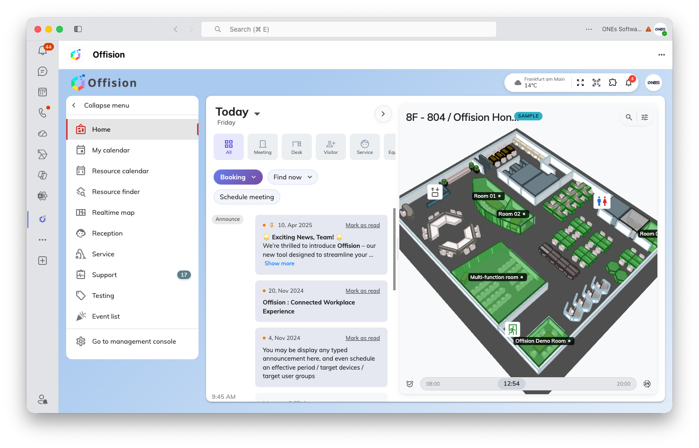
Offision running as a personal tab. The same home screen, inside Teams.

Your administrator can give it to everyone
This is the usual way it happens, and it is worth asking for rather than having
each person search: in the Teams admin centre, under Manage apps,
Offision can be allowed for the organisation, and an app setup policy can
pin it into everybody's sidebar automatically.
It is not only convenience. Offision can send its notifications — a booking
approved, a visitor arrived, a request assigned — to the Teams activity feed,
and that cannot work until the app is deployed across the organisation. Offision
says so plainly when it is not: "The Offision app is not deployed in your
organization's Teams — ask your Teams admin to deploy it."
Turning the notifications on is separate again, and it is done in the Offision
admin console under Marketplace, where a Microsoft 365 Global Administrator
grants consent once. A normal account cannot complete that step.
Once they are arriving, Teams lets each person mute them by subject rather than
one message type at a time — Booking updates, Service request updates,
Visitor updates, Support ticket updates, Attendance updates and a
catch-all Offision notification — in Teams' own notification settings.
Where in Offision: admin app → marketplace/apps (Integrations)

What is different inside Teams
Location check-in does not work here. Teams does not let a page inside it
see where you are, so a room that requires a location check-in cannot be
checked into from the Teams tab. Offision tells you so and offers two ways out:
open Offision in a browser, or use the phone app. Both are covered in
Check in by QR code and GPS.
The side menu is not there, so moving between pages goes through the page
switcher in the toolbar instead. It carries the same unread counts the side menu
shows in a browser, which is the only place to see them inside Teams.
Everything else behaves as it does in a browser, including the theme — Offision
follows whether Teams is in light or dark mode.

Check it worked
Open the tab and make a booking. Then look at your Teams activity feed after
something happens to it — an approval, a reminder. A booking that appears in the
tab but never notifies you means the app is installed but not deployed
org-wide, which is the section above rather than anything on your machine.

