Report a problem at the room panel
Two taps on the panel by the door — which amenity, what is wrong. What the panel asks about who you are, and what the report cannot carry.
2026-08-18 · https://offision.com/help/en/ticketing/report-a-problem-at-the-room-panel/
Nobody walks back to their desk to report a dead projector. The panel outside the
door takes the report where the fault is, in two taps.
Before you start:
The report control only appears when reporting is switched on for the company. If
the panel does not offer it, that is a setting, not a fault with the panel.

Where it is on the panel
Which control you get depends on the panel's skin:
Skin | Where
Modern | Report issue in the room information panel
Mini | Report issue in the menu
In-room control | Report in the dock along the bottom

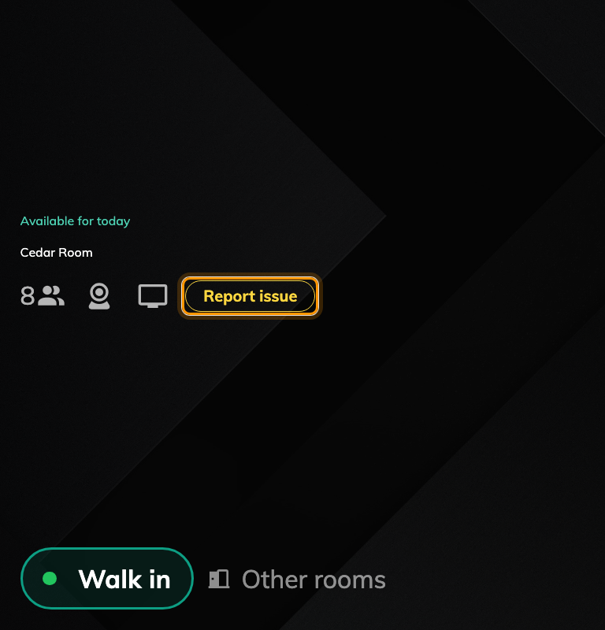
Report issue on the modern skin, beside the room's amenities.
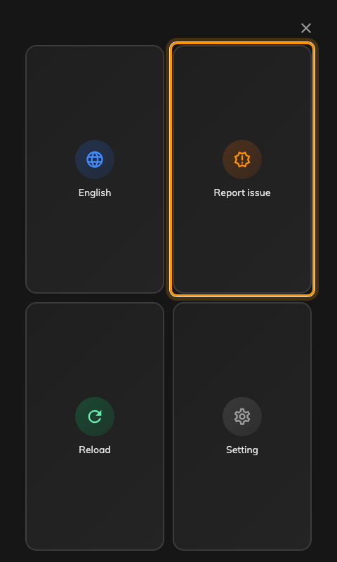
The mini skin's menu, with Report issue among the tiles.
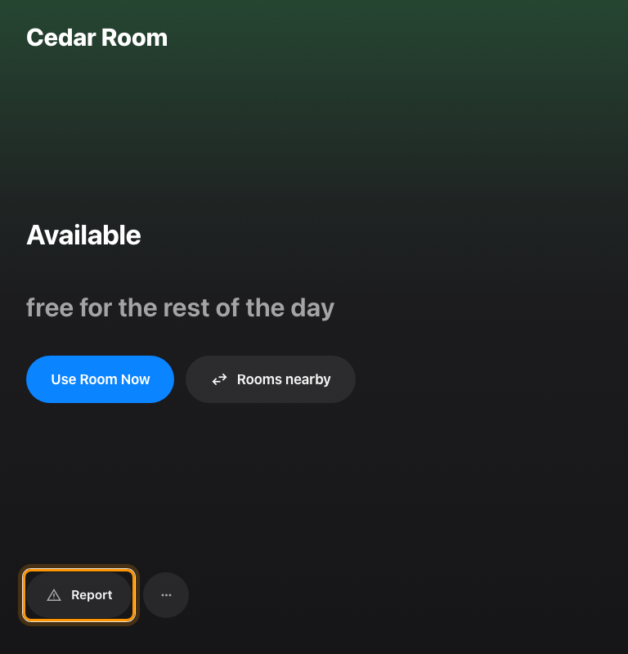
The in-room control skin's dock, with Report at the far left.

1. Which amenity
The panel asks which amenity has the problem, listing the ones set up on that
room, with Others for anything not on the list.
A room with no amenities set up skips this step entirely and goes straight to the
next one — so if your panels never ask this question, the rooms behind them have
no amenities recorded.

2. What is wrong
Four choices: Damaged, Malfunction, Out of battery and Other.
That is the report. The panel confirms it and returns to the room.

3. Who reported it — and when you are asked
This is where the skins differ, and it is the part worth understanding before
somebody asks why panel reports have no name on them.
- The in-room control dock never asks. The report is filed as the organizer of
the meeting running in the room, or with nobody named if the room is empty.
- The modern and mini skins ask, using the same identification the panel uses
for check-in — a staff card, a PIN, whatever that panel is set to. An
Anonymous button is always offered beside it, so nobody is forced to
identify themselves to report a fault.
- On a desk or a piece of equipment with somebody booked on it right now, the
report is filed as that person without asking anybody anything.
- A panel set to skip identification behaves like the dock, on every skin.
An anonymous report is a complete, valid ticket. It simply has nobody to notify
about it afterwards.

What a panel report cannot carry
A panel report is deliberately two taps, and it pays for that:
- No photograph. Only the app can attach one.
- No description. There is nowhere to say what you had already tried.
- Its title is always "Report from device". Every panel report in the queue
looks alike by title, so the resource, the amenity and the reason are the only
things distinguishing them.
- It cannot be followed. An anonymous report has no reporter to show it to,
and even a named one does not put the ticket on the panel afterwards.
When the app is the better route:
If the fault needs explaining or photographing — an error code, intermittent
behaviour, damage somebody has to see — report it
from the app instead. The panel is
for the faults where the room and the reason say everything.

Check it worked
The panel confirms the report on screen. To be sure it landed, open Reported
issues in the admin console: a new ticket titled Report from device should be
there, naming that room and the amenity you chose.

