Choose who handles reported issues
Putting people on Support staff, and what that list changes about who is emailed, who is notified, and who a ticket can be assigned to.
2026-08-18 · https://offision.com/help/en/ticketing/choose-who-handles-reported-issues/
Support staff is the list of people who fix things. It is the first thing to
set up in Ticketing, because until somebody is on it a reported issue is announced
to nobody and can be assigned to nobody.
Before you start:
The people you are about to add need Offision accounts already. This page picks
from your directory; it does not create anyone.

1. Open Support staff
Where in Offision: admin app → ticket/support-staff (Support staff)
The list shows who is on it today, and against each one how many issues they are
currently Handling — which is the number to look at before giving anybody
anything else.
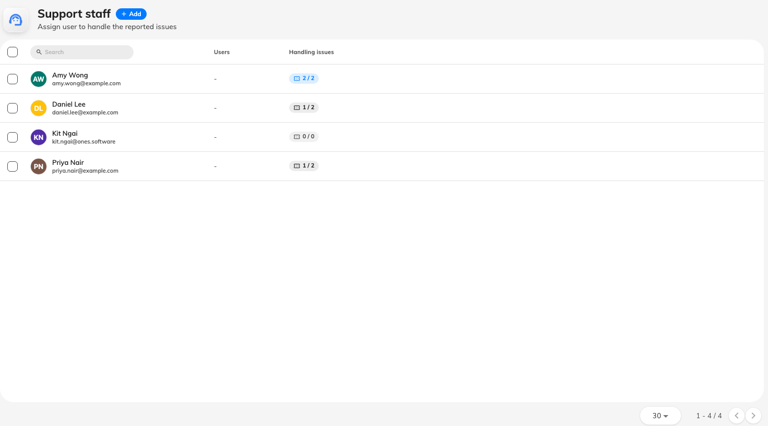
Support staff, with each person's current workload.

2. Add the people
Add offers two routes:
- Add user — one person at a time. Use it for a facilities team of four.
- Add user group — everybody in an existing group, and everybody added to that
group afterwards. Use it where the team changes and you would rather maintain
the group than this page.
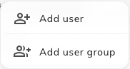
Adding a person or a whole user group to support staff.
Removing somebody takes them off the list. It does not touch tickets already
assigned to them, so check their Handling count and reassign first — otherwise
those tickets stay pointed at somebody who is no longer looking.

3. Know what the list actually changes
Being on Support staff does three things, and it is worth reading them as three
rather than one:
- A ticket can be assigned to them. The assignee picker in the queue is this
list.
- They are notified in the app whenever an unassigned issue is reported —
anywhere in the estate.
- They are emailed about the same reports.
Support manager is a different thing:
Support staff is who does the work. Support manager is the permission that
lets somebody open the Ticketing pages at all, and it is granted in
Directory with the rest of the permissions — not here.
The two overlap only partly, and the gap catches people out: an unassigned report
is emailed to support managers and support staff alike, but the in-app
notification goes to support staff only. A manager who never added themselves
to this list will see the email and never see the bell.

What this page does not do
- It does not assign anything. Offision never picks a person for a ticket —
no round-robin, no least-loaded. Every assignment is somebody's decision in the
queue.
- It does not scope anyone to a building. Everybody on this list hears about
every unassigned report, estate-wide. Narrowing who hears about which rooms is
what a ticket policy
is for.
- It does not set working hours. Ticketing has no equivalent of service hours;
a report at 3 a.m. is announced at 3 a.m.

Check it worked
Report a test issue against any room. Everyone you just added should get the New
issue reported email, and see it in the app. Then open the ticket in the queue
and confirm they appear in the Assign to list.

