Which time zone applies
The system time zone is a fallback. Anything that carries its own zone wins, which is why two people can read one booking differently and both be right.
2026-08-15 · https://offision.com/help/en/system/which-time-zone-applies/
The system time zone decides the time for everything that has not been given one
of its own.

The part that surprises people
A room can run on a different time from the system default — and you will not
find a time zone anywhere on the room to explain it.
It comes from the room's business hour. A business hour carries a time zone
alongside the days and opening times it defines, and every room it is applied to
follows that zone. A room with no business hour, or one whose business hour has
no zone, falls back to the system time zone.
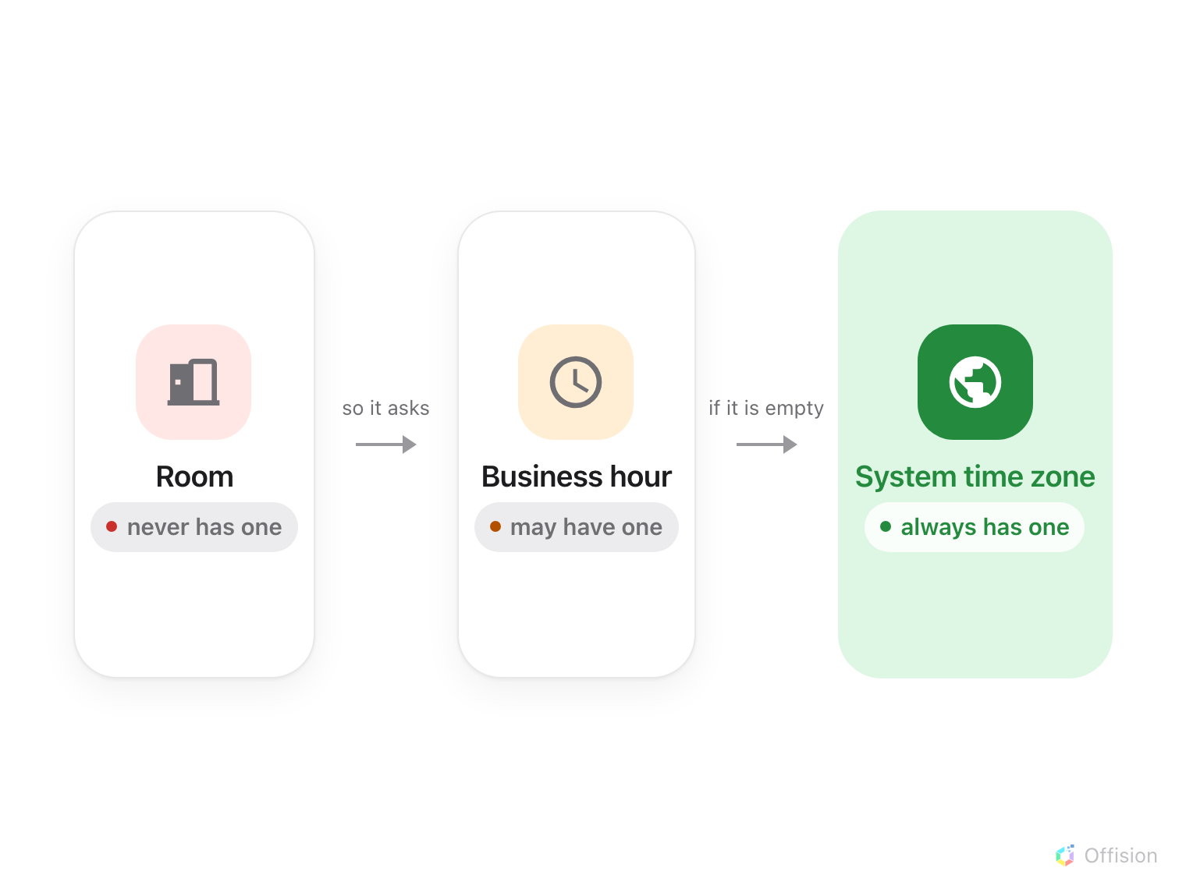
How a room's time zone is decided. The first level that has one wins.
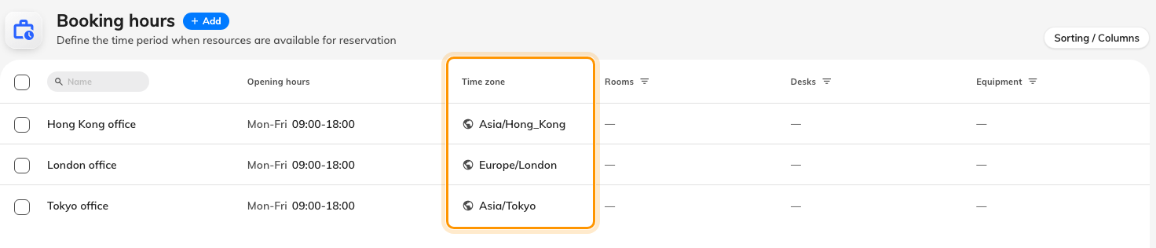
Each business hour carries its own time zone.
People are the same in spirit: each person keeps their own display preference,
which is why two colleagues can look at one booking, read different clock times,
and both be correct.

Why it works that way
An organisation in more than one city has no single right answer. If one global
setting won, every site outside headquarters would read the wrong time, and the
people most affected — the ones booking those rooms — would be the least able to
fix it.
Keeping the zone on the business hour rather than on each room is what makes
opening times mean anything. 09:00–18:00 is not a fact on its own; it is only a
fact somewhere. The same object that decides when a room can be booked has to
decide where in time those hours are counted, or a Tokyo room would open at
nine in London.
It also means one edit moves a whole site. Change the business hour and every
room on it moves together, instead of a hundred rooms drifting apart one at a
time.

What it does not control
A building's time zone. A building shows one, taken from the location on its
map, but that is a label for the site rather than the rule a booking follows. The
booking follows the room's business hour.
Whether times read as 1:00 PM or 13:00. That is a display preference each
person sets for themselves, not a system setting, and it changes nothing about
when anything is scheduled.
The clock on the device in front of you. Offision does not reset a phone or
a PC. When a device's own zone differs from the one in use, Offision points it
out and offers to reload rather than quietly overriding it — so a laptop still
on holiday time shows a prompt, not a silently wrong calendar.
Where in Offision: admin app → system-account/ui-settings (System interface)

