UI customization settings reference
Every field on the eight UI customization pages — the two logo pages, the two calendars, the sticker menu, the booking form, the floor-plan labels and the catch-all.
2026-09-04 · https://offision.com/help/en/system/ui-customization-settings-reference/
Eight pages, in rail order. Every one of them saves from the same footer, which
appears once something has changed.
Where in Offision: admin app → ui-customization (UI customization)

Home page
Field | What it does | Notes
Use Transparent Background for Logo | Off, one logo drawn on white. On, two logos and no backing tile | The switch decides which fields below exist
Home page logo | The single logo, on a white background | Only while the switch is off. 348×88
Home page Logo (For light theme) | The logo a reader in light theme sees | Only while the switch is on
Home page Logo (For dark theme) | The logo a reader in dark theme sees | Only while the switch is on
Home page layouts | Which home cards people get, each with its own Enable switch, in the order you drag them | Rows marked Default are what a new account starts with
Allow user create their own layouts | Lets a person add pages of their own
Allow user reorder the page | Lets a person move the cards you set | Turning it off does not undo a rearrangement already made
Allow user upload profile background | Lets a person replace their backdrop

Login page
Field | What it does | Notes
Use Transparent Background for Logo | The same fork, for the sign-in card
Login page logo | The single logo, on a white background | Only while the switch is off
Login page Logo (For light theme) |  | Only while the switch is on
Login page Logo (For dark theme) |  | Only while the switch is on
Login page image | An image of your own beside the sign-in card
Hidden local login in User Portal | Removes the email and password form | Only once single sign-on covers everybody
Show instruction text in User Portal Login page | Shows a block of your own text under the form | The text is edited beneath the switch

Resource calendar
The user portal's booking grid. Covered in full by
Restyle the booking calendar people see.
Field | What it does | Options
Column width | How many resources fit on screen | Narrow / Normal / Wide
Row height | How much of the day fits without scrolling | Compact / Normal / Tall
Color | The colour of a booking with no purpose
Show other users' appointment subject | Whether a colleague's booking says what it is
Show title of appointments waiting for approval | The same, for a booking not yet confirmed
Fields | The lines a booking card prints | Booking / People / your custom fields
Booking purpose card | One override per purpose — its own colour and fields | A purpose with no override uses the default card
Show full details for others' bookings | Under Booking details. Opens the same booking card as your own on a colleague's booking; actions stay hidden | On where colleagues need each other's notes and attendees. Off (the default) leaves the reduced card

Schedule
Field | What it does
Convert to online meeting | Offers "drop the room and add an online meeting" on the sticker's Cancel menu
Cancel room booking only | Offers "keep the meeting and attendees; release the room only"

Both are covered by
Choose what the cancel menu offers.

User booking form
Field | What it does | Options
Resource description | Whether the chosen room's own description prints under the resource picker | Hidden / Show description / Show as caution

Show as caution draws the same words on an amber notice. It is informational
either way and never blocks a booking. Covered by
Show a room's description on the booking form.
Only resources that have a description contribute, so the block does not appear
on a form where nothing has anything to say.

Floor plan
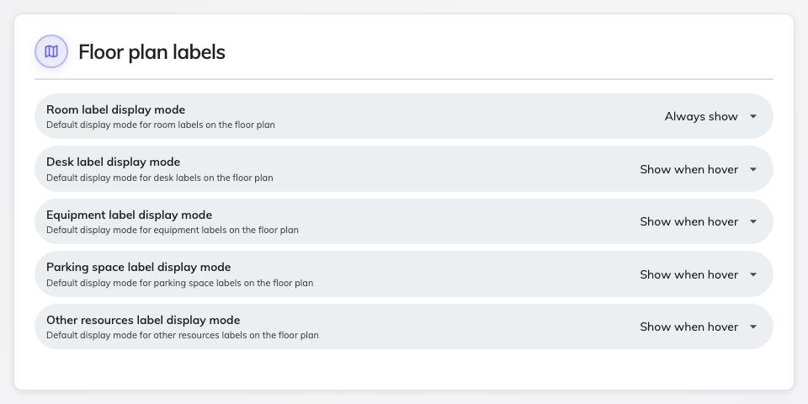
One label mode per resource kind.
One field per resource kind — Room, Desk, Equipment, Parking
space and Other resources — each set to Always show, Show when
hover or Hidden.
These are defaults, not locks: a reader can still turn labels on for a map
where you hid them. Set what a map should look like when it first opens.

Others
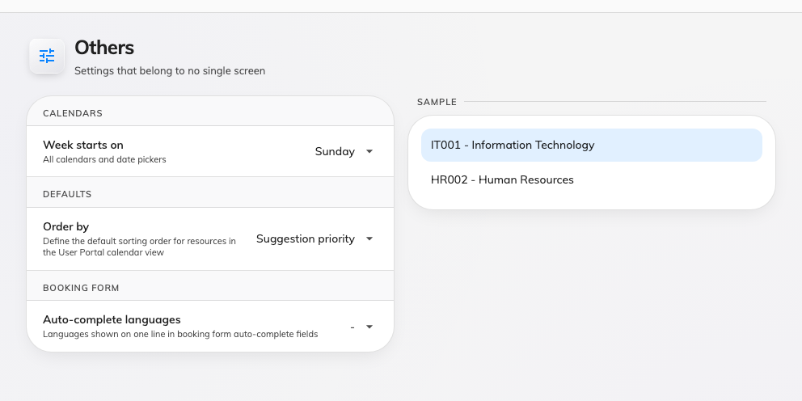
The catch-all: the day the week starts on, a default order, and which languages an auto-complete field shows.
Calendars sits first on the page, above the defaults.
Field | What it does | Options
Week starts on | The first column of every calendar and the first column of every date picker, across the console, the user app and the mobile apps | Sunday (default) / Monday / Saturday

The rest of the page:
Field | What it does | Options
Order by | The default order of resources in the user portal calendar | Suggestion priority / Favourite / Last booking time / Location / Name / Capacity / Availability
Auto-complete languages | Which languages appear on one line in the booking form's auto-complete fields | Any of the tenant's enabled languages

Auto-complete languages replaced a single switch:
Before 4.5.11 this was one on/off toggle. It is now a choice of languages, so a
bilingual office can show both without showing all of them. See
Booking form settings for what those
fields are.
Week starts on is one setting for the whole tenant:
It is not a per-person preference, and it is not read from the browser's locale:
one answer applies to everybody. It reaches the console's calendars, the user
app and the mobile apps; a signage weekly schedule lays its own week out and is
not affected.

Management calendar
The console's own calendar, below the divider — the one page here that restyles
the screen an administrator works in.
Field | What it does | Options
Column width | How many resources fit on a page | Narrow / Normal / Wide
Row height | How much of the day fits without scrolling | Compact / Normal / Tall
Color | The colour of a booking block with no purpose
Fields | The lines a booking block prints | Drag to reorder
Cancel room booking only | Offers the room-only cancel on the console's sticker | The console has never offered Convert to online meeting
Booking purpose card | One override per purpose | As on the resource calendar
Resource description | The same three values, for the console's own booking form. Set separately from the user app's | Hidden / Show description / Show as caution

The block's left edge always shows booking state, whatever colour you pick —
that stripe is not configurable, because it is the only thing on the block that
distinguishes a confirmed booking from one waiting for approval.

