Set the system time zone
Pick the zone every schedule, board and report falls back to. About two minutes, and it applies to everyone at once.
2026-08-15 · https://offision.com/help/en/system/set-the-system-time-zone/
Before you start:
You need an account that can open System config. The change applies to everyone
at once, so make it outside busy hours if the shift is a large one.

1. Open System interface
Go to System config › System interface. The time zone sits in the first
section, Account settings, under the account name and languages.
Where in Offision: admin app → system-account/ui-settings (System interface)

2. Choose the zone
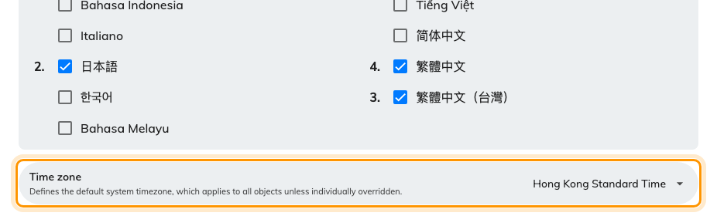
Account settings, with the system time zone.
Pick the city, not the offset. The list is organised by offset, which makes
+08:00 look like a reasonable answer — but an offset is only correct until the
next daylight saving change. A city carries its own rules, so Los Angeles moves
an hour in spring and Hong Kong does not, and neither needs your attention
again.
Where several cities share your rules, any of them is correct. Pick the one your
colleagues would recognise.

3. Save
The save bar appears at the foot of the page once you have changed something.
This is the default, not a global override. Buildings and people can carry
their own zone, and when they do, theirs wins — see
Which time zone applies before you conclude the
setting has not worked.

4. Check it worked
Open a booking and a door panel. Both should read the new local time.
Panels pick the change up on their next refresh rather than instantly, so give
one a minute before treating a stale clock as a fault. If a building still
shows the old time, that is expected — its zone comes from its location, not
from here.

