Send email from your own address
Point Offision at your own mail server so notifications arrive from your domain instead of ours. About fifteen minutes, and you can test before saving.
2026-08-16 · https://offision.com/help/en/system/send-email-from-your-own-address/
Before you start:
You need an account that can open System config, and the host, port, username
and password of a mailbox your mail provider will relay through. The page only
appears while you are viewing the root organization — switch back from a
sub-organization first.

1. Open Email setting
Go to System config › Settings › Email › Email setting.
Where in Offision: admin app → system-account/email-settings (Email setting)

2. Change the email mode
Out of the box Offision sends through its own mail service, and the first
setting on the page says so: Email mode is
Send by offision (mail.offision.com). That address is ours, not yours, and
nothing on this page can change it — so switching the mode to SMTP Server is
not one option among several, it is the whole job. Everything else on this page
only appears once you have.
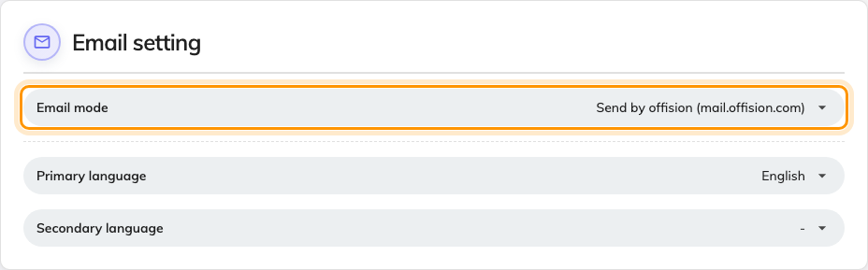
Email mode, still on the Offision default.
Leaving it alone is a perfectly good answer if nobody minds where the mail comes
from. Mail sent through your own server is the one that carries your domain,
lands in the right spam bucket, and shows up in your own sent-mail auditing.

3. Fill in the server
Email server setting appears underneath. Enter the SMTP server host and
Port, then the Username and Password of the mailbox Offision will
send through.
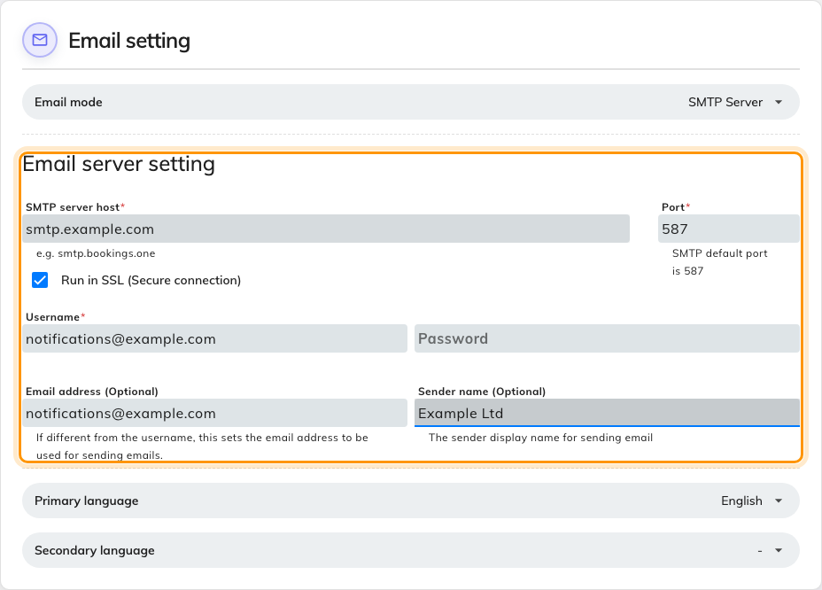
Email server setting, filled in.
Run in SSL (Secure connection) is the one real decision here. Leave it on
and the port defaults to 587 and the connection is encrypted. Turn it off and it
falls back to port 25 in the clear, which is what the red warning under the
checkbox is about — every message, and the password that sent it, crosses the
network readable. Turn it off only on a relay that never leaves your own
network.
Offision signs in with a username and password. There is no OAuth option, so a
mailbox that requires modern authentication needs an app password or a dedicated
relay account rather than someone's normal sign-in.
Coming back to change something else:
The password comes back masked, and stays as it is unless you type over it.
Leave the field alone when you are only editing the host or the sender.

4. Set who the mail comes from
Two fields at the bottom decide what a recipient actually sees, and both are
marked optional because Offision will fall back to the username without them:
- Email address is the address the mail comes from. Leave it blank and the
username is used, which is usually right — set it when the account you
authenticate with is not the address you want people to reply to.
- Sender name is the friendly name beside that address, so the mail reads as
from your organisation rather than from a mailbox.
Offision does not verify the domain, but your mail provider does. A from address
outside the mailbox you authenticated with is the single most common reason the
settings look correct and the test still fails — check your provider's rules on
sending as another address before assuming the details are wrong.

5. Send a test before you save
Scroll to Email style and choose Send testing email. Enter an address
you can read and choose Send.
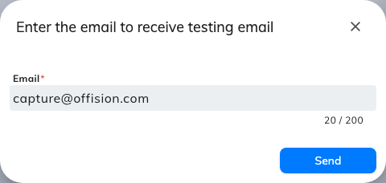
Sending a test to an address you can check.
The test uses what is on screen, not what is stored, which is why it comes
before the save rather than after it. A bad host or a rejected password fails
here while your working email settings are still untouched.

6. Save
The save bar appears at the foot of the page once something has changed.

7. Check it worked
Send a real message through Offision — inviting someone from
Add people to Offision is the quickest — and open
it in the recipient's inbox. The from address and sender name should be yours.
If the test passed but real mail does not arrive, the settings are right and the
problem is downstream: look at your provider's rejected-mail log rather than at
this page. And if you were changing the branding as well, that is
Put your logo on Offision emails.
Everything Offision sends leaves through this sender, scheduled reports
included — so a report that stops arriving is worth checking here before
anywhere else. Booking's is
Email your managers a forecast of upcoming bookings.

