Move to Offision from another system
The order to bring an existing workplace across: buildings, then rooms and desks, then people, then bookings and visits — each stage imported from a spreadsheet exported out of the old system, and why that order is fixed.
2026-08-20 · https://offision.com/help/en/system/move-to-offision-from-another-system/
Almost everything in Offision can be created from a spreadsheet — resources,
people, bookings, visits. So a migration is not a data project: export each list
from the system you are leaving, reshape the columns in Excel, and import it
here. What matters is the order, because each import names things created by
the one before it.
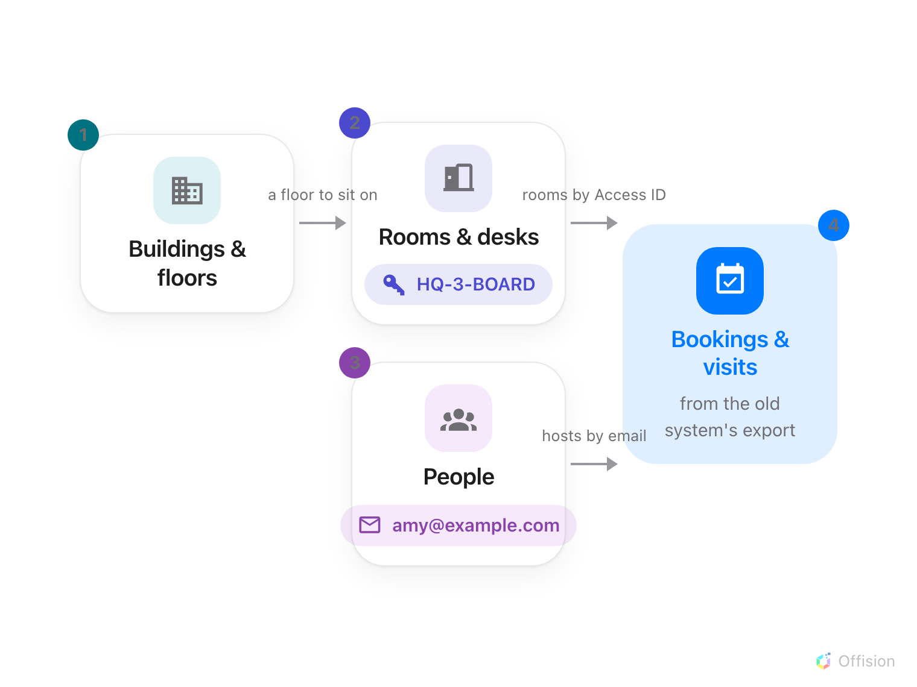
Each import names things created by the one before it — rooms by Access ID, people by email — so the order is fixed.
Before you start:
You need an administrator account, and the exports from your old system — most
can produce Excel or CSV. Only the future needs migrating: bookings and visits
that already happened stay in the old system's archive.

1. Export from the old system
Take whatever it offers — room lists, staff lists, upcoming bookings, expected
visitors. The columns will not match Offision's templates, and that is fine: at
every import below you first download Offision's own template, then copy the
old system's columns across in Excel. That copy-paste is the actual migration
work, and a spreadsheet is the one place everyone can do it.

2. Buildings and floors
Everything else hangs off a location, so the estate comes first — there is no
import for it, and it does not need one: it is a handful of records, made once.
See Add a building and its floors.

3. Rooms and desks
On the resources list, Import (beside Add) creates rooms, desks or
equipment in bulk from a template — names in every language, and capacity for
rooms. See Add a room.
Then give each room an Access ID — a stable code like HQ-3-BOARD — on the
resource form. The booking import's sheet names rooms by that code, and its
dialog has a reference page listing which rooms still lack one.

4. People
On the people list, Import creates and updates the whole directory from one
sheet — see Add people to Offision.
The imports below name organizers and hosts by these email addresses, so people
must land before bookings do.
If the company runs Microsoft 365 or Google Workspace, connect the directory
instead of importing it — accounts then arrive and update themselves.

5. Bookings
Export the old system's upcoming bookings, reshape them into the booking
template — rooms by Access ID, organizers by email — and import them on the
management calendar. Every booking rule is still enforced, so what could not
have been booked by hand will not import silently either. See
Import bookings from a spreadsheet.

6. Visits
Export the expected visitors, reshape them into the visiting template — one row
per visitor, locations by import ID, hosts by email — and import them on the
Invitation calendar. Invitations, approval and badges behave as if each visit
had been typed in. See
Import visits from a spreadsheet.

7. Check it worked
Run one day end-to-end before retiring the old system: make a booking as an
ordinary employee, check in at the panel, and let one imported visit's guest
check in at reception. Every import above ends with its own verification step —
this one proves the pieces work together.

What this does not cover
History does not migrate — Offision starts recording check-ins, logs and
reports from day one. And none of the imports carry your rules: booking
windows, approval, quotas and visiting purposes are configured, not imported —
work through each module's own articles once the data is in.

